CODE:
import java.sql.*;
public class Main {
public static void main(String[] args) {
System.out.println("Hello word");
try {
Class.forName("org.postgresql.Driver"); //driver ka naam
} catch (ClassNotFoundException e) {
System.out.println("Error loading driver");
}
//4. Create Connection
// jdbc:dbName://address:port/database
String url = "jdbc:postgresql://localhost:5432/oop_lab";
String user = "postgres";
String password = "admin";
Connection connection = null;
//connecting database //exception at getconnection (checked) // so deal with it by try catch
try {
connection = DriverManager.getConnection(url, user, password);
System.out.println("Successfully connected");
} catch (SQLException e) {
System.out.println("Error in establishing connection w database");
System.out.println(e.getMessage());
}
try {
Statement statement = connection.createStatement();
// result set is used to get database's response
//all of these resonses are saved in result set, thats why we put loop on resultset
ResultSet resultSet = statement.executeQuery("select * FROM student");
//using while loop bcz we dont know how much data is there
while (resultSet.next()) {
System.out.println("Student ID" + resultSet.getInt("student_id"));
System.out.println("Student Name: " + resultSet.getString("student_name"));
System.out.println();
}
//CREATE DATA - INSERTION
// //whenever manipulation is required in databases, (all except read) - DONT USE EXECUTEQUERY, USE EXECUTEUPDATE
// System.out.println("Record inserted");
String dataInsert = "insert into " + "student (student_id, student_name, student_age, student_grade) VALUES (6, 'Fatima', 21, 'A')";
statement.executeQuery(dataInsert);
System.out.println("Record Inserted");
//UPDATE DATA
String dataUpdate = "Update student " + "set student_name = 'Ali_test' "
+ "where student_id = 3";
statement.executeUpdate(dataUpdate);
System.out.println("Updated");
}
// 4. DELETE DATA
String dataDelete = "DELETE FROM students WHERE id = 4";
id 5
int deleteRowsAffected = statement.executeUpdate(dataDelete);
query
if (deleteRowsAffected > 0) {
System.out.println("Deleted successfully");
} else {
System.out.println("No rows were deleted");
}
catch(Exception e){
System.out.println("Error");
System.out.println(e.getMessage());
}
}}

OUTPUT:
- Read:
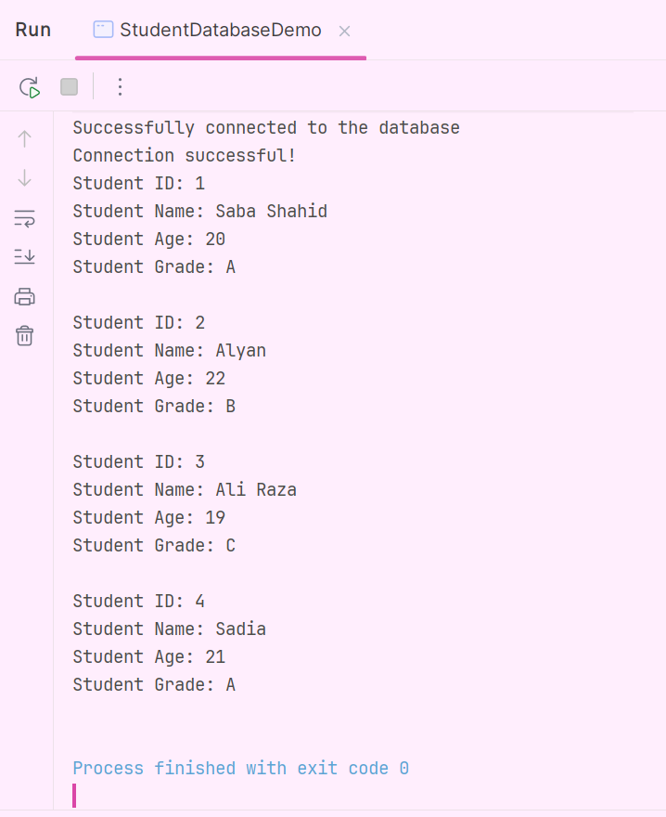

- Create:

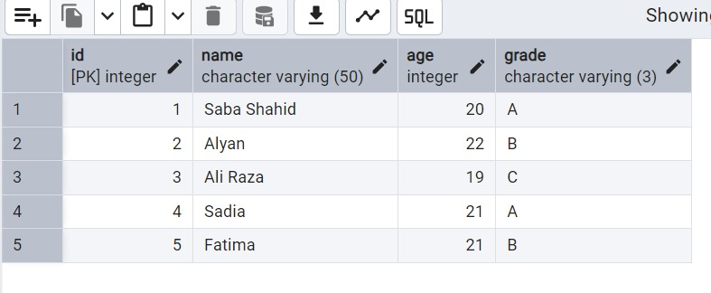
- Update:

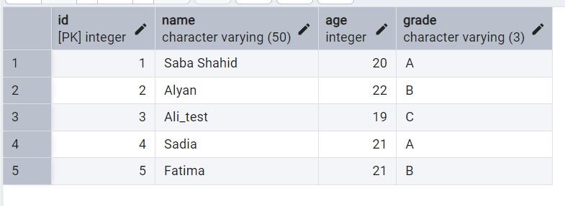
- Delete:
