CODE:
// SABA SHAHID
// ENROLL: 02-134241-048
// CS 2-A
// LAB ASSIGNMENT 11
import javax.swing.*;
import java.awt.*;
import java.awt.event.ActionEvent;
import java.awt.event.ActionListener;
public class Counter {
private JTextField welcomeToTheCounterTextField;
private JButton clickToCountButton;
private JTextPane countTextPane;
// Initialize karein ge for counting
private int count;
public Counter() {
clickToCountButton = new JButton("Click to Count");
clickToCountButton.addActionListener(new ActionListener() {
@Override
public void actionPerformed(ActionEvent e) {
count++; // Increment count
welcomeToTheCounterTextField.setText("Count: " + count);
//count show krne k liye
countTextPane.setText("Count: " + count);
}
});
// Initialize JTextPane
countTextPane = new JTextPane();
//made it non editable
countTextPane.setEditable(false);
//initializing count
countTextPane.setText("Count: 0");
}
public static void main(String[] args) {
// doing Framing and stuff cuz i couldnt figure out to do it the other way, learned it from yt ::p
JFrame frame = new JFrame("Counter Application");
frame.setDefaultCloseOperation(JFrame.EXIT_ON_CLOSE);
frame.setSize(400, 300);
Counter counter = new Counter();
frame.setLayout(new FlowLayout());
frame.add(counter.welcomeToTheCounterTextField = new JTextField("Count: 0", 20));
frame.add(counter.clickToCountButton);
frame.add(counter.countTextPane);
frame.setVisible(true);
}
}

GUI:
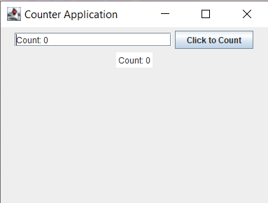
AFTER COUNTING:
