CODE:
import java.io.*;
import java.nio.file.Files;
import java.nio.file.Paths;
public class Main {
public static void main(String[] args) {
BufferedReader br = new BufferedReader(new InputStreamReader(System.in));
try {
// AskING user for file name
System.out.println("Enter the name of the text file: ");
String fileName = br.readLine() + ".txt";
// making that file
File file = new File(fileName);
if (file.createNewFile()) {
System.out.println("File created: " + fileName);
}
// Writing som init
FileWriter fw = new FileWriter(file, true);
PrintWriter pw = new PrintWriter(fw);
System.out.println("Enter the content to write to the file: ");
String content = br.readLine();
pw.println(content);
pw.close();
// Reading and printed the content as output
String filePath = fileName;
String fileContent = new String(Files.readAllBytes(Paths.get(filePath)));
System.out.println("Content of the file:");
System.out.println(fileContent);
} catch (IOException e) {
e.printStackTrace();
}
}
}

OUTPUT:
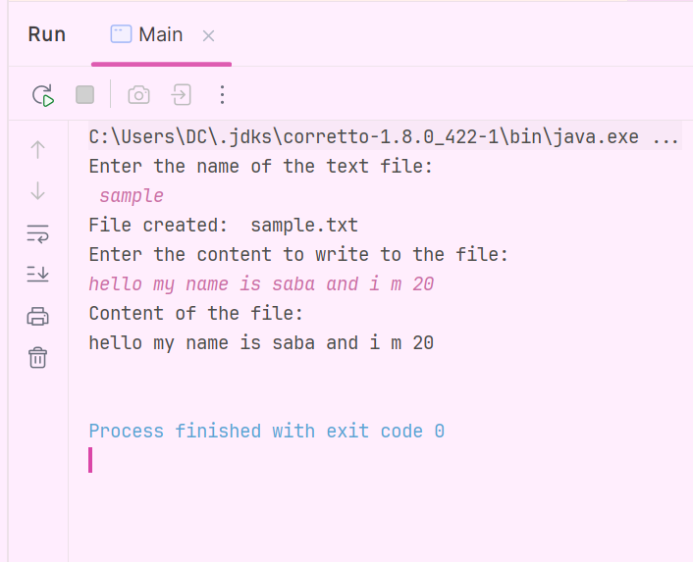
TXT FILE CREATED:
