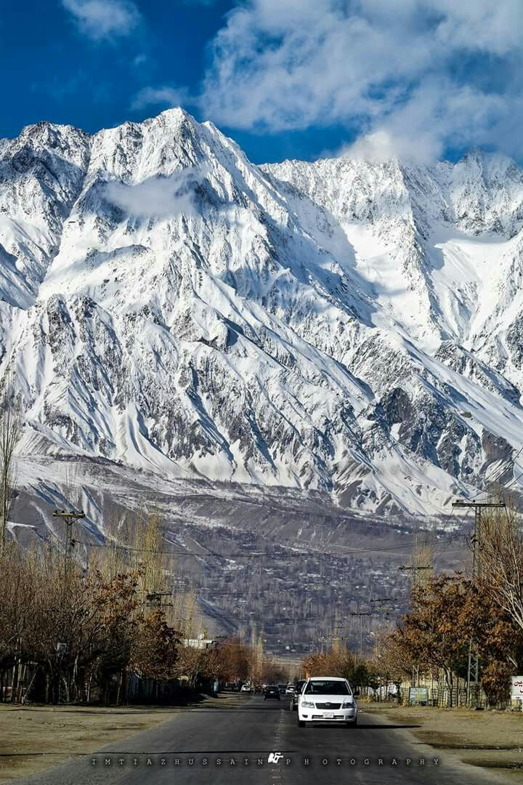

SABA SHAHID
02-134241-048

BS CS 2-A

SKARDU
Pakistan

TABLE OF CONTENTS

- Introduction
  - Overview of Skardu
- Significance and reason of fame
  - Main reasons of being well known
- Skardu’s potential
  - Histrorical cultural sites like Shigar Fort
  - Geographical unique landscapes and ecosystem
  - Recreational trekking, lakes and resorts
  - Economic role of tourism and local crafts
- Main attractions
  - K2, Shangrilla Resort
  - Deosai Park
  - Satpara Lake
  - Historic Forts
- Promoting tourism
  - Infrastructure
  - responsible tourism
  - Digital marketing
- Visuals
- References

- INTRODUCTION

  - Overview
Skardu, a mesmerizing valley in the Gilgit-Baltistan region of Pakistan, is renowned for its breathtaking landscapes, rich cultural heritage, and as a gateway to some of the highest peaks in the world, including K2. This report explores the essentials of Skardu, its fame, historical and geographical significance, recreational and economic potential, and features that attract tourists. Additionally, it discusses ways to improve and promote tourism in Pakistan.

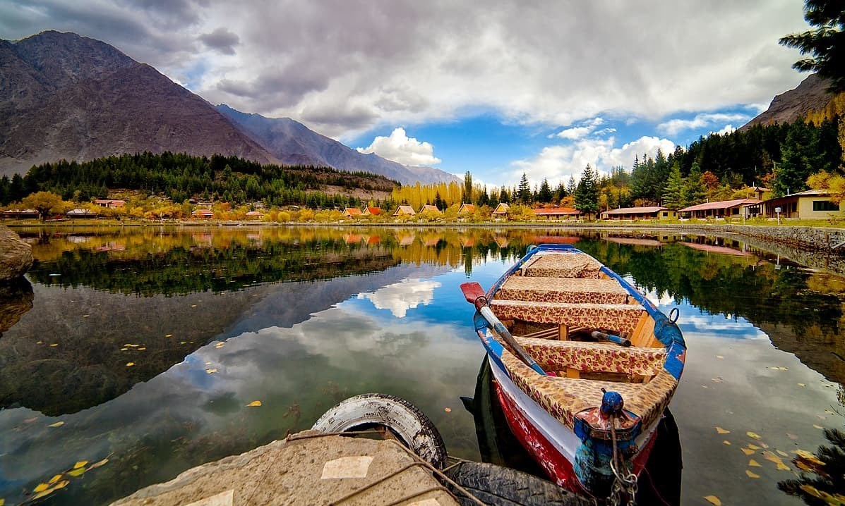

- SIGNIFICANCE

2.1. Reason of being famous

Skardu is famous for:

- Natural Beauty: The stunning landscapes, including lakes, mountains, and valleys.

- Adventure Sports: A hub for trekking and mountaineering, attracting adventurers globally.

- Cultural Heritage: Rich history and unique architecture, including ancient forts and mosques.

- Gateway to High Peaks: Proximity to K2 and other significant mountains.

2.3.
- SKARDU’S POTENTIAL

3.1. historical Significance

- Early Settlements: Skardu has a rich history influenced by various cultures, including Tibetan Buddhism.

- Maqpon Dynasty: The region was ruled by the Maqpon dynasty, which contributed to its cultural and architectural heritage.

- Mughal Influence: The Mughal Empire integrated Skardu into its realm, further enriching its history.

3.2. geographical Aspect

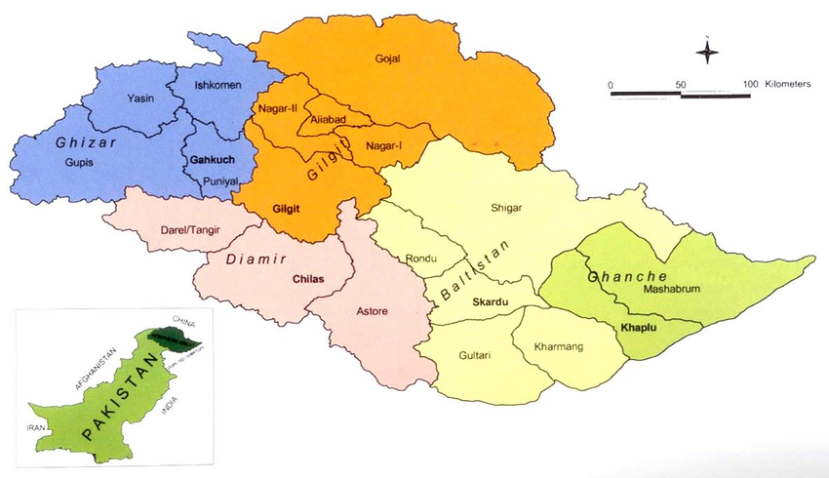
- Location: Skardu is located at the confluence of the Indus and Shigar rivers, surrounded by the Karakoram and Himalayan Mountain ranges.

- Climate: Cold semi-arid climate with hot summers and extremely cold winters. Ideal for summer tourism.

- Natural Features: Home to stunning lakes like Kachura and Satpara, and the Deosai National Park, known for its unique biodiversity.

3.3. Recreational Potential

- rekking and Mountaineering: Popular routes include the Baltoro Glacier and K2 Base Camp.

- Cultural Tours: Visits to historical sites like Skardu Fort and Chaqchan Mosque.
- Adventure Activities: Opportunities for rock climbing, paragliding, and fishing.

3.4. economic Potential

- Tourism Revenue: Skardu's economy heavily relies on tourism, providing jobs and supporting local businesses.

- Agriculture: The fertile land supports agriculture, particularly fruits and vegetables, contributing to the local economy.

- Future Growth: With proper infrastructure and marketing, Skardu can attract more tourists, boosting economic development

.
4. Main attractions

4.1. K2, Shangrilla Resort

- K2: Known as the "Savage Mountain," K2 is the second-highest peak in the world and a major attraction for mountaineers and trekkers. Its challenging routes and breathtaking views draw adventurers from around the globe.

- Shangrilla Resort: Nestled near the Upper Kachura Lake, this resort offers a serene environment with stunning views of the surrounding mountains. It’s a popular spot for tourists seeking relaxation and natural beauty.
.

4.2. Deosai Park

- Deosai National Park is a UNESCO World Heritage Site known for its vast plains and rich biodiversity. The park is home to the Himalayan brown bear and offers stunning landscapes, making it a popular destination for nature lovers and trekkers.

4.3. Satpara lake

- Satpara Lake is a stunning freshwater lake located just a few kilometers from Skardu. The lake’s crystal-clear waters and surrounding mountains create a picturesque setting, making it a favorite spot for picnics, boating, and photography.

4.4. Historical Forts

- Skardu is home to several historic forts, including Skardu Fort and Kachura Fort. These ancient structures offer insight into the region's history and architecture, providing panoramic views of the valley and surrounding landscapes.

4. PROMOTING TOURISM
M

4.1. Infrastructure

- Improving infrastructure, including better road access, airports, and accommodations, is critical for making Skardu more accessible and comfortable for tourists. Developing transportation and amenities will also support the local economy and encourage longer stays.

4.2. Responsible Tourism

- Promoting responsible tourism practices, such as conservation efforts, eco-friendly accommodations, and waste management, will help protect Skardu's natural beauty. Involving local communities in conservation and sustainable practices ensures long-term environmental and cultural preservation.

4.3. Digital marketing

- Digital marketing campaigns that showcase Skardu’s unique landscapes, historical sites, and cultural richness can attract a global audience. Social media, travel blogs, and virtual tours can highlight Skardu as a premier adventure and cultural destination, drawing in both local and international tourists.

5. VISUALS
M

- Skardu is a photographer’s paradise, with its surreal landscapes and vibrant cultural sights. From the turquoise waters of Satpara Lake and Shangrila Resort nestled against lush greenery to the stark, rugged peaks of K2 and the expansive Deosai National Park, each scene in Skardu captures a different aspect of nature’s beauty. Historical sites like Shigar Fort and Kharpocho Fort add cultural depth, offering a glimpse into Skardu’s ancient Balti heritage. These captivating visuals make Skardu an unforgettable destination, appealing to adventurers and serenity-seekers alike.

- Short documentary https://www.youtube.com/watch?v=qzoNSrbuhK8

6. REFERENCES
M

6.1. Websites
  - Pakistan Tourism Development Corporation (PTDC). Explore Pakistan.
  - Lonely Planet. Skardu
  - UNESCO. Doesai NationaL Park

6.2. Travel blogs
  - Skardu: A Hidden Gem in Pakistan.
  - K2: k2 documentary

6.3. Reports
  - Tourism Development in Pakistan: Opportunities and Challenges.

6.4. Social Media
  - Instagram and Facebook pages dedicated to Skardu tourism often feature stunning photographs and personal experiences from travelers.

