ASSIGNMENT 01
Marks: 05

NAME: SABA SHAHID
CLASS: CS 2-A
REG. NO: 02-134241-048
COURSE: OBJECT ORIENTED PROGRAMMING
COURSE CODE: CSC-210

Marks Obtained: ______________________

Theoretical Assignment
Read Carefully:
- The deadline for this assignment is before or on 15/10/2024.

WARNING: This is an individual assignment; you must solve it by yourself. Any form of plagiarism will result in receiving a zero in the assignment.

WARNING: Late submissions will not be accepted. Any assignment submitted after the cutoff time will receive zero.

- You have to answer and submit in SOFTCOPY of the given draft on your LMS.

QUESTION (Do as Directed) (5 Marks)
(CLO1, PLO1, C2)

- Explain the following challenges associated with OOP:
  - Steep learning curve
  - Larger program size
  - Slower program execution
  - Its not a one-size fits all solution.

ANSWER:
- Steep learning curve:

Steep learning curve refers to the initial difficulty of learning something that is considered to be very challenging. OOP requires an understanding and usage of encapsulation, inheritance, abstraction and polymorphism. Moreover, the concept of objects and classes which can be challenging for new users and those who are accustomed to imperative programming.
- Larger program size:

OOP can lead to more code, specially if the program requires the use of multiple classes and inheritance hierarchies. It tends to generate larger programs compared to procedural programming because of the additional layers of abstraction, the use of objects, classes, and methods.
- Slower program execution:

OOP programs typically require more instructions to be executed in contrast to procedural programs, making them slower. Additionally, the indirect access to data through methods can add to the program's overhead, another reason could be the overhead associated with method invocation and object creation.
- It’s not a one-size fits all solution:

OOP is not ideal for every problem. Some tasks are more efficiently handled by procedural programming, especially simple, straightforward problems that do not require the overhead of objects and classes. OOP can overcomplicate a solution when a simpler paradigm might be efficient.

- Classify the Imperative Programming Paradigm and Declarative Programming Paradigm. Also, elaborate that Object-Oriented Programming lies in which paradigm?

ANSWER:

Imperative Programming Paradigm:

The focus of this paradigm is to break the problem into discrete pieces that can be solved in a series of commands that determine the behavior of the program to be altered. For example, control flow structures such as loops and conditionals are common and so programmers can be given instructions on how to specify each operation in detail. Languages that fall under the issue include C, C++ and Java.

Declarative Programming Paradigm:

The declarative language paradigm has no detail on how the program will do the work but rather what work it should do. This takes away specifics on how the implementation has to be done to achieve the impact and concentrates on the logic whereby the output is achieved. One of the languages are SQL which is used to query databases and HTML used for structuring web pages.

Paradigm of OOP:

Though OOP belongs to the imperative programming paradigm, it is still integrated with certain elements that make OOP stand out even more from imperative programming. OOP includes how data and methods are structured around the notion of objects and has the features of inheritance and polymorphism which enables reusable and modular codes. Java, C++, and Python offer OOP features that help developers create easy-to-manage and adaptable software by organizing code around real-world objects.

- Summarize the concept of the Constructor, also write a small program to copy a constructor.
ANSWER:

Constructor:
A constructor in Java is a special method used to initialize objects. It is called when an object of a class is created. The constructor usually sets initial values for the object's attributes. A constructor has the same name as the class and no return type. There are two types of constructors:
Default Constructor: This is provided by Java if no constructor is explicitly defined, and it initializes the object with default values. These contain no parameters.
Parameterized Constructor: This constructor allows passing parameters to initialize an object with specific values. It takes arguments to initialize an object's attributes with specific values.

Example:
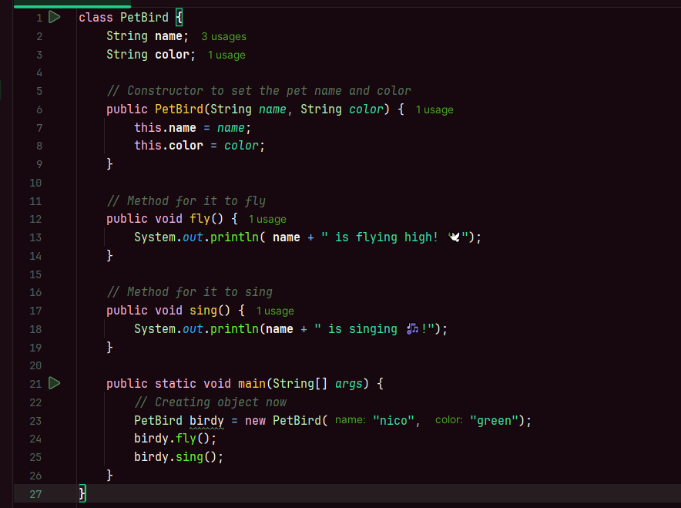
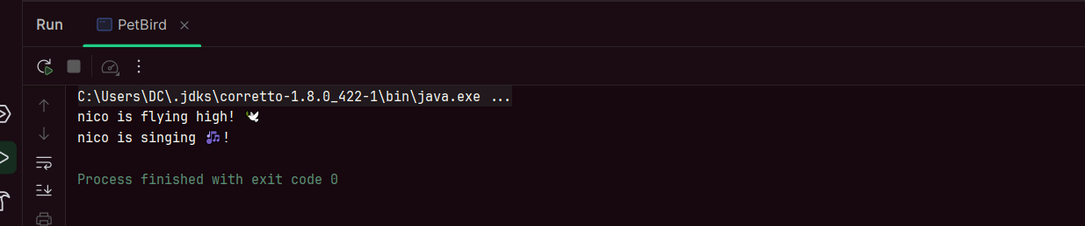

- Explain if is it always necessary to create objects from a class. Also, relate the instantiation process with static methods declaration within a class.
ANSWER:

In Java, static methods and variables can be accessed directly through the class name
without instantiating an object, which enables utility functions to be used efficiently without
the overhead of creating an object. However, for instance-specific behavior, such as
accessing instance methods or variables, it is necessary to create an object using the new
keyword. This distinction between static and instance-level functionality allows Java classes
to provide both class-level behavior and operations specific to individual objects, depending
on the context and the programmer's needs.

- Are class and structure the same? If not, what's the difference between a class and a structure? Infer among class and structure.
ANSWER:

Classes and structures are not the same. The key difference is as below:
CLASS | STRUCTURE
Members are private by default resultingly they can’t be accessed directly from outside the class. | Members of a structure are public by default so they can be accessed directly.
Classes are used for more complex data with functions and various kinds of access control. | Structures are used for simple data grouping unlike classes.

****************************

