BAHRIA UNIVERSITY
Karachi Campus
Department of Computer Sciences

NAME: SABA SHAHID
ENROLLNMENT: 02-134241-048
COURSE TEACHER: DR. SAFDAR
CLASS: BS (CS) 3-A

CLO-1 PLO-1 (BT level- C2)

Answer the following on any selected topic:
- Illustrate the detailed working model.
- Explain main funtionalilties.

Topic: Internet of Things (IoT) – A Smart Revolution

  - Introduction

- Definition of IoT
The Internet of Things (IoT) refers to a network of interconnected devices that collect, share, and analyze data through the internet. These devices include everyday objects embedded with sensors, software, and connectivity features that enable seamless communication and automation. IoT allows real-time monitoring, smart decision-making, and automation of tasks across different industries.
- Importance and Impact on Modern Technology
IoT has transformed modern technology by enabling automation, enhancing efficiency, and improving decision-making. It plays a crucial role in various domains, including healthcare, smart homes, industries, and urban planning. The integration of IoT leads to cost savings, enhanced productivity, and improved quality of life.
- Examples of IoT Applications

Smart Homes: Smart thermostats, lighting systems, and security cameras.
Healthcare: Wearable fitness trackers, remote patient monitoring.
Industry: Predictive maintenance, automated production lines.
Smart Cities: Intelligent traffic management, pollution control systems.

  - IoT Architecture & Working Model
- Components of IoT

- Sensors & Actuators – Collect data from the environment and trigger responses.
- Connectivity – Wireless communication using Wi-Fi, Bluetooth, Zigbee, LoRa, etc.
- Cloud Computing – Centralized data processing and storage.
- User Interface – Applications and dashboards for monitoring and control.

- How IoT Works – Step-by-Step Model

- Data Collection: Sensors gather real-time environmental data such as temperature, motion, humidity, etc.
- Data Transmission: Gateways transmit the collected data to cloud servers via wireless protocols.
- Processing & Analysis: Cloud platforms analyze the data using AI algorithms to derive insights.
- Decision Making: Based on the analysis, actions are triggered (e.g., turning off appliances, sending alerts).
- User Interaction: Users receive notifications and can control IoT devices via mobile apps or web dashboards.

  - Detailed explanantion on Working
In a smart home IoT system, various connected devices work together to enhance automation, security, and convenience. The process begins with sensors embedded in devices such as smart thermostats, motion detectors, and cameras, which continuously collect data about temperature, movement, and environmental conditions. This data is then transmitted via wireless communication protocols like Wi-Fi, Zigbee, or Bluetooth to a central IoT gateway or cloud server. The cloud platform processes this data using artificial intelligence (AI) algorithms to recognize patterns and automate actions. For instance, if a motion sensor detects no movement in a room for an extended period, it can instruct the smart lighting system to turn off, conserving energy. Additionally, users can interact with their smart home systems through mobile apps or voice assistants like Alexa and Google Assistant, allowing remote control of appliances, security cameras, and thermostats. Over time, machine learning enables the system to adapt to user preferences, such as adjusting indoor temperatures based on past behaviors. This seamless interconnectivity of devices in a smart home improves energy efficiency, security, and user convenience, making it one of the most practical applications of IoT technology.

  - Diagrammatic Workflows

IoT Enabled House Control

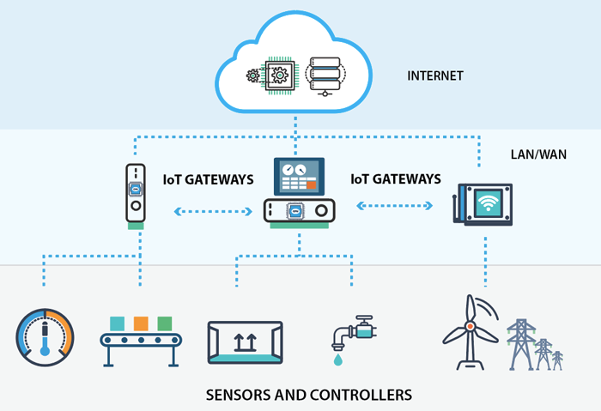

  - IoT Functionalities

- Data Collection & Processing: IoT devices collect real-time data from the environment and process it for meaningful insights.
- Automation & Control: Devices operate autonomously based on AI algorithms or pre-set rules.
- Remote Monitoring: Users can track and control IoT systems remotely via mobile applications.
- Interconnectivity: IoT devices communicate with each other seamlessly through protocols like MQTT, HTTP, and CoAP.
- Security & Privacy Management: Encryption, authentication, and secure cloud storage ensure data integrity and protection.

- Applications of IoT

- Smart Homes: Devices like Alexa, Google Home, and smart appliances enhance home automation by allowing voice commands and remote control.
- Healthcare: IoT-based wearables such as smartwatches monitor vital signs like heart rate and oxygen levels, assisting in remote patient care.
- Industrial IoT (IIoT): Enhances automation and predictive maintenance in industries by using sensors to detect machine failures before they occur.
- Smart Cities: IoT aids in urban planning through smart traffic lights, automated street lighting, and pollution monitoring systems.
- Agriculture: Automated irrigation and climate monitoring optimize farming efficiency, reducing water usage and increasing crop yield.

- Challenges & Future Trends in IoT

Challenges:
- Security Risks: Vulnerabilities to hacking and data breaches pose significant threats to IoT networks.
- Scalability Issues: Managing billions of interconnected devices requires a robust and scalable infrastructure.
- Energy Consumption: IoT devices need low-power solutions for sustainable and long-term operation.
Future Trends in IoT:
- AI-Driven IoT: Artificial Intelligence (AI) and Machine Learning (ML) will make IoT devices smarter and more autonomous.
- 5G & 6G Connectivity: Faster and more efficient communication between devices will enhance real-time IoT applications.
- Quantum IoT: The integration of quantum computing with IoT will enable ultra-secure communications.

- Conclusion

The Internet of Things (IoT) is revolutionizing the way we interact with technology, creating a more connected and automated world. From smart homes to industrial automation, IoT has enhanced efficiency, convenience, and decision-making across multiple domains. Despite facing challenges such as security risks and scalability issues, continuous advancements in AI, cloud computing, and network technologies like 5G are driving IoT’s rapid evolution. The future of IoT promises even greater innovations, including AI-driven automation, ultra-secure quantum computing applications, and widespread smart city initiatives. As IoT continues to expand, its integration into everyday life will redefine industries, improve quality of life, and shape the digital landscape of the future.

References:
- Gubbi, J., Buyya, R., Marusic, S., & Palaniswami, M. (2013). Internet of Things (IoT): A Vision, Architectural Elements, and Future Directions. Future Generation Computer Systems, 29(7), 1645-1660.
- Khan, M. A., & Salah, K. (2018). IoT Security: Review, Blockchain Solutions, and Open Challenges. Future Generation Computer Systems, 82, 395-411.
- Zibtek. (n.d.). IoT Architecture Explained. Retrieved from https://www.zibtek.com/blog/iot-architecture/

