REPORT WRITING ASSIGNMNET
Title Page
Title: Mental Health Issues: Causes, Impacts, and Solutions
Submitted to: Miss. Saba Qadir
Submitted by: Saba Shahid
Date: 23/05/25
Course/Department: Communication Skills
Table of Contents
- List of Abbreviations
- Executive Summary
- Introduction
- Body
- 4.1 Common Mental Health Disorders
- 4.2 Causes of Mental Health Issues
- 4.3 Effects on Individuals and Society
- 4.4 Stigma and Misconceptions
- Conclusion
- Recommendations
- References
- Appendices
- List of Abbreviations:
- WHO: World Health Organization
- PTSD: Post-Traumatic Stress Disorder
- OCD: Obsessive-Compulsive Disorder
- NAMI: National Alliance on Mental Illness
- Executive Summary:
Mental health has emerged as a critical global concern, with the World Health Organization (WHO) reporting that 1 in 4 individuals worldwide will experience a mental health disorder in their lifetime. This report examines the prevalence, causes, impacts, and solutions surrounding mental health issues, with a particular focus on the exacerbating effects of the COVID-19 pandemic (see Appendix A). The key findings are:
- Common disorders, including anxiety, depression, and PTSD, which significantly impair daily functioning.
- Root causes, spanning biological (genetics), psychological (trauma), and environmental (social isolation) factors.
- Far-reaching consequences, from reduced individual productivity to economic burdens on healthcare systems.
- Persistent stigma, which discourages help-seeking and perpetuates isolation.
The report advocates for multi-level interventions, such as government-funded mental health programs, workplace mental health policies, and school-based education initiatives. Immediate action is needed to address this public health crisis, particularly in light of the pandemic’s lingering effects.
This analysis serves as a call to action for policymakers, employers, and communities to prioritize mental health through awareness, accessibility, and systemic change.
- Introduction:
Mental health is a critical component of overall well-being, yet it is often overlooked. According to the WHO, mental health disorders affect 1 in 4 people globally. This report explores common mental health conditions, their root causes, consequences, and potential solutions. The purpose is to raise awareness and advocate for actionable strategies to mitigate this growing issue.
- Body:
4.1 Common Mental Health Disorders
Anxiety Disorders: Excessive fear or worry (e.g., Generalized Anxiety Disorder, Panic Disorder).
Mood Disorders: Persistent sadness or mood swings (e.g., Depression, Bipolar Disorder).
Psychotic Disorders: Distorted thinking (e.g., Schizophrenia).
PTSD: Trauma-related anxiety.
Eating Disorders: Unhealthy eating behaviors (e.g., Anorexia Nervosa).
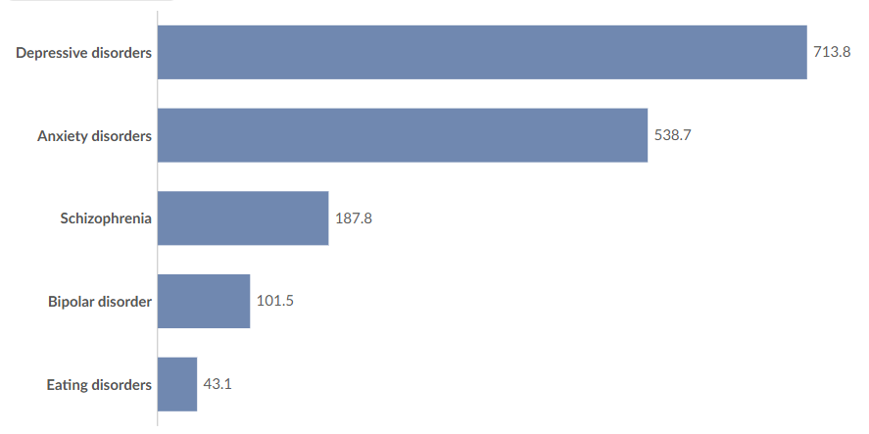
appendix A showing increase in mental health conditions during 2020
4.2 Causes of Mental Health Issues
Biological: Genetics, brain chemistry imbalances.
Psychological: Trauma, chronic stress, low self-esteem.
Environmental: Poverty, unemployment, social isolation.
Lifestyle: Substance abuse, poor sleep, sedentary habits.
4.3 Effects on Individuals and Society
Individuals: Reduced productivity, suicidal tendencies, physical health decline.
Society: Economic costs (e.g., lost workdays), healthcare system strain.
4.4 Stigma and Misconceptions
Misbeliefs: “Mental illness is a choice” or “Therapy is only for the severely ill.”
Consequences: Prevents help-seeking, increases isolation.
- Conclusion
Mental health issues are pervasive and multifaceted, requiring urgent attention. Combating stigma, improving access to care, and promoting preventive measures are vital steps toward a healthier society.
- Recommendations
- Government Action: Fund mental health programs and integrate care into primary health systems.
- Workplace Initiatives: Implement mental health policies and employee support systems.
- Education: Introduce mental health literacy in schools.
- Community Support: Expand helplines and peer-support networks.
- References
  - World Health Organization. (2022). Mental Health Report.
  - National Institute of Mental Health. (2023). Anxiety Disorders.
  - American Psychological Association. (2021). Stigma and Mental Health.
- Appendices
Appendix A: Mental Health Issues Increase Statistics during 2020

