An Analysis of Tesla Deaths in Different Countries

*A_group_148*

*Saba Shakoor, Pooja Dilipbhai Solanki, Sai Kiran Chittibommala, Sailendrakannan*

*Sivakumar Murugeswari, Ranjith Maliga Guruprakash*

*Thursday 13, 2023*

**Abstract**

Context: Tesla Deaths is a record of Tesla accidents that involved a driver, occupant, cyclist, motorcyclist, or pedestrian death, whether or not the Tesla or its driver was at fault.

Question: This study asks, Is there a difference in the mean of Tesla deaths among different countries?

Method: We analyzed the mean difference of tesla deaths for the first assignment of the September 2022 instance of the Team Research and Development module at the University of Hertfordshire.

Results: Although there is no random variation in the mean of deaths among different countries, a pairwise.wilcox.test function is used for the distribution of deaths analysis.

Conclusion: The result suggests that there is room for tesla to improve in producing all kinds of vehicles.

# Introduction

According to Tesla, Autopilot makes highway driving more fun, gives you more confidence behind the wheel, and improves your safety on the road. though genuinely. Tesla Autopilot works very similarly to the technologies that airplane pilots use when conditions are clear, although driverless automobiles are still a few years away.

One of the main reasons for unintended injuries and fatalities worldwide is motor vehicle accidents. Many studies have been done to examine different aspects of auto accidents. Although just a small number of them target newly developing electric vehicles, the majority of them target traditional internal combustion engine vehicles (ICEVs) (EVs).

This study aims to compare marks assigned by multiple graders on the same assignment. Specifically, we ask the following research question:

Is there a difference in the mean of Tesla deaths among different countries?

The null hypothesis is:

H0: There is no difference in the mean of Tesla deaths among different countries.

The alternative hypothesis is:

Halt : There is a difference in the mean of Tesla deaths among different countries.

# Visualization

The Tesla deaths dataset shows the data of Tesla accidents in which date, location, state, deaths, driver, and many more data are available. The updated record of tesla deaths has 274 rows which have been representing the crash data for instance location of the crash, year, and date. This record has other sheets in which additional data and analysis on vehicle miles travel and many more data are presented.

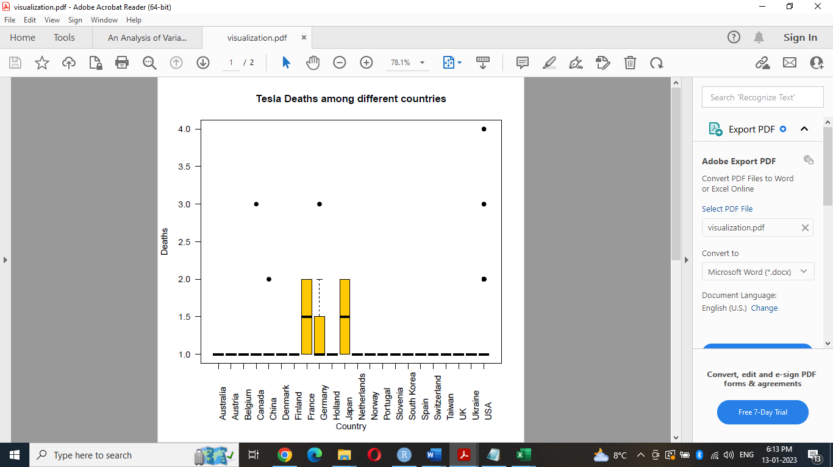

Figure 1: Deaths assigned by each country. Countries are sorted in alphabetic order.

Figure 1 shows the boxplot visualization allows checking out the mean of Tesla deaths among different countries. This boxplot demonstrates the wide difference in the deaths assigned by different counties: the median deaths range from barely 1.5 for France and Japan. Furthermore, the USA has the highest number of death whereas other countries appear to have the lowest number of deaths just by 1.

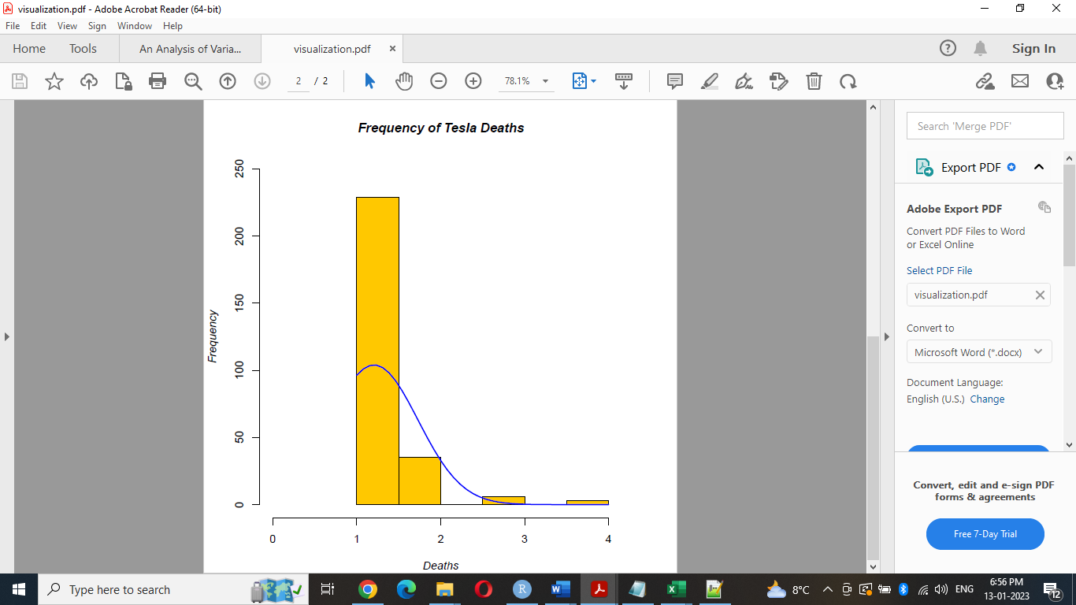

Figure 2: Distribution of deaths

Figure 2 demonstrates a histogram displaying the frequency distribution of deaths. This histogram displays that deaths are skewed toward the low end, which means it has a long tail in the positive direction (Descriptive Statistics).

**Analysis**

Figure 2 proposes the deaths are not normally distributed, thus we used nonparametric pairwise.wilcox.test function provided by the R statistical programming language (R Core Team 2021). This test performs a Wilcoxon-Mann-Whitney test (Mann and Whitney 1947) comparing the set of deaths for each country with other countries, in a pairwise fashion. The Wilcoxon-Mann-Whitney test judges whether two sets of values are distributed differently; specifically, it tests whether, when all values from both sets are ordered, one set is significantly skewed toward one end of the scale (Dalgaard 2008).

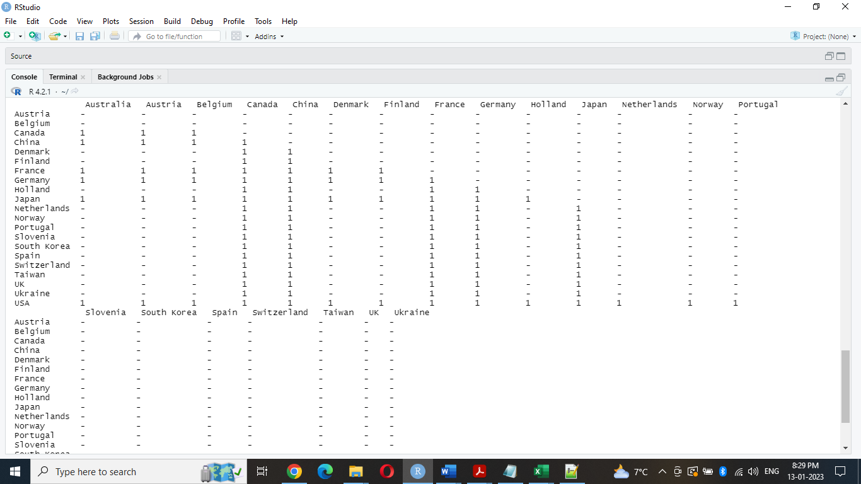

Figure 3: P-values resulting from pairwise Wilcoxon test comparing pairs of country deaths.

Figure 3 *P*-values resulting from this pairwise analysis. Each entry shows the probability that the observed difference between the two sets of countries is not random and the values are not normally distributed. According to figure 3, we can see that there is no potentially significant difference in any case that is (*α* < 0.05). So, we can consider the null hypothesis in each case of comparison.

# Conclusions

By looking at figure 2, it shows that the histogram bench is towards the lower end and has a positive direction. Applying the Wilcoxon-Mann-Whitney test reveals that values are not normally distributed.

According to the dataset of the tesla deaths record, we can see the extreme death count in value which is 1, and it has a matrics of different reasons involved or reported.

In the future, the result suggests that there is room for tesla to improve in producing all kinds of vehicles

# References

Ingle, S. and Phute, M., 2016. Tesla autopilot: semi-autonomous driving, an uptick for future autonomy. *International Research Journal of Engineering and Technology*, *3*(9), pp.369-372.

Tatarek, T., Kronenberger, J. and Handmann, U., 2017. *Functionality, advantages and limits of the tesla autopilot*. Institut Informatik, Hochschule Ruhr West.

Rice, D., 2019. The driverless car and the legal system: Hopes and fears as the courts, regulatory agencies, waymo, tesla, and uber deal with this exciting and terrifying new technology. *Journal of Strategic Innovation and Sustainability*, *14*(1), pp.134-146.

Descriptive Statistics Available at: <http://www.cvgs.k12.va.us/DIGSTATS/main/descriptv/d_skewd.html> (Accessed: 13 January 2023).

R Core Team. 2021. *R: A Language and Environment for Statistical Computing*.

Vienna, Austria: R Foundation for Statistical Computing. <https://www.R-project.org>.

Mann, H. B., and D. R. Whitney. 1947. “On a Test of Whether one of Two Random

Variables is Stochastically Larger than the Other.” *The Annals of Mathematical*

*Statistics* 18 (1): 50–60. <https://doi.org/10.1214/aoms/1177730491>.

Dalgaard, Peter. 2008. *Introductory Statistics with R*. 2nd ed. Statistics and

Computing. Springer.

Biau, David Jean, Brigitte M. Jolles, and Raphael Porcher. 2010. “P Value and the

Theory of Hypothesis Testing: An Explanation for New Researchers.” *Clinical*

*Orthopaedics and Related Research* 468 (3): 885–92.