Saba Taha   
200901038  
BSCS-01-B

Operating Systems Assignment #03

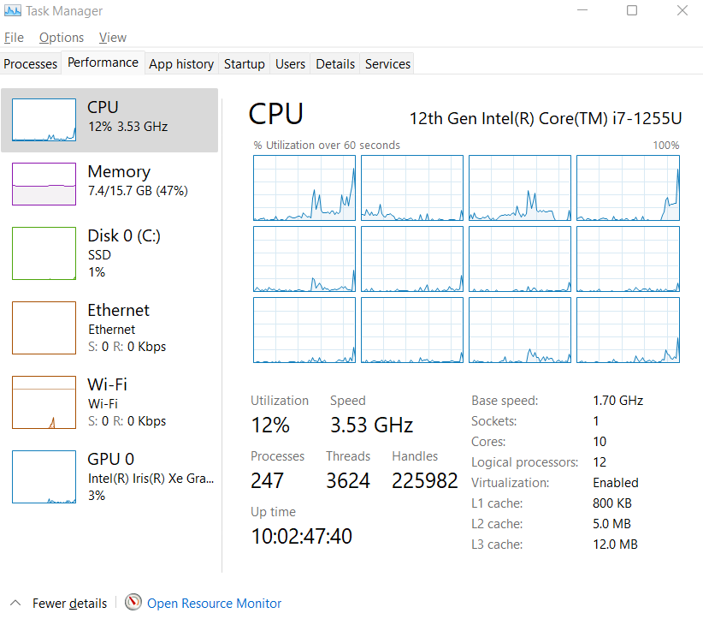

**Code:**

import threading

#import random

import time

unsorted_list = []

#for i in range (50):

# unsorted_list.append((random.randint(0,100)))

size = int(input("Enter length of Array and then the Values: "))

for i in range (0, size):

elements = int(input())

unsorted_list.append(elements)

print("Unsorted List: \n" + str(unsorted_list) + "\n")

def merge(first_half, second_half):

i = j = 0

len_f = len(first_half)

len_s = len(second_half)

sorted_list = []

while i<len_f and j<len_s:

if first_half[i]<second_half[j]:

sorted_list.append(first_half[i])

i+=1

else:

sorted_list.append(second_half[j])

j+=1

while i<=len_f-1:

sorted_list.append(first_half[i])

i += 1

while j<=len_s-1:

sorted_list.append(second_half[j])

j += 1

return sorted_list

def merge_sort(listx):

if len(listx) > 1:

mid = len(listx)//2

left_side = listx[:mid]

right_side = listx[mid:]

x = merge_sort(left_side)

y = merge_sort(right_side)

t1 = threading.Thread(target = x)

t2 = threading.Thread(target = y)

t1.start()

t2.start()

time.sleep(1.0)

t1.join()

t2.join()

return merge(x, y)

return listx

finished_list = merge_sort(unsorted_list)

print("Sorted List Using Multithreaded MergeSort: \n" + str(finished_list))