Jenkins

Steps for MavenJava Automation:
Maven Java Automation Steps:
Step 1: Open Jenkins (localhost:8080)
├── Click on "New Item" (left side menu
Step 2: Create Freestyle Project (e.g., MavenJava_Build)
├── Enter project name (e.g., MavenJava_Build)
├── Click "OK"
└── Configure the project:
├── Description: "Java Build demo"
├── Source Code Management:
└── Git repository URL: [GitMavenJava repo URL]
├── Branches to build: */Main or */master
└── Build Steps:
├── Add Build Step -> "Invoke top-level Maven targets"
└── Maven version: MAVEN_HOME
└── Goals: clean
├── Add Build Step -> "Invoke top-level Maven targets"
└── Maven version: MAVEN_HOME
└── Goals: install
└── Post-build Actions:
├── Add Post Build Action -> "Archive the artifacts"
└── Files to archive: **/*
├── Add Post Build Action -> "Build other projects"
└── Projects to build: MavenJava_Test
└── Trigger: Only if build is stable
└── Apply and Save

└── Step 3: Create Freestyle Project (e.g., MavenJava_Test)
├── Enter project name (e.g., MavenJava_Test)
├── Click "OK"
└── Configure the project:
├── Description: "Test demo"
├── Build Environment:
└── Check: "Delete the workspace before build starts"
├── Add Build Step -> "Copy artifacts from another project"
└── Project name: MavenJava_Build
└── Build: Stable build only // tick at this
└── Artifacts to copy: **/*
├── Add Build Step -> "Invoke top-level Maven targets"
└── Maven version: MAVEN_HOME
└── Goals: test
└── Post-build Actions:
├── Add Post Build Action -> "Archive the artifacts"
└── Files to archive: **/*
└── Apply and Save

└── Step 4: Create Pipeline View for Maven Java project
├── Click "+" beside "All" on the dashboard
├── Enter name: MavenJava_Pipeline
├── Select "Build pipeline view" // tick here
|--- create
└── Pipeline Flow:
├── Layout: Based on upstream/downstream relationship
├── Initial job: MavenJava_Build
└── Apply and Save OK

└── Step 5: Run the Pipeline and Check Output
├── Click on the trigger to run the pipeline
├── click on the small black box to open the console to check if the build is success
Note :
- If build is success and the test project is also automatically triggered with name
“MavenJava_Test”
- The pipeline is successful if it is in green color as shown ->check the console of the test project
- The test project is successful and all the artifacts are archived successfully

II. Maven Web Automation Steps:
└── Step 1: Open Jenkins (localhost:8080)
├── Click on "New Item" (left side menu)

└── Step 2: Create Freestyle Project (e.g., MavenWeb_Build)
├── Enter project name (e.g., MavenWeb_Build)
├── Click "OK"
└── Configure the project:
├── Description: "Web Build demo"
├── Source Code Management:
└── Git repository URL: [GitMavenWeb repo URL]
├── Branches to build: */Main or master
└── Build Steps:
├── Add Build Step -> "Invoke top-level Maven targets"
└── Maven version: MAVEN_HOME
└── Goals: clean
├── Add Build Step -> "Invoke top-level Maven targets"
└── Maven version: MAVEN_HOME
└── Goals: install
└── Post-build Actions:
├── Add Post Build Action -> "Archive the artifacts"
└── Files to archive: **/*
├── Add Post Build Action -> "Build other projects"
└── Projects to build: MavenWeb_Test
└── Trigger: Only if build is stable
└── Apply and Save

└── Step 3: Create Freestyle Project (e.g., MavenWeb_Test)
├── Enter project name (e.g., MavenWeb_Test)
├── Click "OK"
└── Configure the project:
├── Description: "Test demo"
├── Build Environment:
└── Check: "Delete the workspace before build starts"
├── Add Build Step -> "Copy artifacts from another project"
└── Project name: MavenWeb_Build
└── Build: Stable build only
└── Artifacts to copy: **/*
├── Add Build Step -> "Invoke top-level Maven targets"
└── Maven version: MAVEN_HOME
└── Goals: test
└── Post-build Actions:
├── Add Post Build Action -> "Archive the artifacts"
└── Files to archive: **/*
├── Add Post Build Action -> "Build other projects"
└── Projects to build: MavenWeb_Deploy
└── Apply and Save

└── Step 4: Create Freestyle Project (e.g., MavenWeb_Deploy)
├── Enter project name (e.g., MavenWeb_Deploy)
├── Click "OK"
└── Configure the project:
├── Description: "Web Code Deployment"
├── Build Environment:
└── Check: "Delete the workspace before build starts"
├── Add Build Step -> "Copy artifacts from another project"
└── Project name: MavenWeb_Test
└── Build: Stable build only
└── Artifacts to copy: **/*
└── Post-build Actions:
├── Add Post Build Action -> "Deploy WAR/EAR to a container"
└── WAR/EAR File: **/*.war
└── Context path: Webpath
└── Add container -> Tomcat 9.x remote
└── Credentials: Username: admin, Password: 1234
── Tomcat URL: https://localhost:8085/
└── Apply and Save

└── Step 5: Create Pipeline View for MavenWeb
├── Click "+" beside "All" on the dashboard
├── Enter name: MavenWeb_Pipeline
├── Select "Build pipeline view"
└── Pipeline Flow:
├── Layout: Based on upstream/downstream relationship
├── Initial job: MavenWeb_Build
└── Apply and Save

└── Step 6: Run the Pipeline and Check Output
├── Click on the trigger “RUN” to run the pipeline
Note:
- After Click on Run -> click on the small black box to open the console to check if the build is success
- Now we see all the build has success if it appears in green color
├── Open Tomcat homepage in another tab
├── Click on the "/webpath" option under the manager app
Note:
- It ask for user credentials for login ,provide the credentials of tomcat.
- It provide the page with out project name which is highlighted.
- After clicking on our project we can see output.

Pipeline Creation using script
pipeline {
agent any
tools {
maven 'MAVEN_HOME'
}
stages {
stage('git repo & clean') {
steps {
bat 'rmdir /s /q MavenJava' // remove old code
bat 'git clone https://github.com/balasai14/MavenJava'
bat 'mvn clean -f MavenJava'
}
}
stage('install') {
steps {
bat 'mvn install -f MavenJava'
}
}
stage('test') {
steps {
bat 'mvn test -f MavenJava'
}
}
stage('package') {
steps {
bat 'mvn package -f MavenJava'
}
}
}
}

Minikube
minikube start --driver=docker
minikube status
minikube kubectl -- get pods -A
minikube dashboard

kubectl version –client
minikube logs
minikube update-check
minikube update

Minikube Automation Steps
minikube start
kubectl create deployment mynginx --image=nginx
kubectl get deployments

kubectl get pods
kubectl describe pods

Expose Deployment as a Service:
kubectl expose deployment mynginx --type=NodePort --port=80 --target-port=80

Scale the Deployment
kubectl scale deployment mynginx --replicas=4
kubectl get service myngnix

Access the Nginx App
kubectl port-forward svc/mynginx 8081:80
Access the app via http://localhost:8081

Stop and Clean Up
kubectl delete deployment mynginx
kubectl delete service mynginx
minikube stop

Nagios

Pull the Nagios Docker Image
docker pull jasonrivers/nagios:latest

Run Nagios
docker run --name nagiosdemo -p 8888:80 jasonrivers/nagios:latest

Access Nagios Dashboard
Open your browser and navigate to: http://localhost:8888

Login Credentials:
Username: nagiosadmin
Password: nagios

Monitoring Host Details
Navigate to the Host Information Page:
Select a host from the Hosts menu.
Key Details:
Host Status: Indicates if the system is UP or DOWN.
Metrics: View CPU usage, memory status, and network activity.
Actions: Reschedule checks, disable notifications, or schedule downtime.

Stop and Remove Nagios
docker stop nagiosdemo
docker rm nagiosdemo

Jenkins-CI/CD

ngrok

Step 1. Download ngrok
https://ngrok.com/download
Download and extract it for your OS (Windows, macOS, or Linux).

Step 2. Connect Your ngrok Account (optional but useful)
After you sign up (free), ngrok gives you an auth token.
CREATE AUTHENTICATOR [https://dashboard.ngrok.com/get-started/your-authtoken]
Run this command (replace <your_token> with yours):
ngrok config add-authtoken <your_token>
This ensures stable sessions and more control.

Step 3. Start a Tunnel for Jenkins
Assuming Jenkins runs locally on port 8085:
ngrok http 8085
You’ll see output like:
Session Status online
Forwarding https://1234abcd.ngrok.io -> http://localhost:8080
Copy the HTTPS URL (https://1234abcd.ngrok.io) — this is your public Jenkins URL for webhooks.

Step 4. Use it in GitHub Webhook
In your GitHub repo → Settings → Webhooks:
- Payload URL: [paste the url generated by ngrok]

https://1234abcd.ngrok.io/github-webhook/ [please include this – remaining all default]
Now, whenever you push code, GitHub sends an event to that URL, which ngrok forwards to your local Jenkins.

Jenkins Email Notification Setup

1. Gmail: Enable App Password (for 2-Step Verification)
i. Go to: https://myaccount.google.com
ii. Enable 2-Step Verification
- Navigate to:
  - Security → 2-Step Verification
  - Turn it ON
  - Complete the OTP verification process (via phone/email)
iii. Generate App Password for Jenkins
- Go to:
  - Security → App passwords
- Select:
  - App: Other (Custom name)
  - Name: Jenkins-Demo
- Click Generate
- Copy the 16-digit app password
  - Save it in a secure location (e.g., Notepad)

2. Jenkins Plugin Installation
i. Open Jenkins Dashboard
ii. Navigate to:
- Manage Jenkins → Manage Plugins
iii. Install Plugin:
- Search for and install:
  - Email Extension Plugin
3. Configure Jenkins Global Email Settings
i. Go to:
- Manage Jenkins → Configure System

A. E-mail Notification Section
Field | Value
SMTP Server | smtp.gmail.com
Use SMTP Auth | ✅ Enabled
User Name | Your Gmail ID (e.g.,bhargavikumbham@gmail.com)
Password | Paste the 16-digit App Password
Use SSL | ✅ Enabled
SMTP Port | 465
Reply-To Address | Your Gmail ID (same as above)
➤ Test Configuration
- Click: Test configuration by sending test e-mail
- Provide a valid email address to receive a test mail
- ✅ Should receive email from Jenkins

B. Extended E-mail Notification Section
Field | Value
SMTP Server | smtp.gmail.com
SMTP Port | 465
Use SSL | ✅ Enabled
Credentials | Add Gmail ID and App Password as Jenkins credentials
Default Content Type | text/html or leave default
Default Recipients | Leave empty or provide default emails
Triggers | Select as per needs (e.g., Failure)

4. Configure Email Notifications for a Jenkins Job
i. Go to:
- Jenkins → Select a Job → Configure
ii. In the Post-build Actions section:
- Click: Add post-build action → Editable Email Notification
A. Fill in the fields:
Field | Value
Project Recipient List | Add recipient email addresses (comma-separated)
Content Type | Default (text/plain) or text/html
Triggers | Select events (e.g., Failure, Success, etc.)
Attachments | (Optional) Add logs, reports, etc.
iii. Click Save
Now your Jenkins job is set up to send email notifications based on the build status!

EC-2

Create Maven-web-java project in eclipse & push into github

Create the virtual machine (EC2--instance) in aws and connect
Step 1: Login to AWS /canvas account
Step 2: Services -- EC2
Step 3: Choose region which is near ?
Services -- EC2 --- Launch Instance
Stage 1 --Name (Giving name to the machine) ubuntu
Stage 2 -- Select AMI ( Note: Select free tier eligible ) ubuntu server
Stage 3 -- Architecture as 64-bit
Stage 4 -- Instance type ---- t2.micro(default 1 CPU,1 GB RAM)
Stage 5 -- Create a new keypair---a keypair will downloaded with extension .pem
Store key in folder AWS
Stage 6 -- Network Setting ----Create Security group -- ( It deals with ports )
(Note for understanding We have 0 to 65535 ports. Every port is dedicated to special purpose)
Do this step : HERE select http and https
Stage 7 -- Storage - 8GB ( Observation - we have root - it is same as C Drive)
Stage 8 --- click on launch instance
Stage 9: Number of instances ---1
Do this step:---once it is created select that instance and click on connect
Here copy the ssh – i command from SSH client connect tab
We can use powershell /gitbash /webconsole , to connect to ubuntu machine.
NOTE:- cd path of AWS folder // change path
To connect to above terminals we need to go into the path of the keypair.and
paste the ssh -i command from the aws console

Clone the application from github, Write the Dockerfile
install docker ---apt-get update
apt-get install docker.io
apt-get install nano

git clone <paste the github link of maven-web-java project>

navigate to the maven-web-java project

Create the image
nano Dockerfile
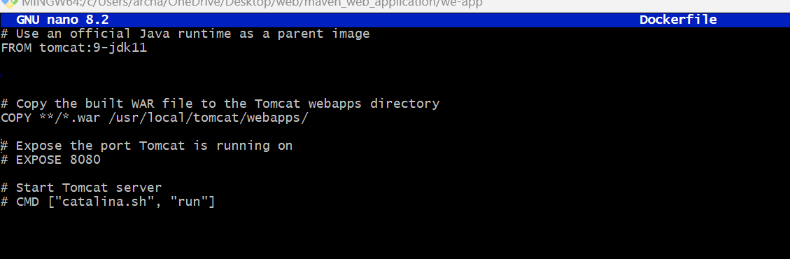

Run the image and access it with public ip of virtual machine
Step 1:- build your image
docker build –t <imagename> .(dot)
Step 2:- check for images
Step 3:- run image
docker run –d --name app-demo –p 6060:8080 <image name>
Step:-4 Accessing the app by public ip of virtual machine

Sequence Diagram
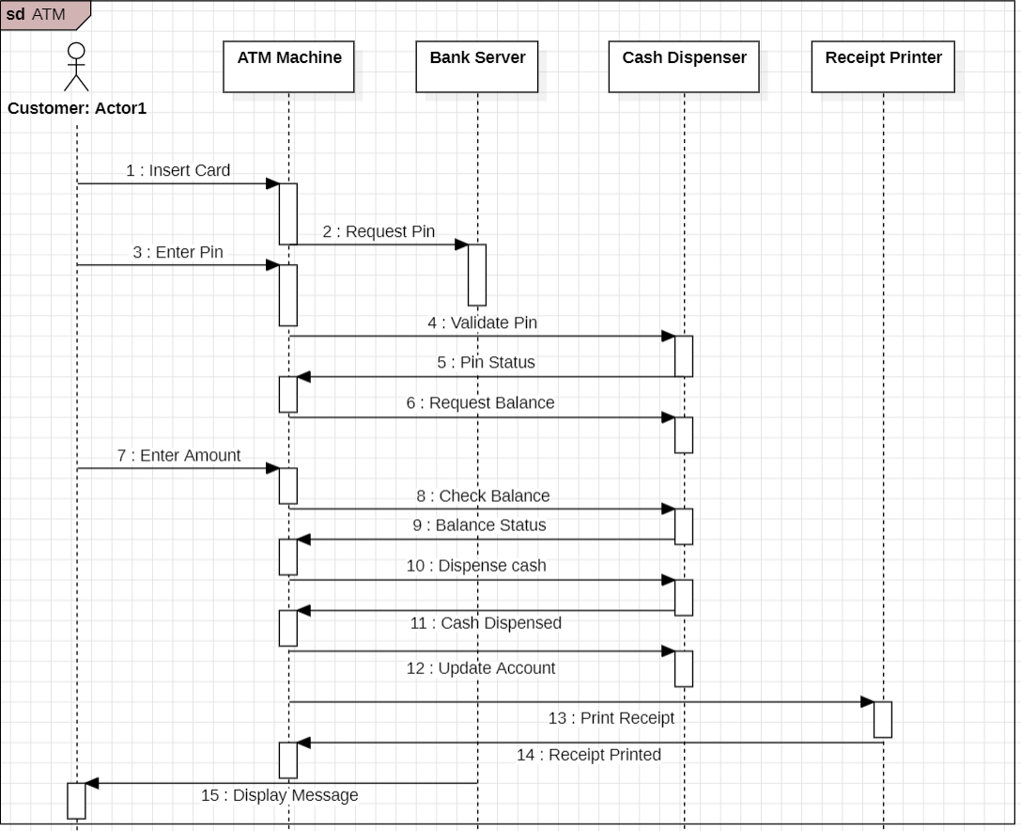

Class Diagram

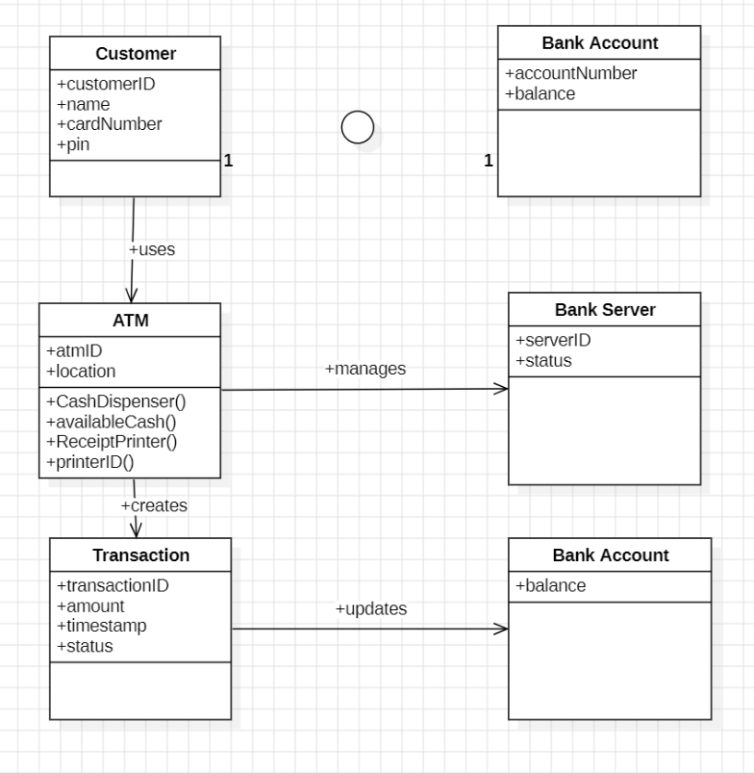

Use case Diagram
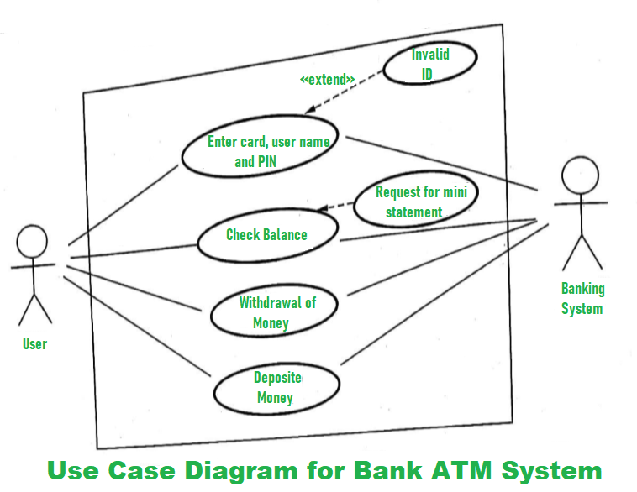

Component Diagram
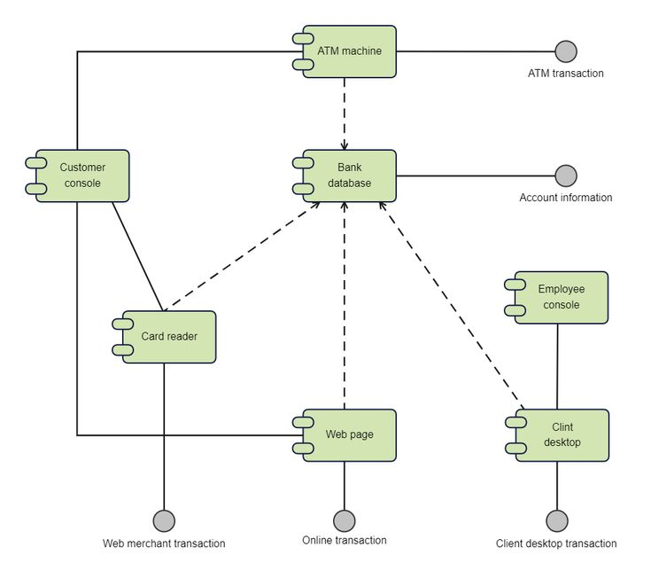
1 DEPLOYMENT OF INDEX.HTML USING EC2 INSTANCE in AWS
Step 1: Login to AWS /canvas account
- Go to course invitation mail and click on start
- Opens the aws academy, select the student login and enter the email and password details
- Click on Modules
- Scroll down and select Lunch AWS Academy Lab-
- Click on start Lab and wait AWS becomes from red to green AWS
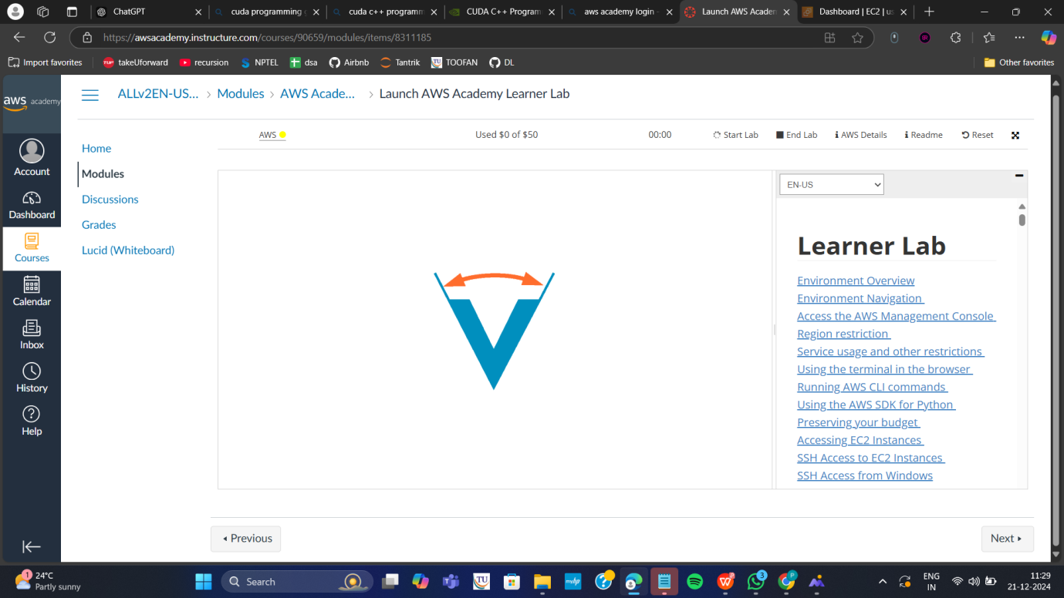
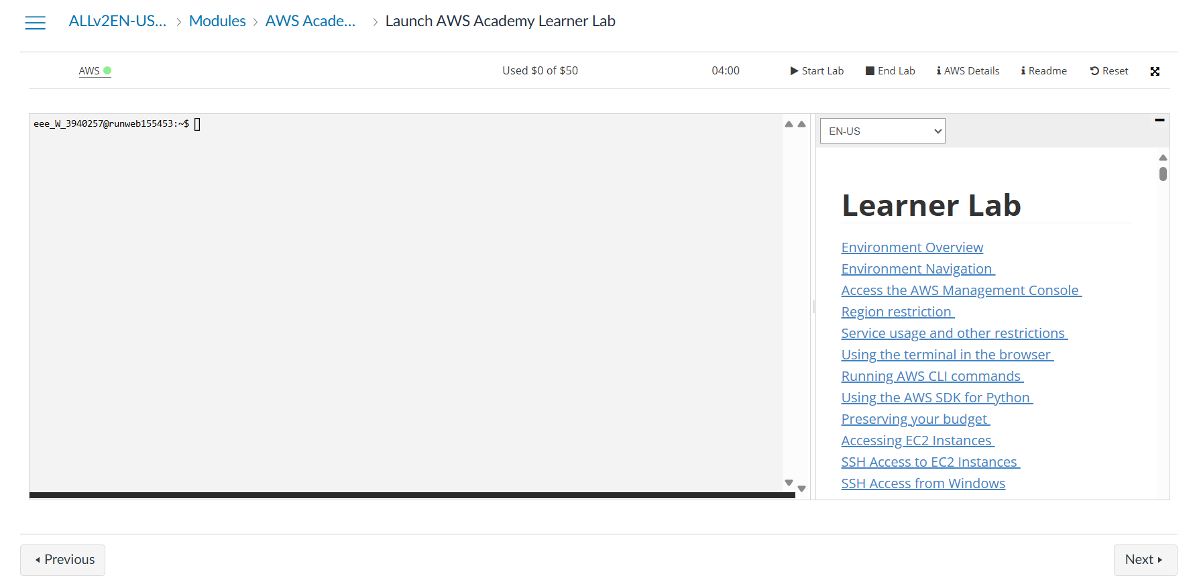
Step 2: Click on EC2 to create instance
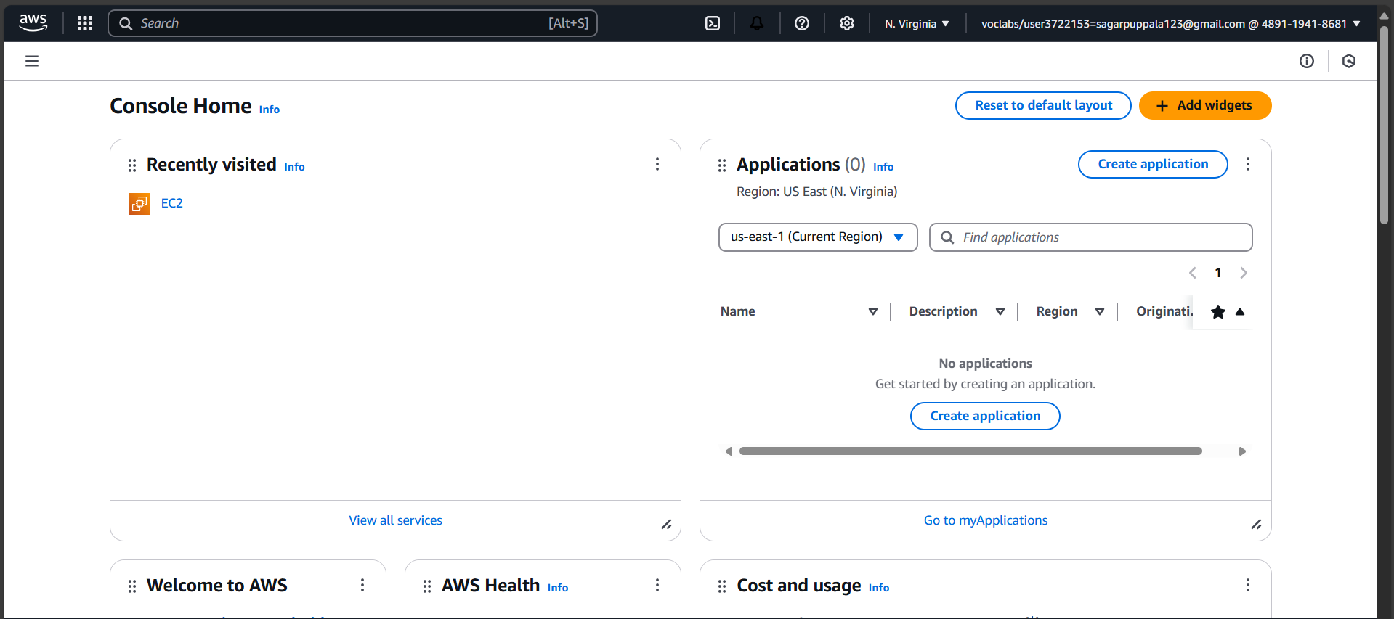
Click on Launch Instance
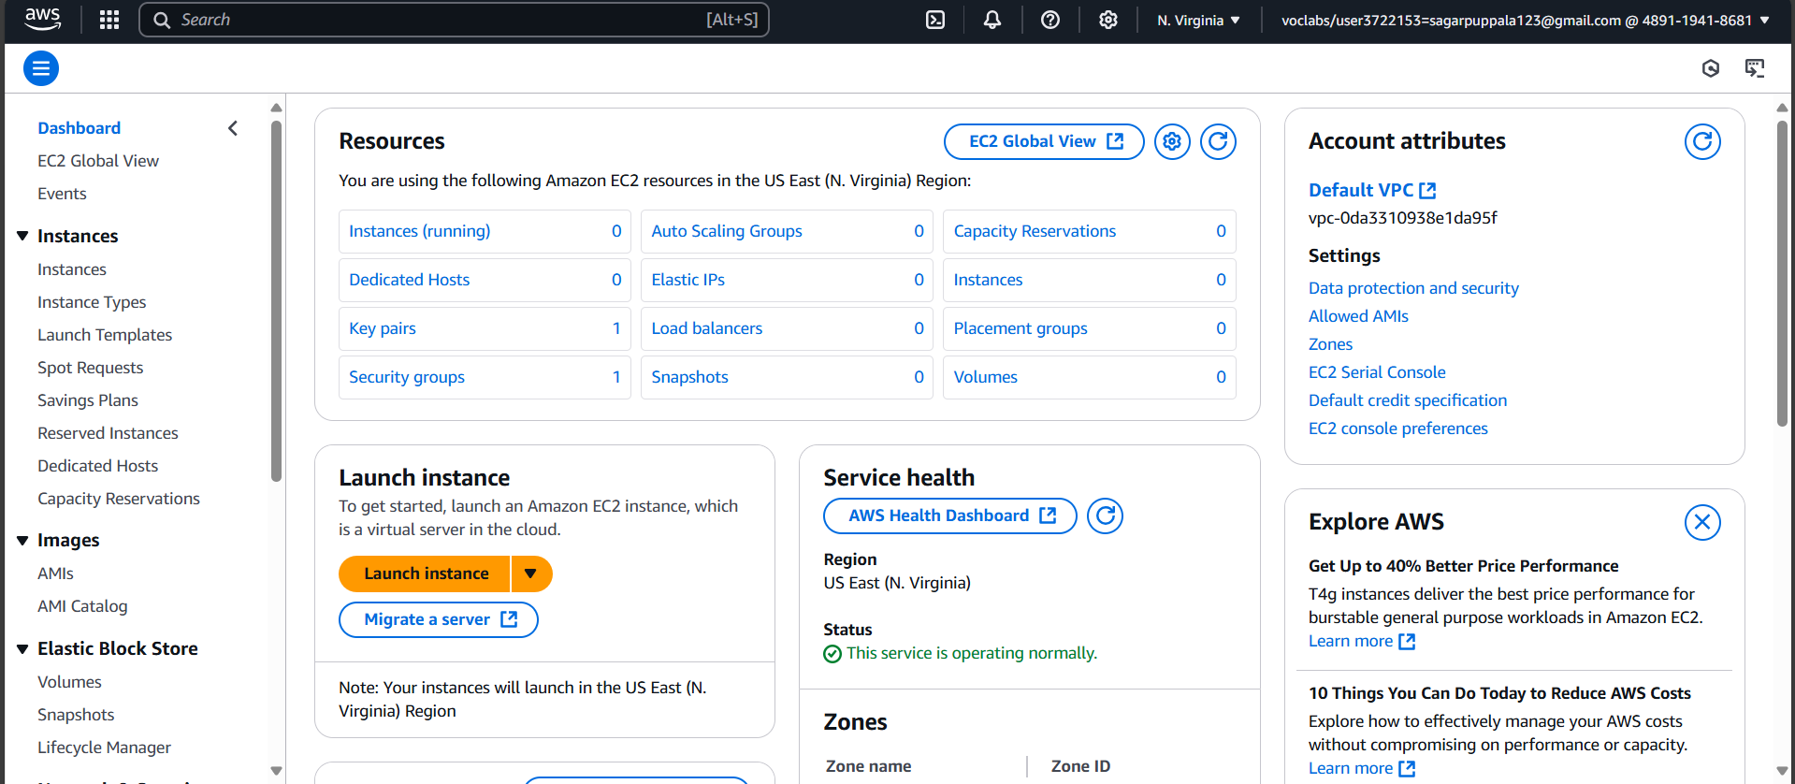

Stage 1 --Name (Giving name to the machine) ubuntu
Stage 2 -- Select AMI ( Note: Select free tier eligible ) ubuntu server
Give name and select ubuntu under application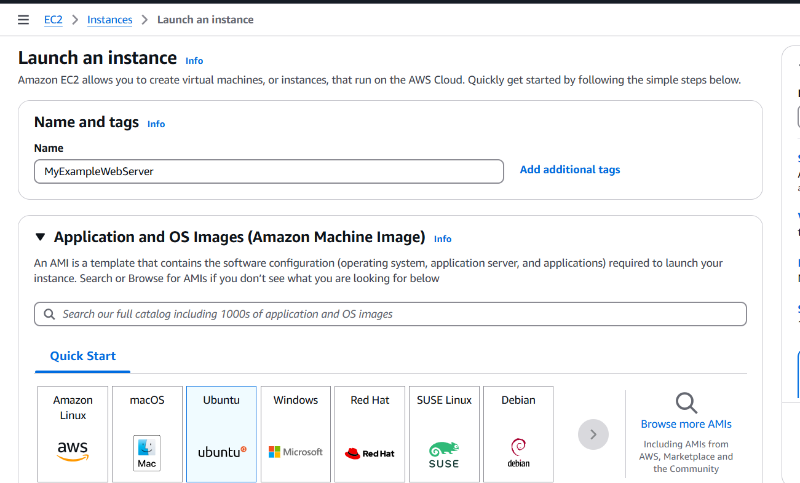Select this free tier option of Ubuntu from here
Stage 3 -- Architecture as 64-bit
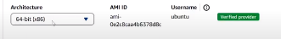Stage 4 -- Instance type ---- t2.micro(default 1 CPU,1 GB RAM)
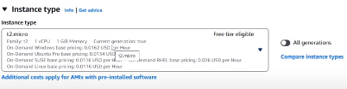Stage 5 -- Create a new keypair---a keypair will downloaded with extension .pem
Store key in folder AWS
First Click on create-new key pair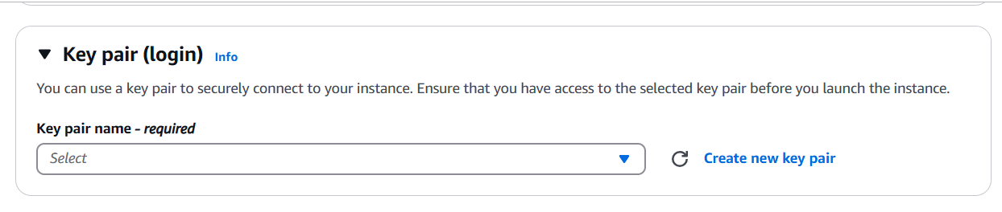Give KeyPair name and click on create key pair
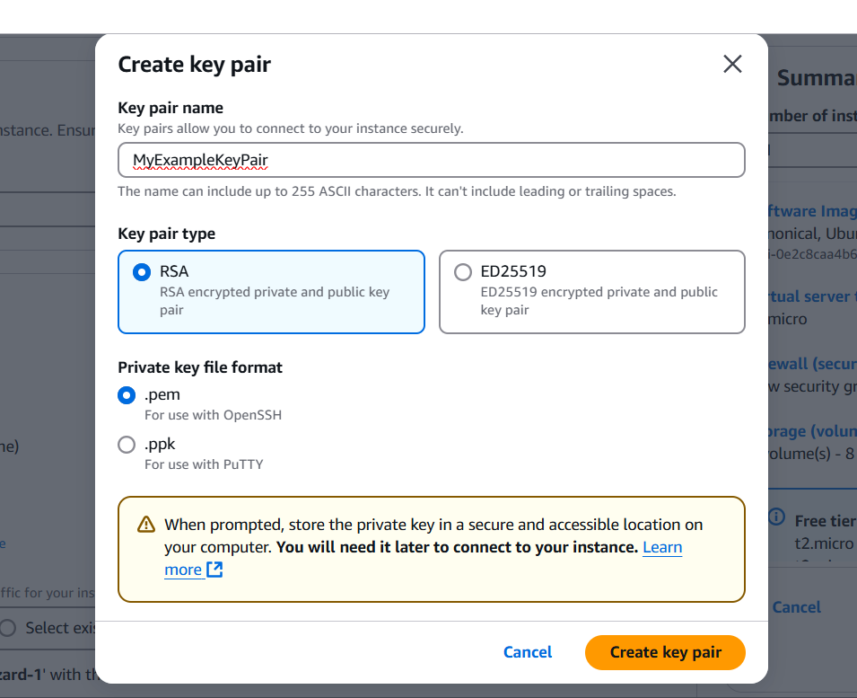Save the .pem file in folder AWS on desktop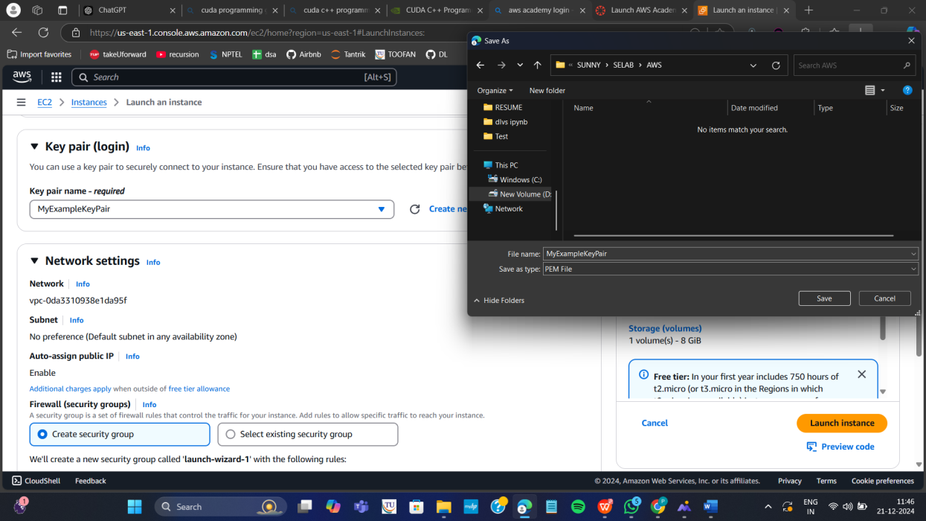

Stage 6 -- Network Setting ----Create Security group -- ( It deals with ports )
(Note for understanding We have 0 to 65535 ports. Every port is dedicated to special purpose)
HERE select https and http (which allow to load your web pages while execution)
In network setting check all the checkboxes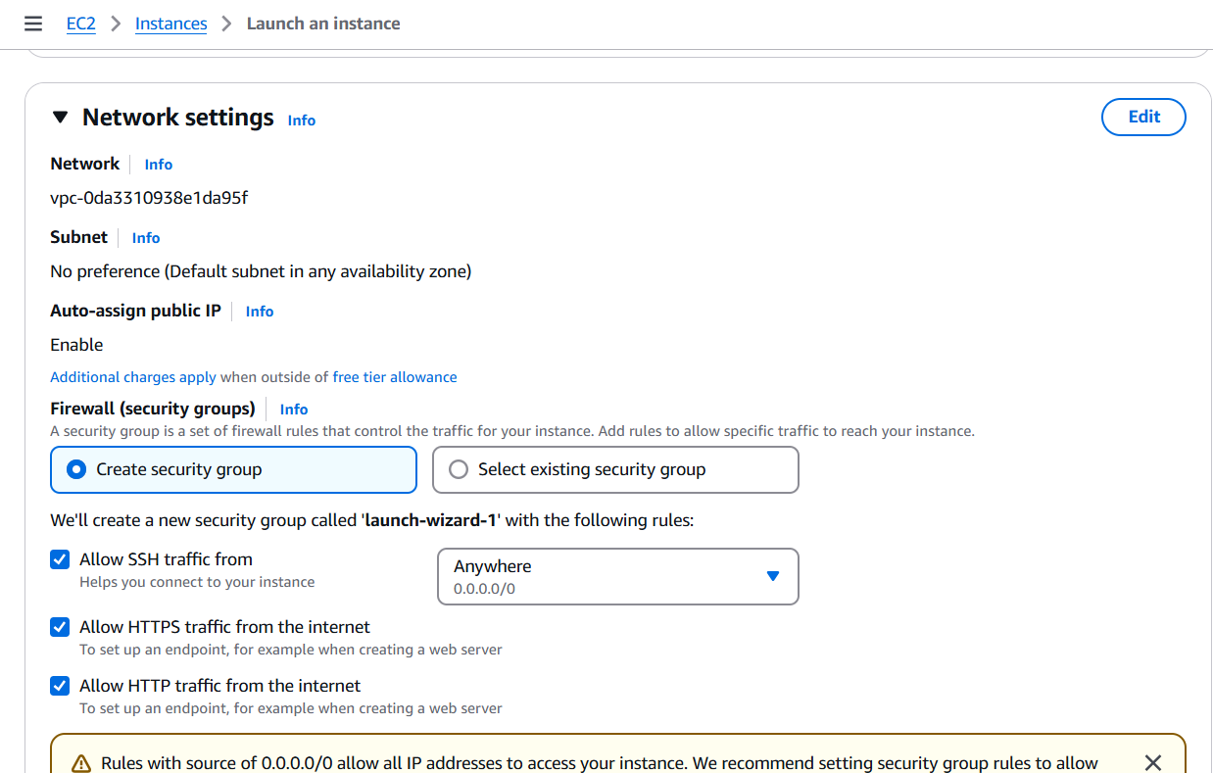
Stage 7 -- Storage - 8GB ( Observation - we have root - it is same as C Drive) it default 8 GB

Stage 8 --- click on launch instance

Now click on the instances
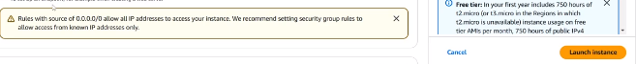
Wait for the Success message to apper in green color
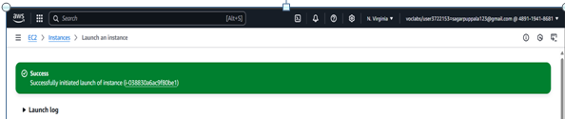

You can see MyExampleWebServer is Running and wait for it to initialize
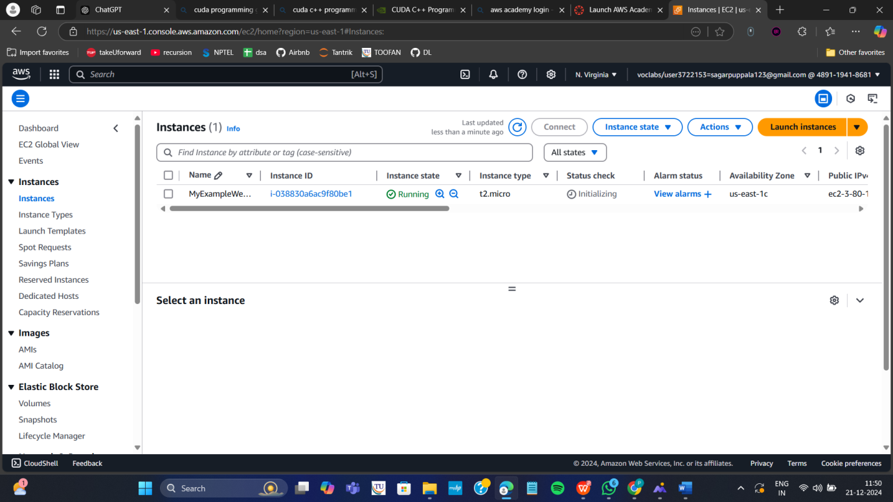
You have to get 2 tests passes.
Important:---- Now check the box and click on connect.
Do this step:---once it is created select that instance
(Tick in checkbox) and click on connect
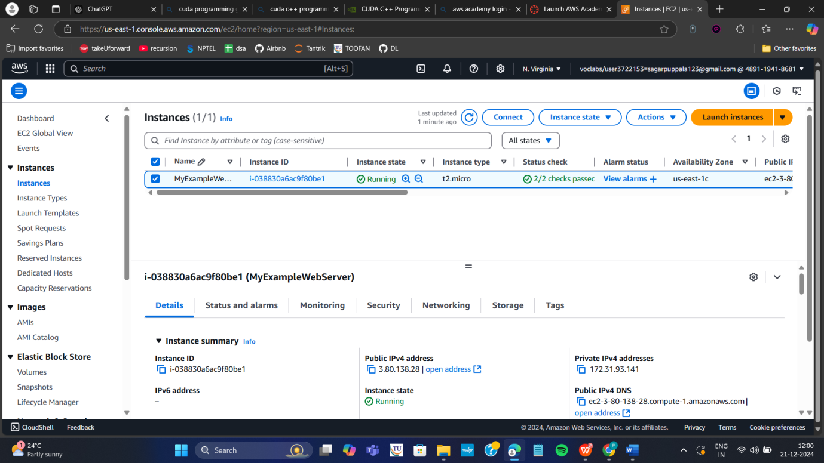
Thus your EC2 instance is running on server.
Step 4: Now you can connect local system to server (EC2 instance) using secure shell SSH.
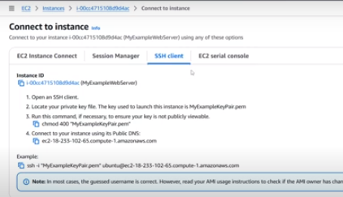
For this, Here copy the ssh – i command from SSH client connect tab and paste later
Next We can use powershell /gitbash /webconsole in administrative mode, to connect to ubuntu machine.
Step a: Copy the path of .pem file that you saved earlier in folder AWS eg. as here D:\SUNNY\SELABWEB\AWS
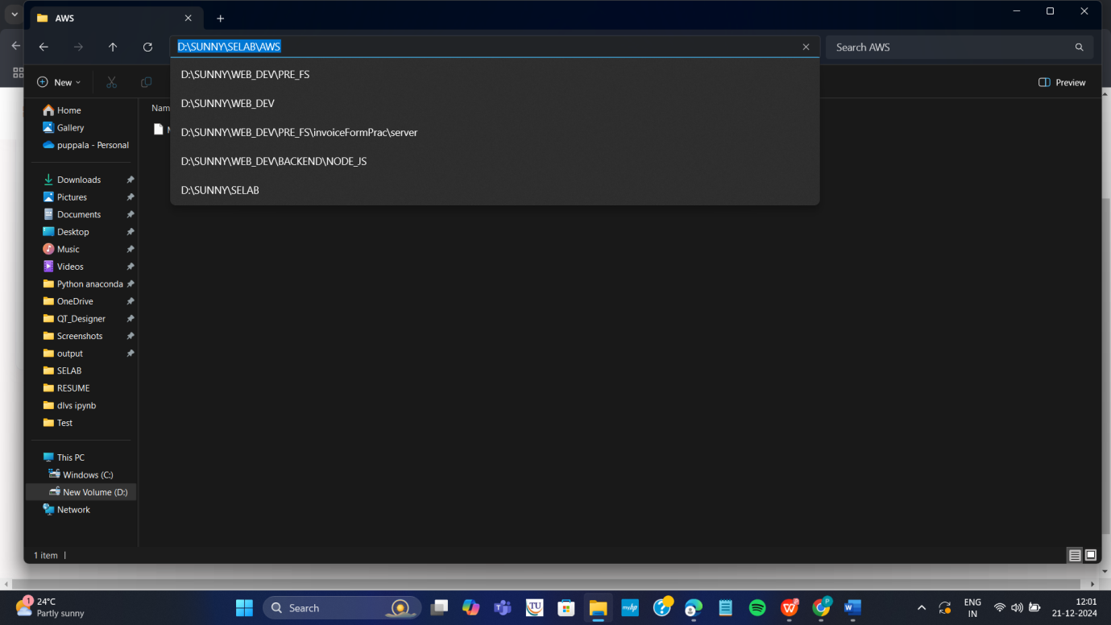
Step b: Open Powershell in administrative mode and navigate to that path.
Type: cd < path>
eg. cd D:\SUNNY\SELABWEB\AWS here specify your .pem path
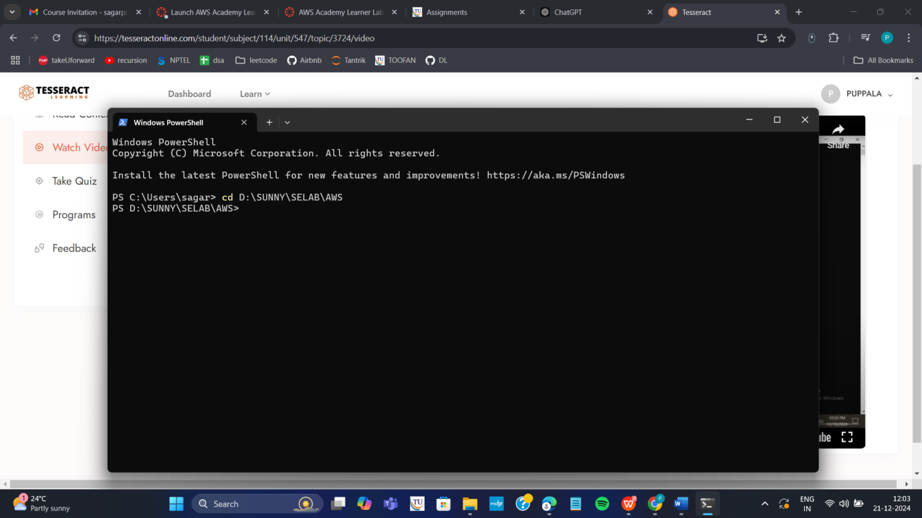
Step c: Go to SSh and copy the command ssh which is present at the below
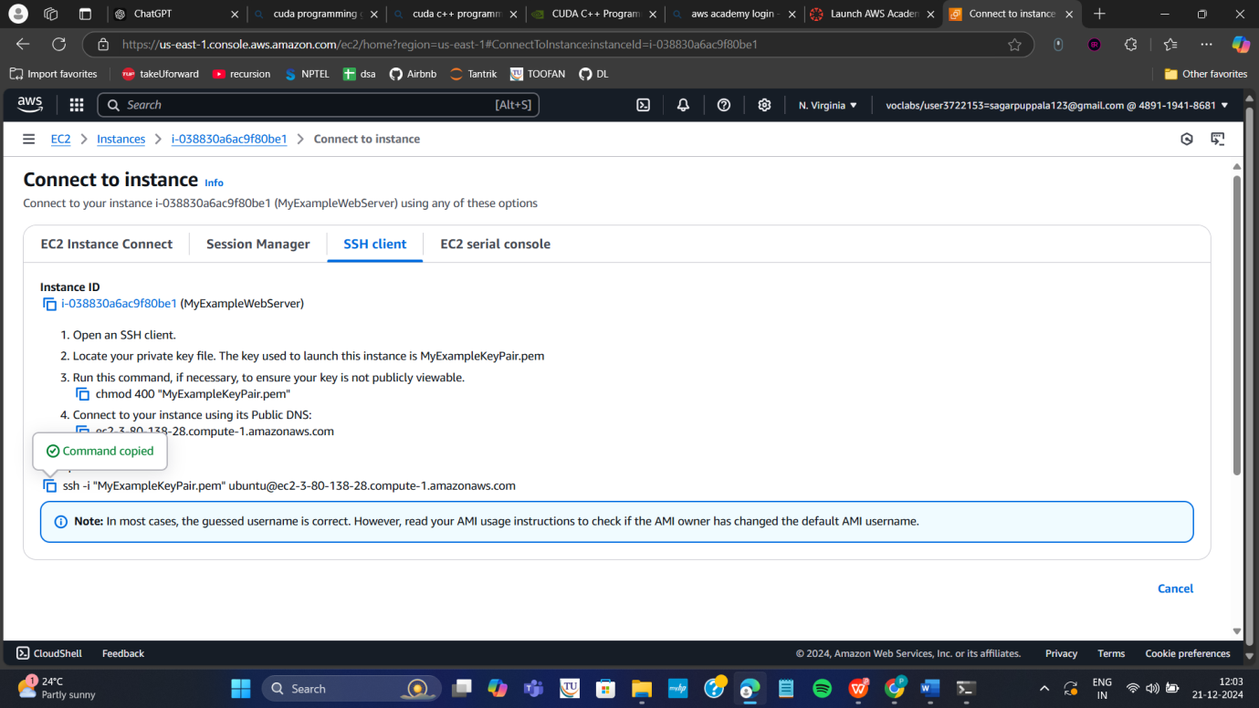
Note: To connect to above terminals we need to go into the path of the keypair.and
paste the ssh -i command from the aws console
Step d: Run the pasted ssh -i command in the terminal
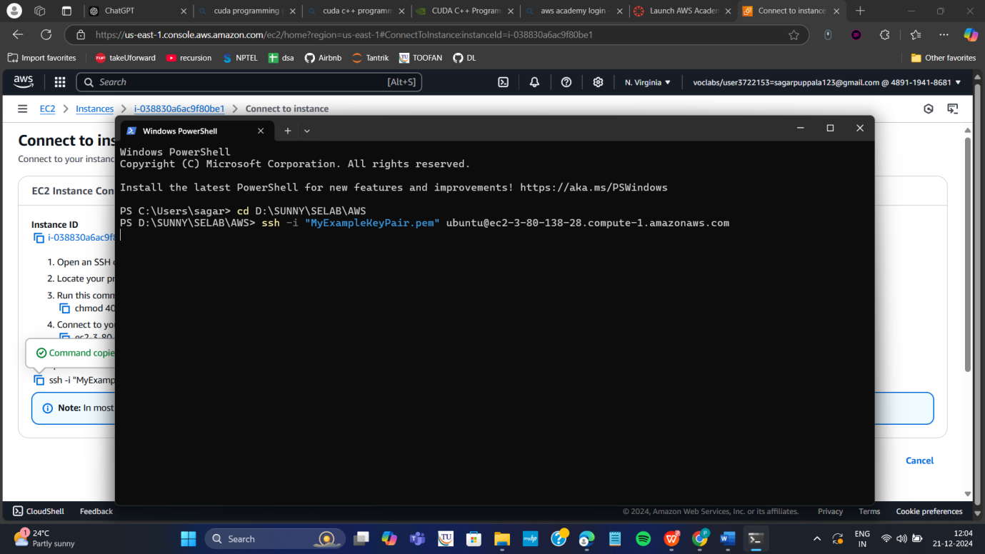
Step 5: Run the following commands to install s/w
- Update all softwares in Ubuntu by command
sudo apt update
2 Install docker by command
sudo apt-get install docker.io

  - Install git by command
sudo apt install git
  - Install nano( text editor) by command
Sudo apt install nano

Step 6: Now we want to create an application, push it into git, create docker image of it and run it

Step a: Create basic index.html file in folder Example and save it
Step b: Open git Bash in folder Example by right clicking with mouse
Step c: In git bash run the following commands
git init
git add .
Git commit –m “first commit”
Step d: Create git repository (here with name AWS)
Step e: Copy command one by one from above repository and run as below
git branch –M main
git remote add origin <https url>
git push –u origin main
Step f: refresh repository and You can now see index.html in github
Step g: Copy http path
Step h: Clone the repository with copied http path by command in command prompt git clone <copied http url>
Step i: Navigate to the cloned folder. Type cd AWS as below, next ls to
Step j: create Dockerfile in above command prompt in ububtu ie in power shell
Nano Dockerfile
FROM nginx:alpine
COPY . usr/share/nginx/html
Step k: Write the following data in Dockerfile and click ctrl+o Enter and then ctrl-x
Step L: Build docker image by executing the following command
sudo docker build –t mywebapp .
Thus image is created
Step m: run the image and map it to port 80
sudo docker run –d –p 80:80 mywebapp
Step n: Go to instances and click on instance here
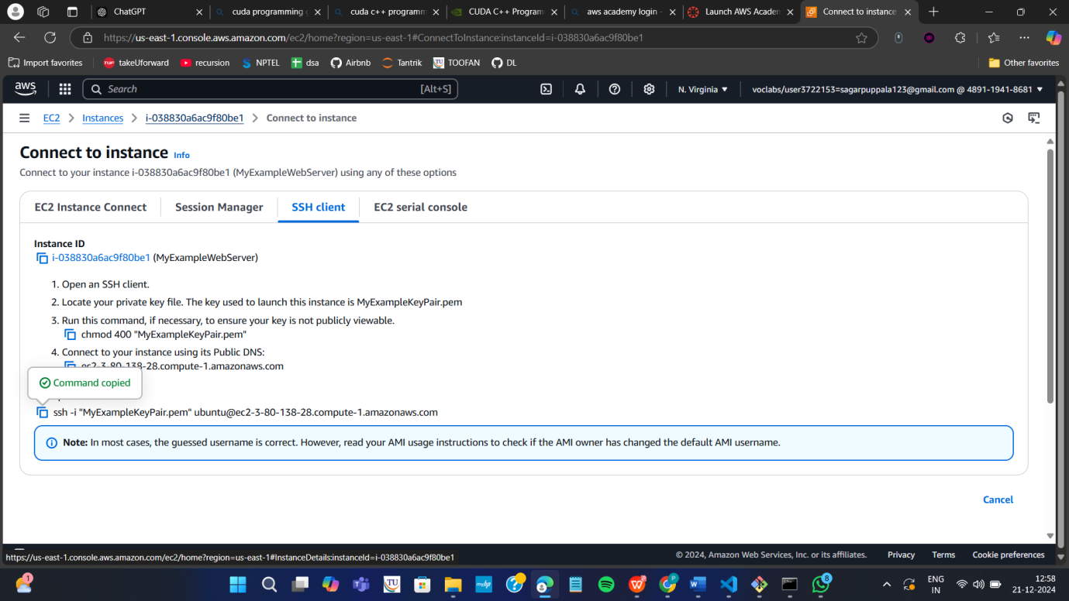
Step o: Copy public ipv4 address
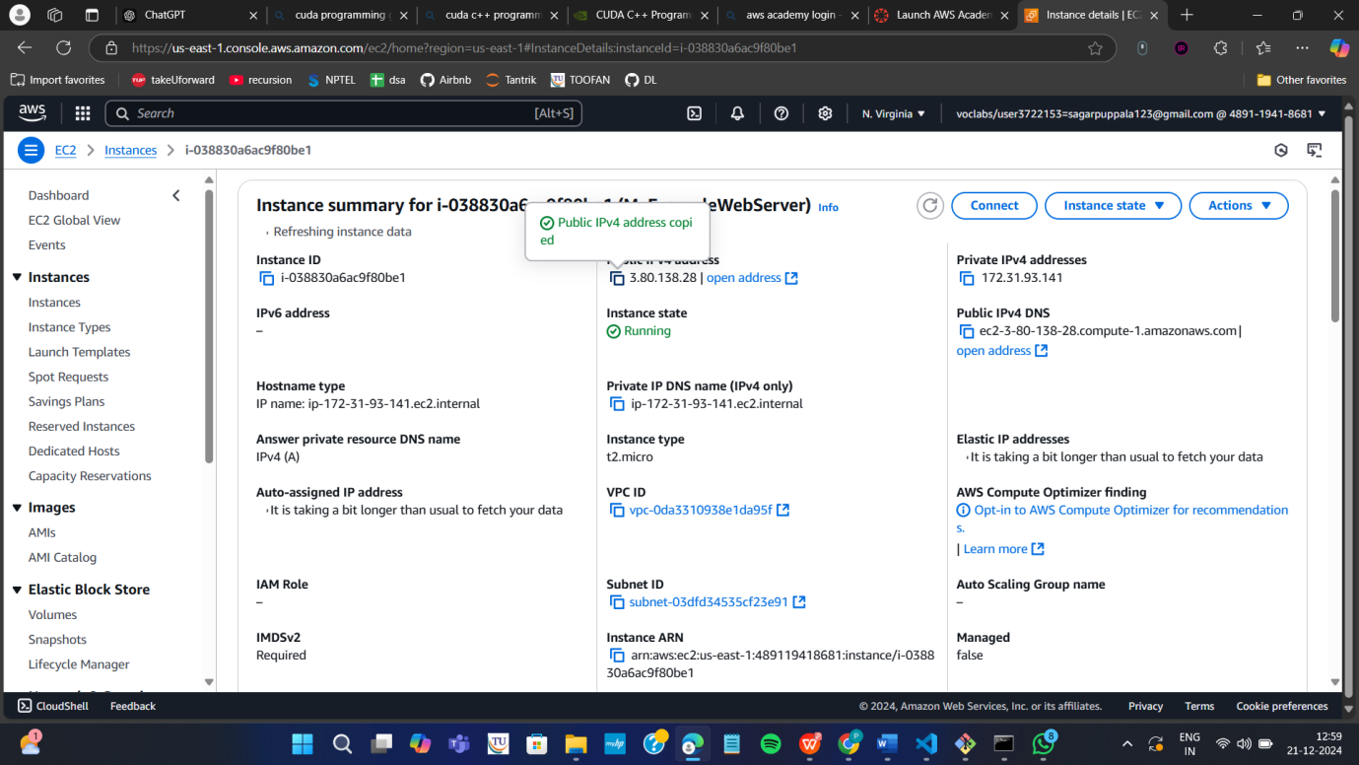
Step p: Paste it in the browser to get below output
Note : if https :__ won’t work then type just http:___
Important do it without fail. Step Q: stop container

Run the following command to stop the container
- sudo docker ps
- sudo docker stop <container-id>

