

Data Technician

Name: Alaa Mostafa
Course Date: 16/12/24
Table of contents
Day 1: Task 1 2
Day 2: Task 1 2
Day 2: Task 2 3
Day 2: Task 3 4
Day 3: Task 1 4
Day 3: Task 2 5
Dataset: 5
Step 1: Create a Pivot Table 5
Step 2: Use the SWITCH Function 5
Submission: 6
Day 3: Task 3 6
Day 4: Task 1 7
Course Notes 9
Additional Information 10

Day 1: Task 1

Please complete the below boxes on commons laws and regulations that must be followed when working with customers data, use the below bulleted list to support your answers.

- What is it
- Why is it important
- Provide a real-world example of how you can follow it
- How does it impact working with data
- What could happen if you breached it

Data Protection Act | The Data Protection Act controls how personal information can be used and individuals’ rights to ask for information about themselves.  It is important because it allows individuals to know what information is held about them and have access to it. It also hold organisations accountable for using those information fairly, lawfully and securely.  Example: Requesting your travel history from the Home Office through Subject Access Request (SAR).  Data protection act impact data in several ways as this act is specifically for data itself, it allows individuals to access, erase and correct their data and imposing strict obligations on organisation on how to handle data.  If its breached potential consequences could include but not limited to fines, criminal charges, loss of public trust.
GDPR | GDPR (General Data Protection Regulation) is a strict EU law giving people more control over their personal data and setting rules for how businesses worldwide must collect, use, and store it.  It is important because it gives individuals control over their personal data and forcing businesses to be transparent and accountable.  Example: Consent – an organization/business must take consent of the individual for storing their data when providing a service.  It impacts data in several ways such as improving credibility and transparency by giving individuals more control over their personal data and imposing strict accountability on businesses.  If breached, business can face hefty fines for non-compliance.
Freedom of Information Act | Freedom of Information Act (FOIA) gives the wider public not just citizens the right to access recorded information held by most UK public authorities.  It is important in order to promote transparency and accountability unless exemptions apply which could be personal information or information related to national security.  Example: Asking local council about number of bus line fines issues within last month.  It requires public bodies to proactively retrieve, manage and release data.  If breached the ICO would issue compliance order if failed to comply potential court charges.
Computer Misuse Act | Introduced in 1990,

Day 2: Task 1

Please research and complete the following tasks within the retail-sales_dataset.xlsx document, paste a print screen into the provided boxes below:

- In the sheet ‘retail_sales_dataset’ add all available data between columns A –J into a ‘table’
- Using the ‘sort’ function, sort ‘Age’ to ‘largest to smallest’
- Using the ‘SUM’ function, show me the commission total in cell ‘L10’
- Using the ‘AVERAGE’ function, show me the average commission in cell ‘L11’

Print screen 1 | 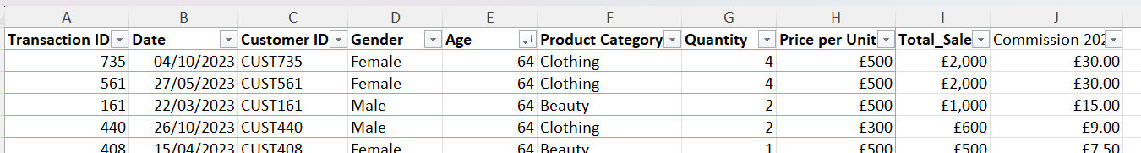
Print screen 2 | 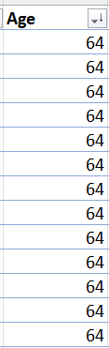
Print screen 3 | 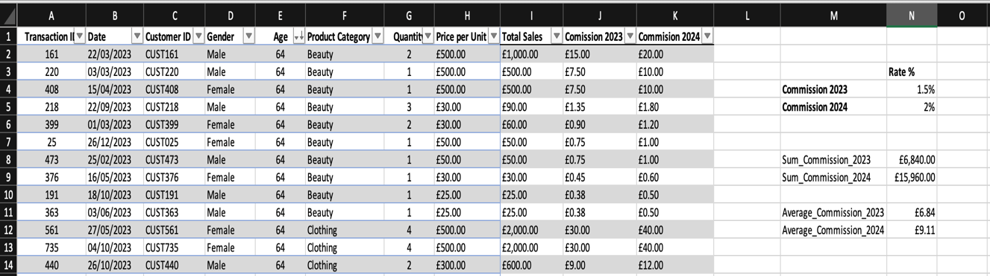
Print screen 4 | 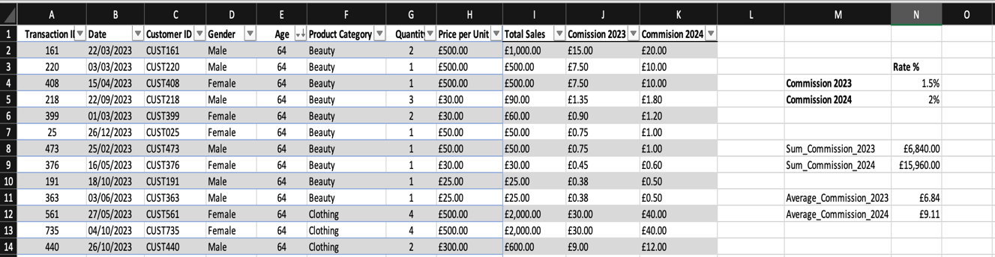

Day 2: Task 2

Please research and complete the following tasks within the retail-sales_dataset.xlsx document, paste print screens into the provided box below:

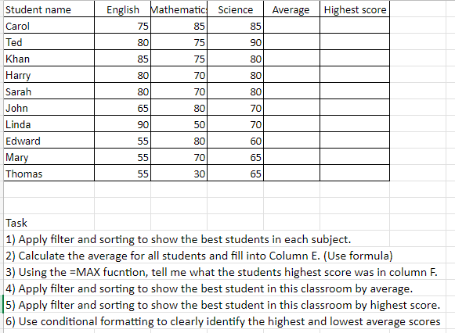

Print screen 1 | 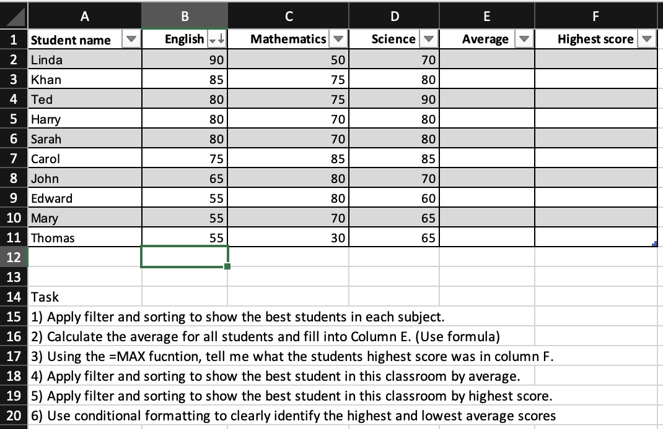  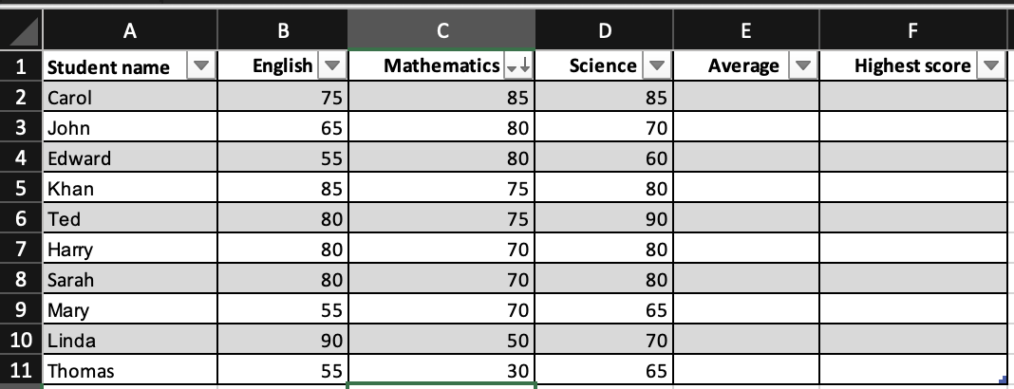  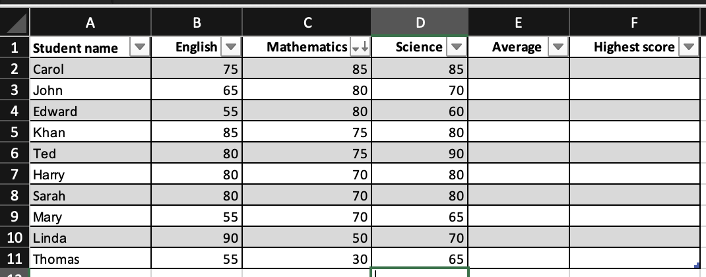  ENGLISH  MATH  SCIENCE  AVERAGE  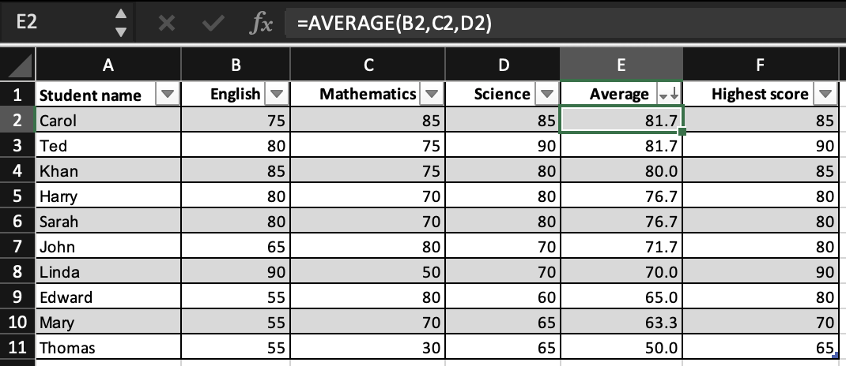  MAX Score  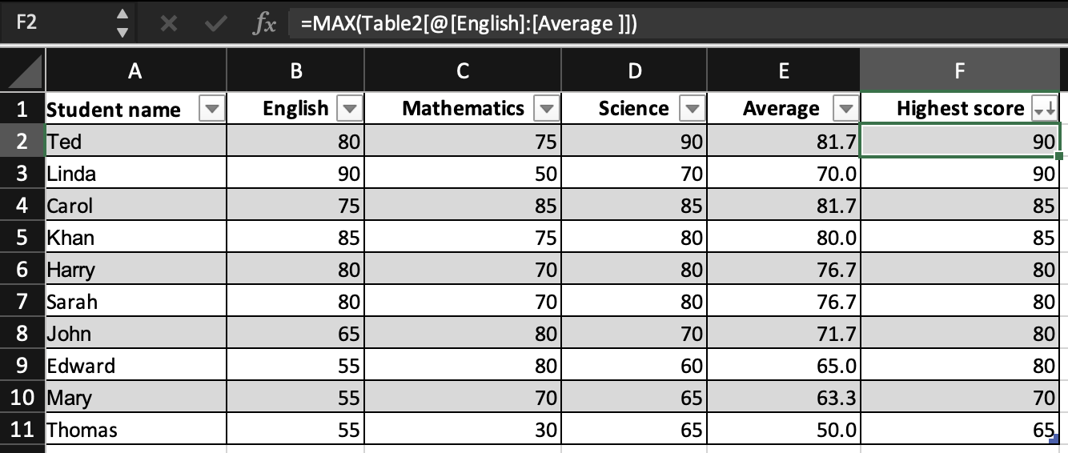
Print screen 2 |   BEST STUDENT BY AVERAGE  Conditional Formatting  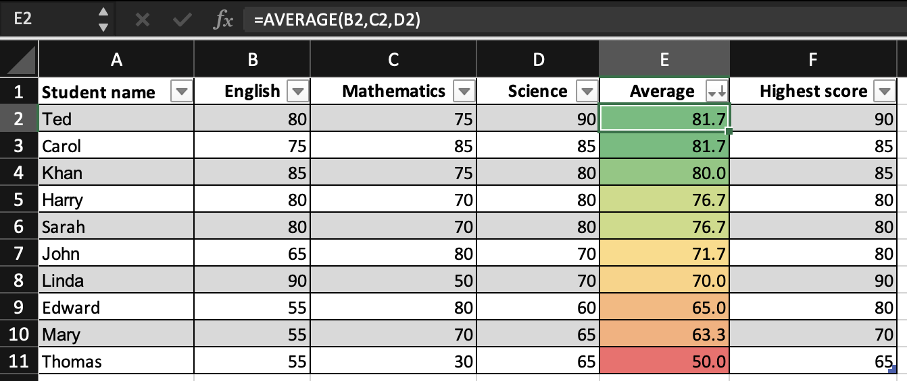

Day 2: Task 3

Using the skills developed today, have some fun with the data set you have imported. Paste your work below and enjoy!

Print screen 1 | 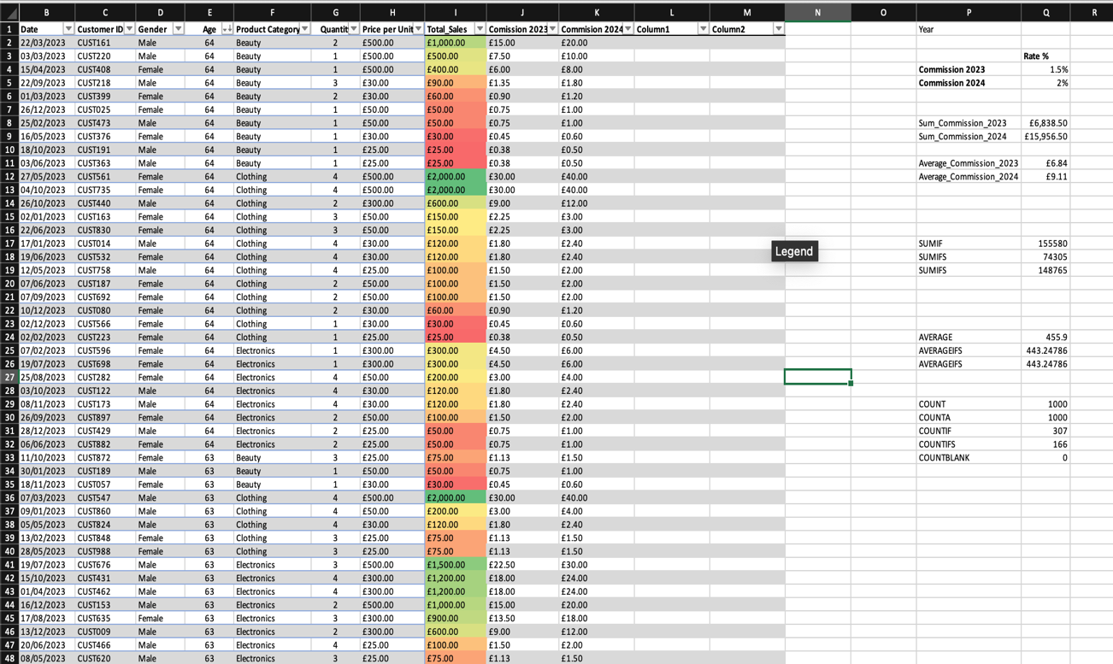

Day 3: Task 1

Please download the dataset ‘Day_3_Task_1_Bike_Sales_Pivot_Lab.xlsx’ and the lab instructions.

Do not worry if you do not complete the lab, just working with data and playing with the pivot table will be good experience.

Please paste your final pivot table below and complete the reflection questions:

Print screen 1 | 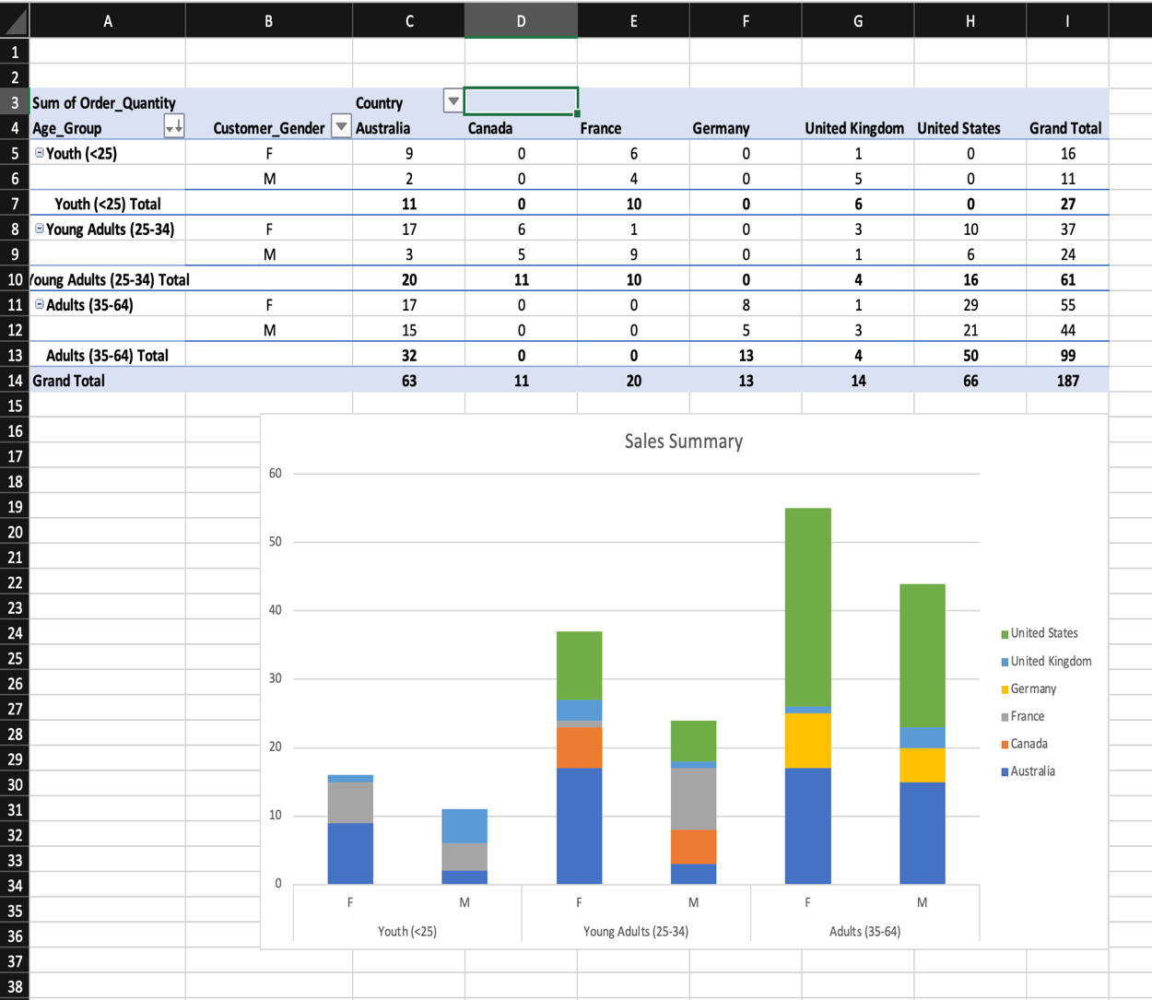
In which markets does Germany have customers? | It appears from the visuals that Germany has customers only in adult’s category with female customers slightly outnumbering their male counterparts.
What country has sales in all markets? | Australia.
What are the most profitable markets by country, age group, and gender? | Female adults (35-64) in the United States.
Any other findings? | The United States was showing as three different countries, I discovered that there were extra spaces between and after it in some cells which I then fixed it.

Day 3: Task 2

The dataset below tracks the sales performance of different products in various counties in England. Please paste the dataset into a blank Excel workbook. Your task is to:
- Create a Pivot Table to summarise the data by county and product.
- Use the SWITCH function to categorise products based on their sales volume.

Dataset:
County | Product | Sales Volume
Yorkshire | Laptops | 500
Yorkshire | Smartphones | 200
Cornwall | Laptops | 700
Cornwall | Printers | 400
Lancashire | Smartphones | 150
Lancashire | Laptops | 600
Essex | Printers | 800
Essex | Smartphones | 300
Durham | Laptops | 250
Durham | Printers | 300
Greater Manchester | Smartphones | 600
Greater Manchester | Laptops | 400

Step 1: Create a Pivot Table
- Select the dataset (columns A to C).
- Insert a Pivot Table to summarise the data by County in the rows and Products in the columns. Use Sales Volume as the value to be summarised.

Step 2: Use the SWITCH Function
In a new column next to your data, use the SWITCH function to categorise products based on Sales Volume as follows:
  - For sales greater than 600: "High"
  - For sales between 300 and 600: "Medium"
  - For sales less than 300: "Low"
SWITCH Function Example:
=SWITCH(TRUE, C2 > 600, "High", C2 >= 300, "Medium", "Low")
- Apply this formula to each row, and check if the products are categorised correctly.

Submission:
- A completed Pivot Table summarising sales by county and product.
- A new column in the dataset categorising products by sales volume using the SWITCH function.
  - Please paste your completed work below

Print screen 1 | 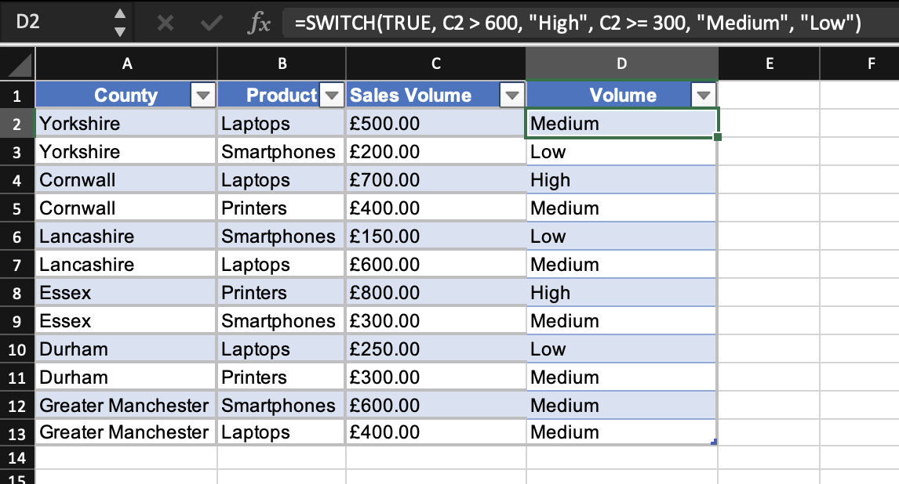  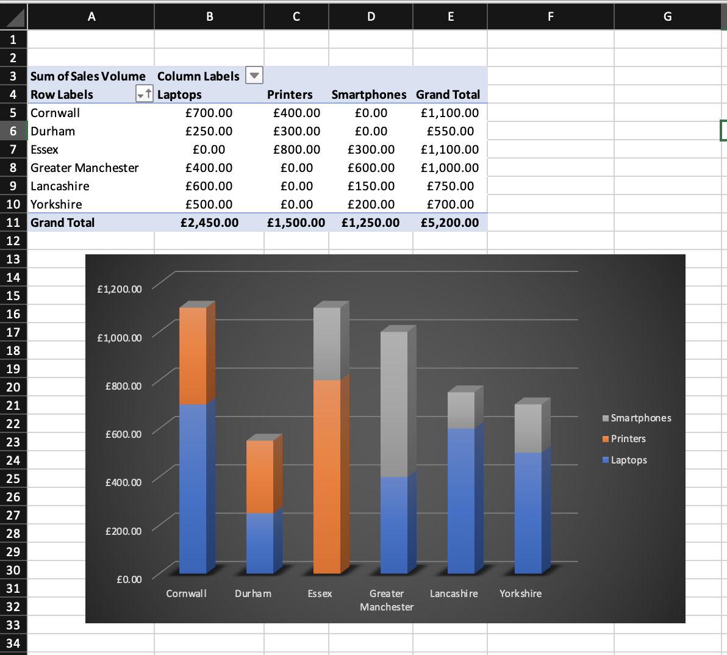

Day 3: Task 3

Please download the dataset ‘Day_3_Task_3_Bike_Sales_Visualisations_Lab.xlsx’ and the the lab instructions. Do not worry if you do not complete the lab, just working with data and playing with the charts will be good experience.

Please paste your results below:

Print screen 1 | 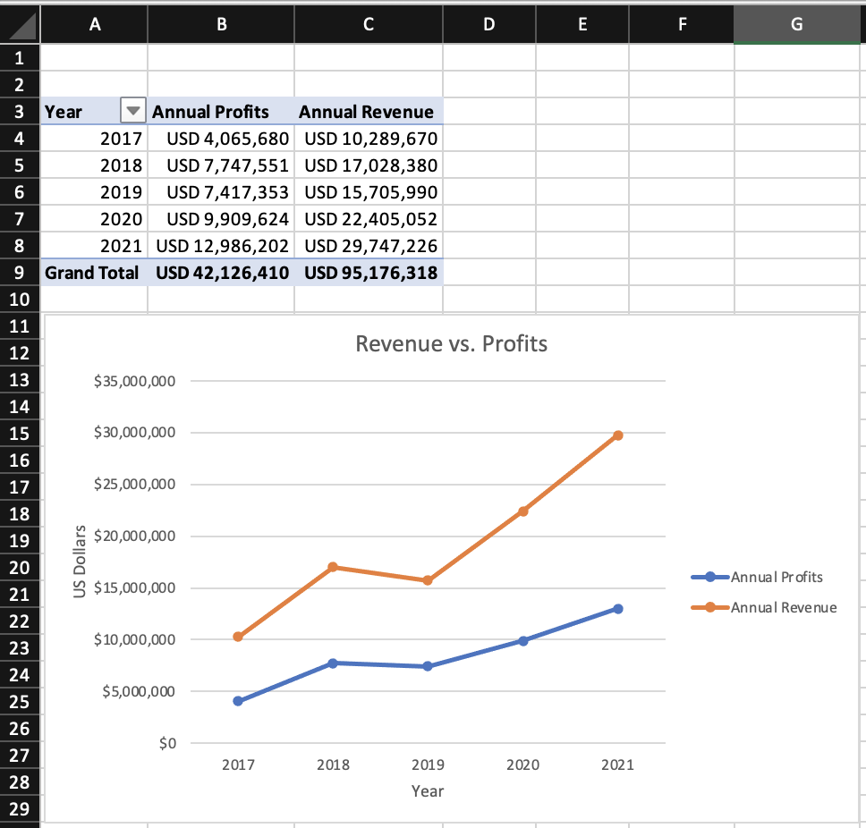  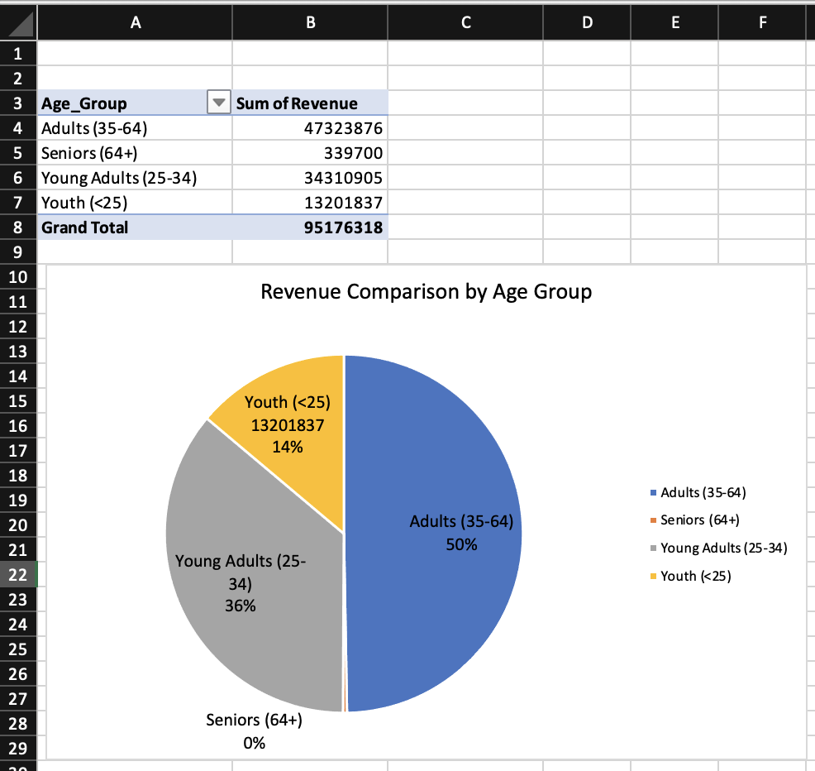  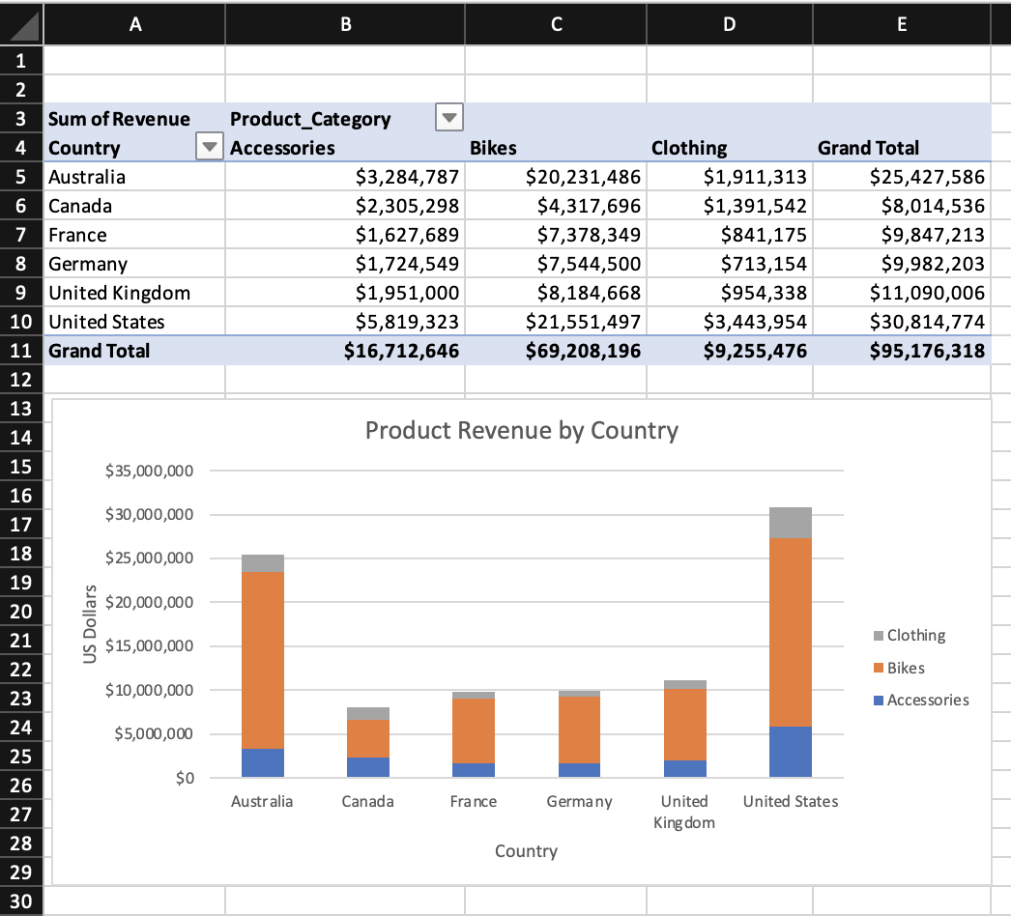

Day 4: Task 1

You have been asked to deliver your analysis findings to the board of directors, with your analysis you have identified that customers are leaving your company at the 12-month point, this is typically when they receive their renewal price.

Conduct research and complete the below questions:

How would you prepare for the delivery? | I would start by making sure I fully understand the data and the key reason customers are leaving at the 12-month renewal stage. I would focus on the main message rather than too much detail, as board members usually want a clear overview.
What tools would you use for the delivery? | I would use PowerPoint and/or Excel to present the findings clearly.
What is prospecting and why would you complete this before your delivery? | Prospecting means understanding the audience you are presenting to. Before the delivery, I would consider what the board is most interested in, such as financial impact, risks, and long-term strategy. Doing this beforehand helps ensure the presentation is relevant and focused on what matters most to senior decision-makers, rather than unnecessary detail.
Tell me best practices for public speaking and providing updates to senior leaders | Good public speaking involves being clear, confident, and well-prepared. It is important to keep information concise, avoid jargon, and focus on key points.
What will you show the board in your delivery? | I would show a summary of the key findings, including a clear trend showing customer churn at the 12-month renewal point. I would also include charts that show the financial impact of customer loss and how renewal pricing affects customer decisions. Finally, I would present a small number of clear recommendations supported by the data.
How will you articulate the changes that are needed? | I would explain the changes by linking them directly to the data. For example, I would explain how renewal pricing is contributing to customer leave and suggest improvements such as better communication before renewal, loyalty incentives, or pricing reviews.
Provide a list of online resources and videos that will support your preparation for public speaking | TEDx Talks, YouTube videos on presentation skills.
Evaluate tools that provide visualisation.  Tell me what they are.  Tell me what you would choose when delivering your presentation and why | Common data visualisation tools include Excel, Power BI, Tableau, and Google Data Studio. Excel is useful for simple charts, while Power BI and Tableau are better for interactive dashboards.  For this presentation, I would choose PowerPoint with clear charts created from Excel.

Course Notes

It is recommended to take notes from the course, use the space below to do so, or use the revision guide shared with the class:
Notes taken on paper notebook.

Additional Information

We have included a range of additional links to further resources and information that you may find useful, these can be found within your revision guide.

END OF WORKBOOK

Please check through your work thoroughly before submitting and update the table of contents if required.

Please send your completed work booklet to your trainer.

