
COLLEGE OF ARTS AND SCIENCES
UNIVERSITI UTARA MALAYSIA

STTXK49512 INDUSTRIAL TRAINING
A252

PROPOSAL

Title: | LLM UUM

STUDENT

Matric No.: | 301909
Name: | AHMAD ABBAS BIN ABU DZARR
Email: | abbasabudzarr@gmail.com
Contact No.: | 011-56867018

ORGANISATION

Name: | Computing Professional Enrichment & Development Division (CoPED)
Address: | Universiti Utara Malaysia, Computing Professional Enrichment & Development Division (CoPED), School of Computing, UUM Sintok, Kedah Darul Aman, Malaysia, Universiti Utara Malaysia, 06010
SUPERVISOR (ORGANISATION)

Name: | Mr. Mohd. Rushdi Idrus
Position: | Manager CoPED
Email: | rushdi@uum.edu.my
Contact No.: | +60 19-492 6968
TOC
1.0 INTRODUCTION 1
1.1 Project Background 1
1.2 Problem Statement 2
1.3 Objective 2
1.4 Scope 3
1.4.1 Document Domain and Standardized Taxonomy Scope 3
1.4.2 Document Processing and Localized Chunking Scope 3
1.4.3 Hybrid Retrieval, Cross-Lingual Matching, and Metadata Filtering Scope 3
1.4.4 Answer Generation, Clarification Handling, and Evaluation Scope 4
1.5 Project Significance 4
1.5.1 Improved Answer Faithfulness and Hallucination Control 4
1.5.2 Accurate Version Control and Cohort-Aware Academic Guidance 4
1.5.3 Enhanced Bilingual Accessibility Across Bahasa Melayu and English 4
1.5.4 Scalable Digital Transformation and Maintainable Knowledge Base for CoPED 4
2.0 PROJECT PLANNING 5
2.1 Methodology 5
2.2 Feasibility Study 5
2.2.1 Tools (Hardware, Software, Database, and AI Models) 5
2.2.2 Cost Estimation 6
2.2.3 Gantt Chart 6
3.0 SUMMARY 7
REFERENCES 8
APPENDIXES 9

1.0 INTRODUCTION

1.1 Project Background
Universiti Utara Malaysia (UUM) generates and maintains an extensive repository of official regulatory, administrative, and academic documents across all of its Centres of Authority (Pusat Tanggungjawab, PTJ)—including the Research Management Centre (RMC), University Treasury (Jabatan Bendahari), Innovation and Commercialisation Centre (ICC), and Legal Department (Jabatan Undang-Undang, JUU)—as well as across all three of its main Academic Colleges: the UUM College of Arts and Sciences (UUM CAS), the UUM College of Business (UUM COB), and the UUM College of Law, Government and International Studies (UUM COLGIS), alongside their respective graduate schools (AHSGS, OYAGSB, and GSGSG) and sixteen constituent academic schools. These university-wide repositories encompass administrative and financial circulars, mandatory application forms, undergraduate and postgraduate academic handbooks, academic calendars, programme brochures, and institutional guidelines. Within the School of Computing, the Computing Professional Enrichment & Development Division (CoPED) plays a central role in driving software innovation and digital transformation initiatives that streamline institutional workflows and unify knowledge accessibility across the entire university.
While Large Language Models (LLMs) [2], [3], [6], [7] store substantial factual knowledge implicitly within their pretrained parameters (parametric memory), standalone generative models exhibit critical limitations when applied to knowledge-intensive institutional tasks [1], [4]. Standalone LLMs rely solely on static pretrained knowledge, cannot easily revise or update their internal memory when university regulations are amended, fail to provide verifiable source provenance, and frequently generate unsupported or fabricated statements ("hallucinations" [4]) when answering specialized regulatory questions. To overcome these limitations, Lewis et al. [1] introduced Retrieval-Augmented Generation (RAG) [1], [5], [11], [12], an architecture that combines pretrained parametric generative models with explicit non-parametric memory (an external document index) [1], [5]. By retrieving relevant passages from authoritative documents using dense passage retrieval [5] and sparse BM25 keyword search [9] and supplying them as context prior to generation, RAG reduces dependence on pretrained parameters, grounds responses in official documentary evidence, and enables knowledge updates by updating the HNSW vector index [10] without retraining the model.
Furthermore, operating a document intelligence system within UUM requires handling both Bahasa Melayu and English queries against documents written in either language. As demonstrated by Litschko et al. [8] in their investigation of Cross-Lingual Information Retrieval (CLIR), general-purpose multilingual text encoders (such as mBERT or XLM) do not automatically guarantee effective cross-lingual retrieval without retrieval-specific adaptation, specialized sentence-level semantic representations, and localized relevance matching across individual document sections. To address these institutional and technical challenges, this project proposes the development of LLM UUM (UUM Circular & Academic Document Intelligence System) at CoPED. The proposed platform integrates a standardized UUM document taxonomy with a Hybrid RAG architecture—combining PostgreSQL pgvector semantic retrieval, PostgreSQL tsvector keyword retrieval, structured metadata filtering, and bilingual cross-lingual retrieval—to deliver accurate, faithful, and traceable answers grounded in official UUM documents.

1.2 Problem Statement
Navigating official regulations, financial claim procedures, and academic requirements at Universiti Utara Malaysia (UUM) currently requires staff, researchers, and students to manually search across multiple departmental websites and lengthy PDF documents. Developing an reliable AI assistant for this domain presents three primary problems:
1. Fragmented Document Repositories and Hallucination Risks in Standalone LLMs: Official UUM circulars, administrative forms, academic handbooks, and programme brochures are dispersed across separate PTJ, college (UUM CAS, UUM COB, UUM COLGIS), and school web portals with inconsistent folder structures and naming conventions. At the same time, relying on general-purpose standalone LLMs to answer UUM regulatory inquiries risks generating inaccurate, outdated, or unsupported claims because standalone models lack access to UUM's external documents and cannot provide verifiable page numbers, circular references, or issuing departments [1]–[4].
2. Version Control, Cohort Dependency, and Limitations of Pure Semantic Search: Evaluating similarity using vector embeddings alone is insufficient when institutional documents are governed by strict applicability conditions. Administrative circulars follow an "Active" versus "Superseded" lifecycle, whereas academic handbooks are bound to a student's specific enrollment intake year (Cohort Year) and academic programme. Without structured metadata filtering and interactive clarification handling for missing user context, a retrieval system may retrieve superseded circulars or apply graduation credit requirements from the wrong academic cohort, compromising both retrieval accuracy and answer faithfulness [1], [5].
3. Lexical–Semantic Trade-offs and Cross-Lingual Retrieval Challenges (English–Bahasa Melayu): UUM users submit queries ranging from paraphrased natural-language questions to exact administrative identifiers (such as form code "RMC 008", circular reference numbers, or course codes), and frequently ask questions in English when the governing circular is written in Bahasa Melayu (or vice versa). Pure keyword search (PostgreSQL tsvector [9]) cannot match cross-lingual terms or paraphrased expressions without language-handling support, whereas general multilingual encoders are vulnerable to monolingual overfitting and whole-document dilution when indexing 100-page handbooks unless localized section-level relevance matching and specialized cross-lingual sentence representations are applied [7], [8].

1.3 Objective
The main objective of this project is to design, develop, and evaluate LLM UUM, a bilingual (English–Bahasa Melayu) Hybrid Retrieval-Augmented Generation (RAG) document intelligence system at CoPED that retrieves authoritative information from official UUM documents and generates accurate, evidence-grounded answers.
The specific objectives of the project are:
1. To standardize and process official UUM documents across all administrative PTJs, academic colleges (UUM CAS, UUM COB, and UUM COLGIS), graduate schools, and constituent schools into a unified taxonomy using localized section-level text chunking [8] and structured relational metadata (Cohort Year, Programme Code, School, Document Category, Edition, Language, and Status).
2. To develop a Hybrid RAG and Cross-Lingual Information Retrieval (CLIR) engine using PostgreSQL that combines dense multilingual semantic retrieval (pgvector) [5], [10] and sparse keyword retrieval (tsvector) [9] with normalised score fusion (proposed 0.60 semantic and 0.40 keyword weighting), bilingual query expansion [8], and metadata filtering.
3. To implement an evidence-grounded answer generation and clarification workflow [1] that enforces strict language mirroring, prompts users for missing cohort or programme details when required, excludes superseded circulars, and cites exact document titles, circular reference numbers, issuing departments, and page numbers.
4. To evaluate the retrieval accuracy and answer faithfulness of the proposed system across monolingual and cross-lingual (English–Bahasa Melayu) UUM queries using standard information retrieval metrics (Recall@K, Precision@K, Mean Reciprocal Rank [MRR], and nDCG) [1], [8] and evidence-grounding verification.

1.4 Scope
The scope of this project is defined across four core technical and operational dimensions:

1.4.1 Document Domain and Standardized Taxonomy Scope
The system indexes all available official UUM documents across administrative PTJs (including RMC, Jabatan Bendahari, ICC, and JUU) and all three academic colleges—UUM CAS (7 schools: SOC, SOE, SAPSP, SMMTC, SCIMPA, SQS, and SLCP), UUM COB (5 schools: SBM, SEFB, TISSA-UUM, IBS, and STML), and UUM COLGIS (4 schools: SOL, SOIS, SOG, and STHEM)—alongside their respective graduate schools (AHSGS, OYAGSB, and GSGSG), UUM Kuala Lumpur Campus (UUMKL), and centralized college-wide repositories. To ensure consistent automated ingestion across diverse portals, school-level repositories are standardized into five core categories: academic_calender, academic_handbooks, forms, postgrad_brochures, and undergrad_programs.

1.4.2 Document Processing and Localized Chunking Scope
Large PDF documents (such as 100+ page undergraduate and postgraduate academic handbooks and multi-clause circulars) undergo automated text extraction and localized text chunking [8] into smaller, targeted sections (e.g., graduation requirements, credit hours, examination rules, and deferment procedures). Each chunk is converted into a dense numerical vector embedding [5] and stored alongside its section heading and page number in PostgreSQL.

1.4.3 Hybrid Retrieval, Cross-Lingual Matching, and Metadata Filtering Scope
The retrieval pipeline combines semantic search (PostgreSQL pgvector) [5], [10] to capture contextual meaning and paraphrased queries with keyword search (PostgreSQL tsvector) [9] to match exact form codes, course codes, and circular reference numbers. Both scores are normalised and combined using a proposed 60/40 weighting design: Score = (0.60 x Semantic Score) + (0.40 x Keyword Score), which will be empirically evaluated against representative UUM queries. Cross-lingual retrieval between English and Bahasa Melayu is supported through multilingual sentence embeddings and bilingual administrative term expansion [8]. Pre-retrieval metadata filtering restricts results by Status (Active vs. Superseded), Cohort Year, Programme Code, School, Document Category, Edition, and Language.

1.4.4 Answer Generation, Clarification Handling, and Evaluation Scope
The generation layer supplies retrieved chunks to the LLM to produce responses strictly grounded in official UUM evidence, complete with source attribution (document title, circular reference, issuing department, and page number). If a query lacks essential context (such as a student's intake year or academic programme for graduation requirements) or if no official document covers the topic, the system requests clarification or communicates the limitation rather than guessing. System evaluation covers both retrieval metrics (Recall@K, Precision@K, MRR, nDCG) [1], [8] across Malay-to-English and English-to-Malay query pairs and answer faithfulness checks.

1.5 Project Significance
The implementation of LLM UUM delivers significant operational, academic, and technical benefits to CoPED and the broader university community:

1.5.1 Improved Answer Faithfulness and Hallucination Control
By grounding LLM generation in retrieved passages from official UUM circulars and academic handbooks rather than relying on standalone pretrained knowledge [1]–[4], the system prevents fabricated regulatory advice and ensures every response is traceable to an official document, section, and page number.

1.5.2 Accurate Version Control and Cohort-Aware Academic Guidance
Integrating metadata filtering with hybrid retrieval [5], [9] ensures administrative staff and researchers only receive regulations from active circulars, while students receive accurate course, credit, and graduation requirements matched specifically to their enrollment cohort year and academic programme.

1.5.3 Enhanced Bilingual Accessibility Across Bahasa Melayu and English
Combining specialized multilingual sentence representations, localized section-level relevance matching, and bilingual term expansion [8] enables local and international students, faculty members, and administrative staff to query UUM policies naturally in either Bahasa Melayu or English regardless of the source document's language.

1.5.4 Scalable Digital Transformation and Maintainable Knowledge Base for CoPED
The non-parametric memory architecture allows CoPED administrators to update UUM's institutional knowledge base immediately—simply by indexing newly issued circulars or new academic handbook editions into PostgreSQL—without incurring the computational cost of retraining or fine-tuning underlying language models [1], [3].

2.0 PROJECT PLANNING

2.1 Methodology
This project adopts an Agile Iterative Development Methodology tailored for data engineering and AI system implementation, divided into five core phases across the 24-week industrial training period:
- 1. Phase 1: Requirement Analysis & Taxonomy Standardization (Weeks 1–4): Auditing existing PTJ and UUM CAS portals, establishing the Master Tracker spreadsheet, and standardizing Google Drive repositories across all 16 UUM schools and administrative departments.
- 2. Phase 2: Database Architecture & Docker Infrastructure Setup (Weeks 5–8): Deploying containerized PostgreSQL 16 (pgvector:pg16) and n8n via Docker Compose, defining relational tables, and configuring HNSW vector [10] and GIN full-text search indexes [9].
- 3. Phase 3: Document Ingestion & Batch Vectorization Pipeline (Weeks 9–14): Developing Python ingestion pipelines (ingest_to_postgres.py) using PyMuPDF to parse PDFs, chunk clauses [8], and execute batch embedding [5] alongside cohort and active-status metadata tagging.
- 4. Phase 4: Hybrid Search, Cross-Lingual Expansion & Multi-API Router (Weeks 15–19): Implementing the retrieval logic combining 60% semantic cosine similarity [5], [10] with 40% BM25 keyword rank fusion [9], strict language mirroring prompts, and Gemini-to-Groq failover.
- 5. Phase 5: n8n Workflow Integration, Testing & Final Report (Weeks 20–24): Building the interactive n8n chat webhook workflow, conducting bilingual retrieval accuracy evaluations (Recall@K, Precision@K, MRR) [1], [8], and compiling the final Industrial Training Report.

2.2 Feasibility Study

2.2.1 Tools (Hardware, Software, Database, and AI Models)
- Hardware: Lenovo LOQ 5 Laptop (Personal host development machine running Windows 11 with WSL2 Ubuntu Linux environment).
- Containerization & Orchestration: Docker & Docker Compose (Local hosting for PostgreSQL and n8n).
- Database & Vector Store: PostgreSQL 16 (Relational metadata storage, 768-d pgvector HNSW index, and GIN tsvector BM25 index).
- Backend & Ingestion: Python 3, PyMuPDF, Pandas, psycopg2 (PDF parsing, semantic chunking, and database upsert).
- AI Models & Routing: Google Gemini API (text-embedding-004, gemini-1.5-flash), Groq, OpenRouter (Primary embedding and generation engine with multi-provider automatic rate-limit failover).
- Workflow & IDE: n8n, Antigravity IDE, VS Code (Visual RAG agent orchestration and software development).

2.2.2 Cost Estimation
The system is designed to operate at zero software and infrastructure cost by leveraging open-source self-hosted containers and permanent free-tier AI APIs. To ensure compliance with UUM's Private and Confidential (P&C) data policies, the local containerized architecture prevents sensitive university documents from being uploaded to public third-party databases.
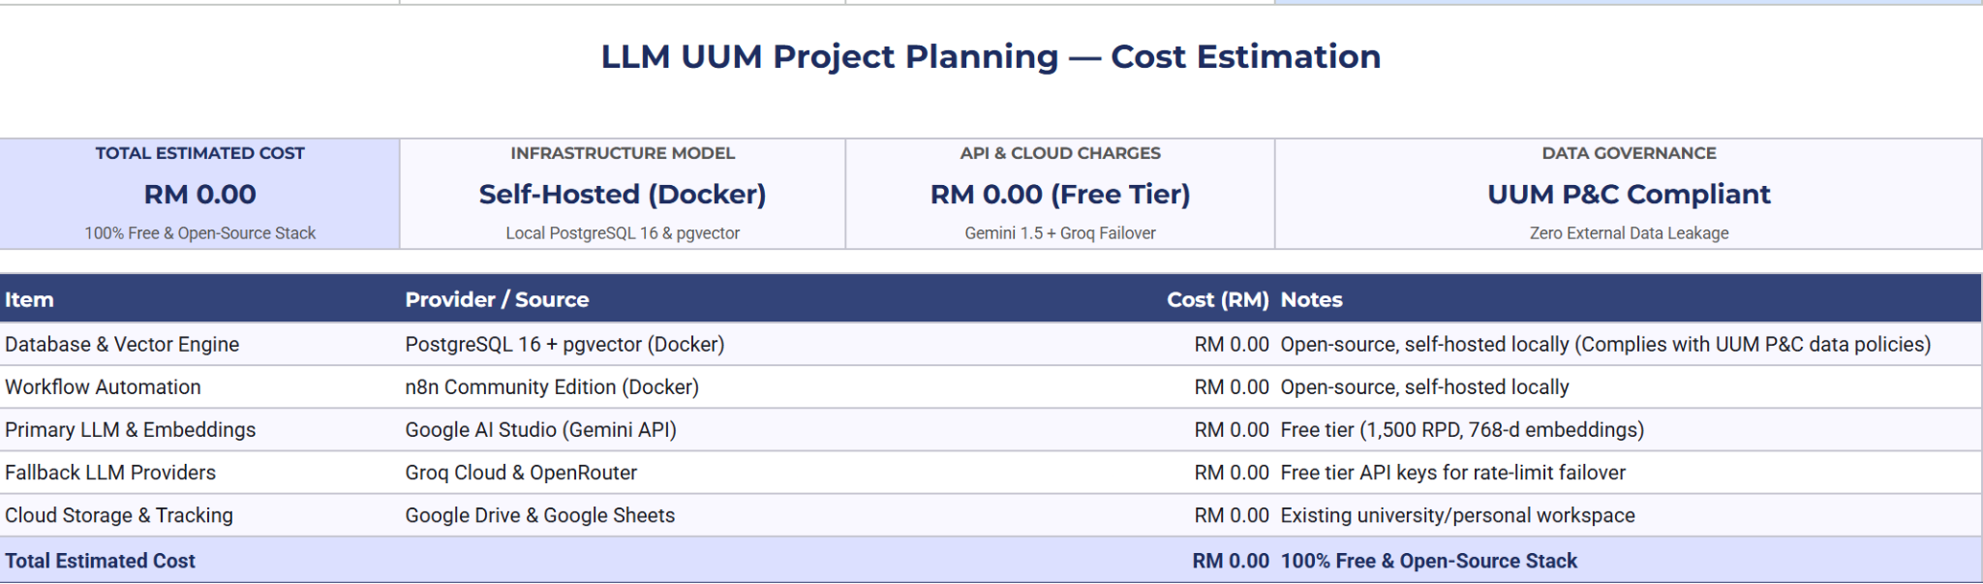
2.2.2.1 Cost estimation

2.2.3 Gantt Chart
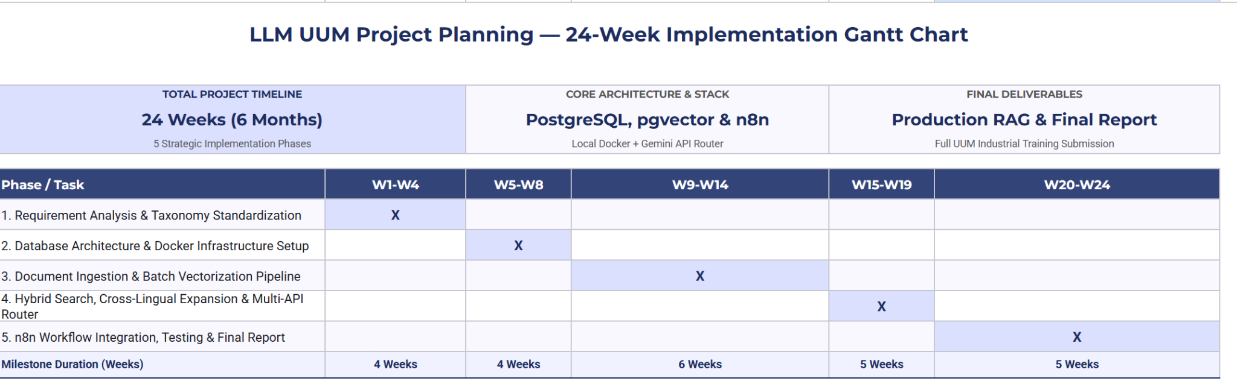
2.2.3 Gantt Chart

3.0 SUMMARY
This proposal outlines the design, development, and evaluation of LLM UUM, a bilingual (English–Bahasa Melayu) Hybrid Retrieval-Augmented Generation (RAG) document intelligence system developed at the Computing Professional Enrichment & Development Division (CoPED), Universiti Utara Malaysia. By combining non-parametric PostgreSQL document indexing (pgvector HNSW dense semantic search [5], [10] and tsvector BM25 keyword search [9]) with localized section-level chunking, cross-lingual query alignment [8], and pre-retrieval metadata filtering (Active circular status and student Cohort Year), the proposed system directly resolves repository fragmentation, version-control risks, and standalone LLM hallucinations [1], [4]. Executed across a 24-week Agile development plan on a Lenovo LOQ 5 host environment using a zero-cost (RM 0.00), locally containerized software stack that safeguards UUM's Private and Confidential (P&C) documents, LLM UUM establishes a scalable, verifiable, and maintainable institutional knowledge platform for UUM staff, researchers, and students.

REFERENCES
[1] P. Lewis et al., "Retrieval-augmented generation for knowledge-intensive NLP tasks," in Advances in Neural Information Processing Systems (NeurIPS), vol. 33, pp. 9459–9474, 2020.
[2] F. Petroni et al., "Language models as knowledge bases?," in Proc. Conf. Empirical Methods in Natural Language Processing and 9th Int. Joint Conf. Natural Language Processing (EMNLP-IJCNLP), Hong Kong, China, Nov. 2019, pp. 2463–2473, doi: 10.18653/v1/D19-1250.
[3] A. Roberts, C. Raffel, and N. Shazeer, "How much knowledge can you pack into the parameters of a language model?," arXiv preprint arXiv:2002.08910, 2020.
[4] G. Marcus, "The next decade in AI: Four steps towards robust artificial intelligence," arXiv preprint arXiv:2002.06177, 2020.
[5] V. Karpukhin et al., "Dense passage retrieval for open-domain question answering," arXiv preprint arXiv:2004.04906, 2020.
[6] A. Vaswani et al., "Attention is all you need," in Advances in Neural Information Processing Systems (NeurIPS), vol. 30, pp. 5998–6008, 2017.
[7] J. Devlin, M.-W. Chang, K. Lee, and K. Toutanova, "BERT: Pre-training of deep bidirectional transformers for language understanding," in Proc. Conf. North American Chapter of the Association for Computational Linguistics: Human Language Technologies (NAACL-HLT), vol. 1, Minneapolis, MN, USA, Jun. 2019, pp. 4171–4186, doi: 10.18653/v1/N19-1423.
[8] R. Litschko, I. Vulić, S. P. Ponzetto, and G. Glavaš, "On cross-lingual retrieval with multilingual text encoders," Information Retrieval Journal, vol. 25, pp. 149–183, 2022, doi: 10.1007/s10791-022-09406-x.
[9] S. Robertson and H. Zaragoza, "The probabilistic relevance framework: BM25 and beyond," Foundations and Trends in Information Retrieval, vol. 3, no. 4, pp. 333–389, Apr. 2009, doi: 10.1561/1500000019.
[10] Y. A. Malkov and D. A. Yashunin, "Efficient and robust approximate nearest neighbor search using hierarchical navigable small world graphs," IEEE Transactions on Pattern Analysis and Machine Intelligence, vol. 42, no. 4, pp. 824–836, 2020, doi: 10.1109/TPAMI.2018.2889473.
[11] K. Guu, K. Lee, Z. Tung, P. Pasupat, and M.-W. Chang, "REALM: Retrieval-augmented language model pre-training," arXiv preprint arXiv:2002.08909, 2020.
[12] K. Lee, M.-W. Chang, and K. Toutanova, "Latent retrieval for weakly supervised open domain question answering," in Proc. 57th Annu. Meeting of the Association for Computational Linguistics (ACL), Florence, Italy, Jul. 2019, pp. 6086–6096, doi: 10.18653/v1/P19-1612.

APPENDIXES
Appendix A : Use case

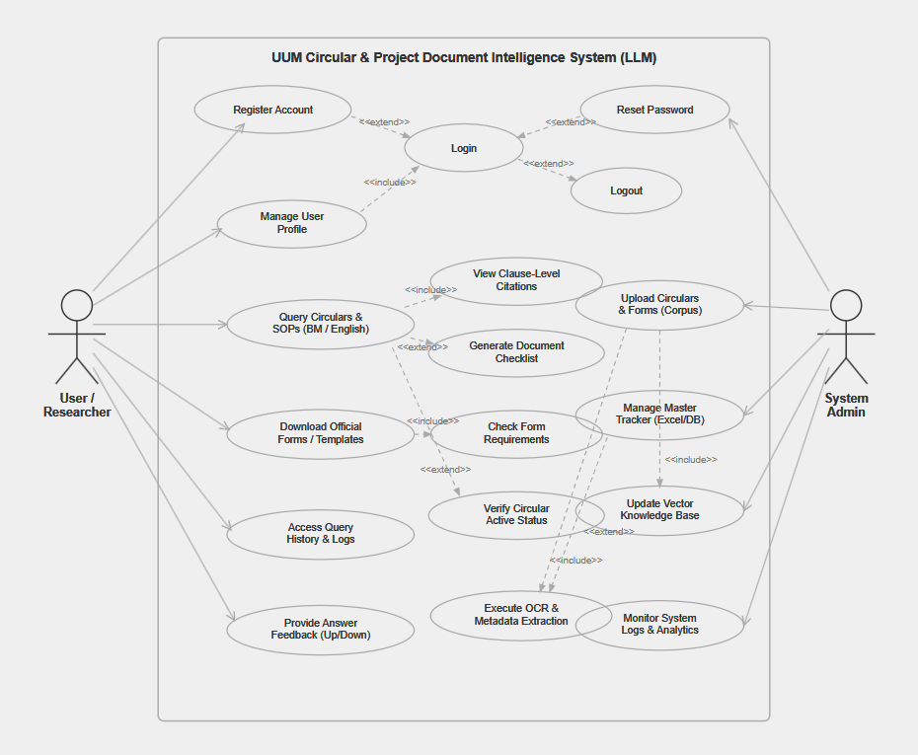

Appendix B : Proposal Endorsement and Approval Sign-Off
Prepared by:
Student’s Signature: Date:

____________________________________
( )

Endorsed by:
Organization’s Supervisor Signature: Date:

____________________________________
( )

