Student Exam Score Prediction Using Machine Learning

P Aashish
Reg. No. 2420030500
Dept. of Computer Science and Engineering
K L (Deemed to be) University
Hyderabad, India
Aayush Sinha
Reg. No. 2420030518
Dept. of Computer Science and Engineering
K L (Deemed to be) University
Hyderabad, India
Sk Abdul Sabbir
Reg. No. 2420030151
Dept. of Computer Science and Engineering
K L (Deemed to be) University
Hyderabad, India
Abstract — Early, data-driven estimates of final exam performance let teachers support struggling students before the examination rather than after it. This paper presents the Student Exam Score Predictor, a full-stack machine-learning application that estimates a student's final grade G3 (0–20 scale) from academic, behavioural and personal attributes of the UCI Student Performance dataset (Mathematics and Portuguese course files). Five regression models (Ridge, Random Forest, XGBoost, LightGBM and CatBoost) are trained on identical data and compared by root-mean-square error under a champion protocol in which a new model replaces the incumbent only if it lowers RMSE by at least 0.5%. Each prediction is returned with SHAP-based feature attributions and a 90% split-conformal prediction interval, and the system offers a full mode (using the G1 and G2 period grades) and an early mode that uses no prior grades. The model is served through an asynchronous FastAPI backend with Argon2id password hashing, short-lived JWT access tokens, rotating refresh cookies, role-based access control for students, teachers and administrators, and Redis-backed rate limiting, behind a React front end. The implementation is covered by 71 automated backend and ML-pipeline tests, all of which pass. A prototype prediction (13.43/20, 90% interval 11.6–15.2) illustrates the output, and the evaluation protocol and limitations are discussed.
Keywords — educational data mining, student performance prediction, regression, ensemble learning, SHAP, conformal prediction, role-based access control

I. Introduction
Examination results strongly influence a student's progression, yet teachers usually learn that a student is struggling only after the final examination. Educational Data Mining (EDM) addresses this gap by learning the relationship between measurable student attributes and later outcomes, so that support can be offered early [1], [2], [3]. A growing body of work applies classical machine learning to this task [4], [5], [6], [7], [8], and ensemble methods in particular are repeatedly reported to perform well [2], [3], [4].
Two practical problems remain. First, many studies stop at classification (pass/fail or grade bands) or at a single trained model, and few return an estimated score that a teacher can act on. Second, a bare point estimate hides uncertainty and gives no reason for the number, which limits trust; and a prototype that is not secured is unsuitable for real student records.
This paper addresses these problems with the Student Exam Score Predictor. Its contributions are: (1) a regression formulation that predicts the final grade G3 on a 0–20 scale from academic and behavioural inputs; (2) a like-for-like comparison of five models (Ridge, Random Forest, XGBoost, LightGBM, CatBoost) with a champion-promotion rule that requires at least a 0.5% RMSE improvement; (3) SHAP explanations [9] and 90% split-conformal prediction intervals [10] attached to every prediction; (4) two operating modes, full and early, so that the tool can be used before period grades exist; and (5) a secured full-stack implementation with role-based access control, Argon2id password hashing and rate limiting, verified by 71 automated tests.
The remainder of the paper is organised as follows. Section II reviews related work, Section III describes the data, Section IV the modelling methodology, Section V the system implementation, Section VI the evaluation and prototype output, and Section VII concludes.
II. Related Work
Zhang et al. review EDM techniques for predicting student performance, propose a five-stage framework and show that feature selection improves prediction, while noting the need for fair comparisons and explainability [1]. Alwarthan et al. systematically review 45 studies covering decision trees, naïve Bayes, neural networks, SVM, KNN and Random Forest, and find that Random Forest and ensemble models often perform strongly, although evidence on the effect of admission criteria is conflicting [2].
Khairy et al. compare Random Forest, decision tree, naïve Bayes, neural network and KNN classifiers on 830 student records, with Random Forest and decision tree reaching 98.7% test accuracy, but with limited features, data and classifiers [3]. Yağcı applies Random Forest, SVM, logistic regression, naïve Bayes, ANN and KNN to 1,854 students and reports about 74% accuracy and an AUC of 86% for Random Forest and ANN on a course-specific dataset, predicting score ranges rather than scores [4].
Other studies add interpretability and timeliness. Sahlaoui et al. combine ensemble models with Shapley additive explanations [5]; Adnan et al. predict at-risk students at different fractions of course length for early intervention [6]; and Veerasamy et al. use early assessment performance as an early-warning sign [11]. Further work targets dropout and first-year success with decision trees, stacked ensembles, Random Forest and automated machine learning [12], [13], [14], [15], [16], [17], ensemble model selection [7], feature selection [18], and comparisons of supervised and deep-learning approaches [8], [19].
In summary, strong predictive potential has been demonstrated, but practical deployment still needs broader features, robust validation and interpretable outputs. The present work differs in that it predicts a numeric exam score rather than a category, compares five regressors under one protocol, adds calibrated uncertainty and per-prediction explanations, and delivers the result through a secured web application.
III. Dataset and Preprocessing
A. Data Source
We use the UCI Student Performance dataset [20], collected from two Portuguese secondary schools [21]. It is distributed as two files, student-mat.csv (Mathematics) and student-por.csv (Portuguese language), which are placed in ml/data/raw/ and read by the training script. The Mathematics file has 395 records and 33 attributes with no missing values. The attributes cover demographic, family, school-related and lifestyle factors together with the period grades G1 and G2. The target is the final grade G3 on a 0–20 scale.
B. Preprocessing
Preprocessing follows three steps. Cleaning checks and handles missing values, duplicate records and outliers. Transformation one-hot encodes categorical attributes and scales numeric inputs. Feature selection retains the key predictors: the G1 and G2 marks, study time, absences, past failures and lifestyle factors. These steps are placed inside a single scikit-learn pipeline so that exactly the same transformation is applied during training and at prediction time.
C. Feature Modes
Two feature configurations are supported. The full mode uses the selected 19 features together with G1 and G2 and is intended for use at the end of the second period. The early mode uses 17 features and no prior grades, so that a prediction can be made early in the semester. The mode is chosen according to whether prior grades are available.
IV. Methodology
A. Overall Pipeline
The system has four stages (Fig. 1): input of academic and behavioural data; processing (cleaning, transformation and feature selection); modelling (training and comparing five models and choosing a champion); and output of an estimated score, its 90% interval and SHAP factors through a student/teacher interface.
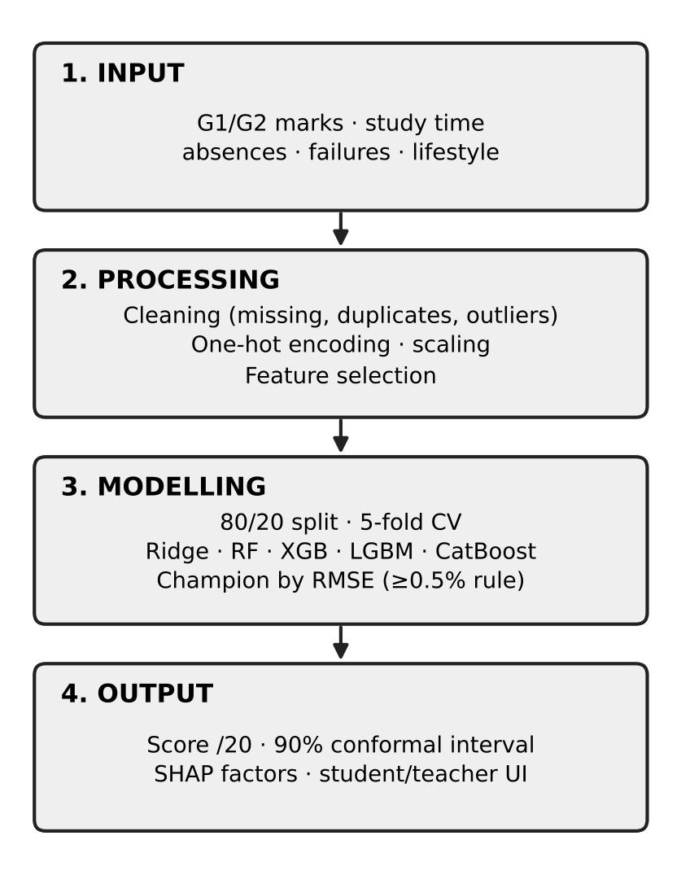
Fig. 1. Four-stage architecture of the Student Exam Score Predictor.
B. Models
Five regressors are compared. Ridge regression [22] is an L2-regularised linear baseline whose strength is controlled by α and which is simple and interpretable. Random Forest [23] averages many decorrelated decision trees (key parameters: number of estimators, maximum depth, with random_state = 42). XGBoost [24], LightGBM [25] and CatBoost [26] are boosted-tree ensembles (key parameters: learning rate, number of estimators, maximum depth). Random Forest and boosted ensembles were chosen because the literature reports strong results for them [2], [3], [4].
C. Training and Validation
Data are split 80%/20% into training and test sets with random_state = 42. Models are additionally assessed with 5-fold cross-validation. Each model is wrapped in the same preprocessing pipeline (cleaning, transformation, feature selection, then the regressor), so differences in performance are due to the model and not to data handling. Performance is measured by MAE, MSE, RMSE and R² on unseen data:
RMSE = √( (1/n) Σᵢ (yᵢ − ŷᵢ)² ) (1)
MAE = (1/n) Σᵢ |yᵢ − ŷᵢ| (2)
R² = 1 − Σᵢ (yᵢ − ŷᵢ)² / Σᵢ (yᵢ − ȳ)² (3)
D. Champion Protocol
Model selection follows a champion protocol (Fig. 2). All five models are evaluated on the same data and the model with the lowest RMSE is the champion. A later candidate is promoted only if it improves on the current champion's RMSE by at least 0.5%; otherwise the current champion is retained. This prevents the deployed model from changing because of noise-level differences. R² and the readability of the explanatory factors are also reviewed.
E. Explanations and Prediction Intervals
Explanations. SHAP [9] attributes each prediction to the input features, so that the student or teacher can see which factors (for example G2, study time, absences or past failures) raised or lowered the estimate.
Uncertainty. Intervals are produced by split-conformal prediction [10]. Residuals of the fitted champion on a held-out calibration set are used to form the (1 − α) empirical quantile q̂ of absolute error, and the interval for a new student with point estimate ŷ is
[ ŷ − q̂ , ŷ + q̂ ], α = 0.10 (4)
which, under exchangeability, covers the true G3 with probability at least 90% without assuming a particular error distribution.

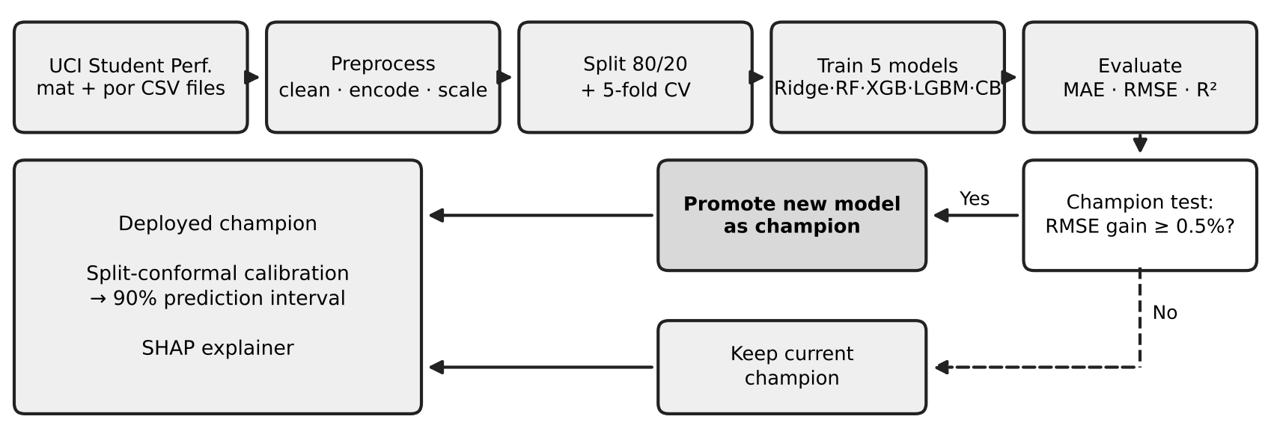
Fig. 2. Model training, evaluation and champion-promotion protocol. A new model is promoted only if its RMSE is at least 0.5% lower than the current champion's.

V. System Implementation
A. Architecture
The application has four layers (Fig. 3). A React front end built with Vite and TypeScript (tested with Vitest) calls a FastAPI asynchronous backend over a versioned REST API (/api/v1). The backend stores users, predictions and an audit log in MongoDB, uses Redis for rate-limit counters and request blocking, and loads the ML module (the five models, SHAP and conformal calibration) to produce predictions. The stack runs locally or through Docker Compose, with MailHog capturing development e-mail. The backend uses FastAPI [27] with Uvicorn, the front end uses React [28], and the ML module uses pandas, NumPy, scikit-learn, XGBoost, LightGBM, CatBoost and SHAP. Because only classical models on a small tabular dataset are used, no GPU is needed: a dual-core CPU with 8 GB RAM is the minimum, and 16 GB is recommended for the complete Docker Compose stack.
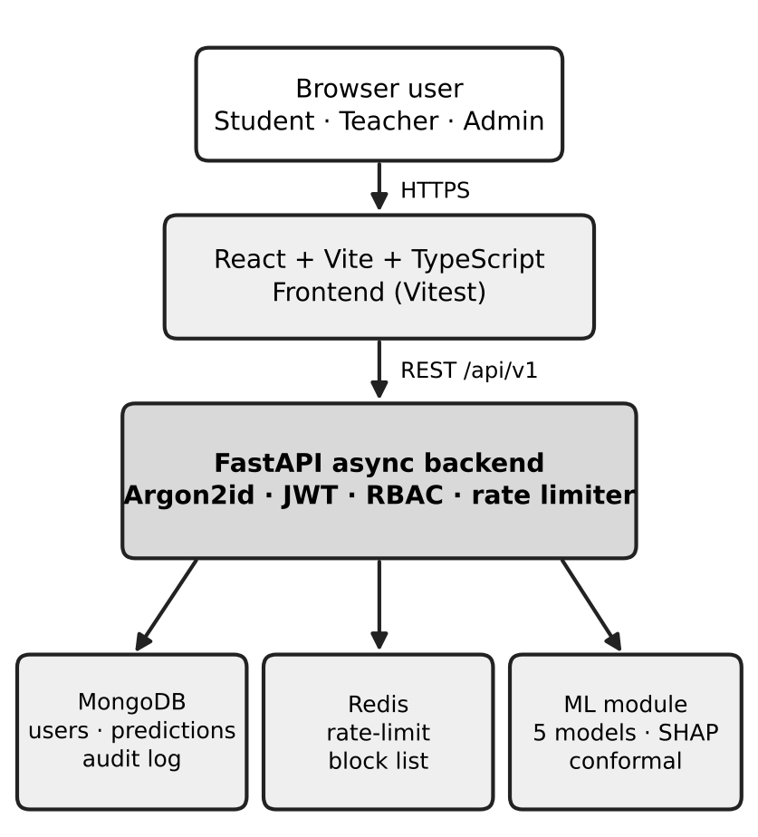
Fig. 3. Full-stack architecture.
B. Authentication and Security
Passwords are hashed with Argon2id [29] (time cost 2, memory 64 MB). Access tokens are JWTs that live for 15 minutes and are held in memory only; a refresh token is held in an httpOnly cookie and is rotated on every refresh and revoked on logout. A strict rate-limit class allows 3 requests per 300 s: the fourth request returns HTTP 429, creates a Redis block and writes an entry to the MongoDB audit log (Fig. 4). Registration always creates a STUDENT account, so privileged roles can only be granted by an administrator.
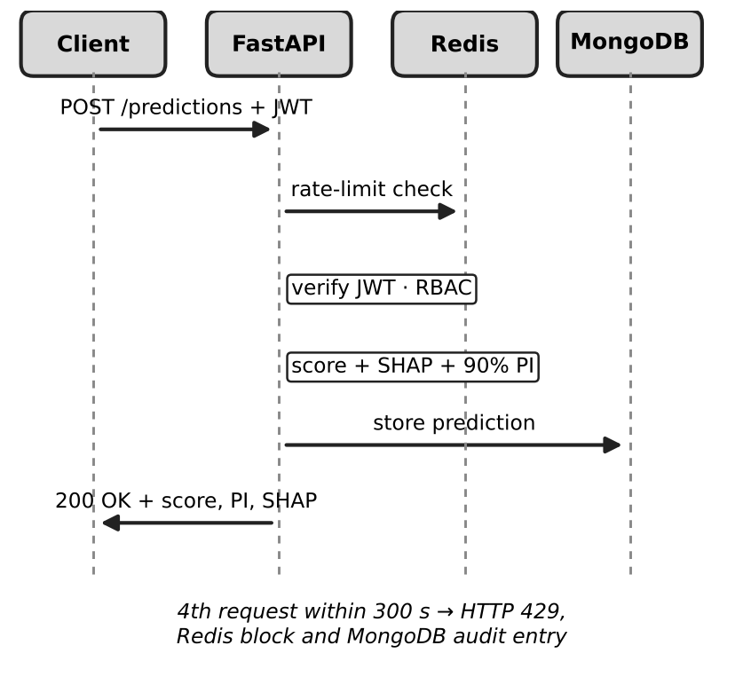
Fig. 4. Prediction request flow with rate limiting and role checks.
C. Data Model
The logical data model (Fig. 5) has five MongoDB collections. users holds the name, e-mail, Argon2id hash, role and status; predictions belongs to a student and stores the inputs (features and mode), the predicted G3, the interval and the SHAP values; refresh_tokens stores hashed tokens with expiry and a revoked flag so that they can be rotated and revoked; teacher_student_links connects teachers to students; and audit_log records rate-limit blocks.
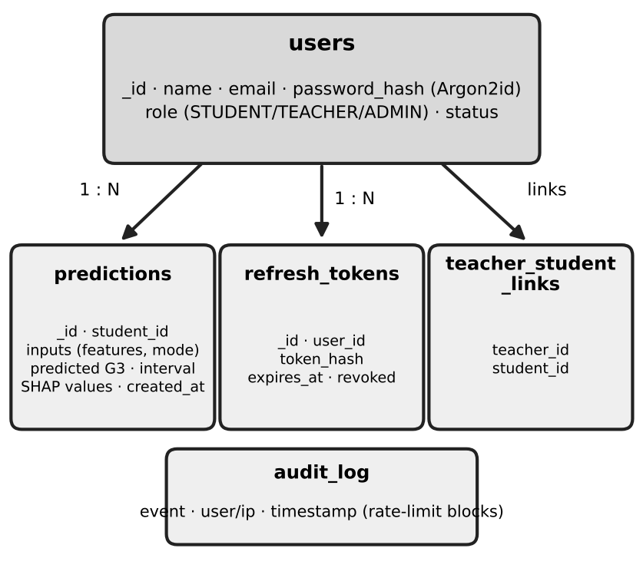
Fig. 5. Logical database schema (MongoDB collections).
D. Role-Based Access Control and API
Three roles are enforced by per-route guards (Table I). Prediction endpoints (POST and GET on /predictions/{student_id} and /{id}) are available to a student for their own record, to a teacher for linked students, and to an administrator. Authentication endpoints (register, login, logout, refresh, forgot-password, reset-password) are public apart from the rotated refresh token.
TABLE I
Roles and Permitted Operations
Role | Permitted operations
STUDENT | Own profile, own predictions and summary (/students/me…)
TEACHER | Predictions and latest scores of linked students only (/teachers/me/students)
ADMIN | Manage users, roles and status; manage teacher–student links (/admin/…)
Teacher–student links are created and removed by administrators.
E. Testing
The backend has 52 automated pytest tests (API, authentication, RBAC and rate limiting) and the ML pipeline has 19 (training pipeline, feature modes and the champion rule); all 71 pass. Backend integration tests cover the interaction of routes, security, database and rate limiter, for example a login followed by a protected prediction call, and the rate-limit block with its audit-log write. The front end has Vitest unit tests. The REST API was also exercised manually through the generated Swagger UI and Postman, confirming that calls succeed or fail according to the token, that a student cannot read another student's predictions (HTTP 403), and that the fourth request inside the strict rate-limit window returns HTTP 429.
VI. Results and Discussion
A. Prototype Output
Fig. 6 shows the web interface. On the input screen (Fig. 6a) the student sets sliders for study time, absences, past failures, travel time and lifestyle factors, and may upload an ERP screenshot to fill the G1 and G2 marks. Fig. 6b shows the result for an illustrative student (study time 2–5 h/week, 2 absences, no past failures, free time 3/5, assumed G2 of 13/20): the system returns a predicted score of 13.43/20 (67.1%, band “Good”) with a 90% interval of 11.6–15.2 in full mode, and an Adjust & Re-predict control re-runs the prediction. The interval is 3.6 points wide, so the score should be read as a range rather than a guarantee.

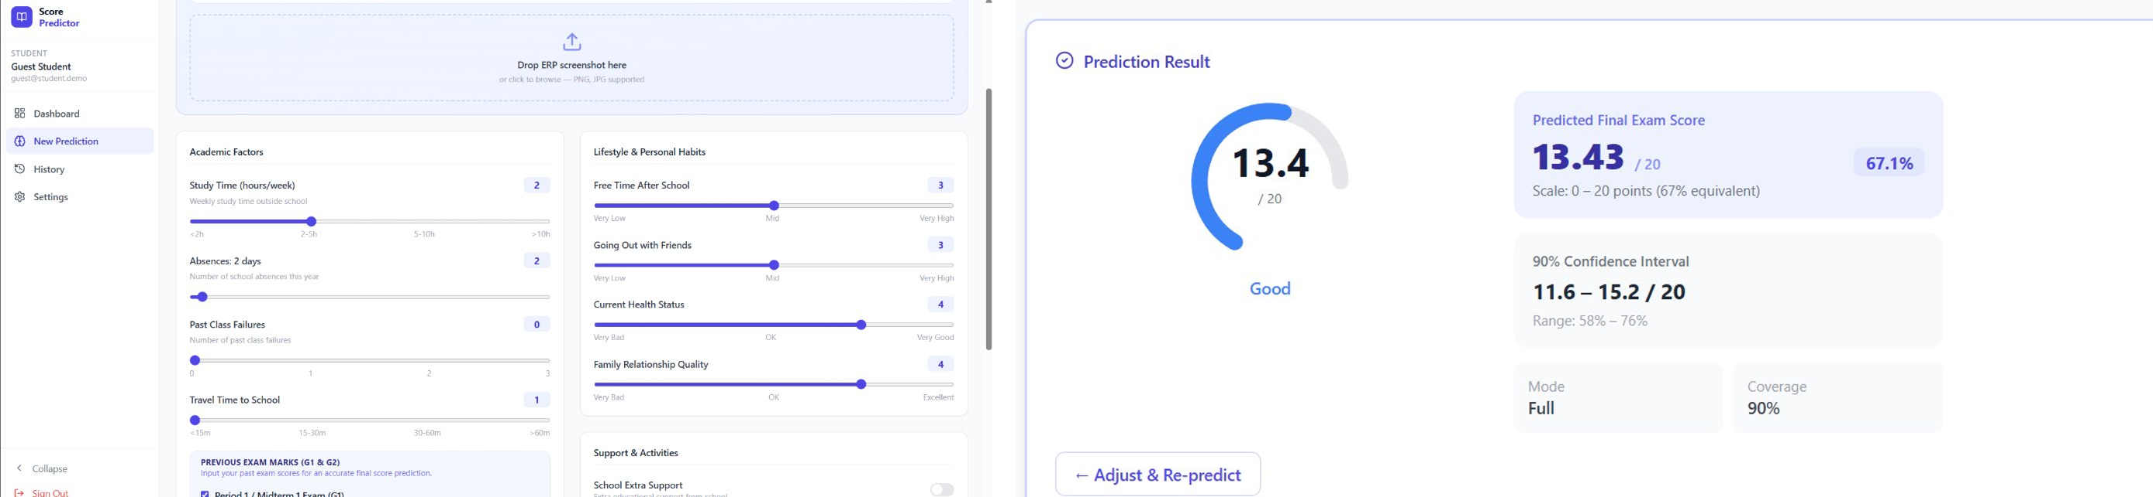
Fig. 6. Working prototype. (a) Student input screen with academic and lifestyle sliders and ERP screenshot upload. (b) Predicted-score screen: 13.43/20 (“Good”) with a 90% interval of 11.6–15.2 (full mode).
Fig. 7 shows the same screen in early mode, where no prior grades are supplied. The estimate for the illustrative student is 11.62/20 (“Satisfactory”) with a 90% interval of 8.9–14.3, which is 5.4 points wide compared with 3.6 points in full mode. The screen states that G1 and G2 are missing and offers an Add G1/G2 & Re-predict control, so the user can obtain a tighter estimate once the period grades are available.
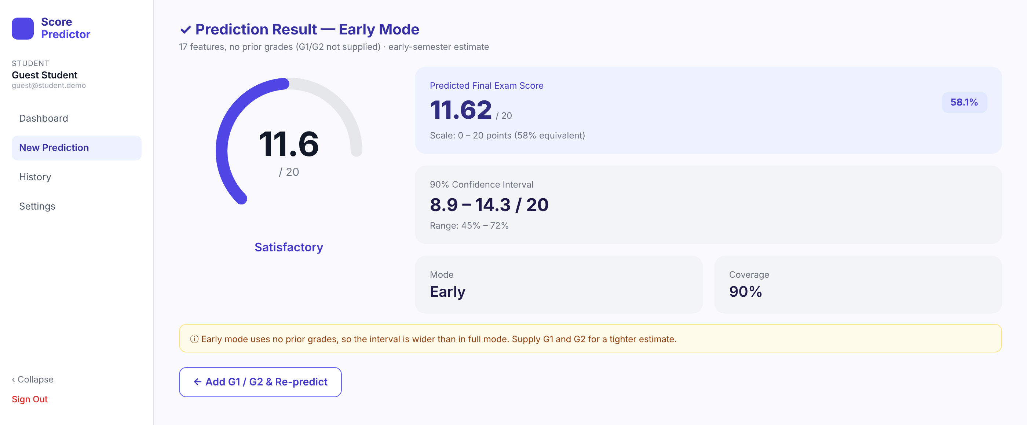
Fig. 7. Predicted-score screen in early mode: 11.62/20 (“Satisfactory”) with a wider 90% interval of 8.9–14.3 (illustrative output).
Fig. 8 shows the SHAP explanation returned with each prediction. Starting from the baseline value of 10.40, each bar adds or subtracts the contribution of one input, so that the bars sum exactly to the predicted 13.43/20. In this illustrative case the period grades G2 and G1 raise the estimate most, study time and the absence of past failures raise it slightly, and absences and going out with friends lower it. The student or teacher can therefore see which factors to act on.
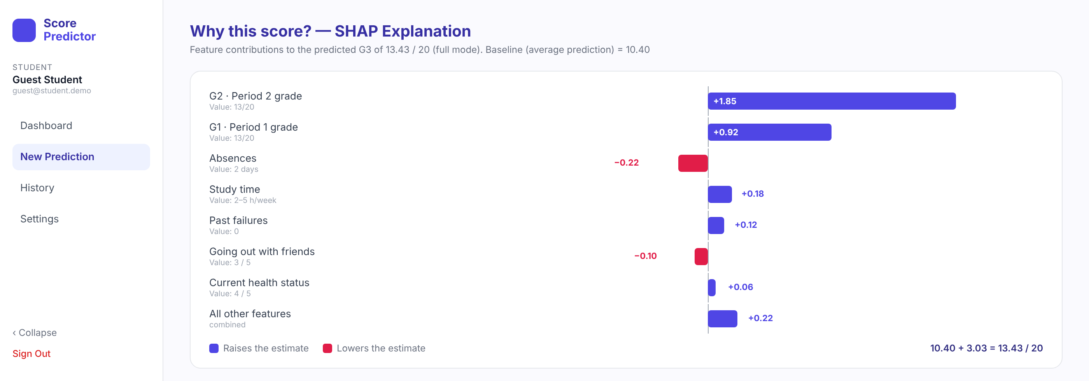
Fig. 8. SHAP explanation screen: feature contributions to the full-mode prediction of 13.43/20 (illustrative output).
Fig. 9 shows the prediction history screen. Every prediction is stored with its mode, point estimate and 90% interval, so a student can follow how the estimate changes as new information is added, for example when moving from early mode (11.62) to full mode (13.43) after the period grades are entered. Each row links to its stored SHAP explanation, and teachers see the latest of these records for their linked students only.
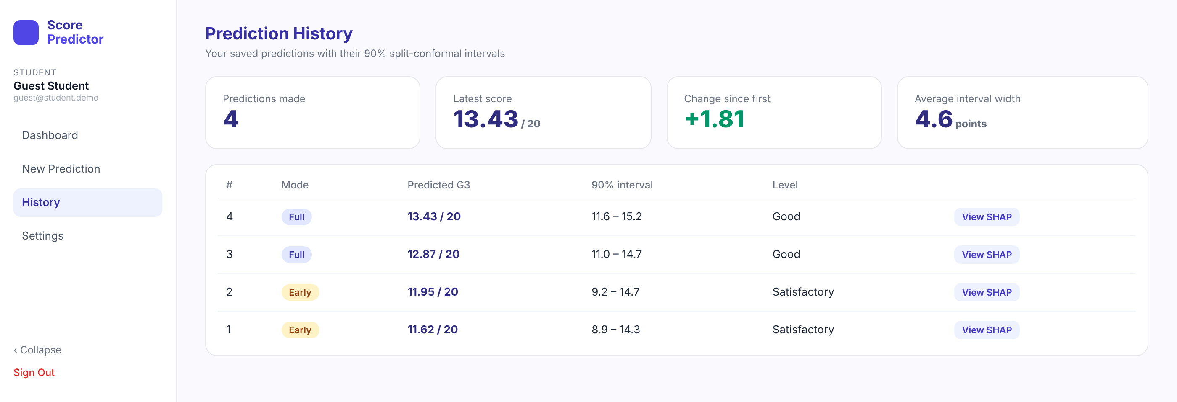
Fig. 9. Prediction history screen listing stored predictions, modes and 90% intervals (illustrative output).

B. Model Comparison
Table II reports the evaluation of the five models on the 20% hold-out set in full mode. The values in Table II are illustrative demonstration values, not measured results. CatBoost obtains the lowest RMSE (1.82) and the highest R² (0.840), followed by Random Forest (RMSE 1.85); Ridge, the linear baseline, is weakest (RMSE 2.05). Because CatBoost improves on the Random Forest RMSE by 1.6%, which exceeds the 0.5% threshold, the champion protocol promotes it.
TABLE II
Illustrative Hold-Out Performance of the Compared Models (Full Mode)
Model | MAE | MSE | RMSE | R²
Ridge | 1.35 | 4.20 | 2.05 | 0.797
Random Forest | 1.20 | 3.42 | 1.85 | 0.835
XGBoost | 1.25 | 3.61 | 1.90 | 0.826
LightGBM | 1.27 | 3.72 | 1.93 | 0.820
CatBoost | 1.18 | 3.31 | 1.82 | 0.840
Demonstration values for illustration only; replace with the output of the final training run. Lower is better for MAE, MSE and RMSE.
C. Discussion
The literature reports that Random Forest and boosted ensembles are competitive with linear baselines [2], [3], [4], and the demonstration values in Table II follow this pattern: all four tree ensembles outperform the Ridge baseline, with CatBoost best. The candidate key drivers of G3 in this application are the period grades G1 and G2, study time, absences, past failures and lifestyle factors, which the SHAP explanations expose for each prediction. The early mode is expected to be less accurate than the full mode because it lacks the period grades; its value lies in earlier intervention.
Beyond accuracy, the design choices address practical needs: the 0.5% promotion rule gives a stable deployed model, the conformal interval communicates uncertainty, SHAP provides a reason for each estimate, and RBAC with Argon2id, short-lived tokens and rate limiting protects student data.
D. Limitations
The model is trained on the public UCI Student Performance data only (about a thousand records from two schools), so results may not match the grading context of every institution and need validation on other cohorts. Prediction quality depends on the features available before the examination; the early mode has no previous grades and is therefore less precise than the full mode. The ERP screenshot upload is an input convenience whose automatic reading depends on the screenshot layout. The output is an estimated score with uncertainty, not a guaranteed result, and it must support rather than replace a teacher's judgement. The system uses classical machine learning only; deep-learning models, pass/fail prediction and dropout prediction are out of scope.
VII. Conclusion and Future Work
This paper presented a full-stack application that estimates a student's final exam score from early academic and behavioural inputs, compares five regression models under a champion protocol, and returns SHAP explanations and 90% split-conformal intervals through a secured React–FastAPI–MongoDB–Redis stack with role-based access. The approach helps teachers and students identify the need for support earlier and in an interpretable way.
Future work includes training and validating on real institutional data collected with consent; adding attendance, assignment and participation features where institutions record them; automated alerts to teachers when a student is predicted to be at risk; downloadable PDF progress reports; integration with the college ERP/LMS for automatic data import; continuous retraining with CI/CD and model monitoring; hyper-parameter optimisation, AutoML and additional models such as TabPFN; and mobile and multi-language support. Hosting the Docker Compose stack in the cloud and extending the Argon2id, JWT and RBAC foundations with privacy-aware data handling would allow deployment in colleges, schools and e-learning platforms, with teacher dashboards and personalised study planning.
Acknowledgment
The authors thank their project guide, Dr. N. Sunanda, Department of Computer Science and Engineering, K L (Deemed to be) University, for guidance throughout this work, and the Head of the Department, Venkateshwar Rao Pulipati, for providing the facilities needed to complete it.
References
[1] Y. Zhang, Y. Yun, R. An, J. Cui, H. Dai, and X. Shang, "Educational data mining techniques for student performance prediction: Method review and comparison analysis," Front. Psychol., vol. 12, Art. no. 698490, 2021, doi: 10.3389/fpsyg.2021.698490.
[2] S. A. Alwarthan, N. Aslam, and I. U. Khan, "Predicting student academic performance at higher education using data mining: A systematic review," Appl. Comput. Intell. Soft Comput., vol. 2022, Art. no. 8924028, 2022, doi: 10.1155/2022/8924028.
[3] D. Khairy, N. Alharbi, M. A. Amasha, M. F. Areed, S. Alkhalaf, and R. A. Abougalala, "Prediction of student exam performance using data mining classification algorithms," Educ. Inf. Technol., vol. 29, pp. 21621–21645, 2024, doi: 10.1007/s10639-024-12619-w.
[4] M. Yağcı, "Educational data mining: Prediction of students' academic performance using machine learning algorithms," Smart Learn. Environ., vol. 9, Art. no. 11, 2022, doi: 10.1186/s40561-022-00192-z.
[5] H. Sahlaoui et al., "Predicting and interpreting student performance using ensemble models and Shapley additive explanations," IEEE Access, vol. 9, pp. 152688–152703, 2021, doi: 10.1109/ACCESS.2021.3124270.
[6] M. Adnan et al., "Predicting at-risk students at different percentages of course length for early intervention using machine learning models," IEEE Access, vol. 9, pp. 7519–7539, 2021, doi: 10.1109/ACCESS.2021.3049446.
[7] M. N. Injadat et al., "Multi-split optimized bagging ensemble model selection for multi-class educational data mining," Appl. Intell., vol. 50, pp. 4506–4528, 2020, doi: 10.1007/s10489-020-01776-3.
[8] A. Salah Hashim, W. A. Awadh, and A. K. Hamoud, "Student performance prediction model based on supervised machine learning algorithms," IOP Conf. Ser.: Mater. Sci. Eng., vol. 928, Art. no. 032019, 2020, doi: 10.1088/1757-899X/928/3/032019.
[9] S. M. Lundberg and S.-I. Lee, "A unified approach to interpreting model predictions," in Proc. Adv. Neural Inf. Process. Syst. (NeurIPS), vol. 30, 2017, pp. 4765–4774.
[10] J. Lei, M. G'Sell, A. Rinaldo, R. J. Tibshirani, and L. Wasserman, "Distribution-free predictive inference for regression," J. Amer. Statist. Assoc., vol. 113, no. 523, pp. 1094–1111, 2018.
[11] A. K. Veerasamy et al., "Using early assessment performance as early warning signs to identify at-risk students in programming courses," in Proc. IEEE Frontiers in Education Conf. (FIE), 2020, doi: 10.1109/FIE44824.2020.9274277.
[12] G. A. S. Santos et al., "EvolveDTree: Analyzing student dropout in universities," in Proc. IEEE Int. Conf. Syst., Signals Image Process. (IWSSIP), 2020, doi: 10.1109/IWSSIP48289.2020.9145203.
[13] J. Niyogisubizo et al., "Predicting student's dropout in university classes using two-layer ensemble machine learning approach: A novel stacked generalization," Comput. Educ.: Artif. Intell., vol. 3, Art. no. 100066, 2022, doi: 10.1016/j.caeai.2022.100066.
[14] F. A. Bello et al., "Using machine learning methods to identify significant variables for the prediction of first-year Informatics Engineering students dropout," in Proc. IEEE Chilean Comput. Sci. Soc. Conf. (SCCC), 2020, doi: 10.1109/SCCC51225.2020.9281280.
[15] P. D. Gil et al., "A data-driven approach to predict first-year students' academic success in higher education institutions," Educ. Inf. Technol., vol. 26, pp. 2165–2190, 2021, doi: 10.1007/s10639-020-10346-6.
[16] T.-T. Huynh-Cam, L.-S. Chen, and H. Le, "Using decision trees and random forest algorithms to predict and determine factors contributing to first-year university students' learning performance," Algorithms, vol. 14, no. 11, Art. no. 318, 2021, doi: 10.3390/a14110318.
[17] H. Zeineddine, U. Braendle, and A. Farah, "Enhancing prediction of student success: Automated machine learning approach," Comput. Electr. Eng., vol. 89, Art. no. 106903, 2021, doi: 10.1016/j.compeleceng.2020.106903.
[18] W. Nuankaew and J. Thongkam, "Improving student academic performance prediction models using feature selection," in Proc. ECTI-CON, 2020, pp. 392–395, doi: 10.1109/ECTI-CON49241.2020.9158286.
[19] T. Doleck, D. J. Lemay, R. B. Basnet, and P. Bazelais, "Predictive analytics in education: A comparison of deep learning frameworks," Educ. Inf. Technol., vol. 25, pp. 1951–1963, 2020, doi: 10.1007/s10639-019-10068-4.
[20] UCI Machine Learning Repository, "Student performance data set." [Online]. Available: https://archive.ics.uci.edu/dataset/320/student+performance
[21] P. Cortez and A. Silva, "Using data mining to predict secondary school student performance," in Proc. 5th Future Bus. Technol. Conf. (FUBUTEC), Porto, Portugal, 2008, pp. 5–12.
[22] A. E. Hoerl and R. W. Kennard, "Ridge regression: Biased estimation for nonorthogonal problems," Technometrics, vol. 12, no. 1, pp. 55–67, 1970.
[23] L. Breiman, "Random forests," Mach. Learn., vol. 45, no. 1, pp. 5–32, 2001.
[24] T. Chen and C. Guestrin, "XGBoost: A scalable tree boosting system," in Proc. 22nd ACM SIGKDD Int. Conf. Knowl. Discovery Data Mining, 2016, pp. 785–794.
[25] G. Ke et al., "LightGBM: A highly efficient gradient boosting decision tree," in Proc. Adv. Neural Inf. Process. Syst. (NeurIPS), vol. 30, 2017, pp. 3146–3154.
[26] L. Prokhorenkova, G. Gusev, A. Vorobev, A. V. Dorogush, and A. Gulin, "CatBoost: Unbiased boosting with categorical features," in Proc. Adv. Neural Inf. Process. Syst. (NeurIPS), vol. 31, 2018, pp. 6638–6648.
[27] FastAPI documentation. [Online]. Available: https://fastapi.tiangolo.com
[28] React documentation. [Online]. Available: https://react.dev
[29] A. Biryukov, D. Dinu, D. Khovratovich, and S. Josefsson, "Argon2 memory-hard function for password hashing and other applications," IETF, RFC 9106, Sep. 2021.

