Fixed and Compression-Aware Knowledge Regularization for GETA-Based Joint Structured Pruning and Quantization
Author Name(s)

Abstract
Model compression is essential for deploying deep neural networks on resource-constrained devices. This paper studies teacher-guided recovery for GETA-based joint structured pruning and weight-only quantization by comparing GETA-only training, fixed vanilla knowledge distillation (KD), and Compression-Aware Knowledge Regularization (CAKR). CAKR activates after target sparsity becomes stable and adapts the teacher signal using compression-state indicators and teacher-correct confidence weighting while keeping cross-entropy as the main objective. Experiments on CIFAR-10 and CIFAR-100 with ResNet20, ResNet56, and VGG7 show that teacher guidance generally improves GETA-compressed models, but the best strategy depends on student capacity and architecture. CAKR improves over GETA-only in all six settings and achieves the highest mean accuracy in three settings, whereas fixed KD is strongest for higher-capacity students such as ResNet56/CIFAR-100. The results show that adaptive KD is safer for smaller or compression-sensitive students, while fixed KD remains a strong recovery baseline for larger or more stable students.
Index Terms—model compression, structured pruning, quantization, knowledge distillation, GETA, CAKR, CNN compression

1. Introduction
Deep neural networks have achieved strong performance in computer vision tasks, but their computational and memory requirements limit deployment on resource-constrained devices. ResNet56 on CIFAR-100, for example, requires 861K parameters and approximately 125M multiply-accumulate operations per inference, well beyond the budgets of many edge devices [22], [23]. Model compression is therefore an important step between training and deployment [1], [2]. Among compression techniques, structured pruning and quantization are widely adopted because they reduce both model size and computational cost [5].
Structured pruning removes hardware-friendly components such as channels, filters, or groups, directly reducing model width and multiply-accumulate operations. Quantization reduces numerical precision, lowering storage and inference cost [2], [14]–[18]. In practice, these techniques are often applied separately, but this can be suboptimal because pruning changes the network structure and may increase sensitivity to low-precision representation. Joint pruning and quantization addresses this by optimizing sparsity and bit-width under a unified process [9], [10].
GETA provides an automatic framework for joint structured pruning and quantization-aware training, with explicit control over target sparsity and bit-width constraints [10]. Although GETA is a strong compression backbone, the compressed student is primarily optimized with cross-entropy. During aggressive joint compression, the student changes continuously as structured groups are removed and quantization parameters are updated. Teacher guidance through knowledge distillation can help recover lost information, but the best form of teacher guidance is not obvious for this setting.
This paper studies teacher-guided recovery for GETA-based joint compression by comparing three approaches: GETA-only (cross-entropy only), fixed vanilla KD, and CAKR, a compression-aware adaptive regularizer that controls the teacher signal using the current compression state and teacher reliability. Prior work has combined KD with pruning and quantization [11]–[13], but none directly addresses fixed versus adaptive KD within GETA-based joint structured pruning and quantization. To the best of our knowledge, this is the first controlled multi-seed comparison of GETA-only, fixed KD, and compression-aware KD for GETA-based joint structured pruning and quantization.
The main contributions of this paper are as follows:
• We study teacher-guided recovery for GETA-based joint structured pruning and weight quantization under a common compression protocol.
• We compare GETA-only, GETA with fixed vanilla KD, and GETA with CAKR across ResNet20, ResNet56, and VGG7 on CIFAR-10 and CIFAR-100.
• We propose CAKR as a controlled compression-aware KD variant that uses stable sparsity activation, teacher-correct confidence weighting, and compression-state indicators to adapt the teacher signal during joint compression.
• We show that CAKR achieves the highest mean accuracy in 3 of 6 settings and consistently improves over GETA-only in all settings, while fixed KD is a stronger recovery baseline for higher-capacity students such as ResNet56. Critically, fixed KD reduces accuracy below the GETA-only baseline on ResNet20/CIFAR-10, while CAKR does not.
• We show that CAKR improves compressed-model accuracy stability: on ResNet20/CIFAR-10, the standard deviation across seeds decreases from ±0.61 (GETA-only) to ±0.13 (CAKR), suggesting more consistent recovery.
The remainder of this paper is organized as follows. Section 2 reviews related work. Section 3 provides background on GETA and KD. Section 4 describes the compared teacher-guided recovery methods. Section 5 presents the experimental setup. Section 6 reports results and discussion. Section 7 concludes the paper.

2. Related Work

2.1 Structured Pruning and Dependency-Aware Compression
Structured pruning removes channels, filters, or dependency-connected groups to obtain hardware-friendly acceleration [1], [5]. Unlike unstructured pruning, structured pruning directly reduces dense tensor dimensions and multiply-accumulate operations. Channel pruning and filter pruning methods remove components based on importance criteria such as magnitude or activation statistics [5]. DepGraph automates structured pruning by tracing structural dependencies between layers, enabling group-wise pruning across diverse architectures [6]. OTO and OTOv2 further integrate sparsity-inducing optimization directly into training, reducing the need for separate prune-and-fine-tune cycles [7], [8]. These dependency-aware methods motivate the structured group view used by GETA for joint pruning and quantization.

2.2 Quantization and Quantization-Aware Training
Quantization reduces storage and arithmetic cost by representing weights or activations with fewer bits [2], [14]. Quantization-aware training (QAT) approaches such as DoReFa-Net and PACT enable low-bit training through differentiable approximations of the quantization function [15], [16]. HAWQ and HAWQ-V2 use second-order sensitivity information to assign different bit-widths to different layers, showing that mixed-precision quantization can preserve accuracy more effectively than uniform quantization [17], [18]. These methods show that bit-width sensitivity is layer-dependent, motivating the learnable quantization approach used in GETA. CAKR is complementary to these quantization methods because it focuses on teacher-guided recovery during GETA-based joint compression rather than changing the quantization scheme.

2.3 Joint Pruning and Quantization
Applying pruning and quantization separately can be suboptimal because pruning changes the network structure and may alter quantization sensitivity. Zhang et al. showed that structured channel pruning and uniform quantization should be considered together rather than as independent post-processing steps [9]. GETA extends this direction by automatically combining structured pruning and quantization-aware training with explicit sparsity and bit-width constraints through a quantization-aware dependency graph and a quantization-aware structured sparse optimizer [10]. In this paper, GETA is used as the common compression backbone for all evaluated methods.

2.4 Knowledge Distillation for Compressed Models
Knowledge distillation transfers soft output information from a teacher model to a student network [3]. Feature distillation methods such as FitNets, RKD, CRD, and PKT further transfer hidden-layer information and representation geometry [4], [19]–[21]. These methods are relevant because CAKR optionally uses a small feature distillation term. Several compression pipelines combine pruning, quantization, and KD to improve recovery: PQK [11] constructs a teacher from pruned weights in a two-phase pipeline, QRPK [12] studies quantization robustness with KD across multiple bit-widths, and a CAKD-based pipeline [13] combines pruning, QAT, and distillation. Unlike these methods, CAKR does not require a multi-stage pipeline or an internal teacher. Instead, it uses the dense pretrained checkpoint as the teacher and adapts the KD signal based on the current compression state during GETA training.

3. Background

3.1 GETA-Only Compression Objective
Let f_s(x; θ_s) denote the compressed student. In GETA-only training, the student is optimized using cross-entropy while GETA jointly updates pruning and quantization-related variables:
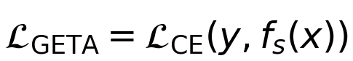 | (1)
After training, GETA constructs the final compressed subnet by removing zero-saliency groups and applying the learned quantization parameters. In this work, GETA-only denotes this process using cross-entropy only, and serves as the primary baseline.

3.2 Vanilla Knowledge Distillation
Let z_t and z_s be teacher and student logits. Vanilla KD minimizes the KL divergence between softened distributions [3]:
(2)
The standard KD objective scales the distillation term by T² to preserve gradient magnitude:
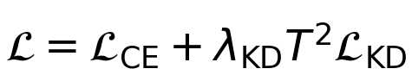 | (3)
In vanilla KD, λ_KD and T are fixed throughout training. This paper compares this fixed-strength teacher signal against a compression-aware adaptive alternative under the same GETA compression protocol.

4. Teacher-Guided GETA Recovery

4.1 Overview
Two teacher-guided recovery strategies are compared on top of GETA: fixed vanilla KD and CAKR. In all cases, the dense checkpoint is used to initialize the student and, for KD-based methods, as the teacher. GETA controls the pruning and quantization process, while the recovery objective controls how teacher information is used during compression. As illustrated in Fig. 1, CAKR activates after the target sparsity becomes stable and adapts the teacher signal using both teacher reliability and compression-state indicators.
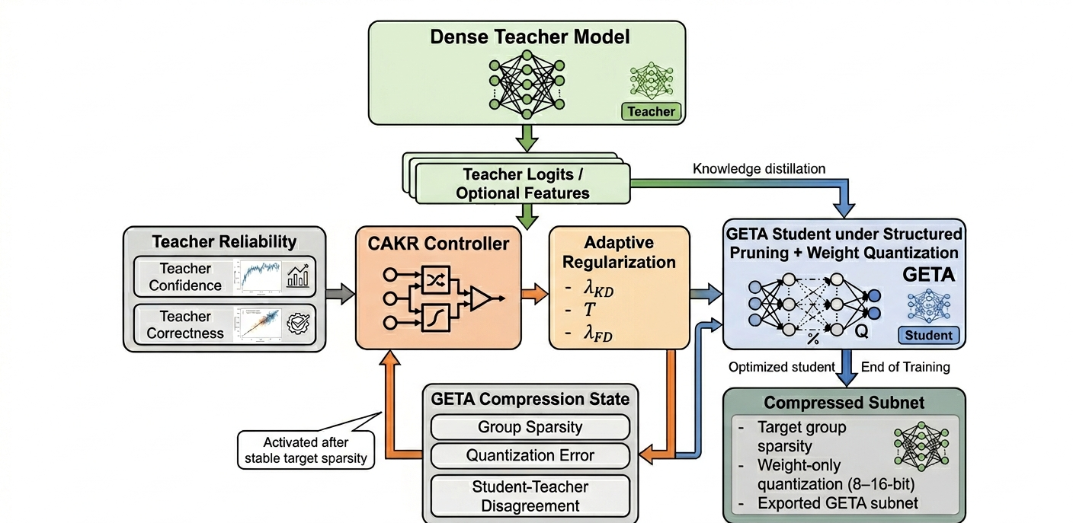
Fig. 1. Overview of the proposed GETA+CAKR framework. The dense pretrained model acts as the teacher, while the student is compressed using GETA-based structured pruning and weight-only quantization. CAKR adapts KD and optional feature distillation after target sparsity becomes stable.

4.2 Fixed Vanilla KD Recovery
The fixed KD baseline applies a constant teacher signal after the target sparsity has stabilized for a predefined number of epochs. The loss is Eq. (3) with T = 3.0 and a fixed λ_KD selected by dataset: 0.06 for CIFAR-10 and 0.08 for CIFAR-100. This baseline is included to test whether simple teacher guidance is already sufficient for GETA recovery, and serves as an important comparison point rather than a weak ablation.

4.3 Compression-Aware Knowledge Regularization (CAKR)
CAKR keeps cross-entropy as the primary objective and adds adaptive teacher-guided regularization using the weighted KD term defined below:
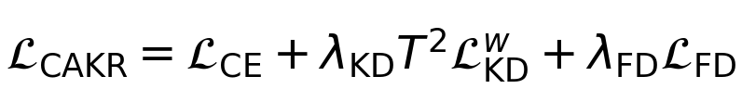 | (4)
The CE term is not down-weighted. CAKR is activated only after the target sparsity is reached and stable, so that teacher guidance does not disturb the early GETA pruning and quantization search.

4.4 Teacher-Correct Confidence Weighting
To reduce negative transfer, CAKR emphasizes teacher guidance only when the teacher is correct and confident. For each sample i, teacher confidence and correctness are defined as:
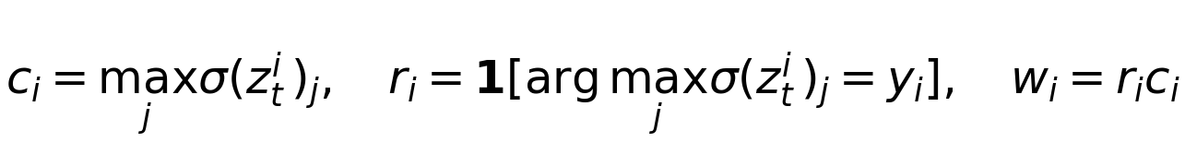 | (5)
The corresponding teacher-correct weighted KD loss is:
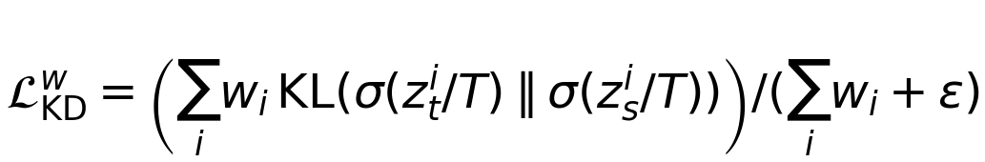 | (6)
This design suppresses KD contributions from incorrect teacher predictions, which is particularly important on harder datasets such as CIFAR-100 where the teacher correct rate is lower.

4.5 Compression-State Controller
CAKR estimates a compression risk score using the current group sparsity G, normalized quantization error Q, and teacher-student disagreement D:
(7)
The KD coefficient and temperature are controlled as:
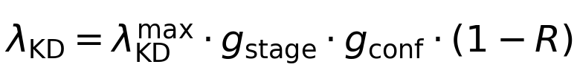 | (8)
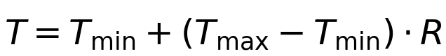 | (9)
Here, the stage gate is zero before target sparsity is stable and one afterward, and the confidence gate is the batch-averaged teacher confidence. A small feature distillation term is optionally added with maximum weight 0.003. The maximum KD weight is selected per model-dataset pair from {0.06, 0.08}, then fixed across all seeds of that setting.

4.6 Training Procedure
The training procedure is: (1) train a dense model and save the best checkpoint; (2) initialize the GETA student from the dense checkpoint; (3) use the same dense checkpoint as the teacher for KD-based methods; (4) run GETA compression with CE only during warm-up and early compression stages; (5) compute compression risk R, teacher confidence g_conf, and teacher correctness after target sparsity is stable; (6) activate fixed KD or CAKR and optimize the combined objective; and (7) select the best checkpoint after stable target sparsity and export the compressed subnet.

5. Experimental Setup
Experiments are conducted on CIFAR-10 and CIFAR-100 [26] using ResNet20, ResNet56 [27], and VGG7 [28]. CIFAR-10 provides a standard 10-class benchmark, while CIFAR-100 provides a harder 100-class setting that causes larger performance degradation after compression. ResNet20 and ResNet56 evaluate residual networks of different depths; VGG7 is included as a non-residual CNN.
All compressed models use GETA with 60% target group sparsity, weight-only quantization in the 8–16-bit range, 150 compression epochs, batch size 128, SGD optimizer with learning rate 0.05, momentum 0.9, weight decay 5e-4, gradient clipping 1.0, 10 warm-up epochs, and 50 ramp epochs. The best checkpoint is selected only after the target sparsity is reached and stable for 10 epochs. Main results are averaged over seeds 123, 234, and 345, reported as mean ± standard deviation. Since only three seeds are used, results should be interpreted as consistent directional evidence rather than statistically definitive claims.
For vanilla KD, T = 3.0 is fixed for all settings, while λ_KD is set to 0.06 for CIFAR-10 and 0.08 for CIFAR-100. For CAKR, the maximum KD weight λ_KD^max is selected from {0.06, 0.08} per model-dataset pair, with the feature distillation term either disabled or used with maximum weight 0.003. Controller weights are fixed at w₁ = 0.35, w₂ = 0.30, w₃ = 0.10 across all settings.
All experiments were conducted on Kaggle using 2× NVIDIA Tesla T4 GPUs with PyTorch 1.13.1 and torchvision 0.14.1. Larger-scale experiments on Tiny ImageNet, ImageNet, and transformer architectures are left for future work due to compute limitations. Although GETA supports a wider range of architectures including transformers, this paper focuses on controlled multi-seed CNN experiments.
Top-1 accuracy is the primary metric. Test loss, MACs, and nonzero parameters are also reported. Table I shows the dense baseline metrics used for student initialization and as teacher models.
Table I. Dense baseline metrics.
Model / Dataset | Dense Acc. (%) | Params | MACs
ResNet20 / CIFAR-10 | 92.96 | 272.47K | 41.00M
ResNet56 / CIFAR-10 | 94.29 | 855.77K | 125.75M
VGG7 / CIFAR-10 | 92.62 | 1.15M | 606M
ResNet20 / CIFAR-100 | 69.14 | 278.32K | 40.82M
ResNet56 / CIFAR-100 | 73.26 | 861.62K | 125.75M
VGG7 / CIFAR-100 | 71.65 | 1.17M | 152.79M

6. Results and Discussion
This section compares GETA-only, GETA+vanilla KD, and GETA+CAKR under the same compression protocol. All results are mean ± standard deviation over three seeds.
Fig. 2 summarizes the accuracy gain over GETA-only for the two teacher-guided variants. The figure highlights the main empirical pattern: CAKR gives a positive gain in every evaluated setting, while fixed vanilla KD is stronger in some higher-capacity or more stable models but falls below GETA-only on ResNet20/CIFAR-10.
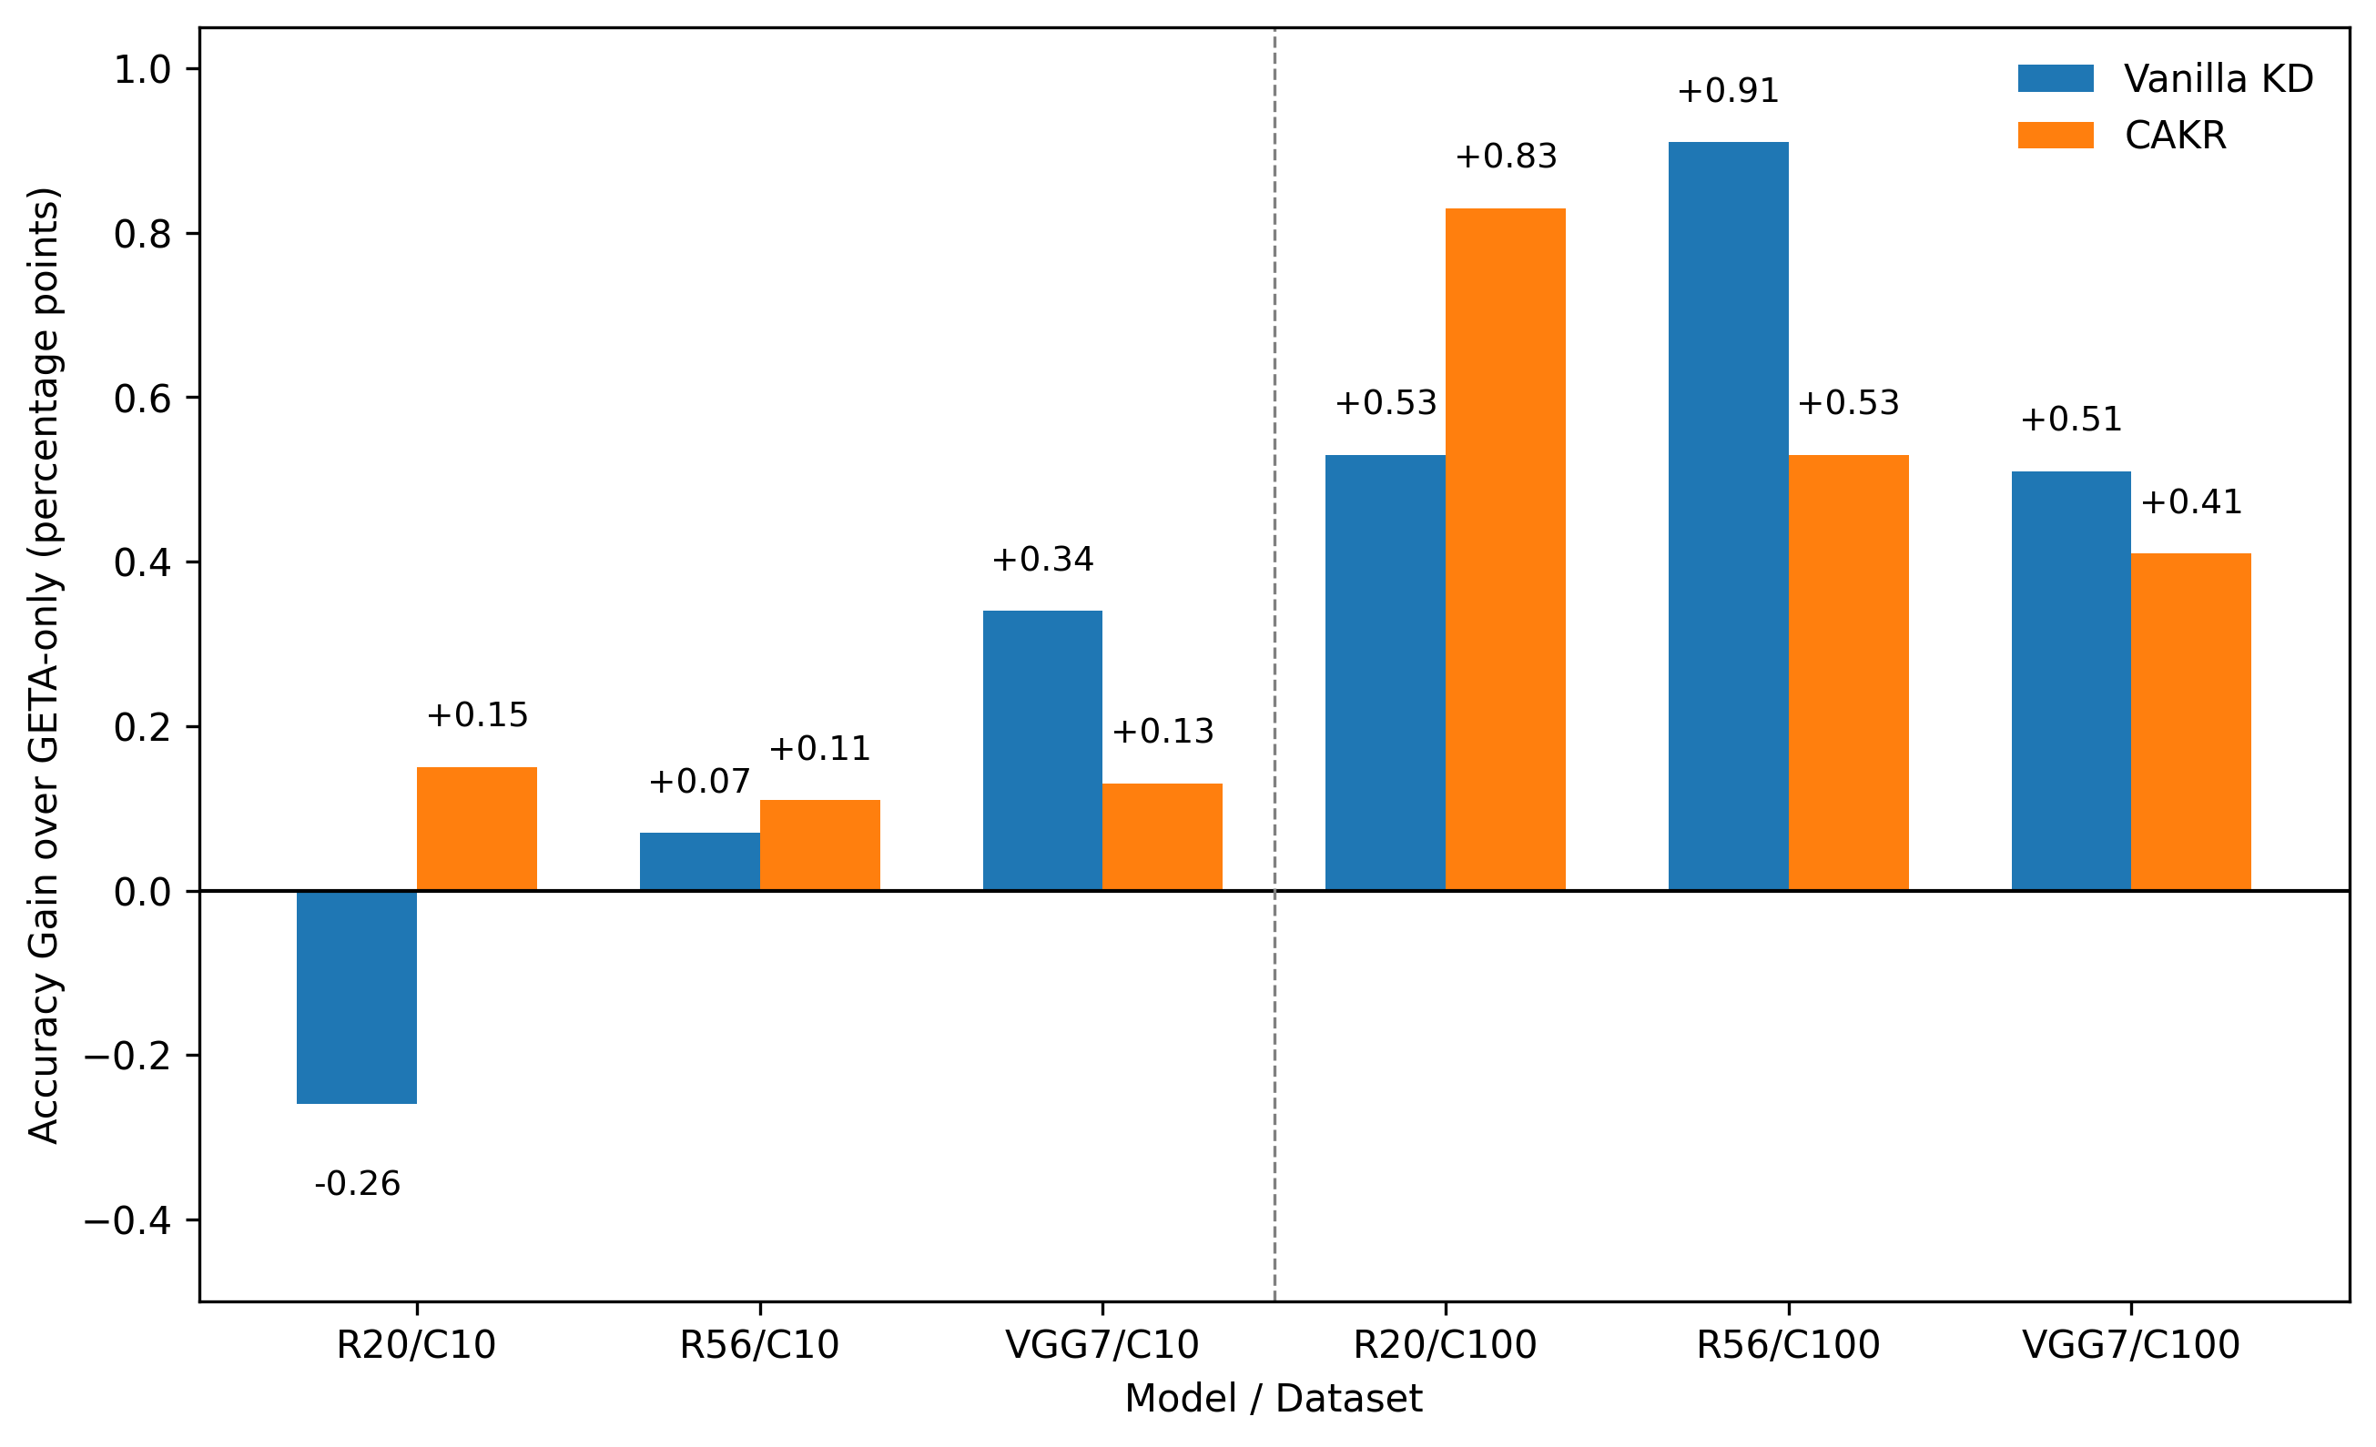
Fig. 2. Accuracy gain over GETA-only for fixed vanilla KD and CAKR across all model/dataset settings. Gains are reported in percentage points relative to the corresponding GETA-only baseline.
Table II reports the main accuracy comparison corresponding to the trend visualized in Fig. 2. Both KD-based methods improve over GETA-only in most settings, but no single strategy is best for all cases. CAKR achieves the highest mean accuracy in 3 of 6 settings. Fixed vanilla KD is strongest for VGG7/CIFAR-10, ResNet56/CIFAR-100, and VGG7/CIFAR-100. Crucially, vanilla KD reduces accuracy below the GETA-only baseline on ResNet20/CIFAR-10 (87.64% vs 87.90%), marked with superscript a in Table II. CAKR achieves 88.05% in the same setting, confirming that compression-aware adaptive control is necessary when fixed KD over-regularizes the smaller student.
Table II. Main accuracy comparison over three seeds. Superscript a indicates vanilla KD below the GETA-only baseline.
Model / Dataset | GETA-only Acc. (%) | Vanilla KD Acc. (%) | CAKR Acc. (%) | Best
ResNet20 / CIFAR-10 | 87.90 ± 0.61 | 87.64 ± 0.34ª | 88.05 ± 0.13 | CAKR
ResNet56 / CIFAR-10 | 93.15 ± 0.19 | 93.22 ± 0.05 | 93.26 ± 0.15 | CAKR
VGG7 / CIFAR-10 | 90.75 ± 0.22 | 91.09 ± 0.13 | 90.88 ± 0.20 | Vanilla KD
ResNet20 / CIFAR-100 | 50.91 ± 0.83 | 51.44 ± 0.67 | 51.74 ± 0.60 | CAKR
ResNet56 / CIFAR-100 | 67.68 ± 0.26 | 68.59 ± 0.09 | 68.21 ± 0.17 | Vanilla KD
VGG7 / CIFAR-100 | 63.57 ± 0.24 | 64.08 ± 0.46 | 63.98 ± 0.21 | Vanilla KD
Both KD methods improve GETA-only in 5 of 6 settings. Vanilla KD is below GETA-only on ResNet20/CIFAR-10 (marked with superscript a). CAKR never falls below GETA-only.

6.1 CIFAR-100 Results
Table III provides the detailed CIFAR-100 compression results, while Fig. 3 visualizes the corresponding top-1 accuracy comparison. CIFAR-100 is the more important benchmark because it has 100 fine-grained classes and causes larger accuracy degradation after compression. Both KD-based methods consistently improve over GETA-only for all three architectures.
Fig. 3 focuses on CIFAR-100, where teacher guidance produces larger gains than in the more saturated CIFAR-10 setting. CAKR is best for the smaller ResNet20 student, whereas fixed KD gives the highest mean accuracy for ResNet56 and VGG7, reinforcing the architecture-dependent behavior of teacher guidance.
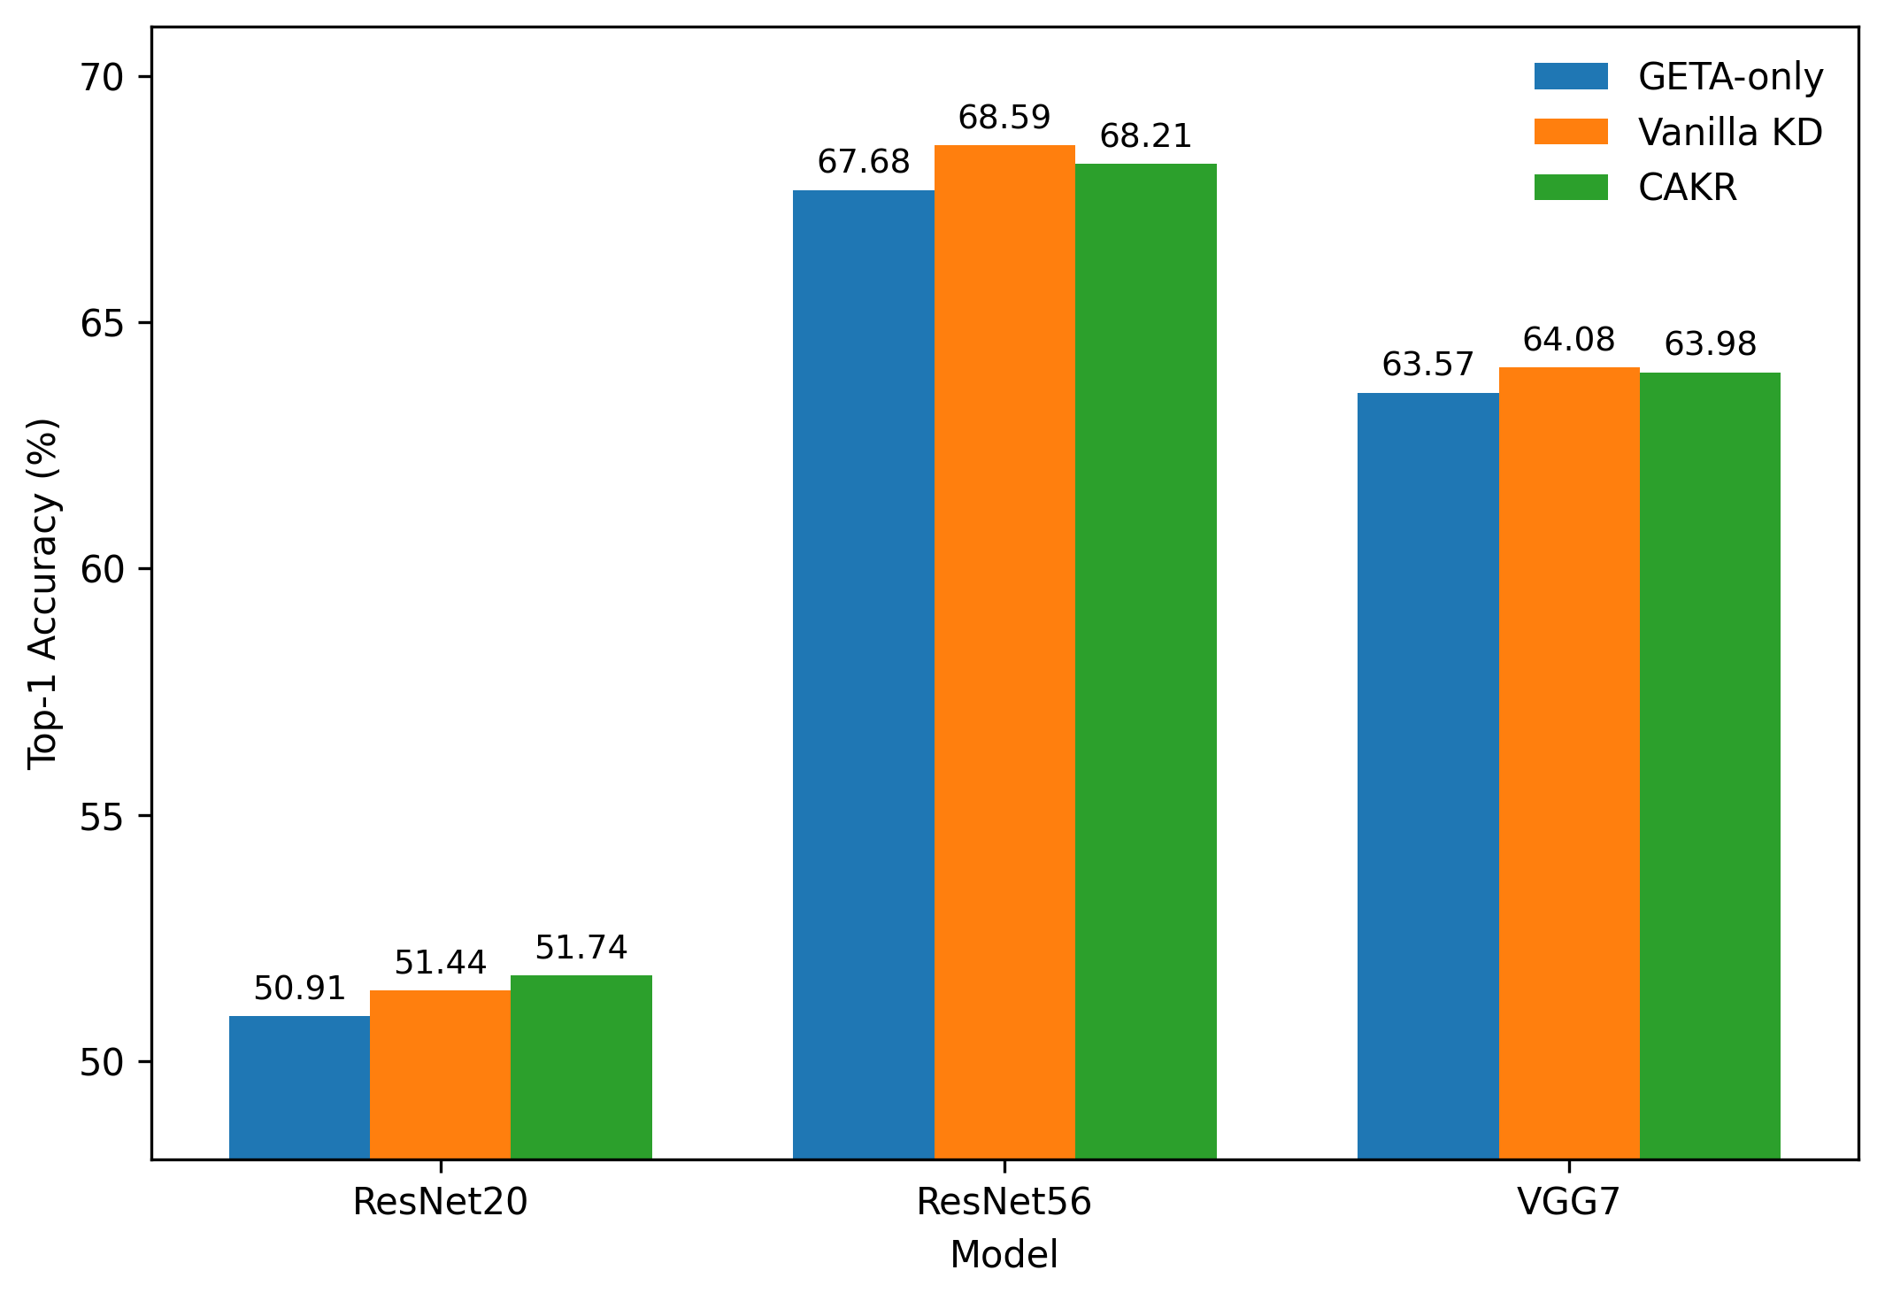
Fig. 3. CIFAR-100 accuracy comparison of GETA-only, fixed vanilla KD, and CAKR across ResNet20, ResNet56, and VGG7.
On ResNet20/CIFAR-100, CAKR is best in accuracy (51.74 ± 0.60%) and test loss (1.7585 ± 0.0152). Vanilla KD also improves over GETA-only (51.44%) but is weaker than CAKR. This suggests that the smaller ResNet20 student benefits from controlled adaptive guidance rather than the stronger fixed signal. On ResNet56/CIFAR-100, vanilla KD achieves the highest accuracy (68.59 ± 0.09%), lower loss, and lower MACs, indicating that the deeper higher-capacity student can absorb the stronger fixed signal effectively. CAKR still improves over GETA-only (+0.53%) and produces the most compact subnet (265.77K vs 267.75K params). On VGG7/CIFAR-100, vanilla KD slightly outperforms CAKR in mean accuracy (64.08 ± 0.46% vs 63.98 ± 0.21%), but CAKR has noticeably lower accuracy standard deviation, suggesting more stable recovery.
Table III. Detailed CIFAR-100 compression results (mean ± std, 3 seeds).
Model | Method | Acc. (%) | Test Loss | MACs | Params
ResNet20 | GETA-only | 50.91 ± 0.83 | 1.7849 ± 0.0371 | 9.95M ± 0.45M | 44.33K ± 1.03K
ResNet20 | Vanilla KD | 51.44 ± 0.67 | 1.7673 ± 0.0328 | 9.80M ± 0.26M | 43.79K ± 1.96K
ResNet20 | CAKR | 51.74 ± 0.60 | 1.7585 ± 0.0152 | 10.23M ± 0.29M | 44.37K ± 1.91K
ResNet56 | GETA-only | 67.68 ± 0.26 | 1.1641 ± 0.0193 | 40.67M ± 0.76M | 267.36K ± 1.60K
ResNet56 | Vanilla KD | 68.59 ± 0.09 | 1.1589 ± 0.0034 | 39.70M ± 0.47M | 267.75K ± 2.72K
ResNet56 | CAKR | 68.21 ± 0.17 | 1.1616 ± 0.0210 | 39.80M ± 1.23M | 265.77K ± 2.51K
VGG7 | GETA-only | 63.57 ± 0.24 | 1.349 ± 0.004 | 27.83M ± 0.49M | 157.35K ± 1.45K
VGG7 | Vanilla KD | 64.08 ± 0.46 | 1.290 ± 0.015 | 28.84M ± 0.75M | 160.63K ± 3.31K
VGG7 | CAKR | 63.98 ± 0.21 | 1.291 ± 0.004 | 29.10M ± 0.80M | 160.06K ± 2.87K

6.2 CIFAR-10 Results
Table IV shows the CIFAR-10 results. Gains are smaller on CIFAR-10 because GETA-only already achieves high compressed accuracy in this saturated setting. The most important finding on CIFAR-10 is that vanilla KD reduces ResNet20 accuracy from 87.90% to 87.64% — falling below the unassisted GETA-only baseline. CAKR improves ResNet20 accuracy to 88.05% and also reduces the standard deviation substantially from ±0.61 to ±0.13, indicating more stable recovery. For ResNet56/CIFAR-10, both KD methods are close to GETA-only: CAKR has the highest mean accuracy (93.26%), while vanilla KD has the lowest standard deviation (±0.05). For VGG7/CIFAR-10, vanilla KD achieves the highest mean accuracy (91.09%), while CAKR (90.88%) still improves over GETA-only. KD-based methods generally increase CE-measured test loss on CIFAR-10, suggesting that teacher regularization adjusts decision boundaries without necessarily improving probability calibration in saturated settings.
Table IV. Detailed CIFAR-10 compression results (mean ± std, 3 seeds).
Model | Method | Acc. (%) | Test Loss | MACs | Nonzero Params
ResNet20 | GETA-only | 87.90 ± 0.61 | 0.370 ± 0.016 | 14.86M ± 0.62M | 40.23K
ResNet20 | Vanilla KD | 87.64 ± 0.34 | 0.407 ± 0.007 | 14.05M ± 0.38M | 40.01K ± 0.66K
ResNet20 | CAKR | 88.05 ± 0.13 | 0.390 ± 0.007 | 14.44M ± 0.58M | 41.38K
ResNet56 | GETA-only | 93.15 ± 0.19 | 0.268 ± 0.007 | 56.79M ± 0.51M | 212.94K
ResNet56 | Vanilla KD | 93.22 ± 0.05 | 0.300 ± 0.002 | 56.86M ± 0.44M | 212.46K ± 1.36K
ResNet56 | CAKR | 93.26 ± 0.15 | 0.289 ± 0.013 | 56.63M ± 0.36M | 213.90K
VGG7 | GETA-only | 90.75 ± 0.22 | 0.301 ± 0.001 | 41.22M ± 1.27M | 157.35K ± 1.45K
VGG7 | Vanilla KD | 91.09 ± 0.13 | 0.341 ± 0.007 | 42.23M ± 1.44M | 159.70K ± 1.73K
VGG7 | CAKR | 90.88 ± 0.20 | 0.318 ± 0.006 | 41.47M ± 1.70M | 160.06K ± 2.87K

6.3 Effect of Student Capacity and Architecture
The most important finding across all settings is that fixed and adaptive teacher guidance are not interchangeable. Vanilla KD uses a fixed effective KD coefficient of 0.54 on CIFAR-10 (T² × λ_KD = 9 × 0.06) and 0.72 on CIFAR-100 (9 × 0.08). This strong constant signal can still degrade accuracy on ResNet20/CIFAR-10 and is weaker than CAKR on ResNet20/CIFAR-100, suggesting that the smaller ResNet20 student is over-regularized by the fixed signal. In contrast, ResNet56 and VGG7 absorb the stronger fixed signal more effectively, and vanilla KD achieves higher accuracy in three of their four evaluated settings.
In our logs, CAKR's adaptive controller reaches a maximum effective coefficient of approximately 0.207–0.257 across settings, which is substantially lower than the fixed vanilla KD coefficients of 0.54–0.72, while still consistently improving over GETA-only. This supports the interpretation that smaller or more compression-sensitive students require controlled teacher guidance, while higher-capacity or more stable students can tolerate and benefit from a stronger fixed signal. The observed pattern is therefore architecture-dependent and should not be attributed to CAKR being universally better.

6.4 Limitations of the Evidence
Several limitations should be noted. First, the vanilla KD baseline uses only two fixed configurations: T = 3.0 with λ_KD = 0.06 for CIFAR-10 and λ_KD = 0.08 for CIFAR-100. More detailed per-model tuning of vanilla KD might perform better, particularly on ResNet20/CIFAR-10 where even the lower fixed coefficient may be too strong. This is a valid concern; however, CAKR's compression-state controller naturally adapts the effective KD strength without manual per-setting tuning of the KD weight, which may be the practical advantage in deployment. Second, results are limited to three seeds per setting; larger-scale statistical testing would strengthen the conclusions. Third, experiments are restricted to CNNs on CIFAR-10/CIFAR-100; generalization to larger datasets and transformer architectures remains to be validated.

7. Conclusion
This paper studied teacher-guided recovery for GETA-based joint structured pruning and weight quantization. Fixed vanilla KD and a compression-aware adaptive variant (CAKR) were compared against GETA-only under the same compression protocol across ResNet20, ResNet56, and VGG7 on CIFAR-10 and CIFAR-100.
Teacher guidance generally improves GETA-compressed models, but the best strategy depends on student capacity and architecture. CAKR achieves the highest mean accuracy in 3 of 6 settings and consistently improves over GETA-only in all settings. A key finding is that fixed KD falls below the GETA-only baseline on ResNet20/CIFAR-10, while CAKR avoids this over-regularization. Fixed KD is stronger for higher-capacity students such as ResNet56/CIFAR-100, where its stronger constant signal is more effectively absorbed. CAKR and fixed KD are therefore complementary strategies: CAKR is safer and more suitable for smaller or more compression-sensitive students, while fixed KD can be more effective for higher-capacity models.
Future work will extend this study to larger datasets such as Tiny ImageNet and ImageNet, transformer architectures supported by GETA, and automated selection of KD strength based on model capacity and compression sensitivity.

References
[1] S. Han, J. Pool, J. Tran, and W. J. Dally, "Learning both weights and connections for efficient neural network," in Proc. NeurIPS, 2015, pp. 1135–1143.
[2] B. Jacob et al., "Quantization and training of neural networks for efficient integer-arithmetic-only inference," in Proc. CVPR, 2018, pp. 2704–2713.
[3] G. Hinton, O. Vinyals, and J. Dean, "Distilling the knowledge in a neural network," arXiv:1503.02531, 2015.
[4] A. Romero, N. Ballas, S. E. Kahou, A. Chassang, C. Gatta, and Y. Bengio, "FitNets: Hints for thin deep nets," in Proc. ICLR, 2015.
[5] Y. He and L. Xiao, "Structured pruning for deep convolutional neural networks: A survey," IEEE Trans. Pattern Anal. Mach. Intell., vol. 46, no. 5, pp. 2900–2919, 2024.
[6] G. Fang, X. Ma, M. Song, M. B. Mi, and X. Wang, "DepGraph: Towards any structural pruning," in Proc. CVPR, 2023, pp. 16091–16101.
[7] T. Chen, B. Ji, T. Ding, B. Fang, G. Wang, Z. Zhu, L. Liang, Y. Shi, S. Yi, and X. Tu, "Only train once: A one-shot neural network training and pruning framework," in Proc. NeurIPS, 2021.
[8] T. Chen, L. Liang, T. Ding, I. Zharkov, and Z. Zhu, "OTOv2: Automatic, generic, user-friendly neural network training and compression," in Proc. ICLR, 2023.
[9] X. Zhang, I. Colbert, and S. Das, "Learning low-precision structured subnetworks using joint layerwise channel pruning and uniform quantization," Appl. Sci., vol. 12, no. 15, Art. no. 7829, 2022.
[10] X. Qu, D. Aponte, C. Banbury, D. P. Robinson, T. Ding, K. Koishida, I. Zharkov, and T. Chen, "Automatic joint structured pruning and quantization for efficient neural network training and compression," in Proc. CVPR, 2025, pp. 15234–15244.
[11] J. Kim, S. Chang, and N. Kwak, "PQK: Model compression via pruning, quantization, and knowledge distillation," in Proc. Interspeech, 2021, pp. 4568–4572.
[12] J. Kim, "Quantization robust pruning with knowledge distillation," IEEE Access, vol. 11, pp. 26419–26426, 2023.
[13] W. Chae and K. Seo, "Pipeline of pruning, knowledge distillation, and quantization for model compression," J. Electr. Eng. Technol., 2025.
[14] I. Hubara, M. Courbariaux, D. Soudry, R. El-Yaniv, and Y. Bengio, "Quantized neural networks: Training neural networks with low precision weights and activations," J. Mach. Learn. Res., vol. 18, no. 187, pp. 1–30, 2018.
[15] S. Zhou, Y. Wu, Z. Ni, X. Zhou, H. Wen, and Y. Zou, "DoReFa-Net: Training low bitwidth convolutional neural networks with low bitwidth gradients," arXiv:1606.06160, 2016.
[16] J. Choi, Z. Wang, S. Venkataramani, P. Chuang, V. Srinivasan, and K. Gopalakrishnan, "PACT: Parameterized clipping activation for quantized neural networks," arXiv:1805.06085, 2018.
[17] Z. Dong, Z. Yao, A. Gholami, M. Mahoney, and K. Keutzer, "HAWQ: Hessian aware quantization of neural networks with mixed-precision," in Proc. ICCV, 2019, pp. 293–302.
[18] Z. Dong, Z. Yao, D. Arfeen, A. Gholami, M. W. Mahoney, and K. Keutzer, "HAWQ-V2: Hessian aware trace-weighted quantization of neural networks," in Proc. NeurIPS, 2020.
[19] Y. Tian, D. Krishnan, and P. Isola, "Contrastive representation distillation," in Proc. ICLR, 2020.
[20] W. Park, D. Kim, Y. Lu, and M. Cho, "Relational knowledge distillation," in Proc. CVPR, 2019, pp. 3967–3976.
[21] N. Passalis and A. Tefas, "Learning deep representations with probabilistic knowledge transfer," in Proc. ECCV Workshops, 2018.
[22] A. G. Howard et al., "MobileNets: Efficient convolutional neural networks for mobile vision applications," arXiv:1704.04861, 2017.
[23] M. Sandler, A. Howard, M. Zhu, A. Zhmoginov, and L.-C. Chen, "MobileNetV2: Inverted residuals and linear bottlenecks," in Proc. CVPR, 2018, pp. 4510–4520.
[24] V. Sze, Y.-H. Chen, T.-J. Yang, and J. S. Emer, "Efficient processing of deep neural networks: A tutorial and survey," Proc. IEEE, vol. 105, no. 12, pp. 2295–2329, 2017.
[25] S. K. Esser et al., "Learned step size quantization," in Proc. ICLR, 2020.
[26] A. Krizhevsky, "Learning multiple layers of features from tiny images," Univ. Toronto, Tech. Rep., 2009.
[27] K. He, X. Zhang, S. Ren, and J. Sun, "Deep residual learning for image recognition," in Proc. CVPR, 2016, pp. 770–778.
[28] K. Simonyan and A. Zisserman, "Very deep convolutional networks for large-scale image recognition," in Proc. ICLR, 2015.

