**Bug Report**

|  |  |
| --- | --- |
| Total Bug / Error/Issues | 06 |
| Name | Sabbir Ahamed |
| Reporter | Sabbir Ahamed |
| Submit Date | 24/Sep/2023 |
| Summary | Details of some bugs or errors and reports expected and actual results |
| URL | https://parabank.parasoft.com/ |
| Operating System | Windows 10 |
| Browser | Chrome 117 |
| Assigned to | JSEncoder.com |

**Issue 01:** Solutions menu option is not clickable.

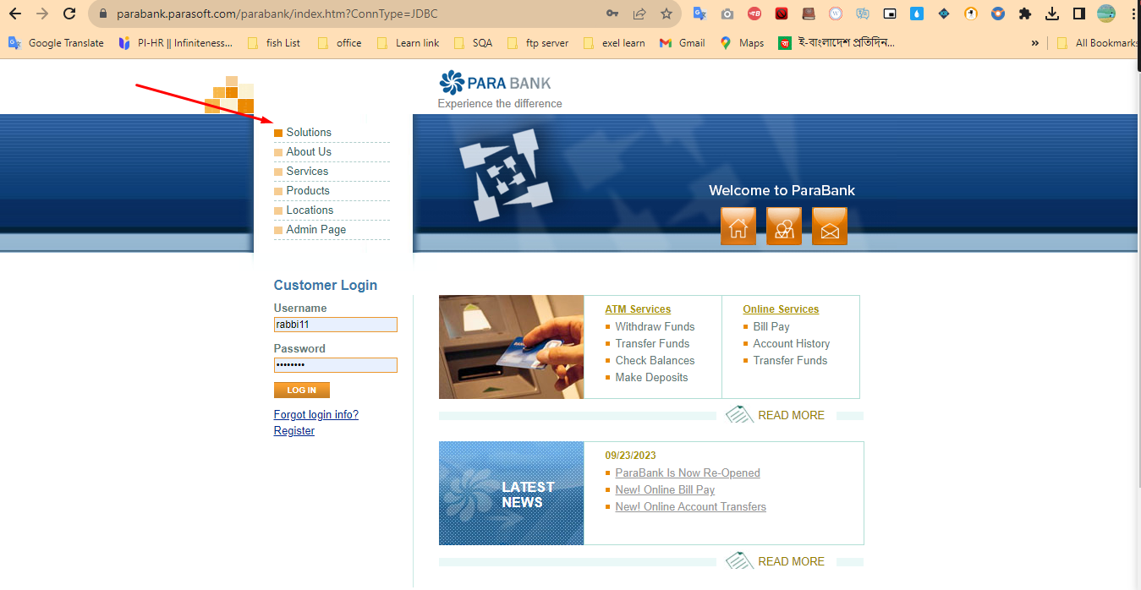

**Description** Here, as there is no hyperlink in this menu option, this menu option is not working. Hyperlinks need to be fixed here.

Steps to reproduce

1. Need Valid website url.
2. go to <https://parabank.parasoft.com>
3. Go to header left menu option.
4. Click solutions option

**Expected result**: Go to solutions page.

**Actual result**: But not worked

**Severity:** High

**Issue 02:** ATM & Online services menu option is not proper work.

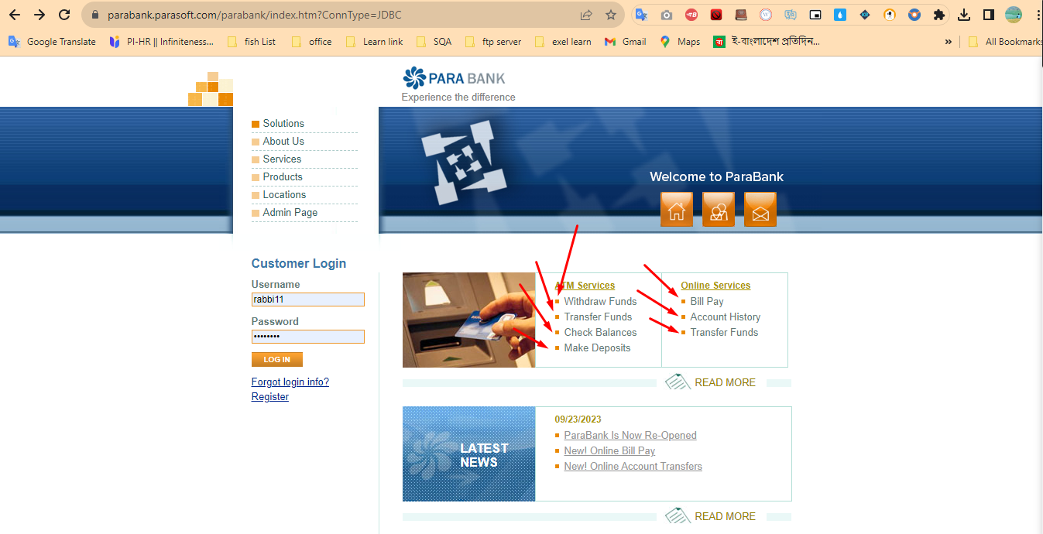

**Description** After clicking on this option here, a new page will open, which is beautifully designed. But instead the leaves are broken. Should be fixed very quickly.

Steps to reproduce

1. Need Valid website url.
2. go to <https://parabank.parasoft.com>
3. Go to ATM services & Online services menu options.
4. Click any option

**Expected result**: go to a proper page. Or when your login, then will show this page. Show this type of text or pop-up.

**Actual result**: But all pages broken.

**Severity:** High

**Issue 03:** Accepted the wrong email or number.

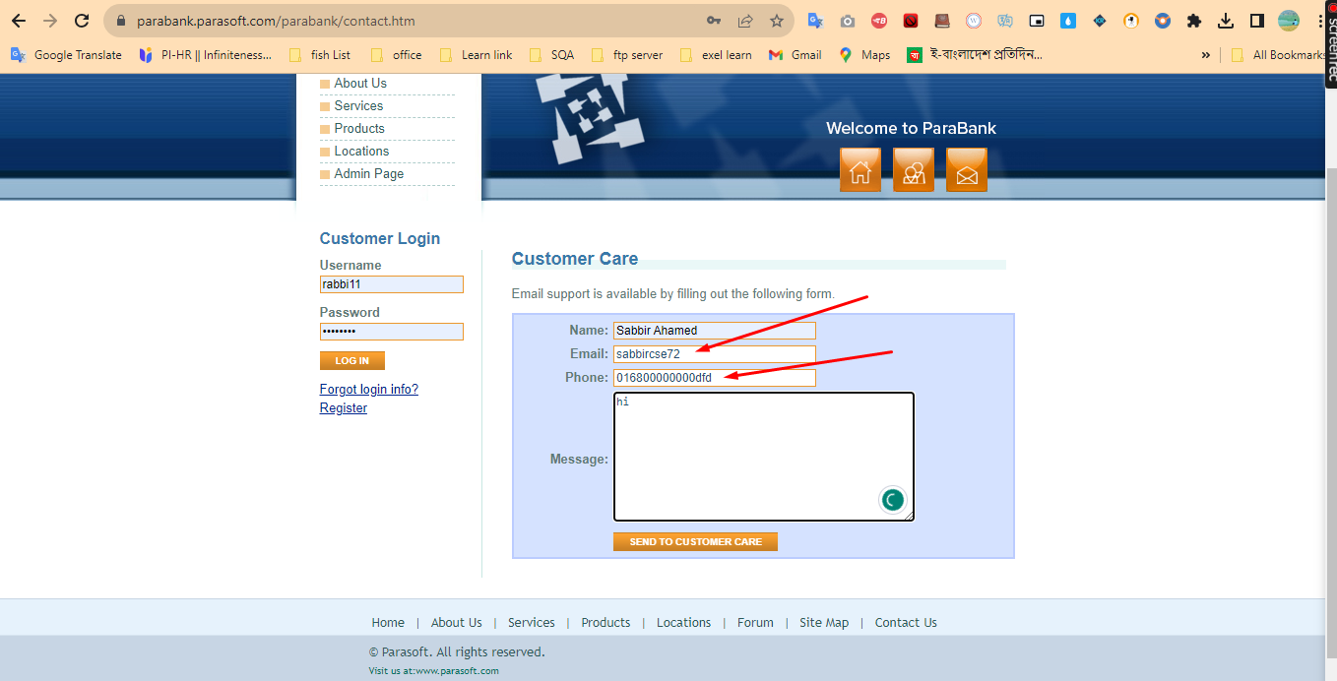

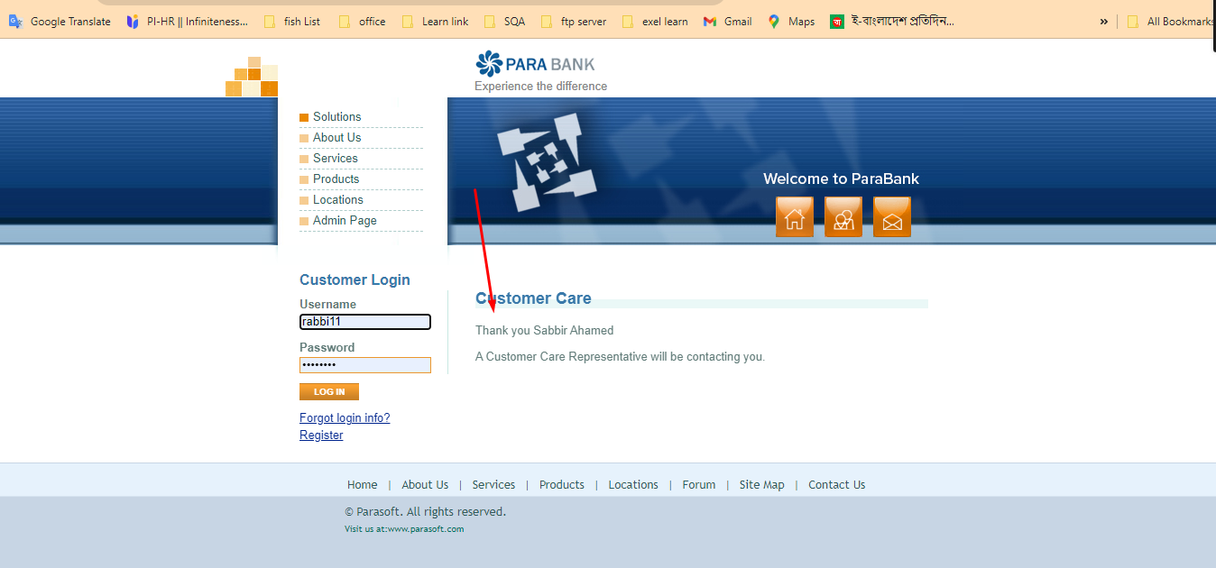

**Description** Here it was necessary to successfully submit the SMS by accepting the correct email and correct number. But even after giving the wrong email and phone number, the SMS is being submitted correctly. Which is not acceptable in any way.

Steps to reproduce

1. Need Valid website url.
2. go to <https://parabank.parasoft.com>
3. Click email icon
4. Insert wrong email &number
5. Click send to customer care button

**Expected result**: Your email & phone number is not valid.

**Actual result**: Message successfully send.

**Severity:** High

**Issue 04:** Accepted the wrong zip code and phone filed blank or long number use and ssn number used wrong

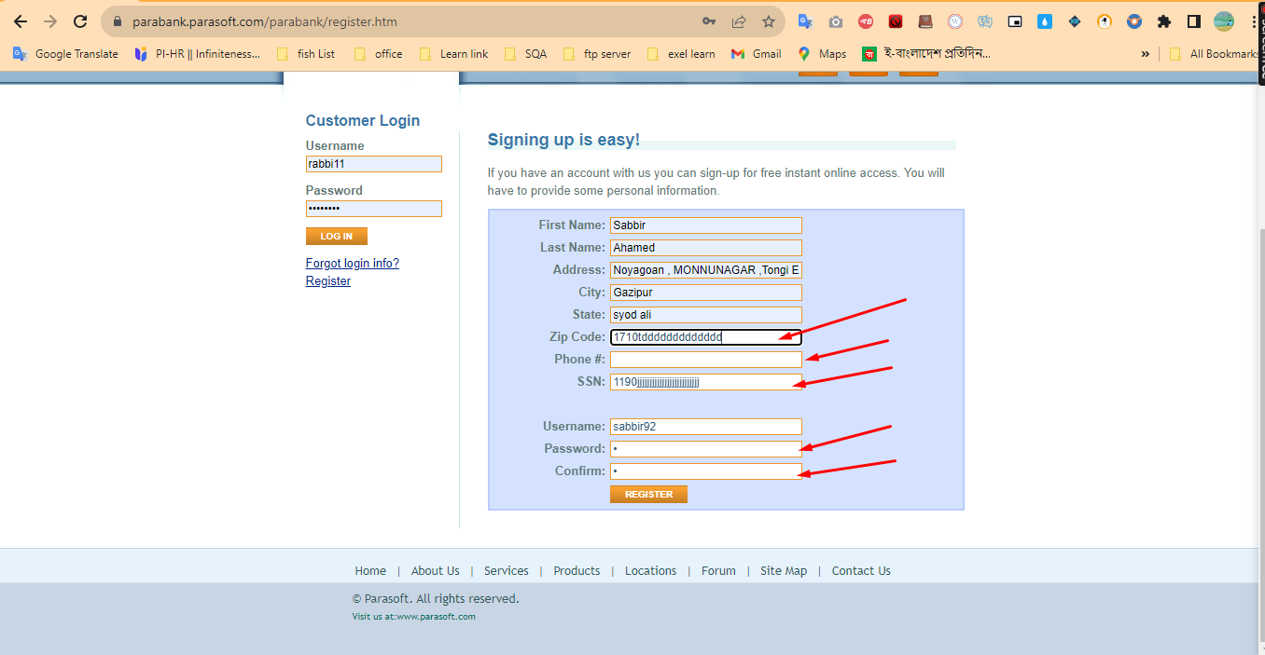

**Description** Here zip code should be proper, phone number should be mandatory, SSN number should be proper and password should be stronger. But here, even after inserting this wrong data it got registered successfully. Which is never acceptable

Steps to reproduce

1. Need Valid website url.
2. go to https://parabank.parasoft.com
3. Click Register option
4. Fill up all filed accept (zip code insert wrong value, phone filed blank & ssn wrong value insert, password is very poor)
5. Click Register Button.

**Expected result**: Alert text is required. Phone number is very important in financial services, ssn number should be different and password should be strong

**Actual result**: But Successfully Register done.

**Severity:** High

**Issue 05:** Balance transfer from same account number to same account number

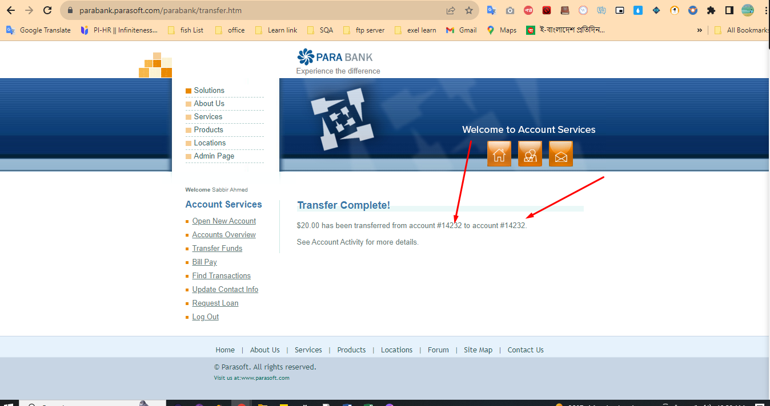

**Description** Same account number of sender and recipient is never acceptable.

Steps to reproduce

1. Need Valid website url.
2. go to <https://parabank.parasoft.com>
3. Insert username & password
4. Click login button
5. Go to account service menu
6. Click Transfer funds option
7. Insert amount value
8. Ensure Sender account number and Receiver Account number.
9. Click Transfer Button.

**Expected result**: Show a text. Both Account number is Same.

**Actual result**: But Successfully Transfer done.

**Severity:** High

**Issue 06:** Any Values accepted Contact info.

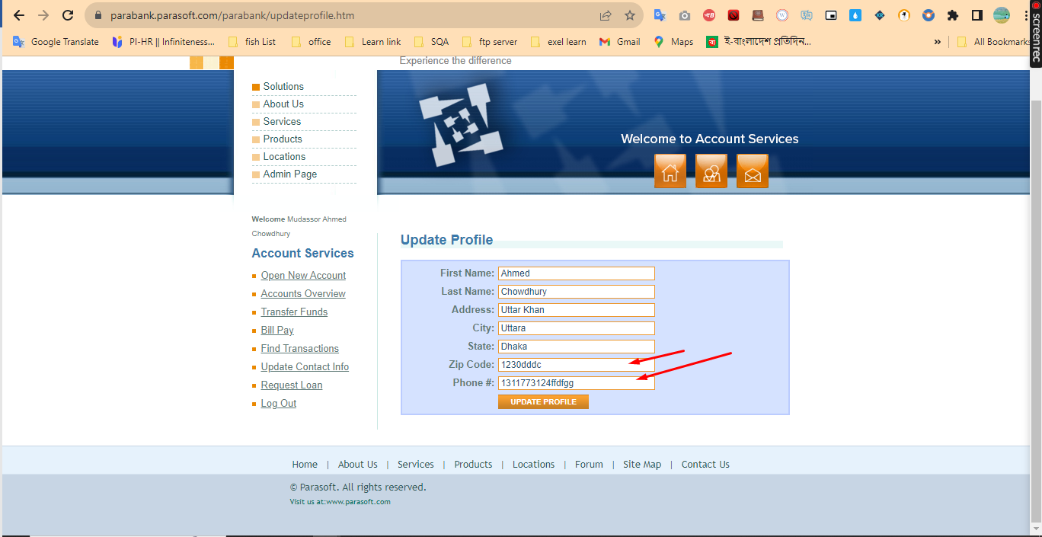

**Description**  I can see here that even after giving phone number and zip code number in combination of number and text, it is being updated successfully

1. go to <https://parabank.parasoft.com>
2. Insert username & password
3. Click login button
4. Go to account service menu
5. Click update contact info option
6. Insert All filed
7. Click Update Profile Button.

**Expected result**: Show a text. Your number is not valid. your zip code is not valid.

**Actual result**: But Successfully Update contact info done.

**Severity:** High