CMPE 306

Fall, 2015

Lab VIII:

Op Amps 2: Integrator and Differentiator Circuits

Sabbir Ahmed

Michael Hammond

Lab Section: 04/ 9 AM, Friday

Teaching assistants:

Kailas Mehta

Sehtab Hossain

1. **Purpose:**

The purpose of this lab is to further study an operational amplifier to implement their features of providing circuits with integration and differentiation of analog inputs signals. The purposes also include verifying the integrator and differentiator operations through LTspice or similar, construct, measure and illustrate those circuits on a breadboard, and perform analyses on measured data to demonstrate the limitations of them as a function of the frequency of the input signal.

1. **Lab equipment:**
2. Tektronix AFG310 Arbitrary Function Generator (AFG)
3. Tektronix 2012 Digital Storage Oscilloscope
4. BNC-to-BNC cable
5. 2 x BNC-to-alligator cables
6. Resistors: 10 kΩ, 20 kΩ, 1 MΩ
7. Capacitors: 100 nF
8. TL074 quad operational amplifier
9. **Procedure:**
   1. **Operational Amplifier Based Integrator Circuit**

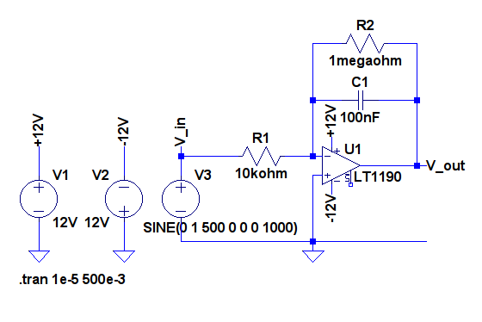

**Figure 1:** RC circuit with the operational amplifier and sinusoidal voltage source

* 1. Consider the Figure 1 circuit and estimate the amplitude of the output response at 500 Hz by using the expression:

* 1. Construct the circuit on the breadboard. Use the 1 V amplitude 500 Hz square wave with DC offset as the input voltage for the AFG to create the sinusoidal function as shown in Figure 2 (see below). Print the result as PRINTOUT1 and verify the calculated $V_{in}(t)$ and $V_{out}(t)$ from Step 1.
  2. Repeat Step 2 by increasing the frequency to 1 kHz, and save the result as PRINTOUT2.
  3. Change the $R_{1}$ resistor value to 20 kΩ, and repeat Step 2 to save as PRINTOUT3.
  4. Change the input voltage to a triangle wave and repeat Step 2, Step 3, and Step 4 and save the outputs as PRINTOUT4, PRINTOUT5 and PRINTOUT6.
  5. Change the input voltage to a sine wave and repeat Step 2, Step 3, and Step 4 and save the outputs as PRINTOUT7, PRINTOUT8 and PRINTOUT9.
  6. **Operational Amplifier Based Differentiator Circuit**

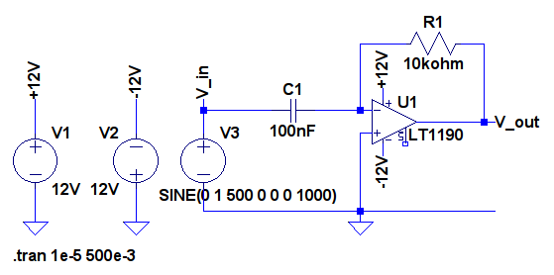

**Figure 3:** RC circuit with the operational amplifier and sinusoidal voltage source

* + - 1. Consider the Figure 3 circuit and estimate the amplitude of the output response at 500 Hz by using the expression:

* 1. Construct the circuit using the 0.5 V amplitude 1 kHz sine wave with DC offset as the input voltage. Print the result as PRINTOUT10 and verify the calculated $V_{in}(t)$ and $V_{out}(t)$ from Step 1.
  2. Change the input to a triangle wave and print out the result as PRINTOUT11.

1. **Measured Data:**

The data collected for this lab report were stored as screen captures displaying both the input and measured output voltages, instead of the conventional tables of data.

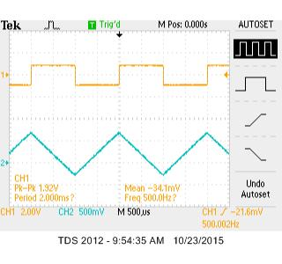

Theoretical result is computed in Calculation 5.2

**PRINTOUT1**

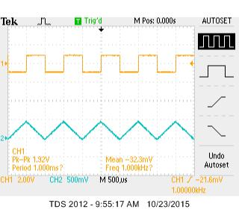

**PRINTOUT2**

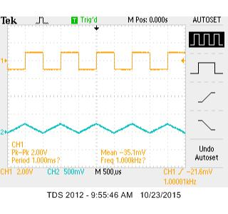

**PRINTOUT3**

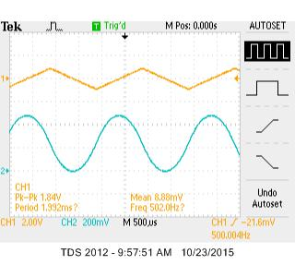

**PRINTOUT4**

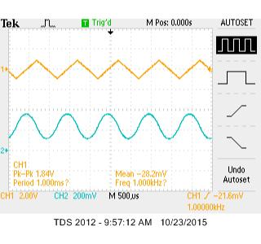

**PRINTOUT5**

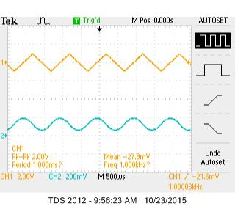

**PRINTOUT6**

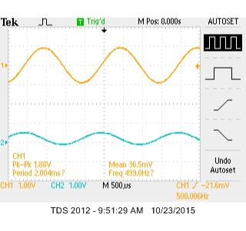

**PRINTOUT7**

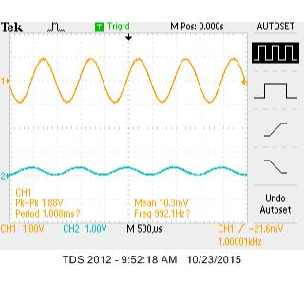

**PRINTOUT8**

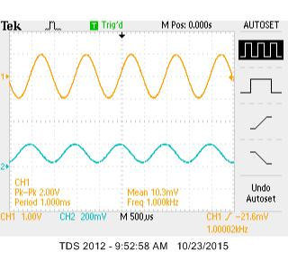

**PRINTOUT9**

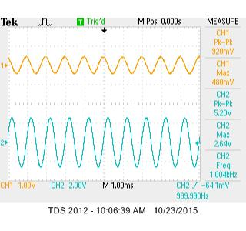

Theoretical result is computed in Calculation 5.2

**PRINTOUT10**

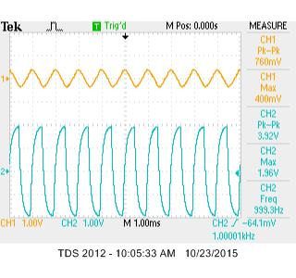

**PRINTOUT11**

1. **Calculations:**
   1. Derivation of the amplitude of the output response of the Figure 1 circuit:

$nV_{out}=G\left(f\right)×V_{in}=\frac{V_{in}}{\sqrt{1+{\left(2πfR_{2}C\right)}^{2}}}$

$=-\frac{1 MΩ}{10 kΩ}×\frac{1 V}{\sqrt{1+{\left(2π(500 Hz)(1 MΩ)(100 nF)\right)}^{2}}}$

* $=$-0.32 V
  1. Derivation of the amplitude of the output response of the Figure 3 circuit:
$nV_{out}=G\left(f\right)×V_{in}=2πfR_{1}CV_{in}$

$=2π(1 kHz)(10 kΩ)(100 nF)(0.5 V)$

* $=$ $π$ V

1. **Graphs:**

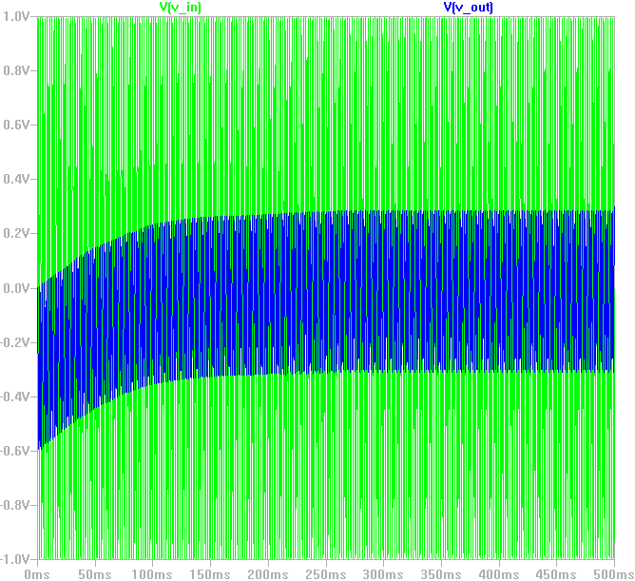

**Figure 2: $V_{in}$**  and $V_{out}$ of the Figure 1 circuit

1. **Conclusion:**

In this lab, I saw the application of integrator and differentiator operational amplifiers. Up till these procedures of constructing and testing out the features of the components, I have only been exposed to the theoretical ideal versions of these types of operational amplifiers. I noticed the error of the measurements to be quite insignificant and close to the theoretical computations.