Sabbir Ahmed

CMPE 306

**Pre-lab IX**

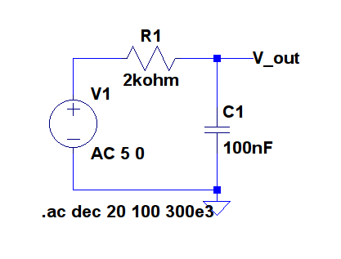

**Figure 1**

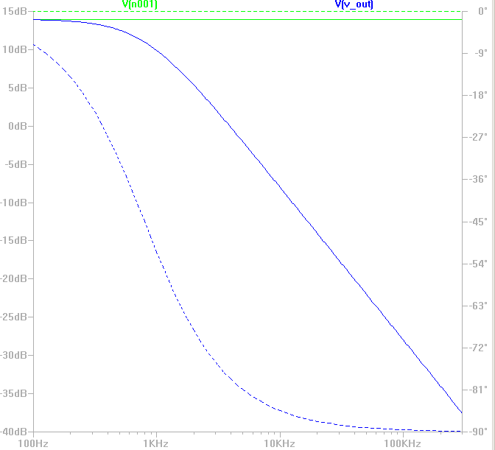

**Plot of Figure 1**

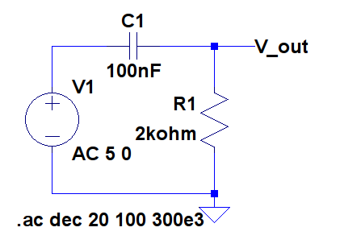

**Figure 2**

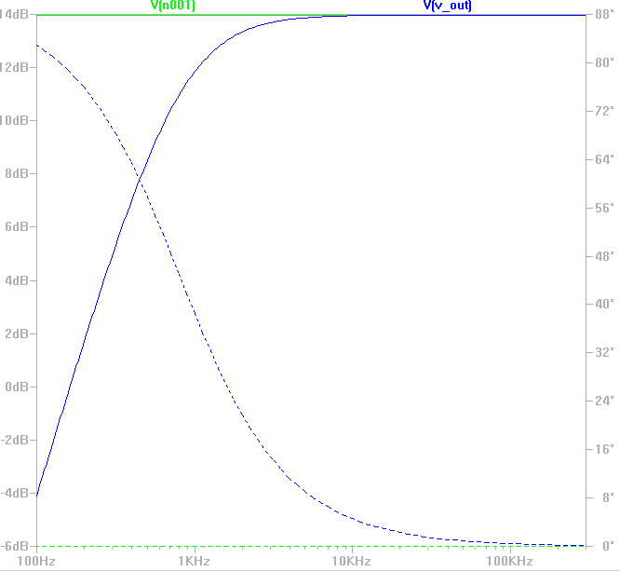

**Plot for Figure 2**

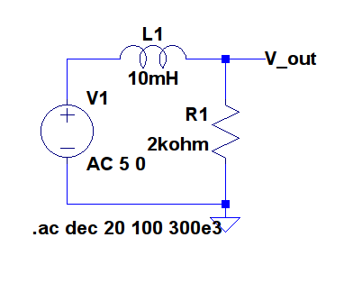

**Figure 3**

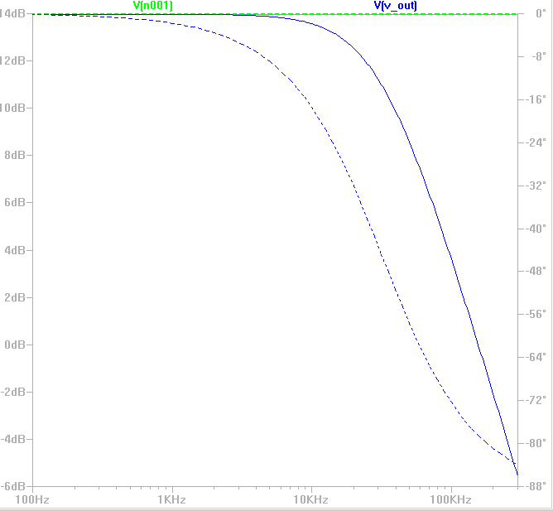

**Plot for Figure 3**

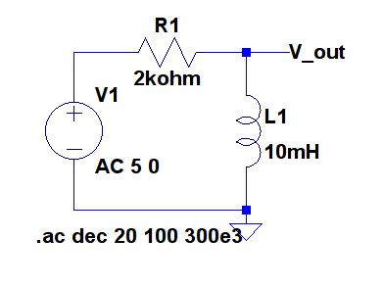

**Figure 4**

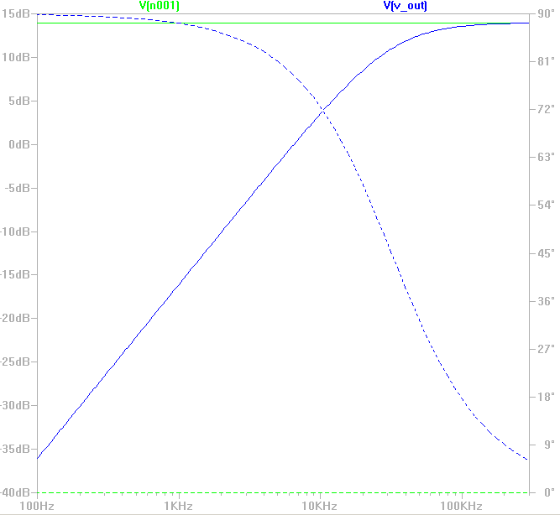

**Plot for Figure 4**