CMPE 306

Fall, 2015

Lab VII:

Transients in RC Circuits

Sabbir Ahmed

Michael Hammond

Lab Section: 04/ 9 AM, Friday

Teaching assistants:

Kailas Mehta

Sehtab Hossain

1. **Purpose:**

The purpose of this lab is to study the transient response of linear RC circuits with step units, measure and illustrate the characteristics of RC circuits constructed on the breadboard, and perform analyses to demonstrate the RC time constant.

1. **Lab equipment:**
2. Tektronix AFG310 Arbitrary Function Generator (AFG)
3. Tektronix 2012 Digital Storage Oscilloscope
4. BNC-to-BNC cable
5. 2 x BNC-to-alligator cables
6. Resistors: 10 kΩ, 2 x 20 kΩ.
7. Capacitors: 10 nF, 100 nF.
8. **Procedure:**
   1. **Simple RC Network**

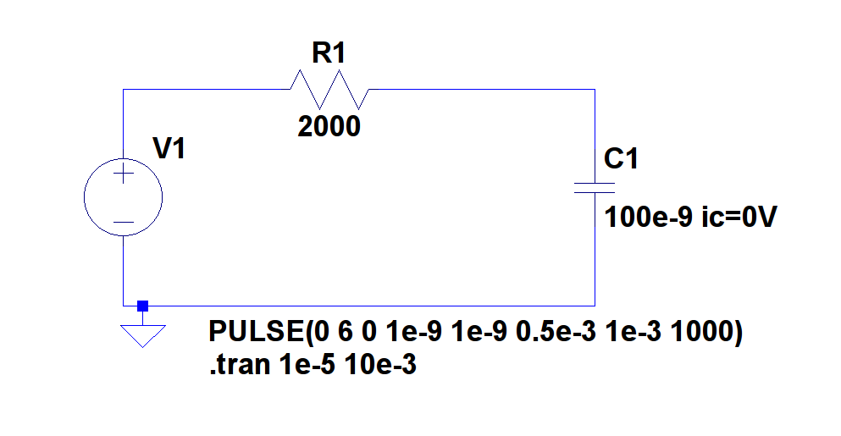

**Figure 1:** Circuit with pulsed voltage source, capacitor initial condition and transient response command

* 1. Derive $v_{C}(t)$ and $v_{R}(t)$ of the circuit from Figure 1 for both the charging period ($0 ms<t<0.5 ms$) and the discharging period ($0.5 ms<t<1 ms$).
  2. Use the 1 kHz square wave with DC offset as the input voltage for the AFG to create the periodic step function as shown in Figure 2 (see below). Print the result as PRINTOUT1.
  3. Construct the circuit on the breadboard, using the step function voltage created in Step 2 as the source.
  4. Use the oscilloscope to measure the AFG input to the circuit, V(n001), and across the capacitor, V(n002) and save it as PRINTOUT1. Vary the frequency of the wave, observe, record and comment the change on the waveforms until setting it back to 1 kHz.
  5. Measure the voltage across the resistor, and save it as PRINTOUT3. Compare the results with the measurement from Step 4.
  6. Calculate the time constants from the measurements in Steps 4 and 5 using the oscilloscope by expanding the time scale to two cycles and moving the display around. Compare the two measured voltages with the theoretical calculations.
  7. Change the capacitor to 10 nF, measure V(n001) and V(n002) and calculate the time constants using an appropriate frequency from the AFG. Save the result as PRINTOUT4.
  8. **More Complicated RC Network**
  9. Construct the circuit from Figure 3 using the same voltage source as in Part 3.1.

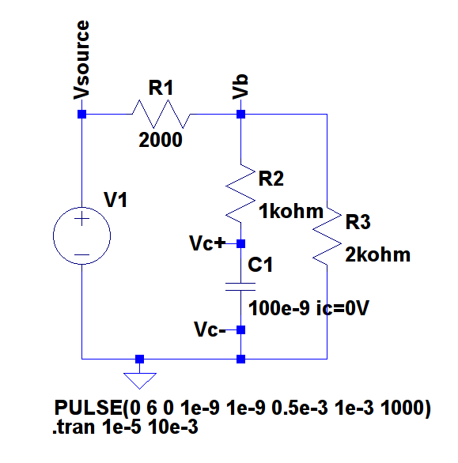

**Figure 3:** Cascaded Operational Amplifier Circuit

* 1. Derive the time constant of the circuit.
  2. Use the oscilloscope to measure $V_{source}(t)$, $V_{b}(t)$ and $V_{c}(t)$ and save them as PRINTOUT5, PRINTOUT6 and PRINTOUT7.
  3. Calculate the time constants using the measured $V_{c}(t)$ and compare it with the predicted time constant.
  4. Use the results from Step 2 to calculate all three resistor current. Use the computation to verify Kirchhoff’s Current Law (KCL), $∑i_{in}=∑i_{out}$, for t = 0- s, 0 s, 20 μs, and 30 μs.

1. **Measured Data:**

The data collected for this lab report were stored as screen captures displaying both the input and measured output voltages, instead of the conventional tables of data.

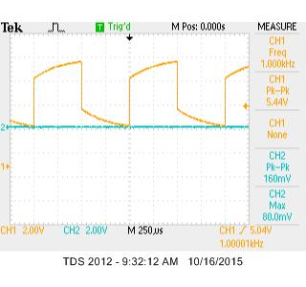

**PRINTOUT1:** 1 kHz square wave input

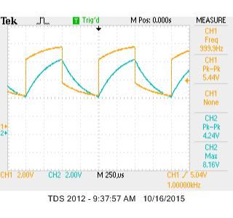

Varying the frequency changed the amplitudes of the waveforms; the higher the frequency, the higher the amplitude.

**PRINTOUT2:** 1 kHz square wave input (V(n001)) and voltage across the 100 nF capacitor (V(n002))

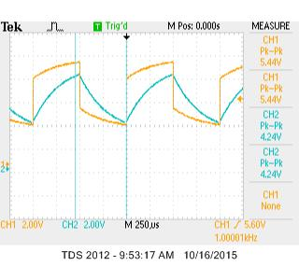

**PRINTOUT3:** 1 kHz square wave input (V(n001)) and voltage across the resistor (V(n002))

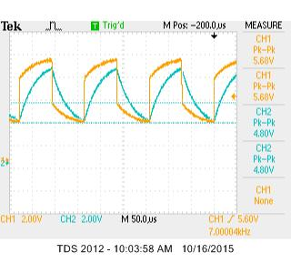

Compared to the 100 nF capacitor, the 10 nF capacitor was much quicker to charge and discharge.

**PRINTOUT4:** 7 kHz square wave input (V(n001)) and voltage across the 10 nF capacitor (V(n002))

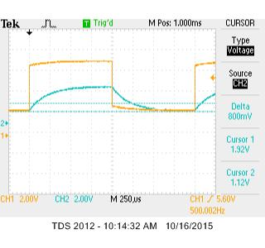

**PRINTOUT5:** 500 Hz square wave input (V(n002)) and $V_{source}(t)$ (V(n002))

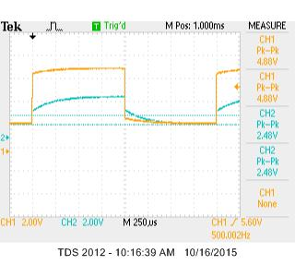

**PRINTOUT6:** 500 Hz square wave input (V(n002)) and $V_{b}(t)$ (V(n002))

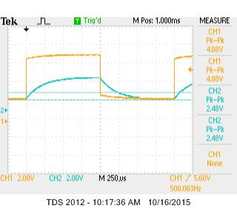

**PRINTOUT7:** 500 Hz square wave input (V(n002)) and $V_{c}(t)$ (V(n002))

1. **Calculations:**
   1. Derivation of $V_{C}\left(t\right)$ and $V_{R}\left(t\right)$ for the charging period ($0 ms<t<0.5 ms$) of the circuit from Figure 1:

* $n$ Since $V_{C}\left(t\right)= V_{C}\left(+∞\right)+\left(V_{C}\left(0\right)-V_{C}\left(+∞\right)\right)e^{-t/τ}$

$τ=RC=\left(2 kΩ\right)\left(100 nF\right)=\frac{1}{5000}$,

$V_{C}\left(0^{-}\right)=V_{C}\left(0^{+}\right)=0 V$, $V_{C}\left(+∞\right)=V_{1}=6 V$

$V_{C}\left(t\right)= 6(1-e^{-5000t})$

* Using Kirchhoff’s Voltage Law (KVL), $∑V_{in}=∑V_{out}$, for the circuit:

$V_{C}(t)+V_{R}(t)=V_{1}$

$CCcV_{R}\left(t\right)=6-6(1-e^{-5000t})nfjdsnffsd$

* $V_{C}\left(0\right)=0 V$, $V_{C}\left(0.5\right)=6\left(1-e^{-5000\left(0.5\right)}\right)≈5.99 V$
* $V_{R}\left(0\right)=6 V$, $V_{R}\left(0.5\right)=6-6\left(1-e^{-5000\left(0.5\right)}\right)≈0 V$
  1. Derivation of $V_{C}\left(t\right)$ and $V_{R}\left(t\right)$ for the discharging period ($0.5 ms<t<1 ms$) of the circuit from Figure 1:
* Since $V_{C}\left(t\right)= V_{C}\left(+∞\right)+\left(V_{C}\left(0\right)-V_{C}\left(+∞\right)\right)e^{-t/τ}$

$τ=RC=\left(2 kΩ\right)\left(100 nF\right)=\frac{1}{5000}$,

$V_{C}\left(0^{-}\right)=V_{C}\left(0^{+}\right)=V_{1}$, $V_{C}\left(+∞\right)=0 V$

$V_{C}\left(t\right)= 6e^{-5000t}$

* Using Kirchhoff’s Voltage Law (KVL), $∑V_{in}=∑V_{out}$, for the circuit:

$V_{C}(t)+V_{R}(t)=V_{1}$

$CCcV_{R}\left(t\right)=6-6e^{-5000t}nfjdsnffsd$

* $V_{C}\left(0.5\right)≈0 V$, $V_{C}\left(1\right)=6\left(e^{-5000\left(1\right)}\right)≈0 V$
* $V_{R}\left(0.5\right)=0 V$, $V_{R}\left(1\right)=6-6\left(e^{-5000\left(1\right)}\right)≈5.99 V$
  1. Time constant of the circuit constructed from Figure 1 with the 100 nF capacitor:
 $τ=RC=\left(2 kΩ\right)\left(100 nF\right)=\frac{1}{5000}$

 2. Time constant of the circuit constructed from Figure 1 with the 10 nF capacitor:
 $τ=RC=\left(2 kΩ\right)\left(10 nF\right)=\frac{1}{50,000}$

 3. Time constant of the circuit constructed from Figure 3:
 $τ=R_{eq}C=\left(2 kΩ\right)\left(100 nF\right)=\frac{1}{5000}$

 $R_{eq}=1 kΩ+\left(2 kΩ∥ 2 kΩ\right)=2 kΩ$

$τ=\left(2 kΩ\right)\left(100 nF\right)=\frac{1}{5000}$

4. Time constant of the circuit constructed from Figure 3 using the measured $V_{C}(t)$:
* Since $V_{C}\left(t\right)= V_{C}\left(+∞\right)+\left(V_{C}\left(0\right)-V_{C}\left(+∞\right)\right)e^{-t/τ}$

and $V_{C}\left(0^{-}\right)=V_{C}\left(0^{+}\right)=0 V$, $V_{C}\left(+∞\right)=2.48 V$,

$V_{1}\left(1 ms\right)=4.88 V$, $t=1 ms$

* $2.48=4.88(e^{-\frac{0.001}{τ}})$, $τ=0.00148$
  1. Current through the resistors in the Figure 3 circuit:
* At charging period:
* $i_{R_{1}}\left(t\right)=\frac{V_{1}\left(0\right)}{R_{1}}e^{-\frac{t}{τ}}$,
* $i_{R_{2}}\left(t\right)=\frac{V_{1}\left(0\right)}{R_{2}}e^{-\frac{t}{τ}}$,
* $i_{R_{3}}\left(t\right)=\frac{-V_{1}\left(0\right)}{3R_{3}}e^{-\frac{t}{τ}}$ (using voltage division)
$i_{C}\left(t\right)=C\frac{{dV}_{C}\left(t\right)}{dt}$

* Using KCL at $t = 0^{-}$:

$i_{R_{1}}(t)+i_{R_{2}}(t)+i_{C}(t)=0$

$i_{R_{1}}(0^{-})+i_{R_{2}}(0^{-})+i_{C}(0^{-})=0$

$0.00244+0.00488+i_{C}\left(0^{-}\right)=0$

1. **Graphs:**

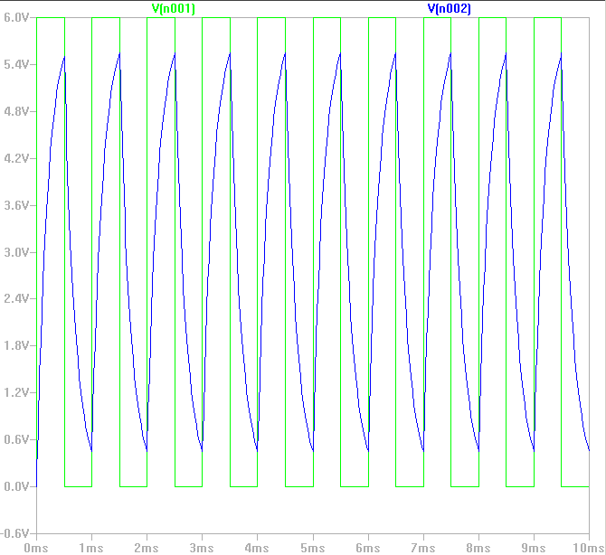

**Figure 2:** Plot of the circuit from Figure 1 showing the square wave input V(n001) and the RC circuit output V(n002)

1. **Conclusion:**

I learned a lot about the behavior of RC circuits under both DC and transient conditions. I learned to calculate the time constant of the circuits using various methods given different initial conditions to calculate with. The time constant I measured using the oscilloscope resulted with a relatively lower error than my other measurements, and that helped me enforce my knowledge of using these devices to power up circuits.