**Sabbir Ahmed**

**CMPE 306**

**Lab X Prelab**

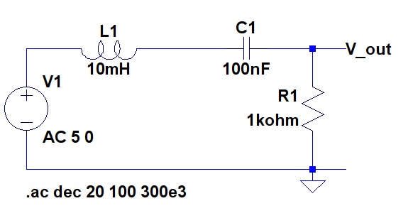

**Figure 1:** RLC circuit for bandpass filter

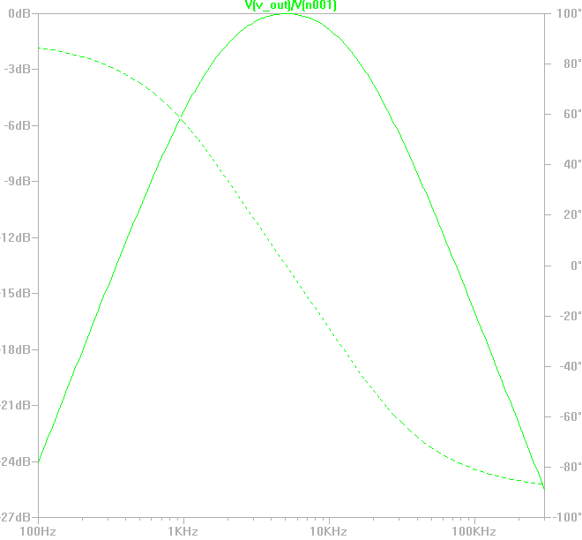

**Plot for Figure 1**

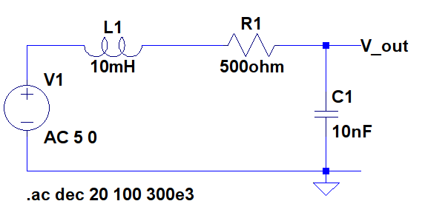

**Figure 2:** RLC circuit #2 for bandpass filter

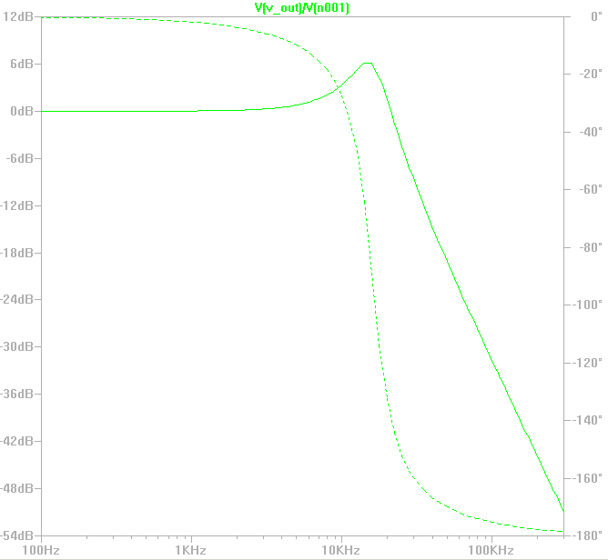

**Plot for Figure 2**