**CMPE314: Principles of Electronic Circuits**

**Dr. Yan**

**Lab 01 Report:**

**Diode Characteristics and Diode-Based Circuit**

**Sabbir Ahmed**

**Yu Fu**

1. **Objective**

Measure and study the I-V characteristics of a diode.

1. **Equipment**
   1. One $220 Ω$ resistor
   2. One 1N4732 Zener diode
   3. Oscilloscope, DC power supply, digital multi-meter, function generator, breadboard
2. **Procedure**

**4.1 Part A. I-V Characteristics of Diode**

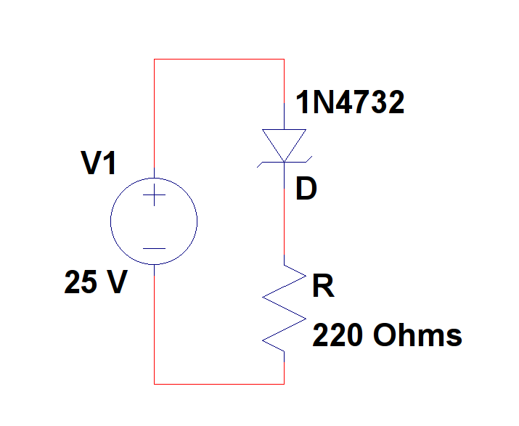

**Figure 1: Diode I-V characteristics measurement circuit**

* 1. Use a 1N4732 Zener diode to construct the circuit from Figure 1.
  2. Sweep the DC power supply from 0 V to 5 V in increments of 0.2 V. Record and plot the results. Determine the turn-on voltage of the diode.
  3. Reverse the polarity, and sweep the power supply from 0 V to 25 V in increments of 0.5 V. Record and plot the I-V curve. Determine the breakdown voltage.
  4. Compare the experimental I-V curves to that on the ideal diode model and linear-piecewise diode model. What are Is and n for this diode based on a fit to the ideal model? What are the forward resistance rf and the Zener resistance rz?

**4.2 Part B. Diode Circuit**

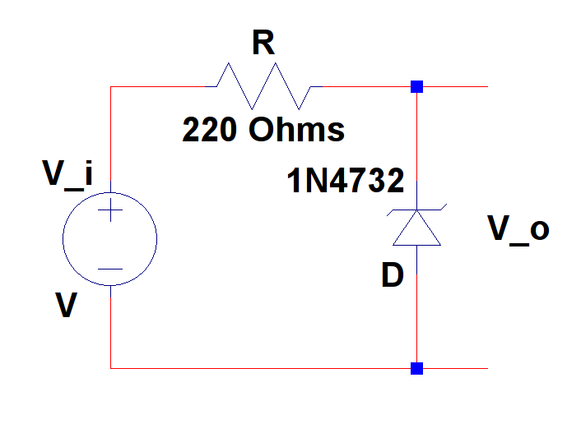

**Figure 2: Diode measurement circuit**

1. Replace the DC power with the signal generator to create the circuit from Figure 2. Set Vi and Vo to the two channels of the oscilloscope. Set Vi to be a sinusoid of 5 kHz.
2. Vary the input amplitude to the signal generator form 0 V to 10 V in increments of 1 V. Observe and record the input and output peak-peak voltages and waveforms.
3. Explain the observed output waveforms. What kind of circuit is this?
4. **Results**

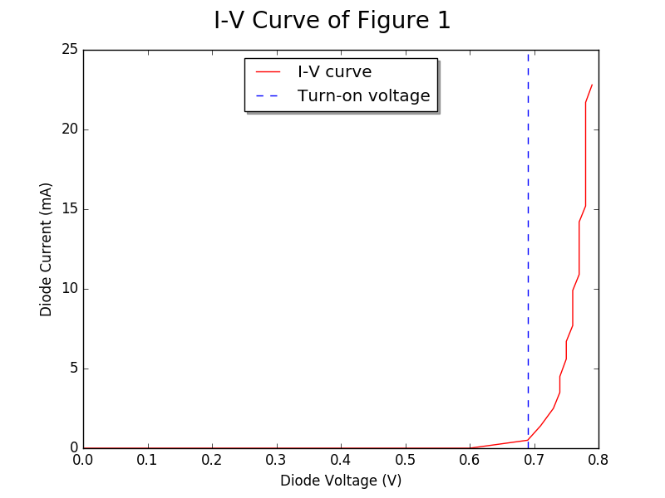

**Figure 3: I-V Curve Observed from Figure 1**

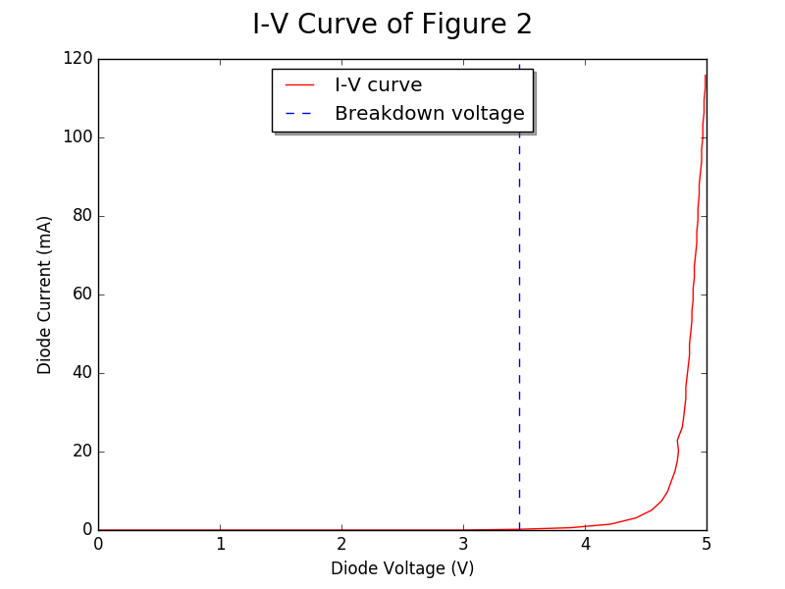

**Figure 4: I-V Curve Observed After Reversing the Polarity of the Power Supply in Figure 1**

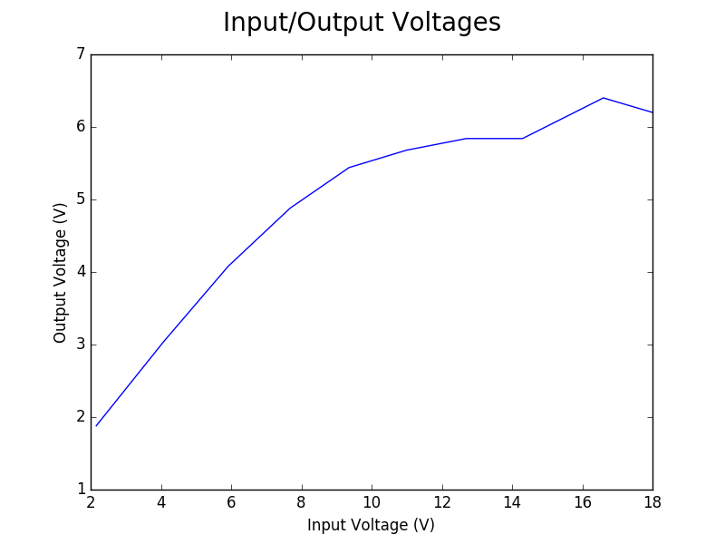

**Figure 5: Non-linear relationship between input and output voltage (peak-peak) of Figure 2**

**Waveforms of Figure 2 as observed in the oscilloscope:**

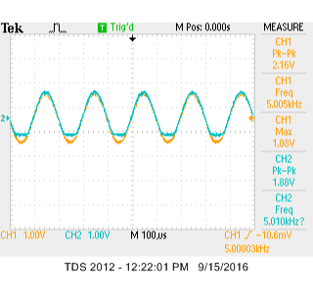 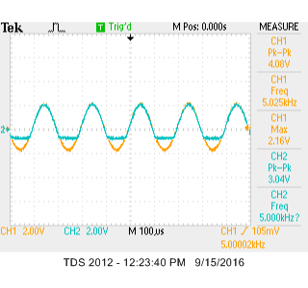 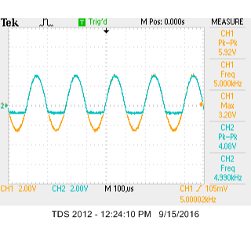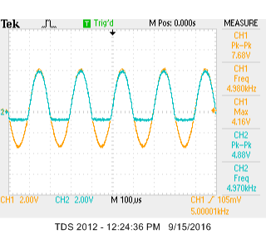 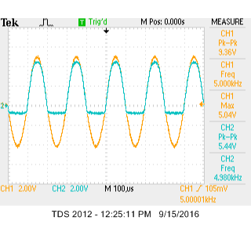 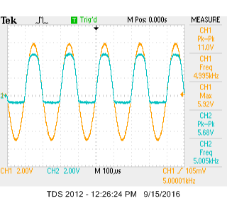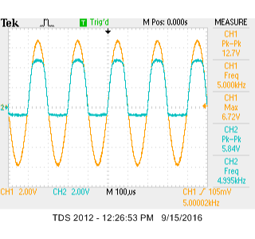 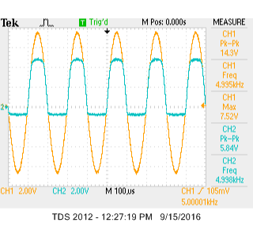 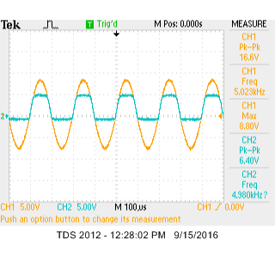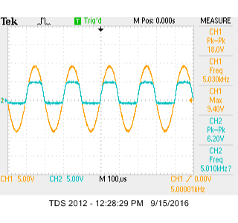

The amplitudes of the output voltages are gradually being levelled out

The circuit emulates a high pass filter

1. **Conclusion**

Diodes are key components to modern electronic circuits. Although their behavior demonstrates complicated relationship among numerous internal and external factors, it is important to fully understand their concept to appreciate their usefulness. During this lab, collection of the data was done flawlessly, however, applying the laws surrounding the circuit component felt challenging to me.