**CMPE314: Principles of Electronic Circuits**

**Dr. Yan**

**Lab 02 Report:**

**Diode-Based Filtered Rectifier and Regulator Circuits**

**Sabbir Ahmed**

**Yu Fu**

1. **Objective**

Examine a filtered rectifier circuit. Theoretically and experimentally determine the proper resistance for the filter

1. **Equipment**
   1. One potentiometer
   2. One 22 µF capacitor
   3. One 1N4740 diode
   4. One 741 operational amplifier
   5. Oscilloscope, DC power supply, digital multi-meter, function generator, breadboard
2. **Background**

Filtered rectifiers convert AC waveforms into useful near-DC waveforms. Rectifiers have many uses including as components of power supplies and as detectors of radio signals. They may be made of solid state diodes, vacuum tube diodes, and other components. A voltage buffer amplifier is used to transfer a voltage from a first circuit, having a high output impedance level, to a second circuit with a low input impedance level. A unity gain buffer, also known as a voltage follower, has a voltage gain of approximately unity, while it provides considerable current gain and thus power gain.

1. **Procedures**

**4.1 Part A. Diode-Based Filtered Rectifier Circuit**

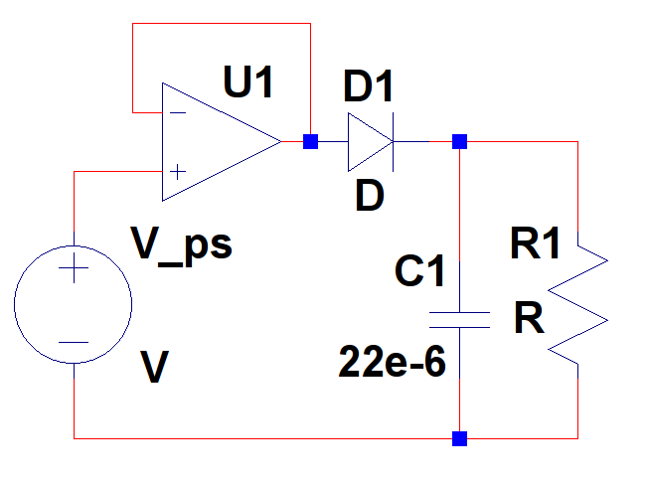

**Figure 1: Filtered Rectifier Circuit**

* 1. Use a 1N4740 diode to construct the circuit from Figure 1.
  2. Set the input signal amplitude to be 5 V and frequency to be 60 Hz.
  3. Vary the potentiometer until the output ripple voltage is less than 10%.
  4. Measure the potentiometer resistance as RL_measured. Compare the expected value for RL with the measured value.

**4.2 Part B. Diode-Based Filtered Regulator Circuit (Simulation)**

1. Simulate the same circuit from Figure 1 on Cadence Orcad PSPICE.
2. **Results**

Since there were no potentiometers available in the lab kit, several resistors of different resistance were used in an iterative/brute-forced manner. The value of RL computed in the pre-lab was around 4 kΩ. RL_measured turned out to be 7.25 kΩ.

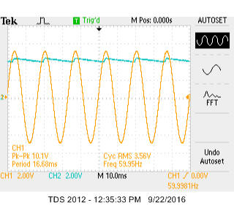

**Figure 2: Waveform of Figure 1 after adjusting the value of RL until the ripple voltage was less than 10%**

The circuit from Figure 1 was simulated on Cadence Orcad PSPICE, assigning the value of RL to RL_measured = 7.25 kΩ.

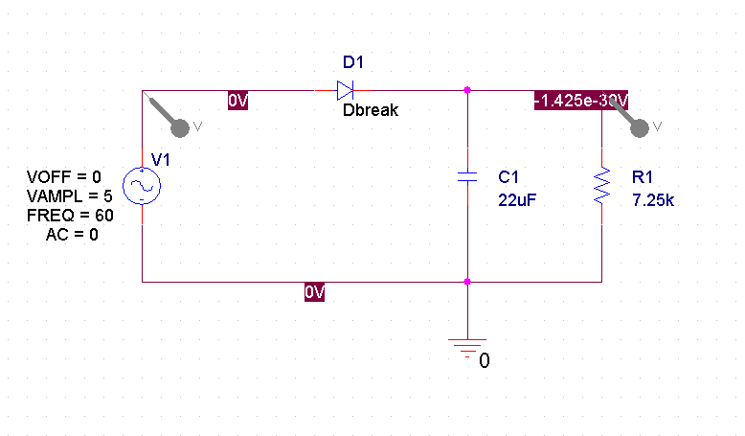

**Figure 3: Simulation of Figure 1 on PSPICE**

The circuit was simulated with the same input waves and the voltage across the diode was plotted. The input/output voltage waveforms simulated on PSPICE appeared almost identical to the waveforms captured on the oscilloscope.

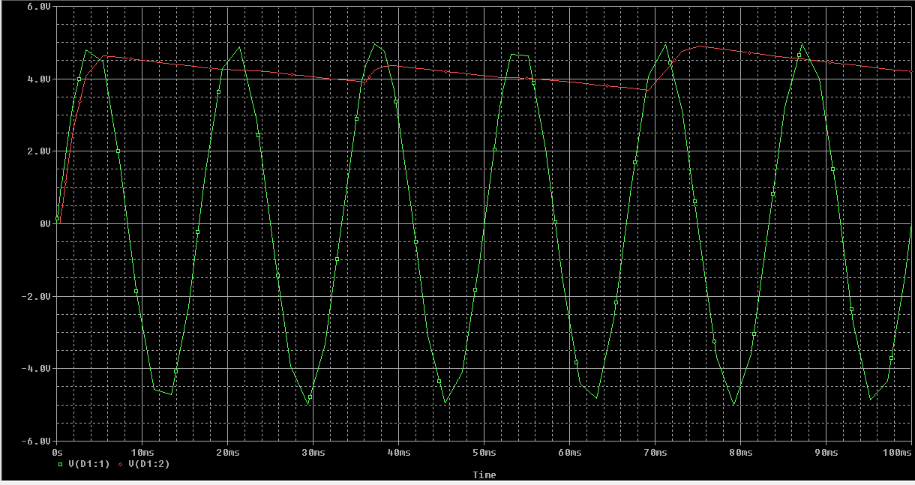

**Figure 4: Voltage Across the Diode of the Circuit Simulated on PSPICE**

1. **Conclusion**

The value of the load resistance, RL,computed theoretically had a very high percentage error to the actual measured value. $\frac{\left|7250-4000\right|}{\left|7250\right|}= 44.8\%$. The result is due to the fact my approach to computing the value on the pre-lab assignment was incorrect, otherwise the value computed theoretically should have been closer to the value measured.