**CMPE314: Principles of Electronic Circuits**

**Dr. Yan**

**Lab 03 Report:**

**Clippers and Clampers**

**Sabbir Ahmed**

**Yu Fu**

1. **Objective**

Construct and measure clipper and clamper circuits and study their characteristics.

1. **Equipment**
   1. Resistors; 2 × 10 kΩ, 1 × 100 kΩ
   2. Capacitors; 1 × 0.22 µF
   3. Diodes; 2 × 1N4738, 1 × 1n4740
   4. Oscilloscope, DC power supply, digital multi-meter, function generator, breadboard
2. **Background**

Clipper circuits limit or constrain signals by clipping off part of the signal in some region or compressing it in that region using a resistive voltage divider. Clamper circuits set a minimum and maximum value on an output AC waveform by shifting the DC level of the steady-state AC signal instead of altering its shape.

1. **Procedures**

**4.1 Part A. Clipper Circuit I**

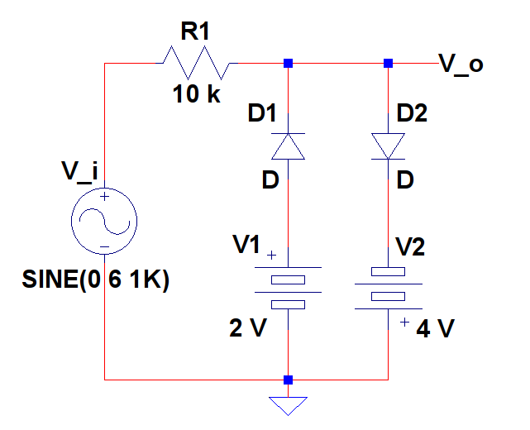

**Figure 1: Clipper Circuit Without Resistor**

* 1. Use a 1N4738 diode to construct the circuit from Figure 1.
  2. Set the input signal amplitude to be 6 V and frequency to be 10 kHz.
  3. Capture the input and output voltages on the oscilloscope with the input being a sinusoidal, square and saw-tooth waveform, respectively.
  4. Save the sinusoidal input and output waveform data to plot alongside their theoretical computation.

**4.2 Part B. Clipper Circuit II**

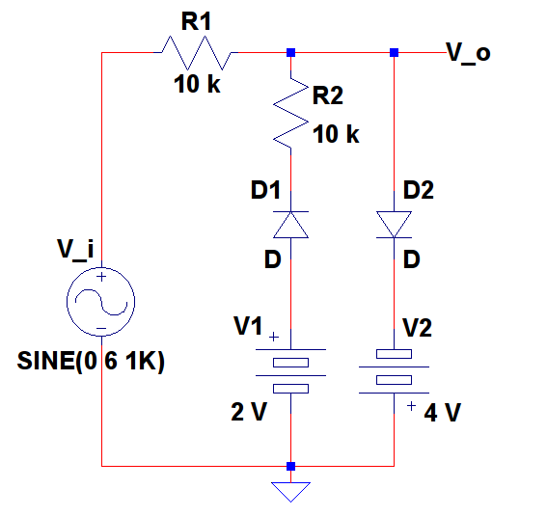

**Figure 2: Clipper Circuit with Resistor**

1. Repeat Part A with Figure 2.

**4.3 Part C. Clamper Circuit**

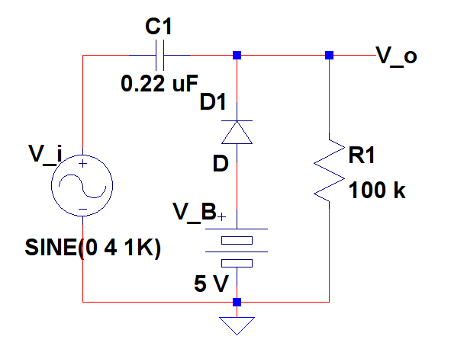

**Figure 3: Clamper Circuit with = 5 V**

1. Use a 1N4740 diode to construct the circuit from Figure 3.
2. Set the input signal amplitude to be 4 V and frequency to be 10 kHz.
3. Capture the input and output voltages on the oscilloscope with the input being a sinusoidal and a square wave with +2 V peaks and -4 V valleys, respectively.
4. Save the sinusoidal input and output waveform data to plot alongside their theoretical computation.

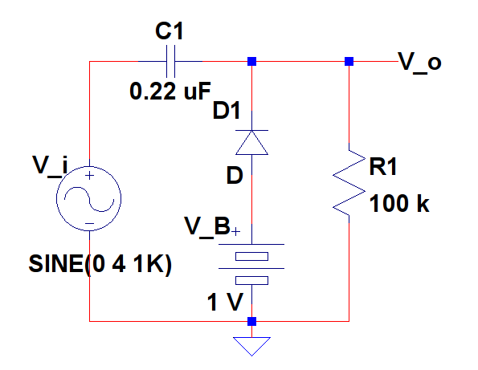

**Figure 4: Clamper Circuit with = 1 V**

1. Repeat steps a. to d. with = 1 V as in Figure 4.
2. **Results**

The clipper circuit from Figure 1 was constructed and the waveform on the oscilloscope was captured.

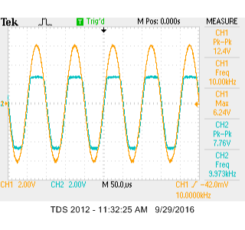

**Figure 5: Waveform of Figure 1 on the Oscilloscope with Sinusoidal Inputs**

The plot data was dumped and simulated as shown below in Figure 6.

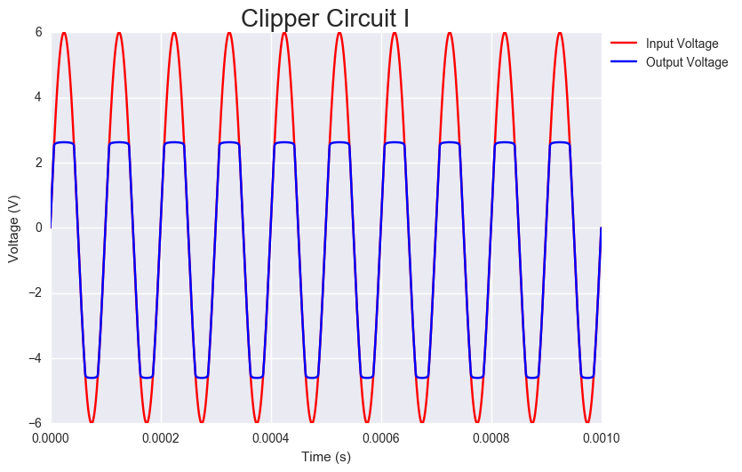

**Figure 6: Simulation of the Figure 1 Waveform**

The waveform was computed theoretically and simulated as well. The input sinusoidal was . The output waveform was constructed as a piecewise function, where the output was clipped at its peak when it reached and at its valley when . The following output was constructed.

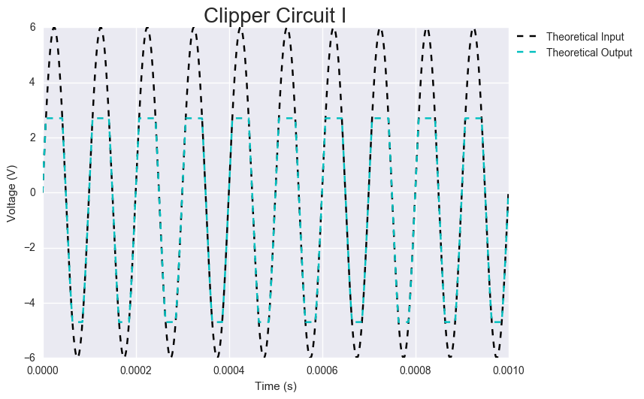

**Figure 7: Simulation of the Theoretical Waveforms of Figure 1**

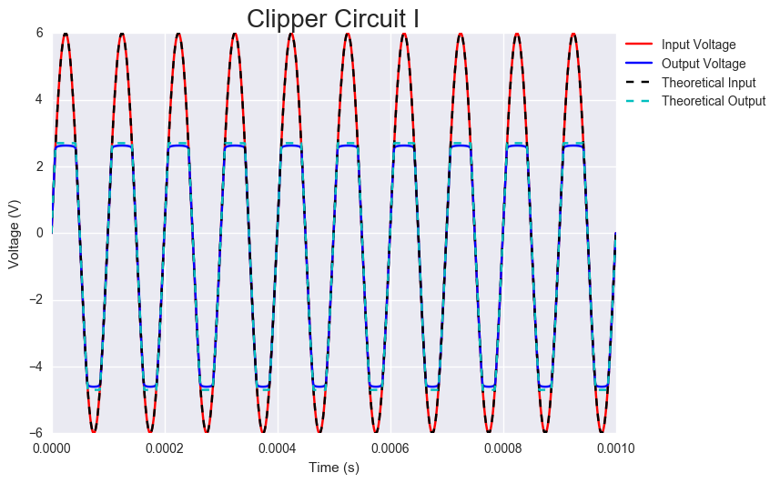

**Figure 8: Simulation of Both the Dumped and Theoretically Computed Waveforms of Figure 1**

The procedure was repeated with a square wave and a saw tooth input and captured on the oscilloscope.

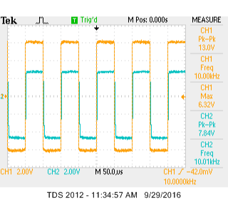 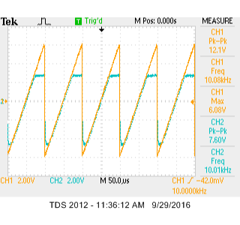

**Figure 9: Waveforms of Figure 1 on the Oscilloscope with Square and Saw-tooth Wave Inputs**

Identical steps were taken to generate waveforms for the clipper in Figure 2.

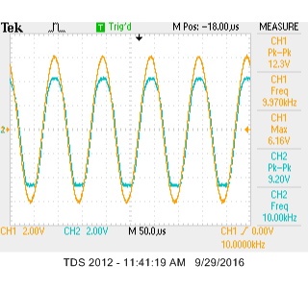

**Figure 10: Waveform of Figure 2 on the Oscilloscope with Sinusoidal Inputs**

The plot data was dumped and simulated as shown below in Figure 11.

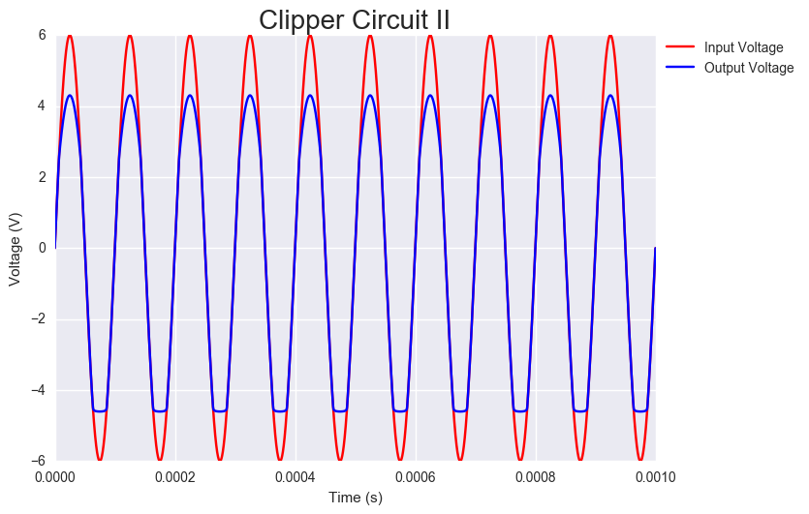

**Figure 11: Simulation of the Figure 2 Waveform**

The waveform was computed theoretically and simulated as well. The input sinusoidal was . The output waveform was constructed as a piecewise function, where the output was clipped at its peak when it reached and at its valley when . The following output was constructed.

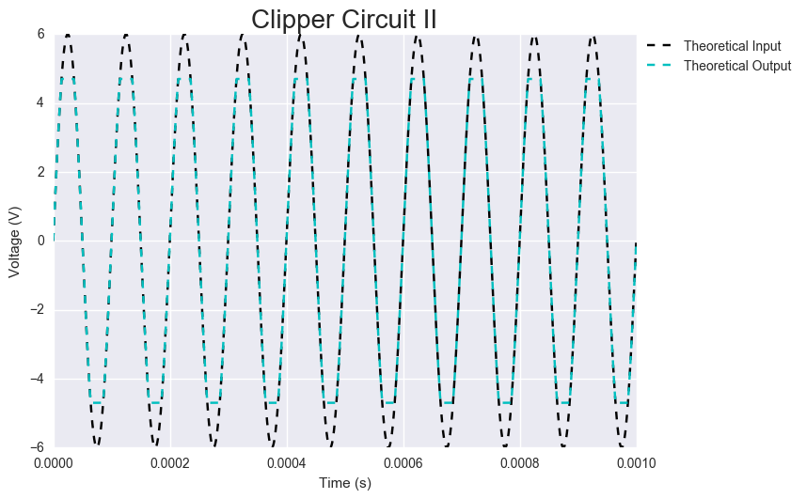

**Figure 12: Simulation of the Theoretical Waveforms of Figure 2**

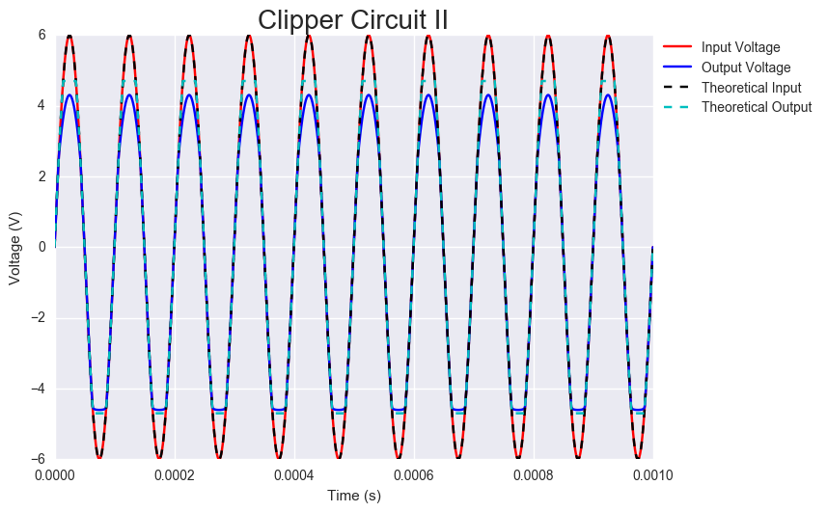

**Figure 13: Simulation of Both the Dumped and Theoretically Computed Waveforms of Figure 2**

The procedure was repeated with a square wave and a saw tooth input and captured on the oscilloscope.

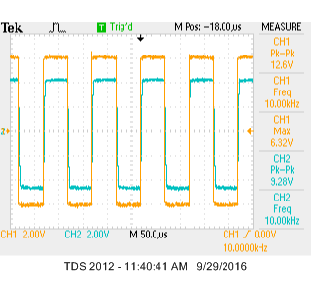 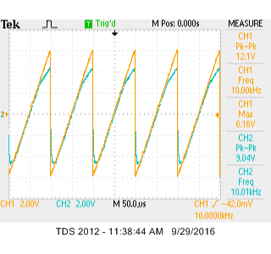

**Figure 14: Waveforms of Figure 2 on the Oscilloscope with Square and Saw-tooth Wave Inputs**

Identical steps were taken to generate waveforms for the clamper circuit in Figure 3.

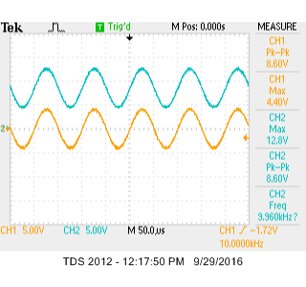

**Figure 15: Waveform of Figure 3 on the Oscilloscope with Sinusoidal Inputs**

The plot data was dumped and simulated as shown below in Figure 16.

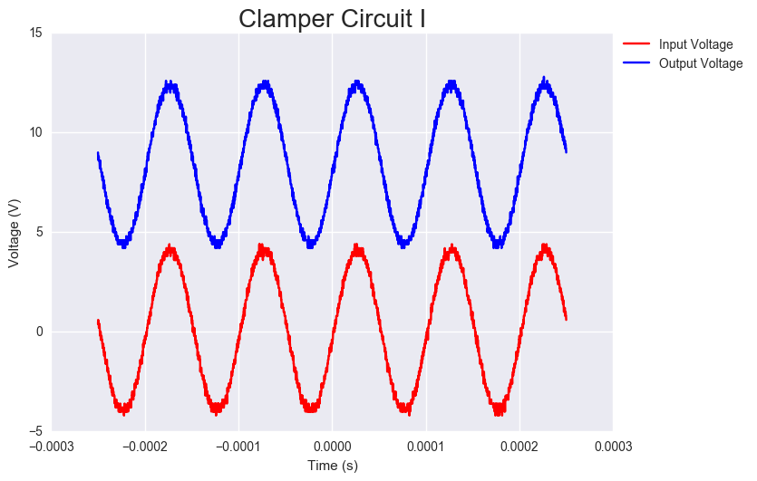

**Figure 16: Simulation of the Figure 3 Waveform**

The waveform was computed theoretically and simulated as well. The input sinusoidal was . The output waveform was simply the input function shifted up . The following output was constructed.

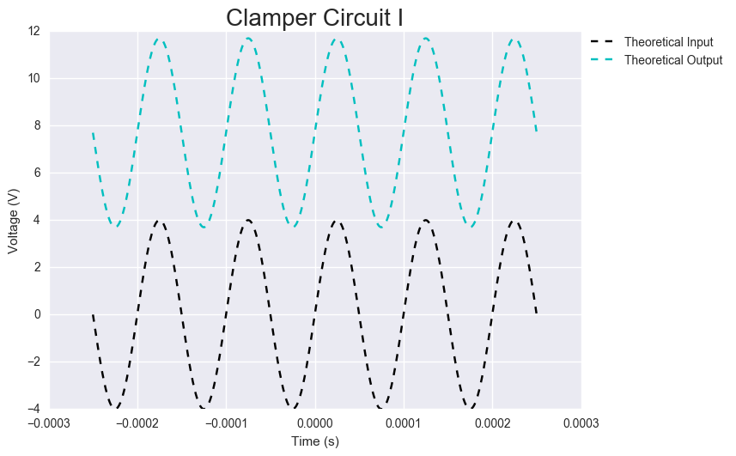

**Figure 17: Simulation of the Theoretical Waveforms of Figure 3**

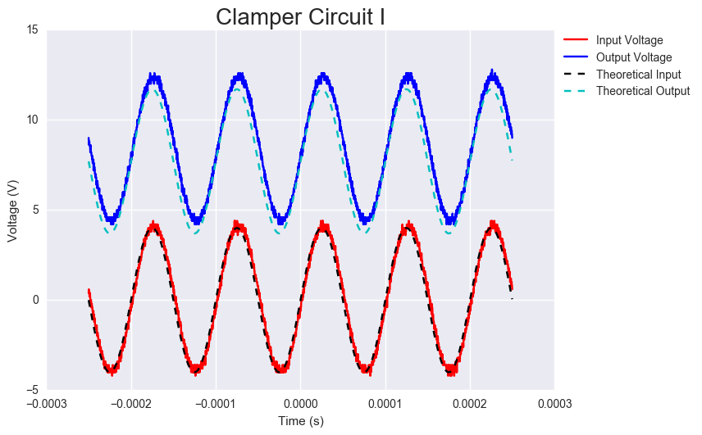

**Figure 18: Simulation of Both the Dumped and Theoretically Computed Waveforms of Figure 3**

The procedure was repeated with a square wave input with an offset of +2 V and captured on the oscilloscope.

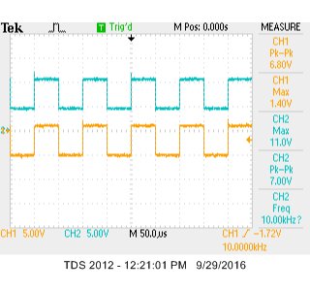

**Figure 19: Waveforms of Figure 3 on the Oscilloscope with Square Wave Inputs**

Identical steps were taken to generate waveforms for the clamper circuit in Figure 4.

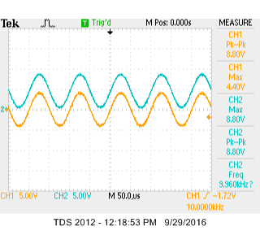

**Figure 20: Waveform of Figure 4 on the Oscilloscope with Sinusoidal Inputs**

The plot data was dumped and simulated as shown below in Figure 21.

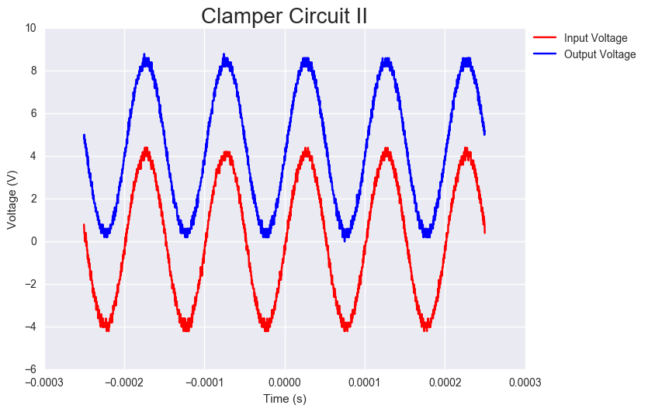

**Figure 21: Simulation of the Figure 3 Waveform**

The waveform was computed theoretically and simulated as well. The input sinusoidal was . The output waveform was simply the input function shifted up . The following output was constructed.

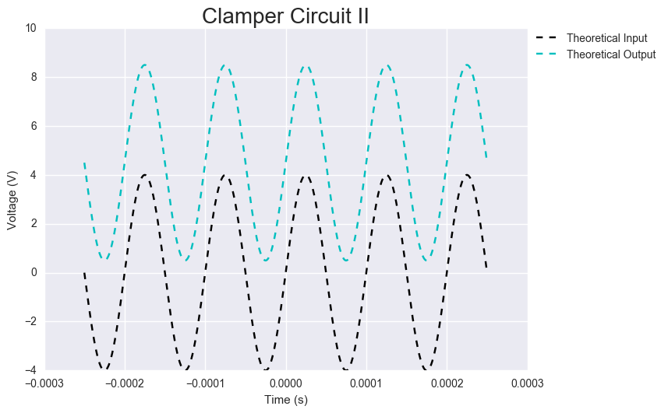

**Figure 22: Simulation of the Theoretical Waveforms of Figure 4**

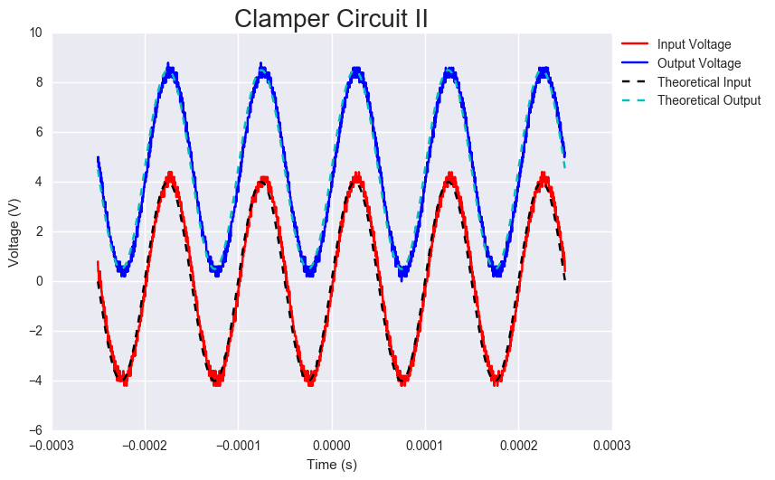

**Figure 23: Simulation of Both the Dumped and Theoretically Computed Waveforms of Figure 3**

The procedure was repeated with a square wave input with an offset of +2 V and captured on the oscilloscope.

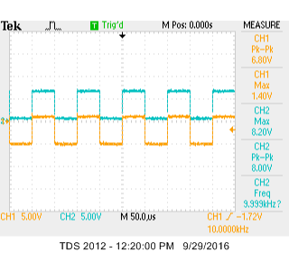

**Figure 24: Waveforms of Figure 4 on the Oscilloscope with Square Wave Inputs**

1. **Conclusion**

The characteristics of clipper and clamper circuits, although appear simplistic, have many uses in real world applications. Simulating the waveforms mathematically was possible without much difficulty as demonstrated.