**CMPE 323: Signals and Systems**

**Dr. LaBerge**

**Final Exam**

**Part II: Simulation Work**

Sabbir Ahmed

1. **Introduction**

We’re going to revisit the Double Sideband Amplitude Modulated waveform from Lab 1. As a reminder, our DSB-AM waveform has the form

$d\left(t\right)= A \left(1+ a_{1}cos\left(2πf_{1}t+ϕ_{1}\right)+ a_{2}cos\left(2πf_{2}t +ϕ_{2}\right)\right)$ (1.1)

(in the labs we had three terms, but two is enough for this problem). In (1.1), $a_{k}$ is an amplitude factor, $f_{k}$ is the frequency of modulation, $ϕ_{k}$ is the relative phase of the modulating component at t = 0, A is an overall amplitude factor, and, for this example, k = 1, 2 for the two modulating terms. DSB-AM is a means of communicating an analog waveform. In this case, the analog waveform is the sum of two sinusoids.

1. **Procedure**

## $d\left(t\right)= A \left(1+ a_{1}cos\left(2πf_{1}t+ϕ_{1}\right)+ a_{2}cos\left(2πf_{2}t +ϕ_{2}\right)\right)$ was plotted with the parameters $A = 1$, $a_{1}=a_{2}=0.2$, $f_{1}$ = 90 Hz, $f_{2}$ = 150 Hz, $ϕ_{1}=ϕ_{2}=-\frac{π}{2}$:

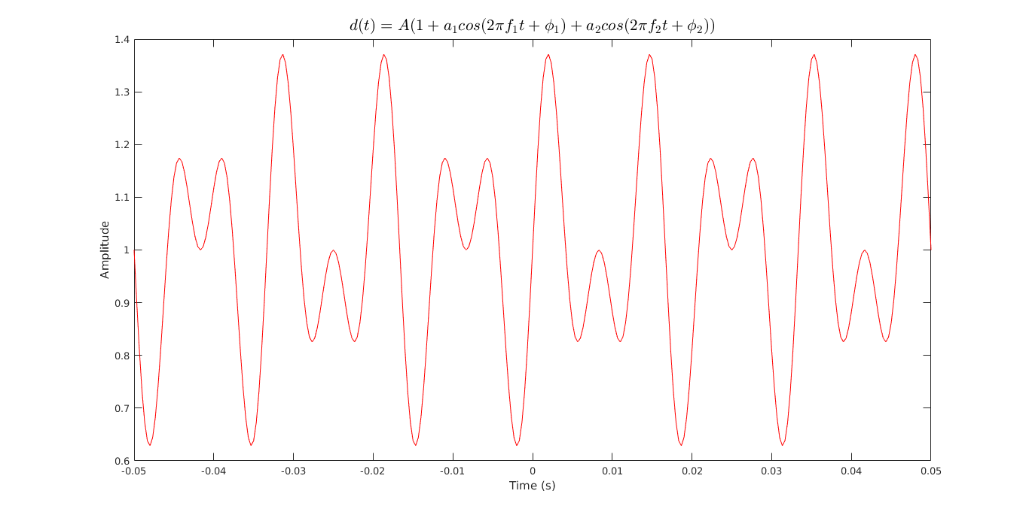

**Figure 4: DBS-AM Waveform Simulated at 10 Times its Nyquist Rate (3000 sps)**

1. The Fourier Transform for the waveform $d(t)$ was computed and plotted, as $D(f)$. A frequency resolution, $Δf$ of 10 Hz with 100,000 samples were used using the relationship $Δf=\frac{F_{s}}{N}$ to perform the FFT:

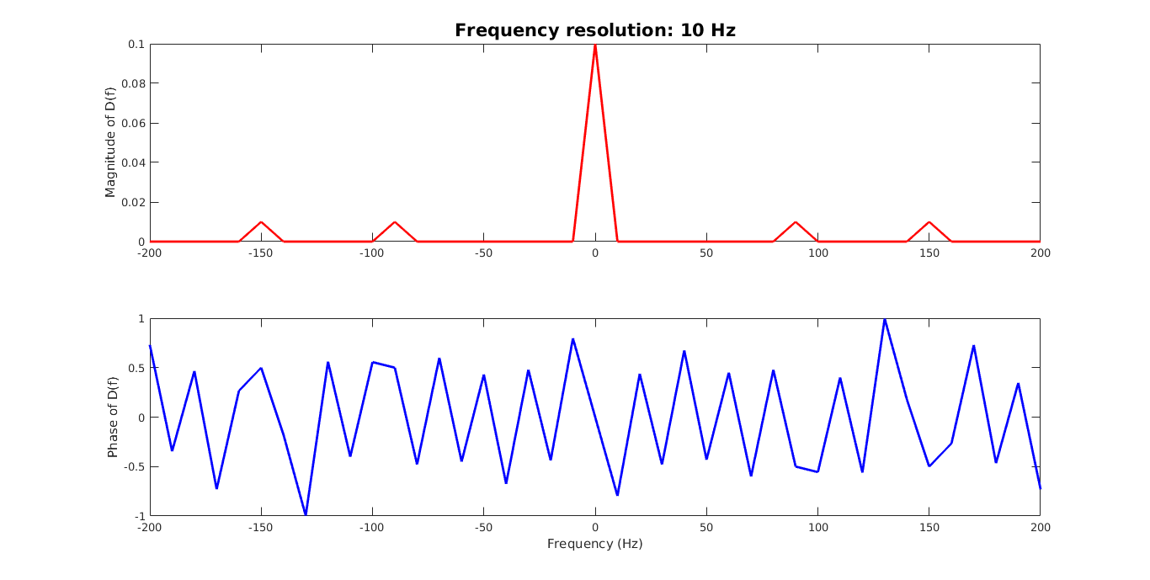

**Figure 5: Magnitude and Phase of $D\left(f\right)$ Computed with a Frequency Resolution of 10 Hz**

1. A new signal $x\left(t\right)=d(t)cos⁡(2πf_{c}t)$ was generated to simulate an amplitude modulation of a carrier signal with $f_{c}=100$ kHz. A sample of $5×f_{c}=500,000$ was used with a frequency resolution of 10 Hz to compute the Fourier Transform of $X(f)$:

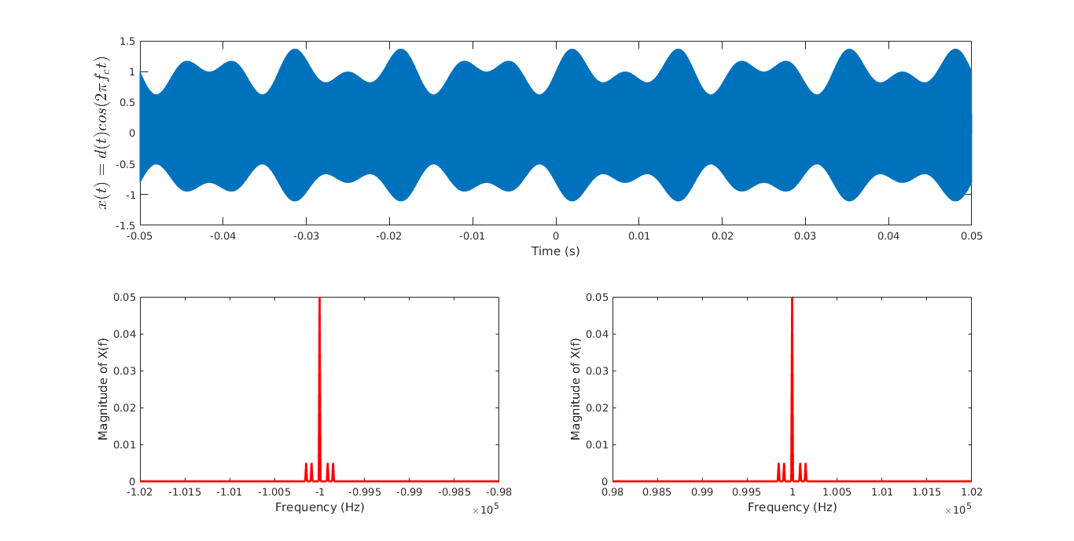

**Figure 6: $d(t)$ Modulated as $x(t)$ (top) and the Magnitudes of its Fourier Transform (bottom) Zoomed in on [-102 kHz, -98 kHz] and [98 kHz, 102 kHz]**

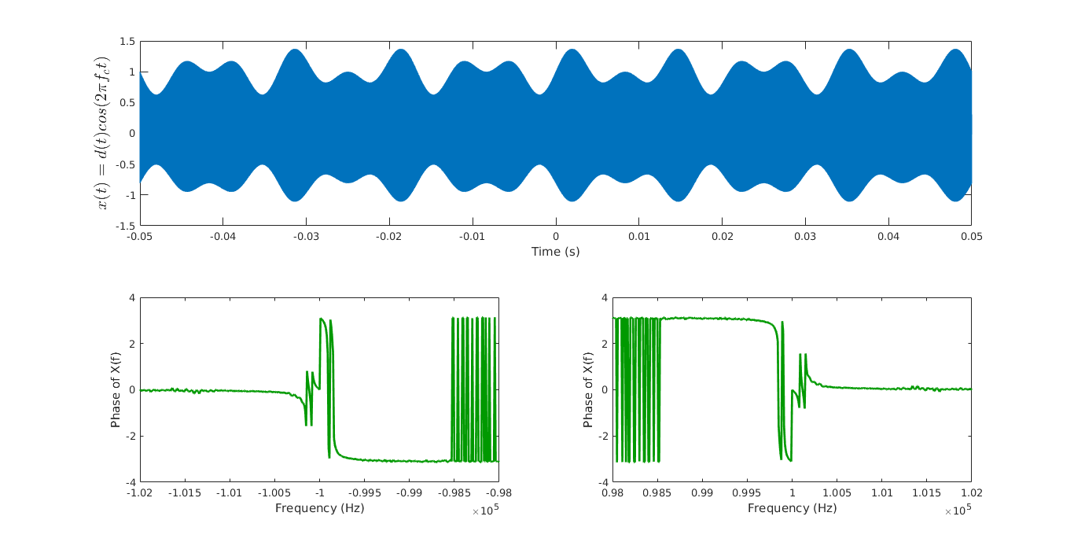

**Figure 7: $d(t)$ Modulated as $x(t)$ (top) and the Phases of its Fourier Transform (bottom) Zoomed in on [-102 kHz, -98 kHz] and [98 kHz, 102 kHz]**

2 sideband impulses on either side of a much longer impulse appear around the same region on both the ranges. The shape of the waveform can be inferred as the reason of its naming as “double sideband amplitude modulated.” The presence of identical waveforms evenly apart in the Fourier domain was caused from the properties of the Fourier Transform dealing with real signals such as the DBS-AM. The properties state the Fourier Transform of such signals is even in magnitude and odd in phase.

1. An adjacent signal $d_{A}\left(t\right)= 1+ a_{1}cos\left(2πf_{1}t+ϕ_{1}\right)+ a_{2}cos\left(2πf_{2}t +ϕ_{2}\right)$ with the parameters $a_{1}=0$, $a_{2}=0.4$, $f_{1}$ = 90 Hz, $f_{2}$ = 150 Hz, $ϕ_{1}=ϕ_{2}=0$ is now present at the input to the signal processing along with the original desired signal. The adjacent signal is modulated with $f_{c}$ = 50 kHz, while the desired signal was modulated with $0≤f_{B}≤10$ kHz. The adjacent signal is also 34 dB higher than the desired signal. To design an analog filter to reduce $d_{A}\left(t\right)$ 30 dB below $d\left(t\right)$ (total 64 dB) a Butterworth filter can be used. The following parameters can be inferred from the prompt:

* Passband amplitude, $A_{p}=3 dB$
* Stopband amplitude, or stopband rejection, $A_{s}=R=64 dB$
* Passband corner frequency, $f_{p}=10 kHz$
* Stopband corner frequency, $f_{s}=50 kHz$

The number of poles of the filter can be computed with the expression

$$N=\left\lceil \frac{0.05{\left(R\right)}_{dB}}{\log_{10}\left(\frac{Ω}{Ω_{C}}\right)}\right\rceil =\left\lceil \frac{0.05{\left(64\right)}_{dB}}{\log_{10}\left(\frac{50 kHz}{10 kHz}\right)}\right\rceil$$

which yields 5 poles. Using the attached MATLAB script (see num13_main.m) the parameters, such as $ν_{s}, ϵ^{2},θ_{k},s_{k}$ and $ω_{C}^{N}$ were computed, and using the transfer function expression:

$$H\left(s\right)=\frac{ω_{C}^{N}}{\left(s-ω_{C}e^{jπ\frac{2k+N-1}{2N}}\right) }$$

for k = 0, 5 poles, and $ω_{C}$ = 1.0005, the following transfer function was generated:

$$H\left(s\right)=\frac{1.0024}{\left(s-1.0005e^{\frac{j3π}{5}}\right)\left(s-1.0005e^{\frac{j4π}{5}}\right)\left(s+1.0005\right)\left(s-1.0005e^{\frac{j6π}{5}}\right)\left(s-1.0005e^{\frac{j7π}{5}}\right) }$$

1. The transfer function of the low pass filter, H(s) was plotted in a pole-zero plot:

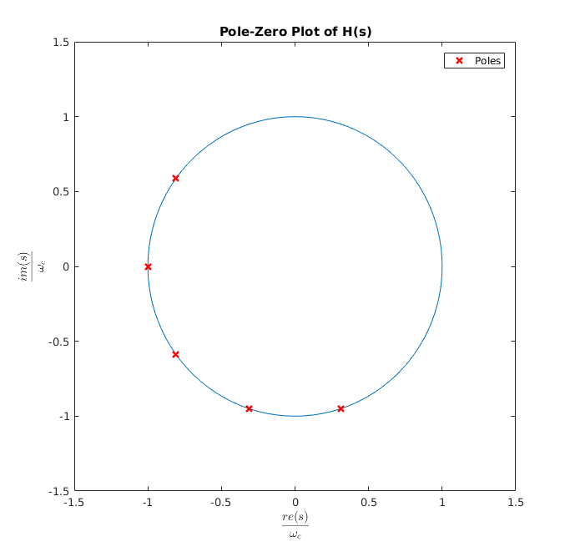

**Figure 8: Pole-Zero Plot of H(s)**

The poles are $\frac{π}{N}=\frac{π}{5}$ radians apart. For a filter to be considered stable, all the N poles must lay on Re(s) < 0.

The frequency response was also generated:

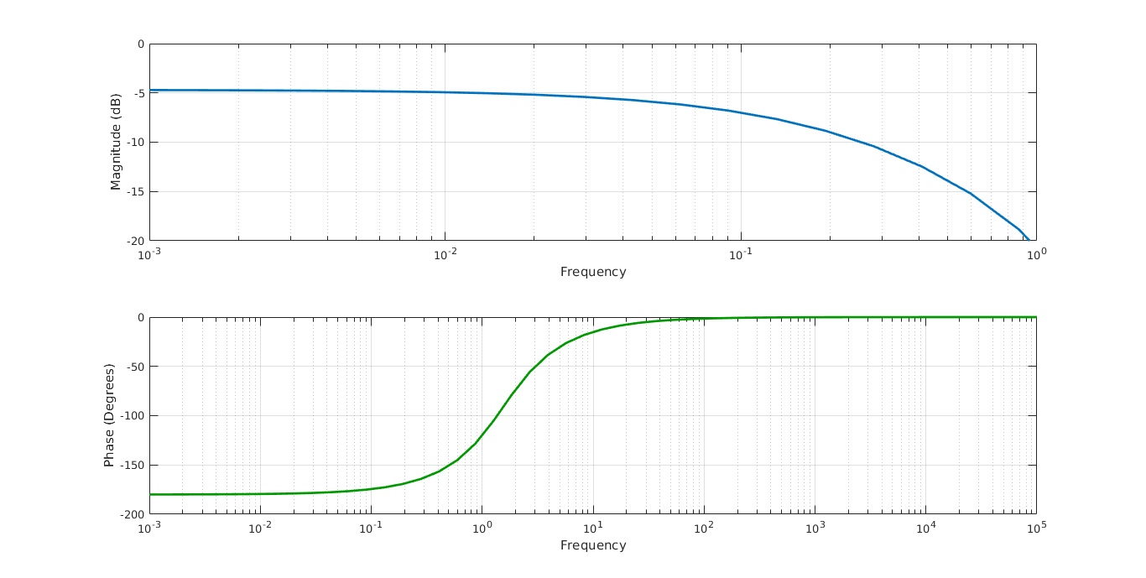

**Figure 9: Frequency Response Bode Plot of H(s)**

1. The poles were generated using MATLAB’s residue(b,a) method:

poles:

$$[0.3092-0.9515i, -0.3092-0.9515i, -0.8094-0.5881i, -1.0005, -0.8094+0.5881i]$$

which yields $h\left(t\right)=1.0024u\left(t\right)\left(e^{±\left(0.3092-0.9515i\right)t}+e^{±\left(0.8094-0.5881i\right)t}+e^{-1.0005t}\right)$.