**CMPE 323: Signals and Systems**

**Dr. LaBerge**

**Lab 02 Report:**

**Sinusoids, Time Delays, Time Scaling**

Sabbir Ahmed

1. **Introduction**

We have been talking about time functions, including common time functions like  and specialized functions like , etc. MATLAB has virtually any common function you might encounter as a built-in function. We can, and should, and will use the anonymous function capability in MATLAB to build the specialized functions.

1. **Equipment**

A computer with MATLAB installed.

1. **Time Delays with Sinusoids**
   1. **Complicated Sinusoid**

Create a Double Sideband Amplitude Modulated (DSB-AM) waveform given by the equation:

x(t) = 1+ 0.25sin(180πt) + 0.15sin(300πt) + 0.4sin(2040πt)

Nyquist Rate = $2 * highest relevant frequency,\frac{2040}{2}= 2040 Hz$

Simulating with a sample rate of 100 times the Nyquist Rate:

$100×2040=204000 Hz=204 kHz$

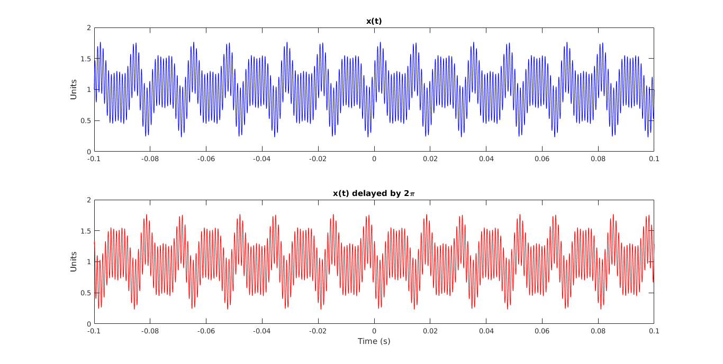

**Figure 1: x(t) with a 2π Delay Demonstrating a Time Delay Corresponding to a Frequency Dependent Phase Shift**

Create a Double Sideband Amplitude Modulated (DSB-AM) waveform is made up of 3 individual linear, time invariant functions.

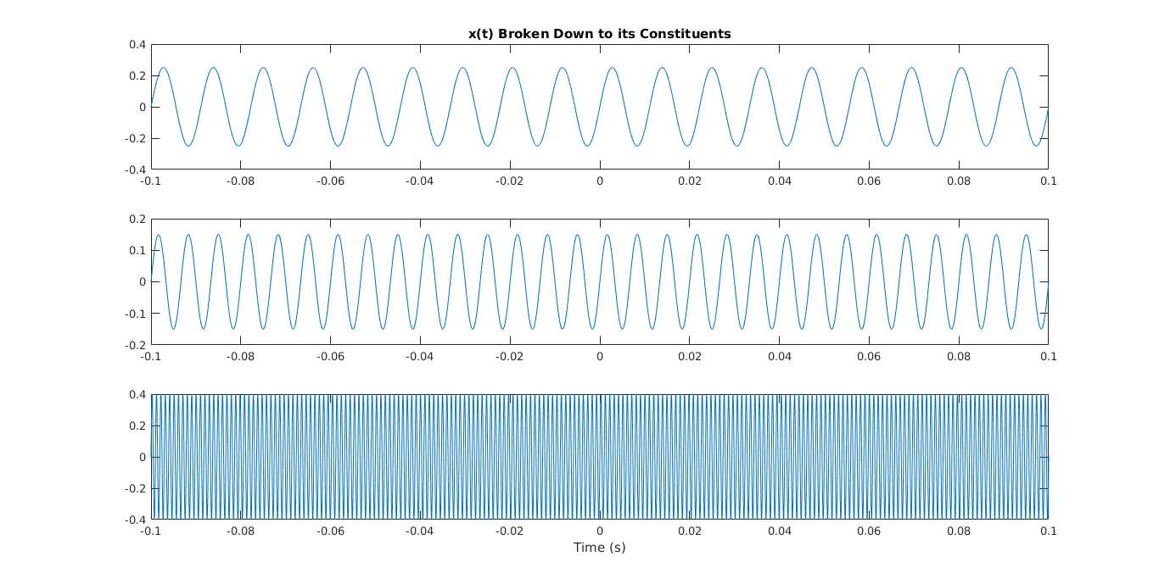

**Figure 2: x(t) Broken Down to its Constituent Functions**

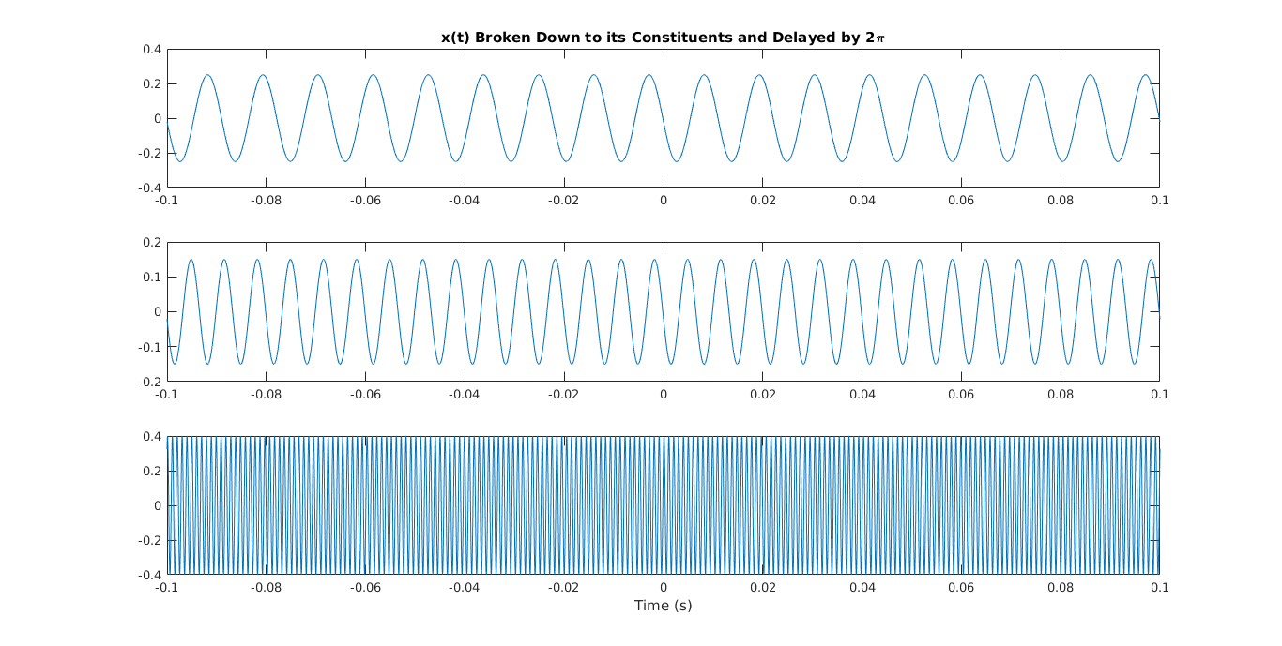

**Figure 3: x(t) with a 2π Delay Broken Down to its Constituent Functions**

* 1. **Complex Exponential**

Plotting a complex exponential with both its real and imaginary parts would create a circular function, which would not be useful for demonstrations of phase shifts and time delays. The following were plotted using the real values of the function against the time domain. ω is initialized at 100 Hz.

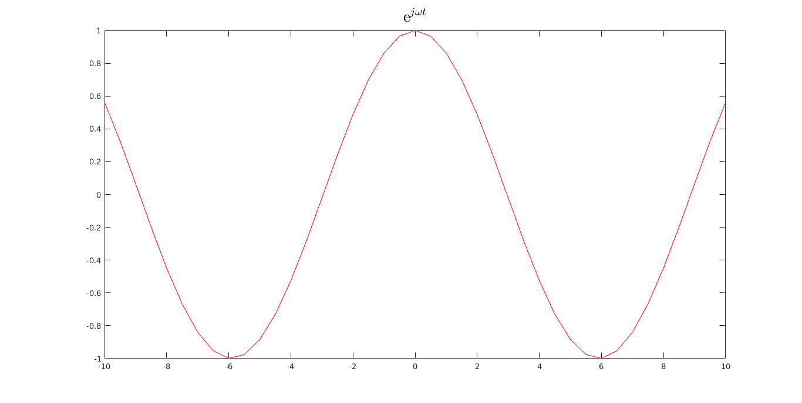

**Figure 4: Complex Exponential with 100 Hz Frequency**

To convert a periodic function from its cycles to frequency, we use the relationship $T=\frac{1}{f}$, where T and *f* represent period and frequency respectively.

$$e^{jωt+2π}=e^{jω\left(t+\frac{2π}{jω}\right)}$$

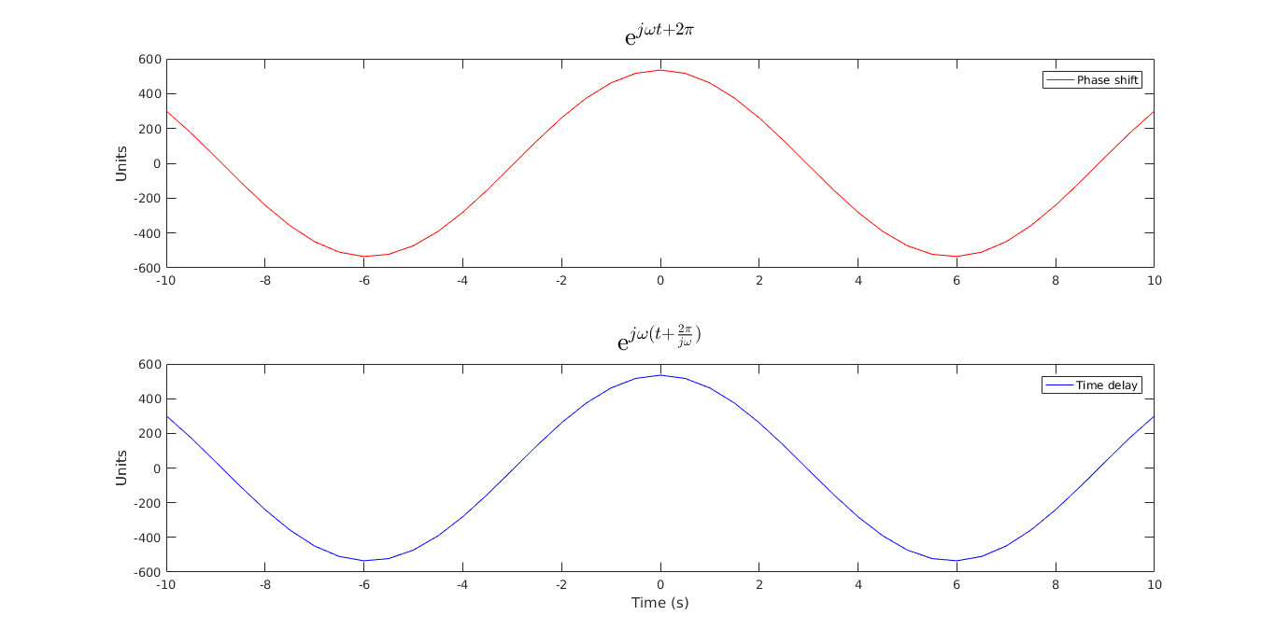

**Figure 5: Complex Exponentials with a Phase Shift of 2π and Time Delay of**

* 1. **Time Scaling**

Using the same complex exponential, the equivalence of scaling the time domain and the frequency can also be demonstrated. ω is initialized at 100 Hz.



**Figure 5: Complex Exponential with 100 Hz Frequency**

The frequency is then adjusted to correspond with the scaling of the time domain. Initializing *a*, the scalingfactor, at 0.1, the new frequency is obtained by $ω_{N}=a×ω_{o}$

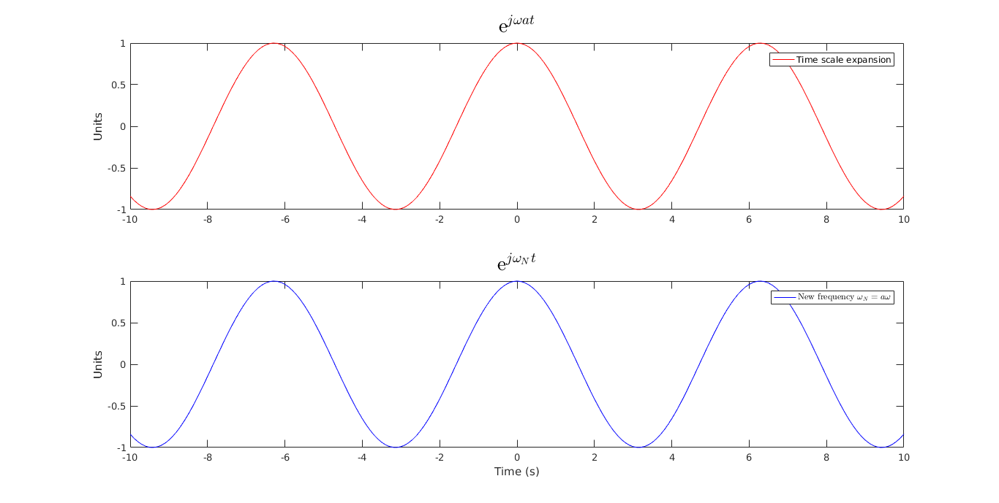

**Figure 6: Complex Exponential with Time Scale Expansion and Changed Frequency**