**CMPE 323: Signals and Systems**

**Dr. LaBerge**

**Lab 07 Report**

**Properties of the Fourier Transform Part I**

Sabbir Ahmed

1. **Introduction**

This lab explores the time shift, complex modulation, and cosine modulation properties of the Fourier Transform by direct computation. In this lab, we will be using what is known as the Discrete Time Fourier Transform (DTFT), not to be confused with the Discrete Fourier Transform (DFT) or the Fast Fourier Transform (FFT). In the DTFT, samples in time are used to compute or estimate the Fourier transform at any convenient set of frequencies. The set of frequencies are not related to the sample times! In the DFT and FFT, the sample times and computation frequencies are closely related!

1. **Equipment**

A computer with MATLAB installed.

1. **Procedure**

## Computing the Fourier Transform of the basic pulse

Using a time array from [-4.096: 0.001: 4.095], the basic anonymous pulse function was used to compute the $pulse(t+\frac{τ}{2},τ)$ for  = 1. Pulses shifted by  and were also computed and plotted

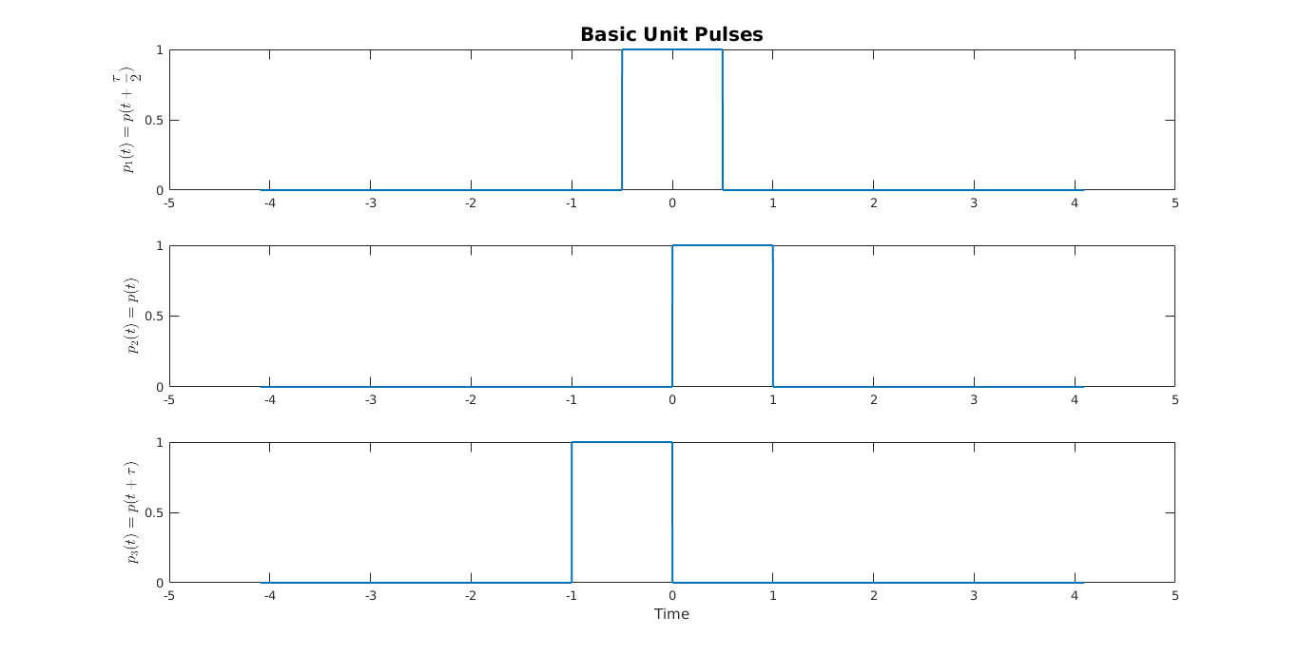

**Figure 1: Basic Unit Pulses**

An algorithm to estimate the Discrete Time Fourier Transform of the three pulses was developed, where DTFT is defined

$$\hat{X}\left(f\right)=T\sum_{-N}^{+N}{x\left(nT\right)e^{-j2π\left(nT\right)f}}$$

with  is the time function under consideration (the pulses),  is the sample interval,  is the time at which the  sample of  is computed, and  is the frequency at which the DTFT is performed.  was used. The pulses were sampled at $dt=0.05$.

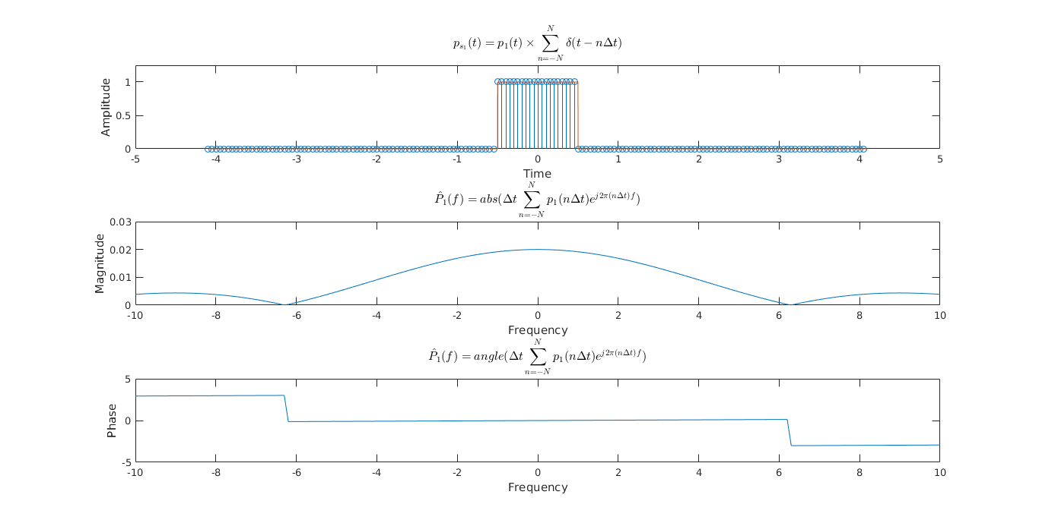

**Figure 2: Discrete Time Fourier Transform on p­1(t)**

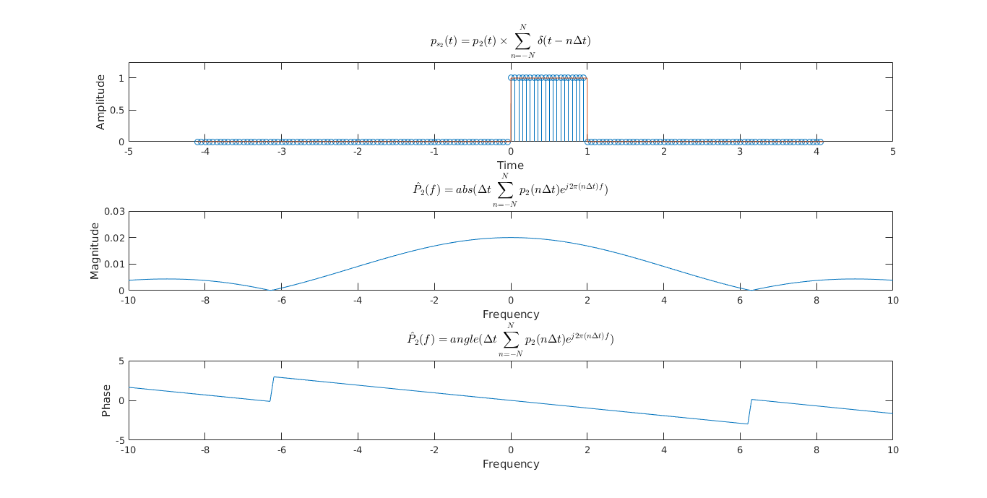

**Figure 3: Discrete Time Fourier Transform on p­2(t)**

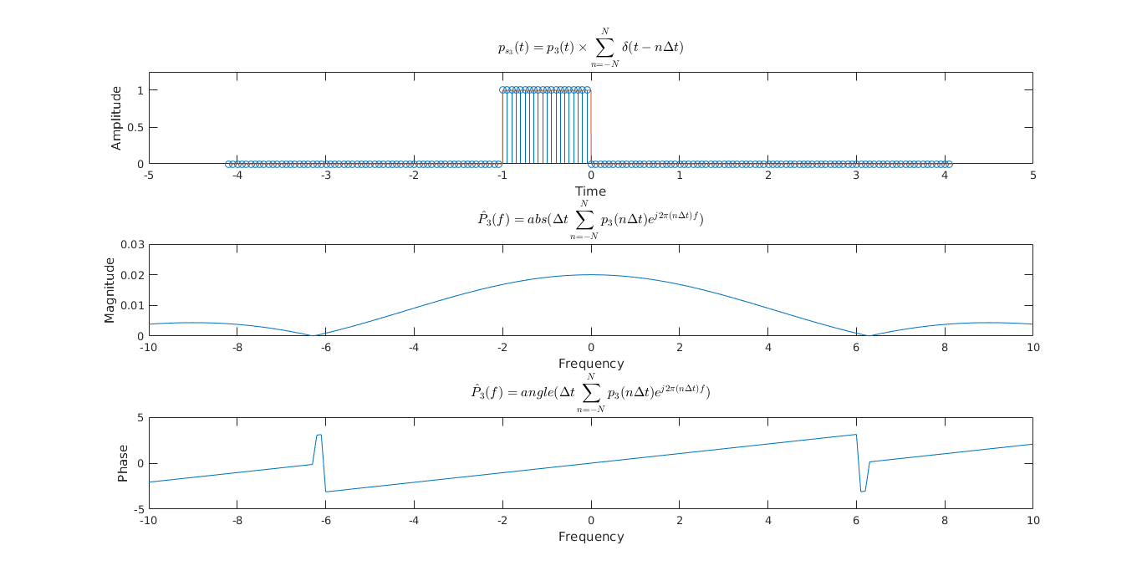**Figure 4: Discrete Time Fourier Transform on p­3(t)**

The magnitudes of the DTFT of the three pulses appear identical, even if the shift is obvious in the time domain. The phases however show distinction in the frequency domain.

## The Complex Modulation Property

Each of the three pulse functions  were taken and multiplied by

$$c\left(t\right)=e^{j2πf_{c}}$$

with . The new pulses were called, and were plotted along with their Discrete Time Fourier Transforms

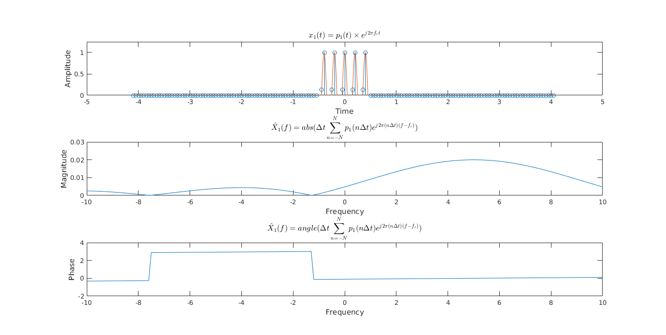

**Figure 5: Discrete Time Fourier Transform on x­1(t)**

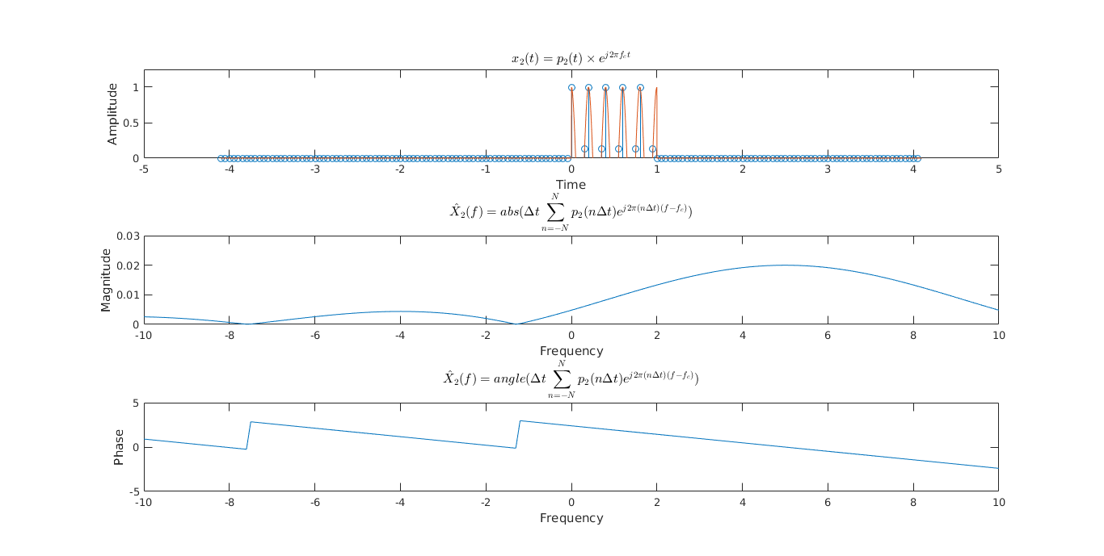

**Figure 6: Discrete Time Fourier Transform on x­2(t)**

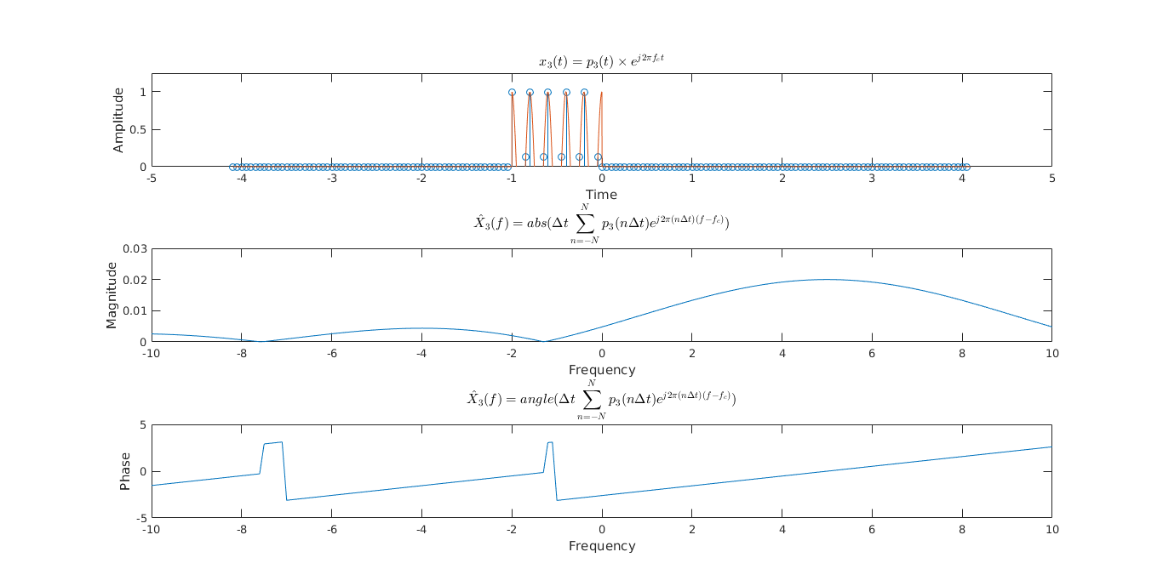

**Figure 7: Discrete Time Fourier Transform on x3(t)**

Similar to before being multiplied by the complex exponential, the magnitudes of the DTFT of the three pulses appear identical. They are however shifted to the right by 5 Hz, of the value of fc. Consistent changes in the phases of the functions cannot be observed, but they appear to be shifted to the opposite direction instead.

## The Cosine Modulation Property

A corollary to the Complex Modulation Theorem is the Cosine Modulation Property, which uses the Euler expansion of the cosine and applies the Complex Modulation Property. Each of the original pulses were taken and multiplied by

$$m\left(t\right)=\cos\left(2πf_{c}t\right)$$

with . The new pulses were called, and were plotted along with their Discrete Time Frequency Transforms.

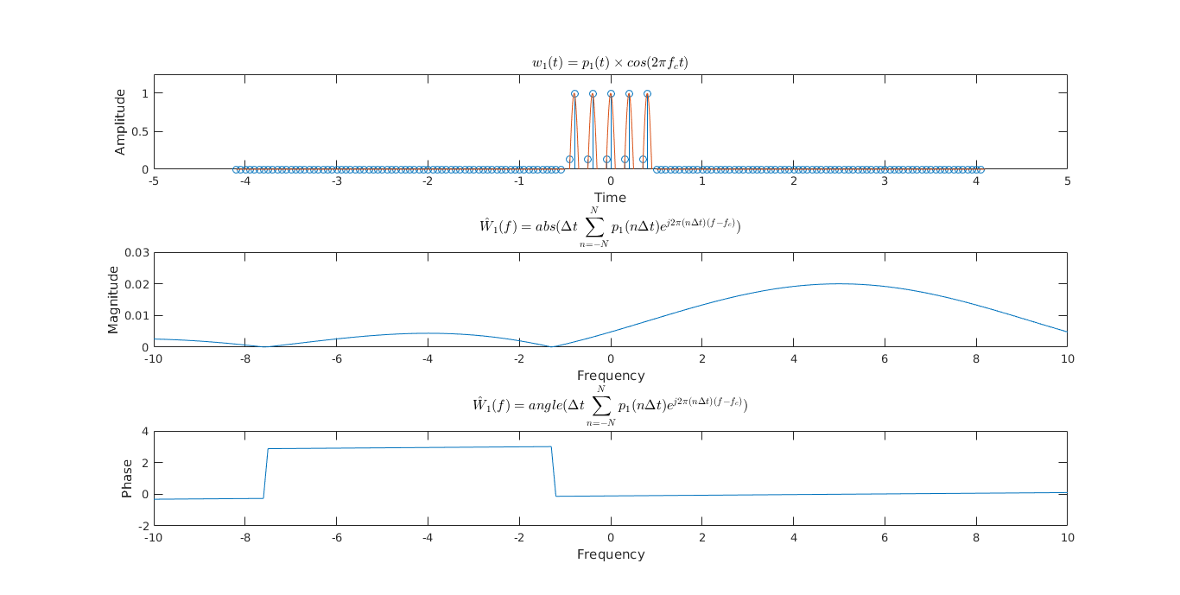

**Figure 8: Discrete Time Fourier Transform on w1(t)**

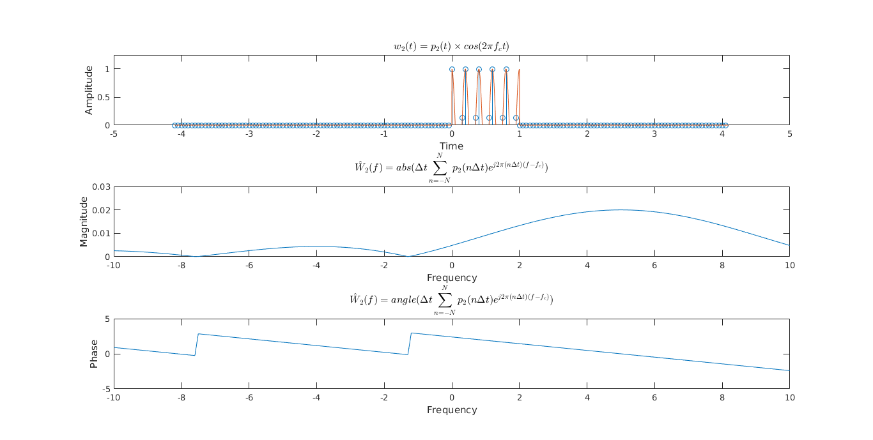

**Figure 9: Discrete Time Fourier Transform on w2(t)**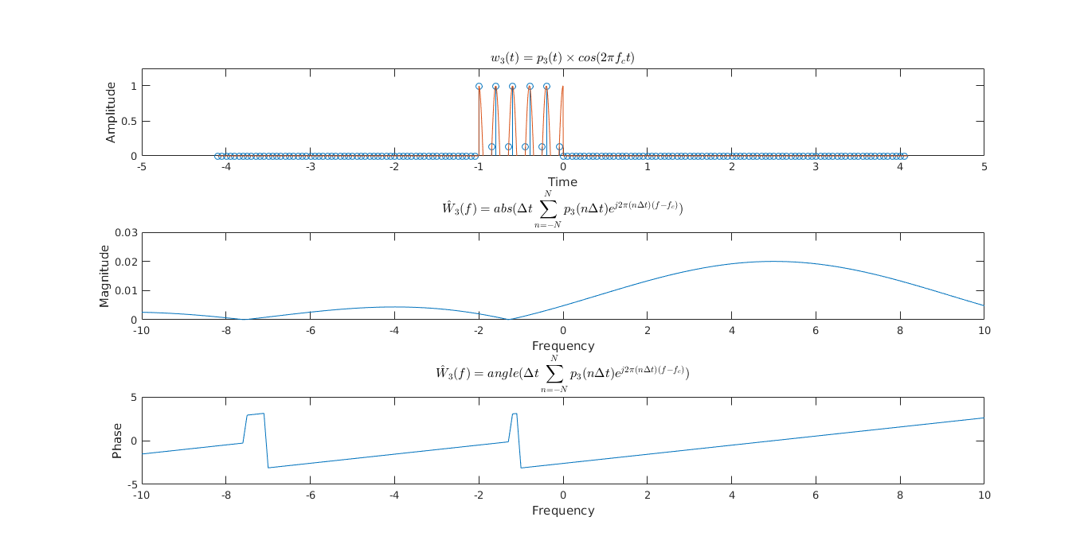

**Figure 10: Discrete Time Fourier Transform on w3(t)**

The functions appear to be identical to when they were multiplied by the complex exponential.