**CMPE 323: Signals and Systems**

**Dr. LaBerge**

**Lab 08 Report**

**Using the Fast Fourier Transform**

Sabbir Ahmed

1. **Introduction**

This lab explores the use of the Fast Fourier Transform (FFT) to do spectrum analysis of sampled data systems. The FFT is an extremely efficient algorithm for computing the Discrete Fourier Transform (DFT).

1. **Equipment**

A computer with MATLAB installed.

1. **Procedure**

## Computing the Fourier Transform of the basic pulse

Using a time array from [-4096: 0.001: 4095], the basic anonymous pulse function was used to compute the $pulse(t+\frac{τ}{2},τ)$ for  = 1. Pulses shifted by  and were also computed and plotted

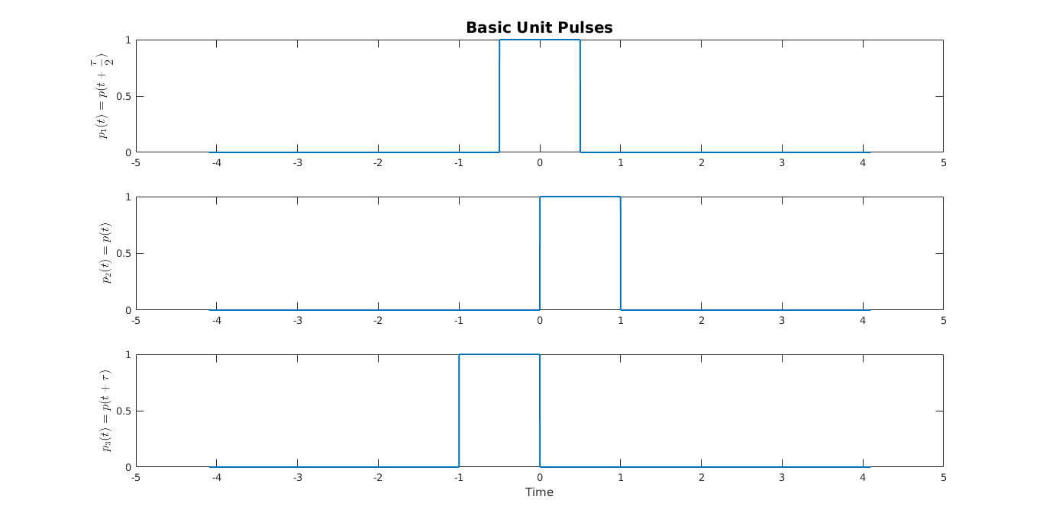

**Figure 1: Basic Unit Pulses**

An algorithm to estimate the Discrete Time Fourier Transform of the three pulses was developed, where DTFT is defined

$$\hat{X}[k]=T\sum_{n=0}^{n=N-1}{x[n]e^{-\frac{j2πkn}{N}}}$$

with $X[k]$ is the result at $f=\frac{k}{T}$, where $k=0,1,2,…,N-2,N-1$, and $x\left[n\right]=x\left(nΔt\right),$ where $n=0,1,2,…,N-2, N-1$.

The Discrete Fourier Transform of the basic unshifted pulse is known to be

$$\int_{\frac{τ}{2}}^{-\frac{τ}{2}}{\left(1\right)\left(e^{j2πf}\right)dt}= τsinc\left(τf\right)$$

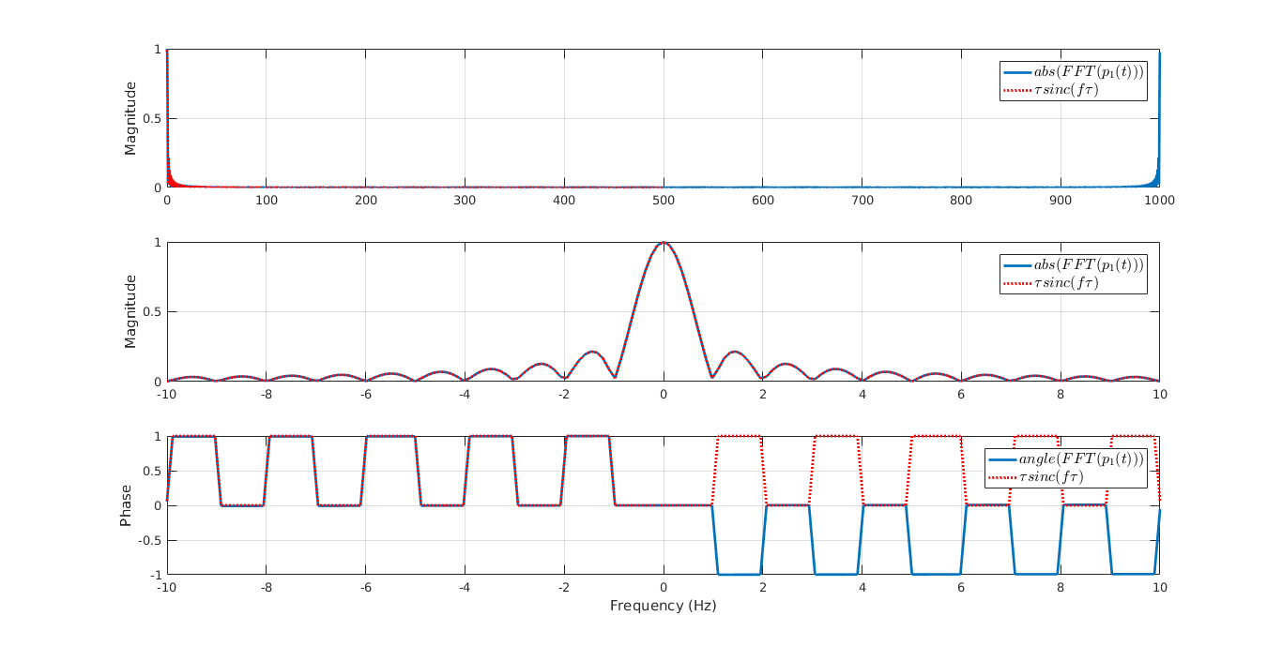

**Figure 2: Fast Fourier Transform of p1(t)**

Using the time shift property of Fourier Transform:

$$F\left(x\left(t-t_{0}\right)\right)=e^{-j2πft_{0}}F(x(t))$$

$$∵p_{2}\left(t\right)=p_{1}\left(t-\frac{τ}{2}\right)→F\left(p_{2}\left(t\right)\right)=e^{-jπfτ}F\left(p_{1}\left(t\right)\right)=e^{-jπfτ}τsinc(τf)$$

$$∵p_{3}\left(t\right)=p_{1}\left(t+\frac{τ}{2}\right)→F\left(p_{3}\left(t\right)\right)=e^{jπfτ}F\left(p_{1}\left(t\right)\right)=e^{jπfτ}τsinc(τf)$$

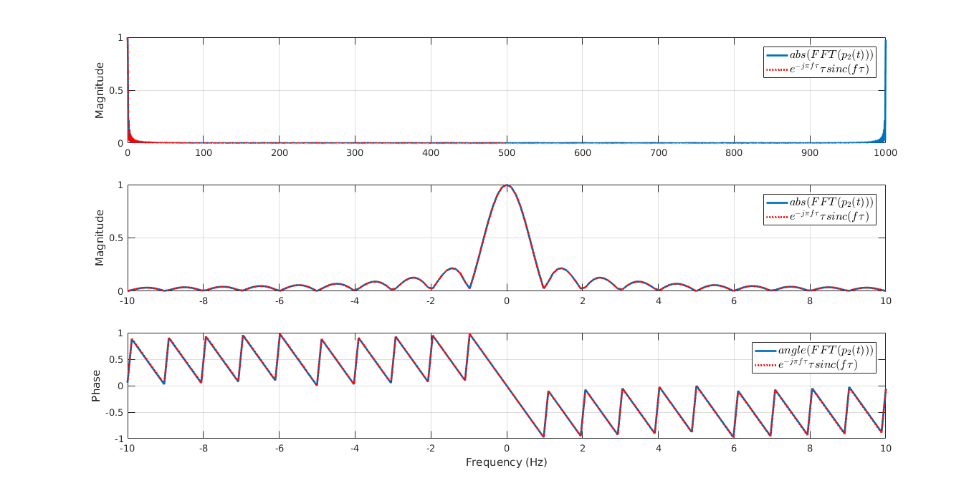

**Figure 3: Fast Fourier Transform of p2(t)**

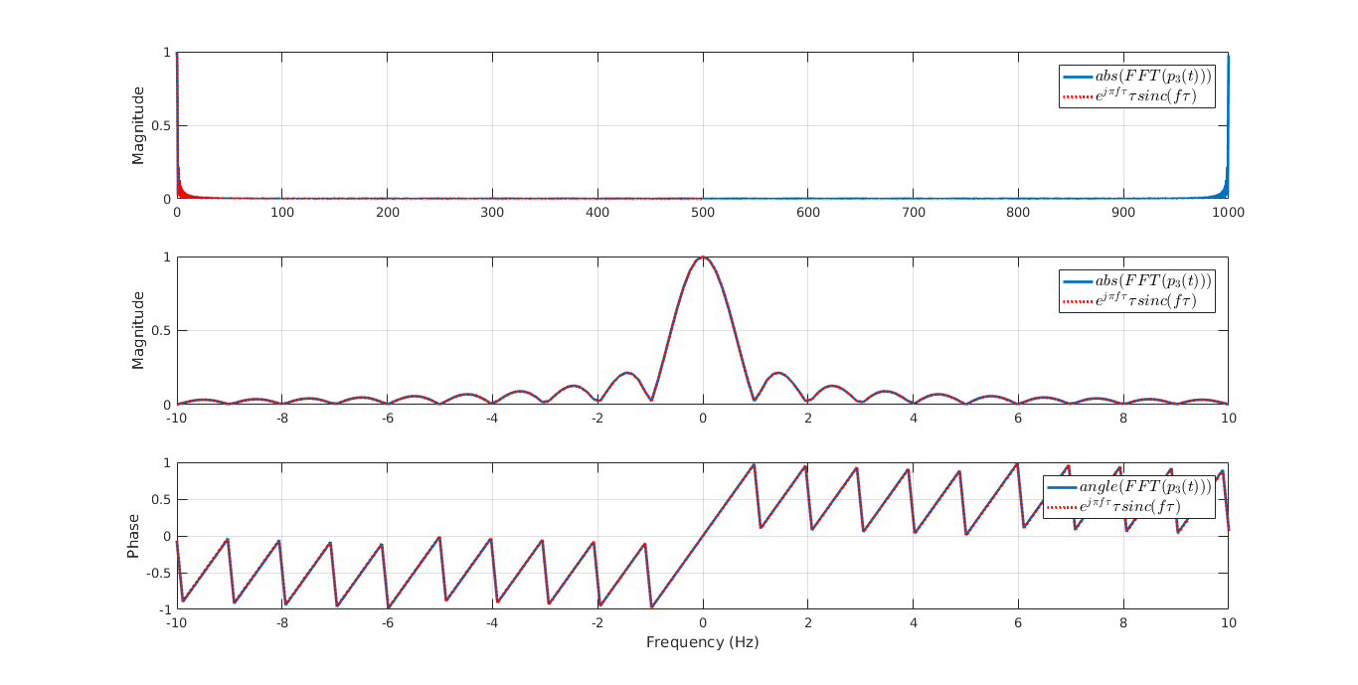

**Figure 4: Fast Fourier Transform of p3(t)**

The theoretical functions appear identical to the values computed by MATLAB’s $fft(x)$ function. The magnitudes of the DTFT of the three pulses also appear identical, even if the shift is obvious in the time domain. The phases however show distinction in the frequency domain. The shifted functions (p2(t) and p3(t)) have their phases appearing inverted of each other.

## The Complex Modulation Property

Each of the three pulse functions  were taken and multiplied by

$$c\left(t\right)=e^{j2πf_{c}}$$

with $f_{c}=5.0049 Hz$. The new pulses were called, and were plotted along with their Discrete Time Fourier Transforms.

Using the modulation property of Fourier Transform:

$$F\left(e^{j2πf_{0}t}x\left(t\right)\right)=X\left(f-f_{0}\right)$$

$$∴F\left(e^{j2πf_{c}t}p_{1}\left(t\right)\right)=τsinc\left(τ\left(f-f_{c}\right)\right)$$

$$∴F\left(e^{j2πf_{c}t}p_{2}\left(t\right)\right)=e^{-jπ\left(f-f_{c}\right)τ}τsinc\left(τ\left(f-f_{c}\right)\right)$$

$$∴F\left(e^{j2πf_{c}t}p_{3}\left(t\right)\right)=e^{jπ\left(f-f_{c}\right)τ}τsinc\left(τ\left(f-f_{c}\right)\right)$$

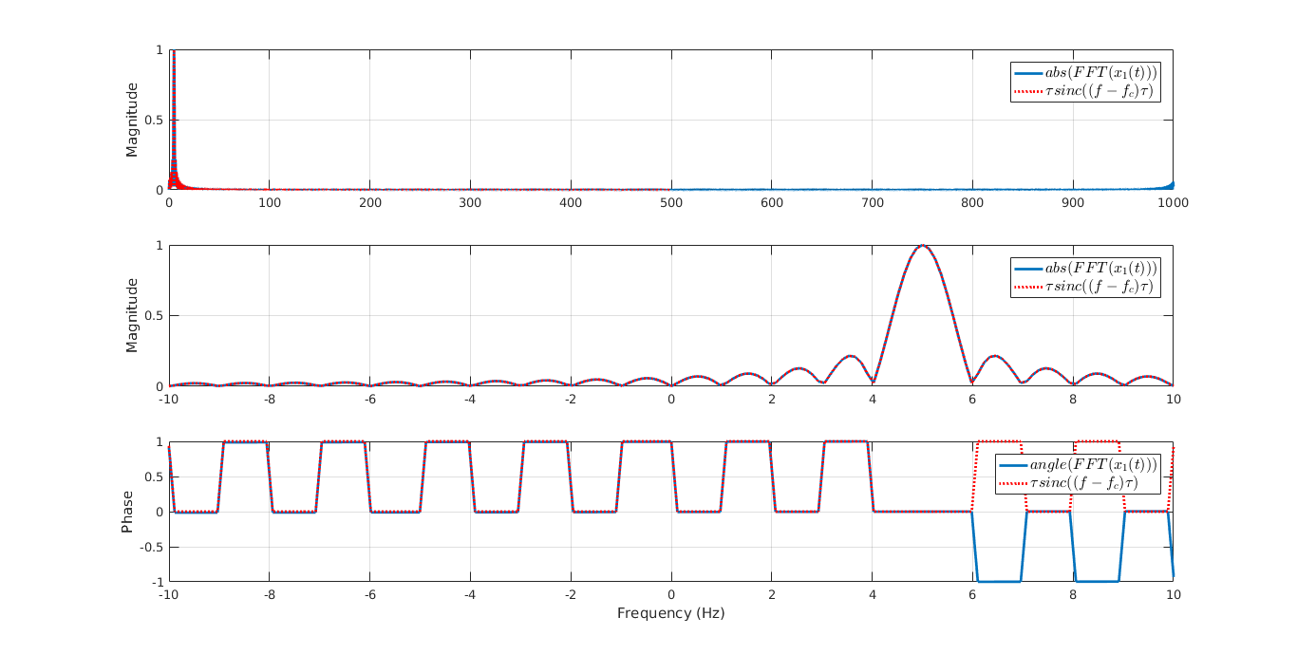

**Figure 5: Fast Fourier Transform on x­1(t)**

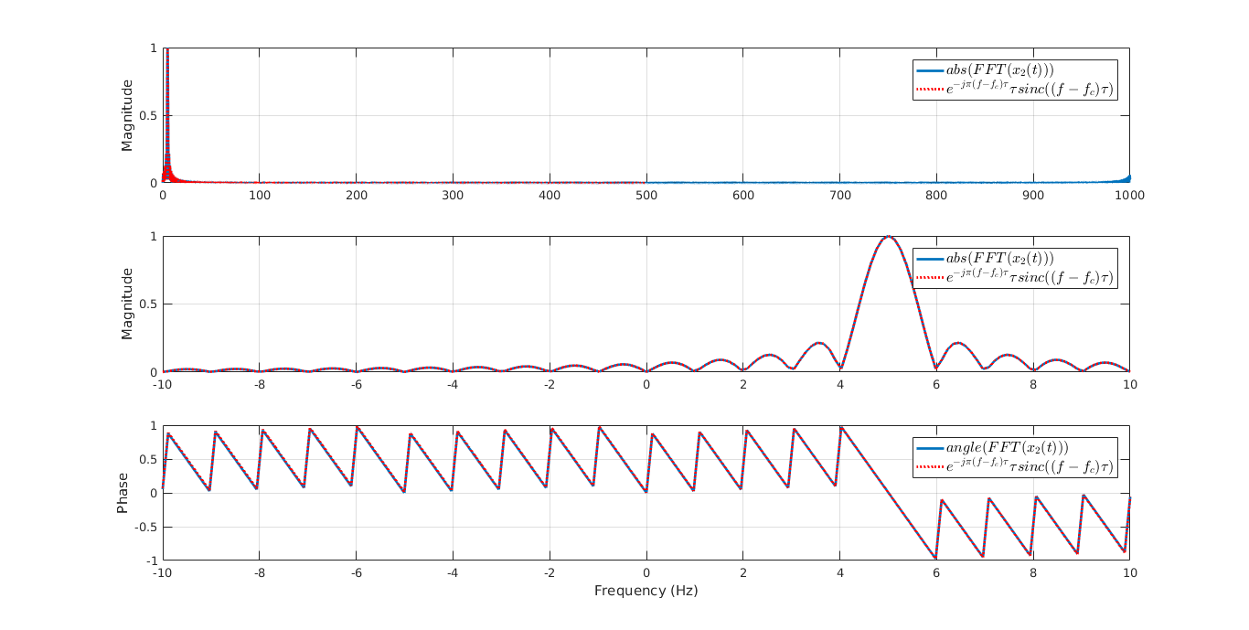

**Figure 6: Fast Fourier Transform on x­2(t)**

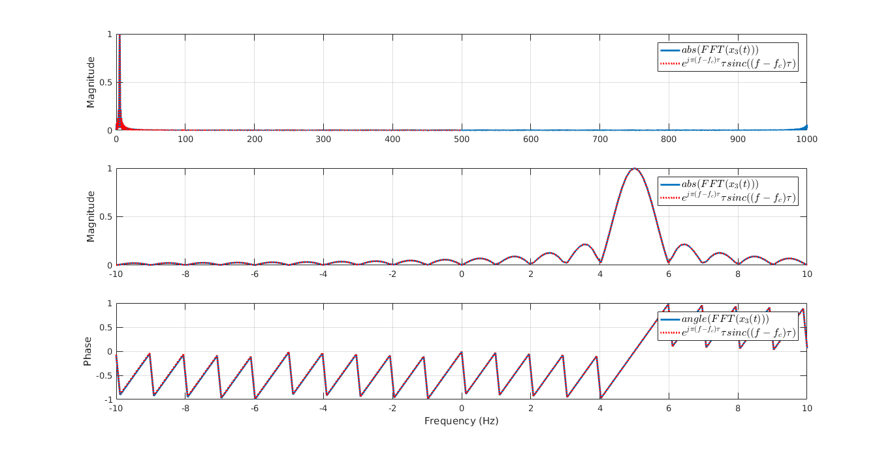

**Figure 7: Fast Fourier Transform on x3(t)**

Both the theoretical and computed functions appear identical to the Fourier Transforms of the original pulses, with their magnitudes and phases shifted to the right by $f_{c}=5.0049 Hz$.

## The Cosine Modulation Property

A corollary to the Complex Modulation Theorem is the Cosine Modulation Property, which uses the Euler expansion of the cosine and applies the Complex Modulation Property. Each of the original pulses were taken and multiplied by

$$m\left(t\right)=\cos\left(2πf_{c}t\right)$$

with $f_{c}=5.0049 Hz$. The new pulses were called, and were plotted along with their Discrete Time Frequency Transforms.

Using the modulation property of Fourier Transform:

$$F\left(e^{j2πf_{0}t}x\left(t\right)\right)=X\left(f-f_{0}\right)$$

And Euler’s Identity:

$$\cos\left(x\right)=\frac{e^{jx}-e^{-jx}}{2}$$

$∵F\left(e^{j2πf_{0}t}x\left(t\right)\right)=X\left(f-f_{0}\right)$ and $F\left(e^{-j2πf_{0}t}x\left(t\right)\right)=X\left(f+f_{0}\right)$

$$∴ F\left(cos⁡(2πf_{c}t)x\left(t\right)\right)=\frac{1}{2}\left(X\left(f-f_{0}\right)+X\left(f+f_{0}\right)\right)$$

$$∴ F\left(\cos\left(2πf_{c}t\right)p_{1}\left(t\right)\right)$$

$$=\frac{1}{2}\left(τsinc\left(τ\left(f-f_{c}\right)\right)+τsinc\left(τ\left(f+f_{c}\right)\right)\right)$$

$$=\frac{1}{2}\left(sinc\left(τ\left(f-f_{c}\right)\right)+sinc\left(τ\left(f+f_{c}\right)\right)\right)$$

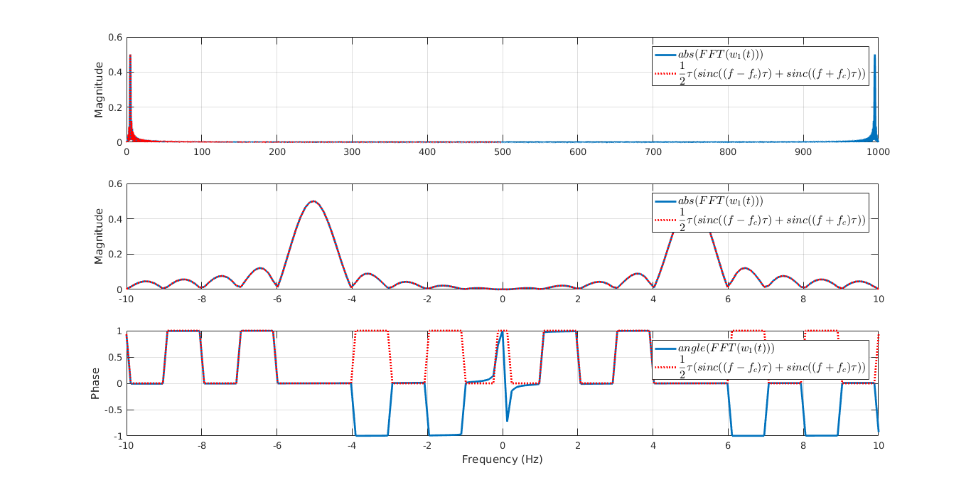

**Figure 8: Discrete Time Fourier Transform on w1(t)**

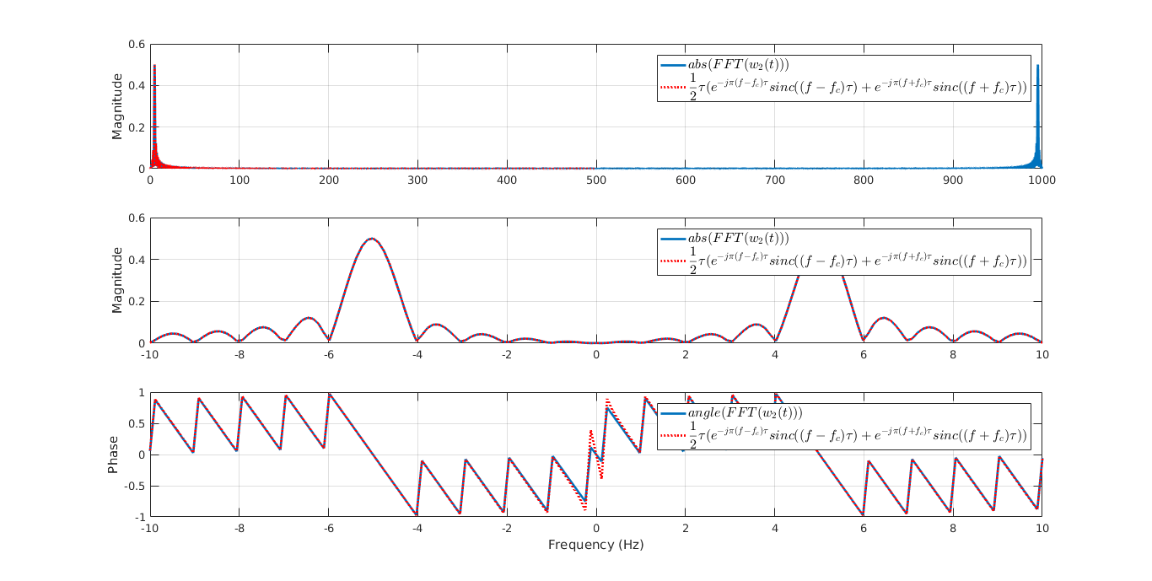

**Figure 9: Fast Fourier Transform on w2(t)**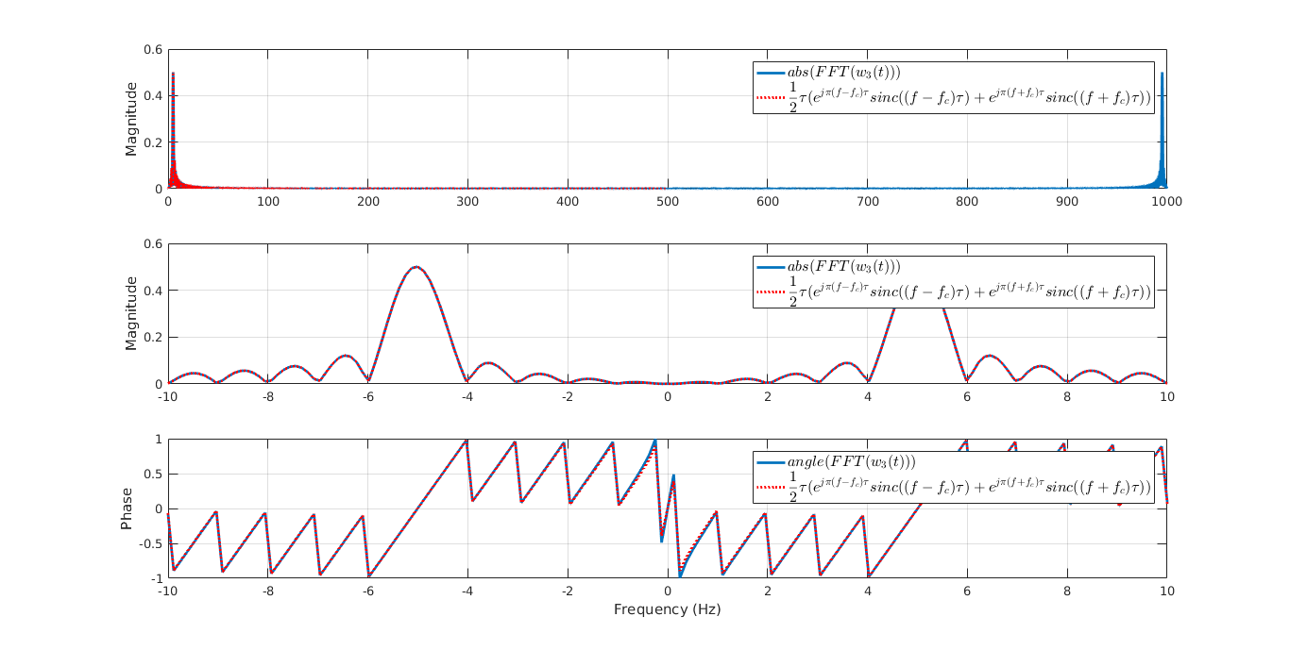

**Figure 10: Fast Fourier Transform on w3(t)**

Both the theoretical and computed functions appear identical to each other except some discrepancies in the phases.