**Sabbir Ahmed**

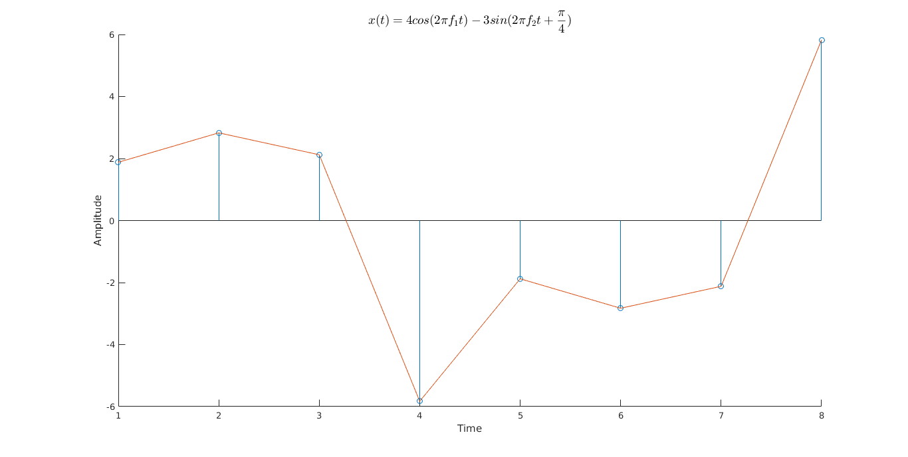

**Figure 1: x[n] sampled at 8 sps**

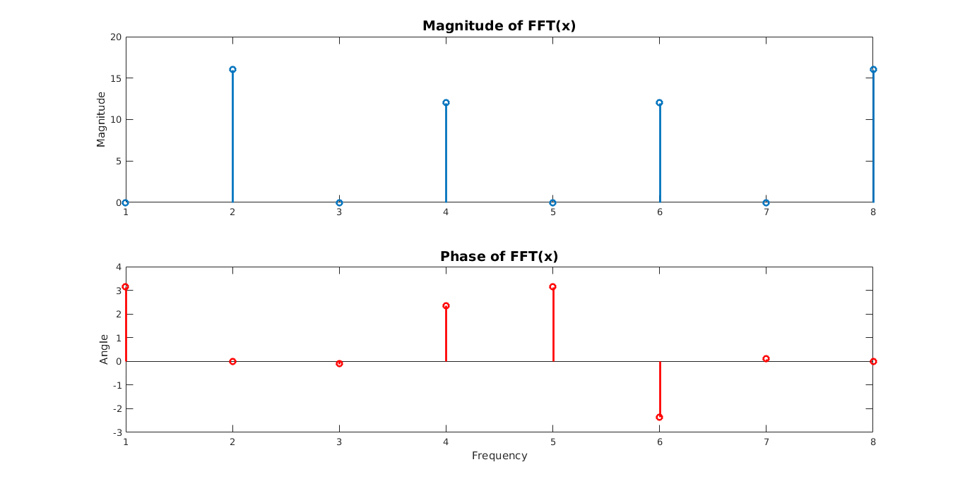

**Figure 2: Fast Fourier Transform of x[n]**