**3. b. Plots:**

The following variables and anonymous functions were used to generate the plots:

lambda = 1;

x = -2*lambda:0.001:0*lambda;

A = 1;

beta = 2*pi;

y1 = @(x, omega_t) (A * cos(omega_t - beta*x));

y2 = @(x, omega_t) (A * cos(omega_t + beta*x));

ys = @(x, omega_t) (y1(x, omega_t) + y2(x, omega_t));

The first plot was generated with the following snippet:

figure;

hold on;

p1 = plot(x, y1(x, pi/4));

p2 = plot(x, y2(x, pi/4));

p3 = plot(x, ys(x, pi/4));

xlabel('x');

ylabel('$$\omega t = \frac{\pi}{4}$$', 'interpreter', 'latex', 'fontsize', 15);

legend([p1; p2; p3], 'y_1(x, t)', 'y_2(x, t)', 'y_s(x, t)');

hold off;

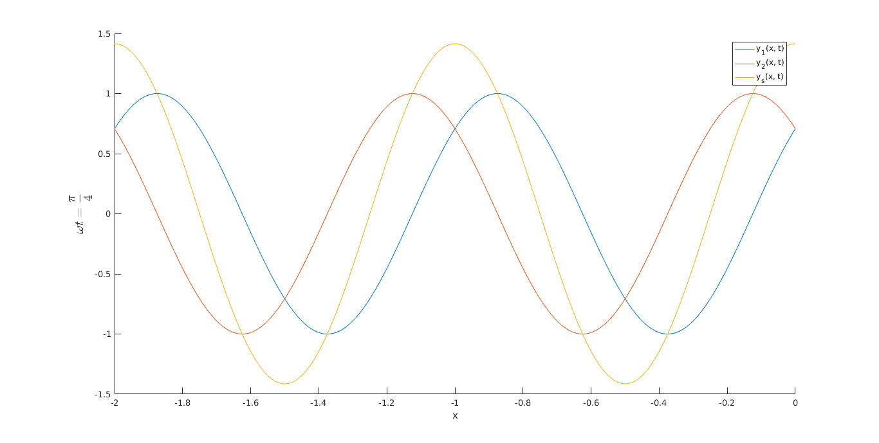

**Figure 1: Current Waves vs -2λ ≤ x ≤ 0 at ωt = π/4**

The second plot was generated with the following snippet:

figure;

hold on;

p4 = plot(x, y1(x, pi/2));

p5 = plot(x, y2(x, pi/2));

p6 = plot(x, ys(x, pi/2));

xlabel('x');

ylabel('$$\omega t = \frac{\pi}{2}$$', 'interpreter', 'latex', 'fontsize', 15);

legend([p4; p5; p6], 'y_1(x, t)', 'y_2(x, t)', 'y_s(x, t)');

hold off;

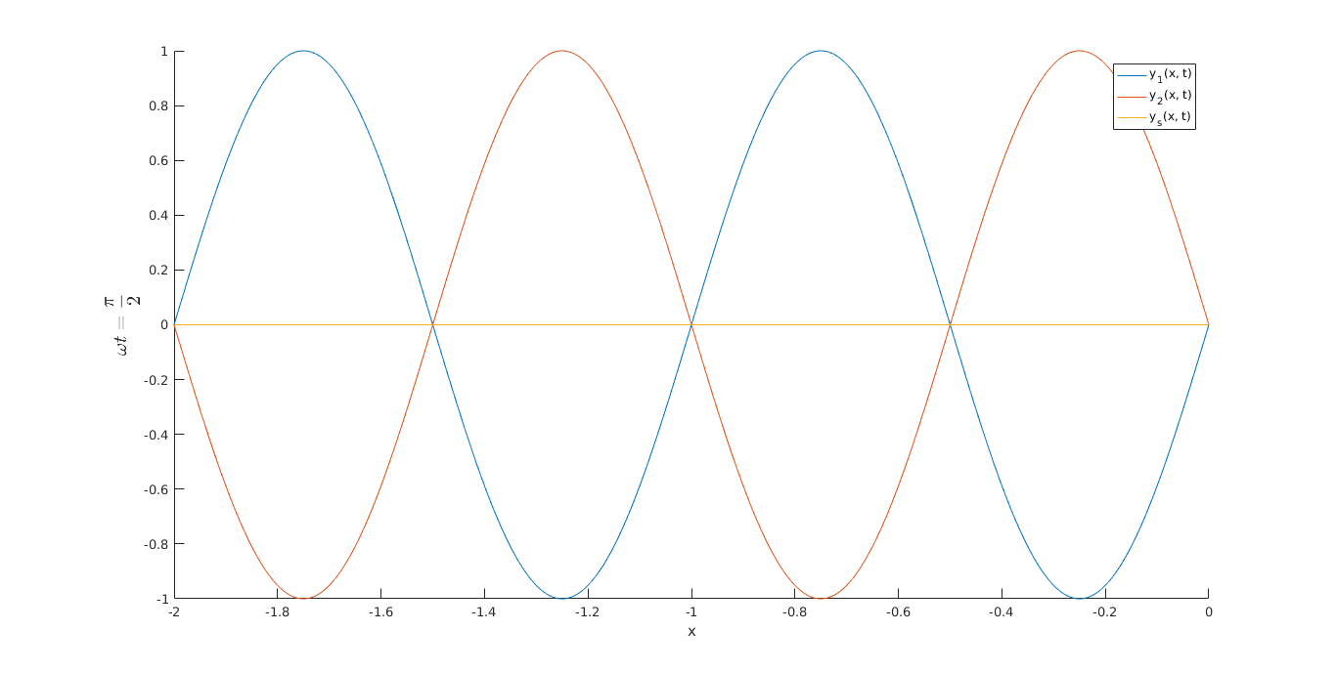

**Figure 2: Current Waves vs -2λ ≤ x ≤ 0 at ωt = π/2**

**6. MATLAB Computations**

a. ln(3 – j5):

z1 = 3 - 5j;

log(z1)

ans =

1.7632 - 1.0304i

b. exp(3 – j4):

z2 = 3 - 4j;

exp(z2)

ans =

-13.1288 +15.2008i

c. exp(3exp(jπ/6)):

z3 = 3 * exp(1j*pi/6);

exp(z3)

ans =

0.9506 +13.4042i