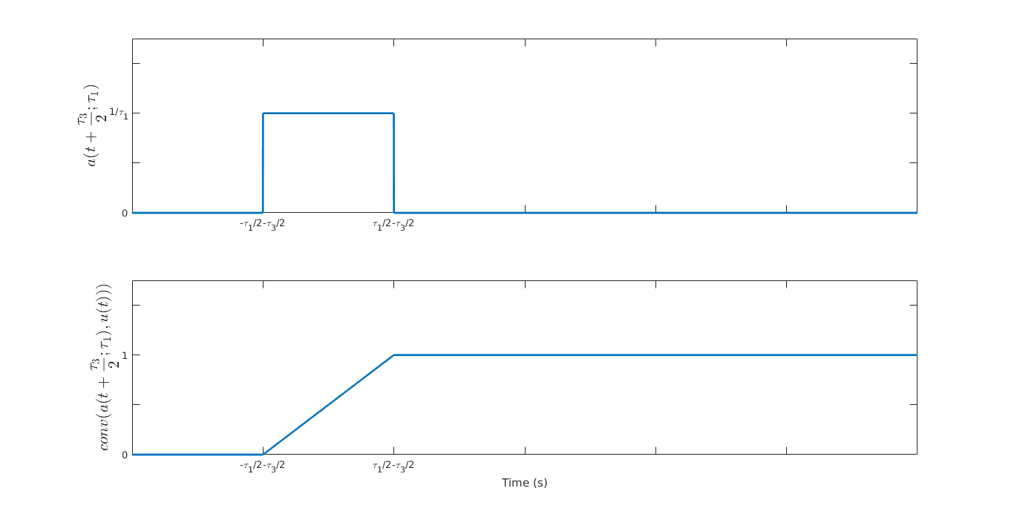

**Figure 1: Demonstration of $y_{1}(t)$ as the output of the convolution of the input $x_{1}\left(t\right)$ with the unit step function**

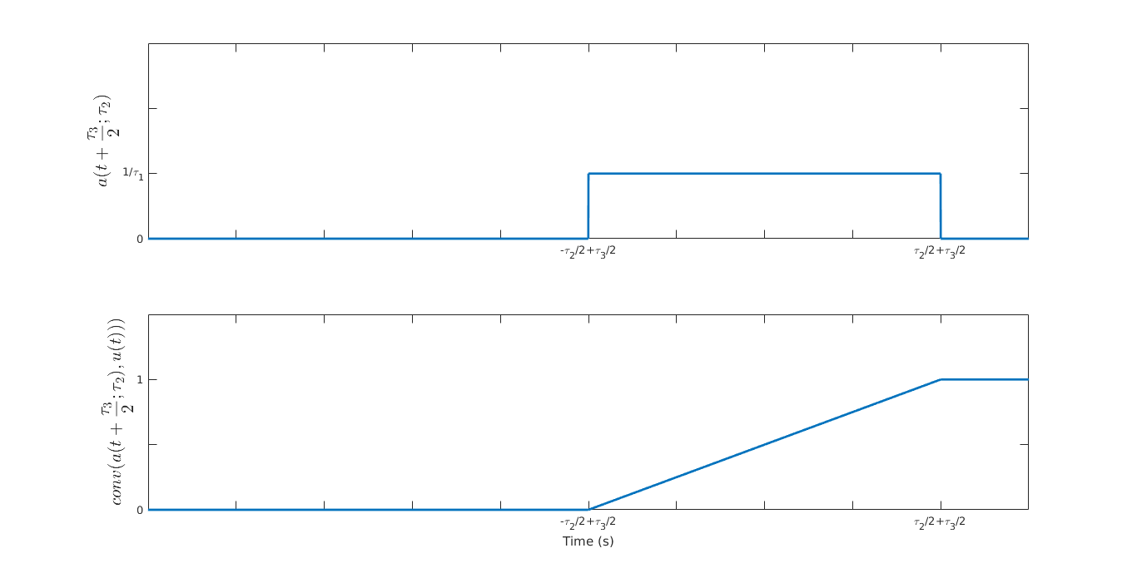

**Figure 2: Demonstration of $y_{2}(t)$ as the output of the convolution of the input $x_{2}\left(t\right)$ with the unit step function**

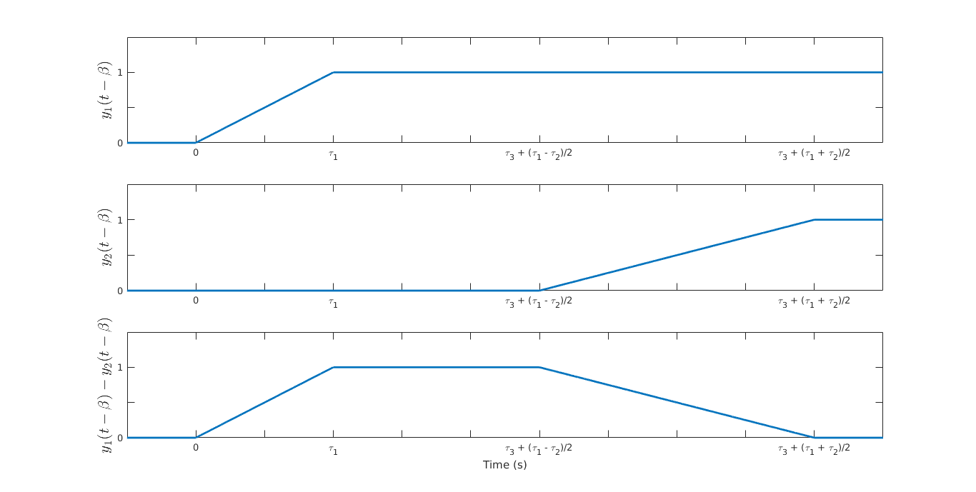

**Figure 3: Demonstration of $w(t)$ as the difference between $y_{1}\left(t\right)$ and $y_{2}\left(t\right)$**