**CMPE314: Principles of Electronic Circuits**

**Dr. Yan**

**Lab 01 Report:**

**Diode Characteristics and Diode-Based Circuit**

**Sabbir Ahmed**

**Yu Fu**

1. **Objective**

Measure and study the I-V characteristics of a diode.

1. **Equipment**
   1. One $220 Ω$ resistor
   2. One 1N4732 Zener diode
   3. Oscilloscope, DC power supply, digital multi-meter, function generator, breadboard
2. **Background**

Lorem ipsum fbsbfsbdfhjsdf

1. **Procedure**

**4.1 Part A. I-V Characteristics of Diode**

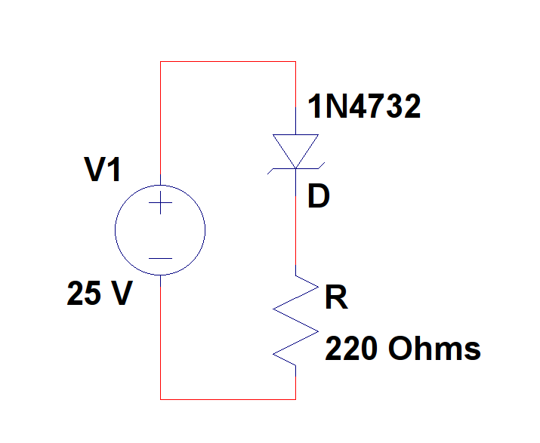

**Figure 1: Diode I-V characteristics measurement circuit**

* 1. Use a 1N4732 Zener diode to construct the circuit from Figure 1.
  2. Sweep the DC power supply from 0 V to 5 V in increments of 0.2 V. Record and plot the results. Determine the turn-on voltage of the diode.
  3. Reverse the polarity, and sweep the power supply from 0 V to 25 V in increments of 0.5 V. Record and plot the I-V curve. Determine the breakdown voltage.
  4. Compare the experimental I-V curves to that on the ideal diode model and linear-piecewise diode model. What are Is and n for this diode based on a fit to the ideal model? What are the forward resistance rf and the Zener resistance rz?

**4.2 Diode Circuit**

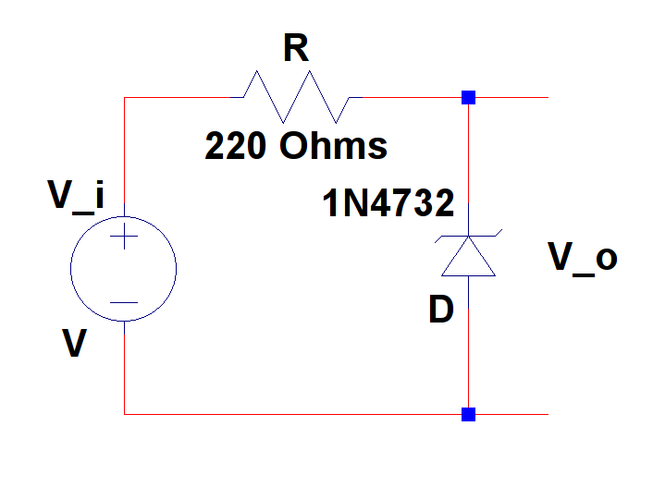

**Figure 2: Diode measurement circuit**

1. Replace the DC power with the signal generator to create the circuit from Figure 2. Set Vi and Vo to the two channels of the oscilloscope. Set Vi to be a sinusoid of 5 kHz.
2. Vary the input amplitude to the signal generator form 0 V to 10 V in increments of 1 V. Observe and record the input and output peak-peak voltages and waveforms.
3. Explain the observed output waveforms. What kind of circuit is this?
4. **Results**