**CMPE314: Principles of Electronic Circuits**

**Dr. Yan**

**Lab 02 Report:**

**Diode-Based Filtered Rectifier and Regulator Circuits**

**Sabbir Ahmed**

**Yu Fu**

1. **Objective**

Examine a filtered rectifier circuit. Theoretically and experimentally determine the proper resistance for the filter

1. **Equipment**
   1. One ___ Ω resistor
   2. One 22 µF capacitor
   3. One 1N4740 diode
   4. One 741 operational amplifier
   5. Oscilloscope, DC power supply, digital multi-meter, function generator, breadboard
2. **Background**

Filtered rectifiers convert AC waveforms into useful near-DC waveforms. Rectifiers have many uses including as components of power supplies and as detectors of radio signals. They may be made of solid state diodes, vacuum tube diodes, and other components. A voltage buffer amplifier is used to transfer a voltage from a first circuit, having a high output impedance level, to a second circuit with a low input impedance level. A unity gain buffer, also known as a voltage follower, has a voltage gain of approximately unity, while it provides considerable current gain and thus power gain.

1. **Procedures**

**4.1 Part A. Diode-Based Filtered Rectifier Circuit**

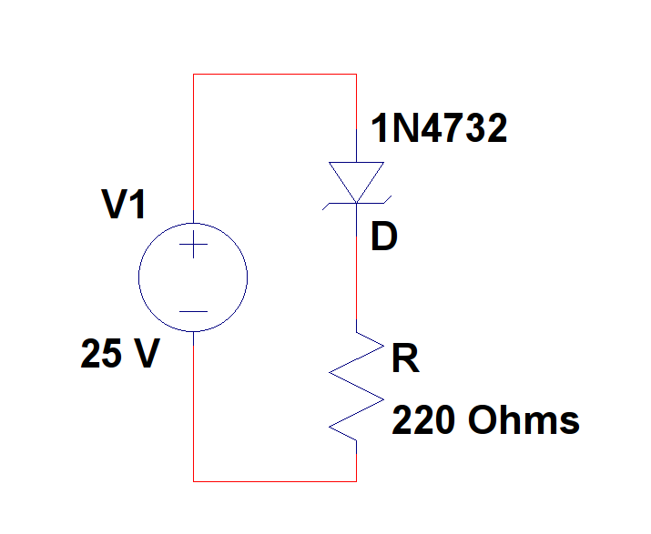

**Figure 1: Diode I-V characteristics measurement circuit**

* 1. Use a 1N4740 diode to construct the circuit from Figure 1.
  2. Set the input signal amplitude to be 5 V and frequency to be 60 Hz.
  3. Vary the potentiometer until the output ripple voltage is less than 10%.
  4. Measure the potentiometer resistance as RL_measured. Compare the expected value for RL with the measured value.

**4.2 Part B. Diode-Based Filtered Regulator Circuit (Simulation)**

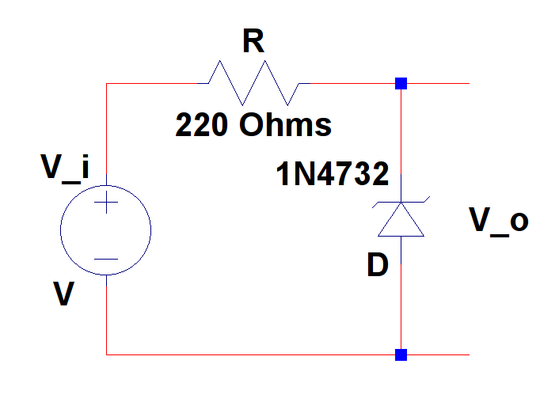

**Figure 2: Diode measurement circuit**

1. Simulate the same circuit from Figure 1 on Cadence Orcad PSPICE.
2. **Results**

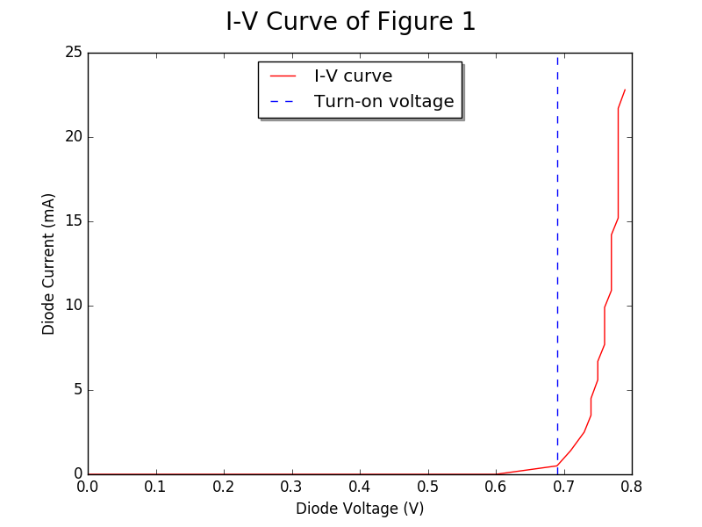

**Figure 3: I-V Curve Observed from Figure 1**

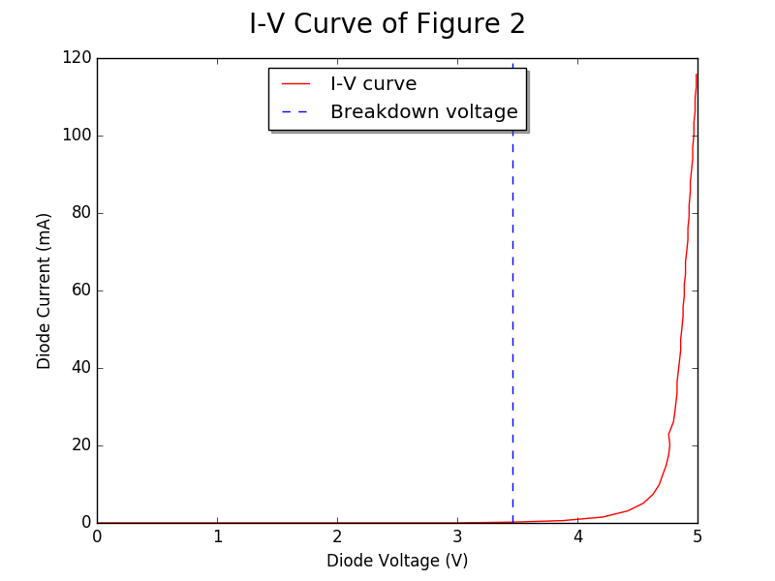

**Figure 4: I-V Curve Observed After Reversing the Polarity of the Power Supply in Figure 1**

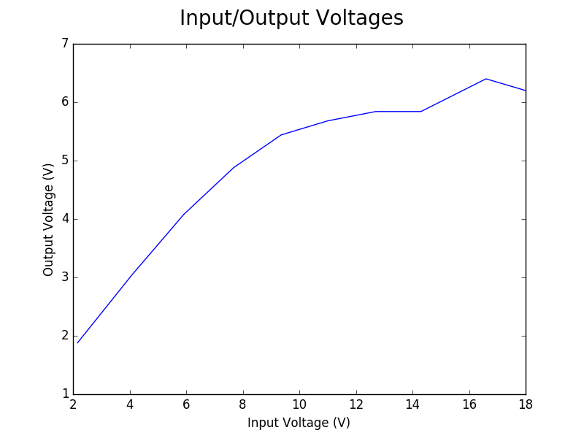

**Figure 5: Non-linear relationship between input and output voltage (peak-peak) of Figure 2**

**Waveforms of Figure 2 as observed in the oscilloscope:**

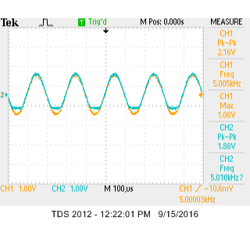 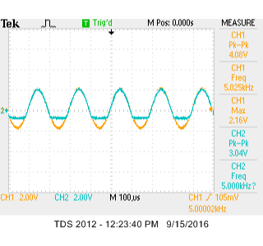 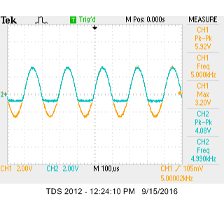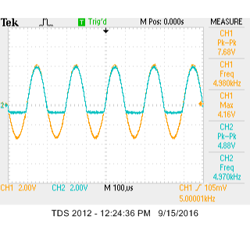 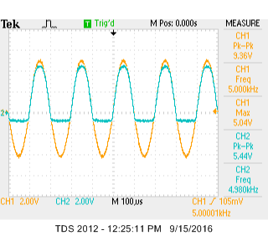 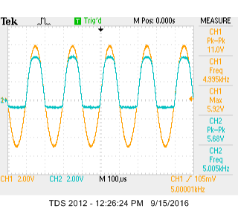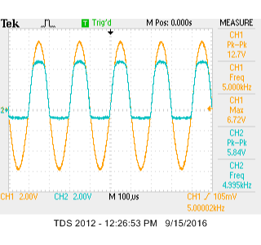 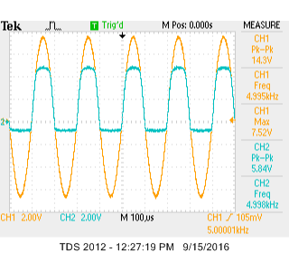 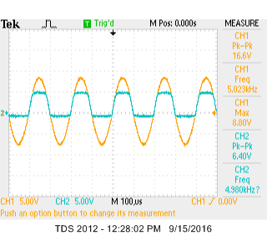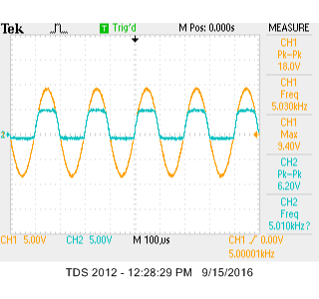

The amplitudes of the output voltages are gradually being levelled out

The circuit emulates a high pass filter

1. **Conclusion**

Lorem ipsum