**CMPE 323: Signals and Systems**

**Dr. LaBerge**

**Lab 02 Report:**

**Sinusoids, Time Delays, Time Scaling**

Sabbir Ahmed

1. **Introduction**

The convolution sum

and the convolution integral

can be easily implemented with precision on MATLAB using its built in method . This lab will allow other ways to estimate the sum and integral to simulate similar results to gain a better understanding algorithmically and mathematically.

1. **Equipment**

A computer with MATLAB installed.

1. **Procedure**
   1. **Simple Pulses**

Using a time array , create two unit amplitude pulses and . Write a MATLAB script to perform the convolution sum, . Plot the two input pulses, the convolution sum, and the convolution integral after solving it separately. Explain any difference between the convolution sum and the analytic result.

Redo the four plots using the built-in MATLAB method, . How should the plot be scaled as to bring the third and fourth plots into approximate agreement?

* 1. **Unequal Pulses**

Redo Part 3.1, replacing with . Explain any changes that occur.

* 1. **Offset Input**

Redo Part 3.1, replacing with . Explain any changes that occur.

* 1. **Offset Input and Offset Impulse Response**

Redo Part 3.1, replacing with and with . Explain any changes that occur, and if the output makes sense.

* 1. **Linear Time Invariant Characteristic**

Using the pulse anonymous function, create inputs that demonstrate that the convolution is linear and time invariant.

1. **Results**

For the following plots, the convolution sum was computed through the attached MATLAB scripts, through iteration (see Appendix B). The integral was computed manually with paper and pencil (see Appendix A). The final output yielded a piecewise function, which was used to plot the convolution integral subplots.

Step 3.1 considered convolving two simple and identical unit pulses. The iterative convolution sum and piecewise convolution integral generated identical plots, which also agreed with the plot generated by MATLAB’s method.

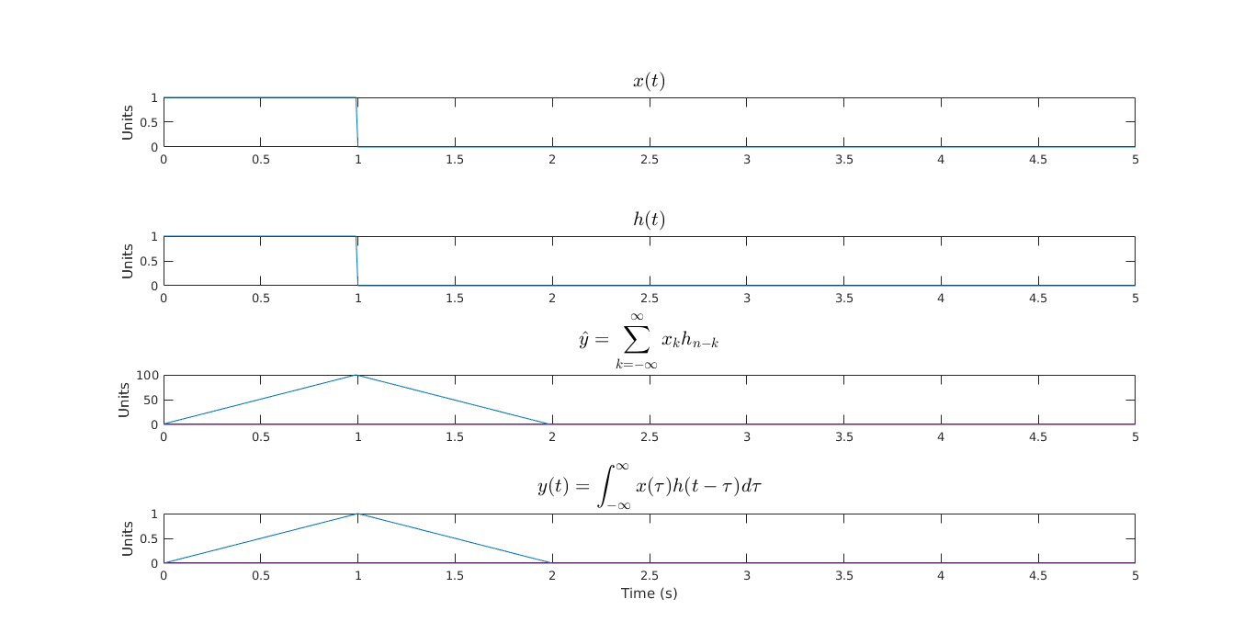

**Figure 1: Convolution of two identical unit pulses, computed by its convolution sum and its convolution integral**

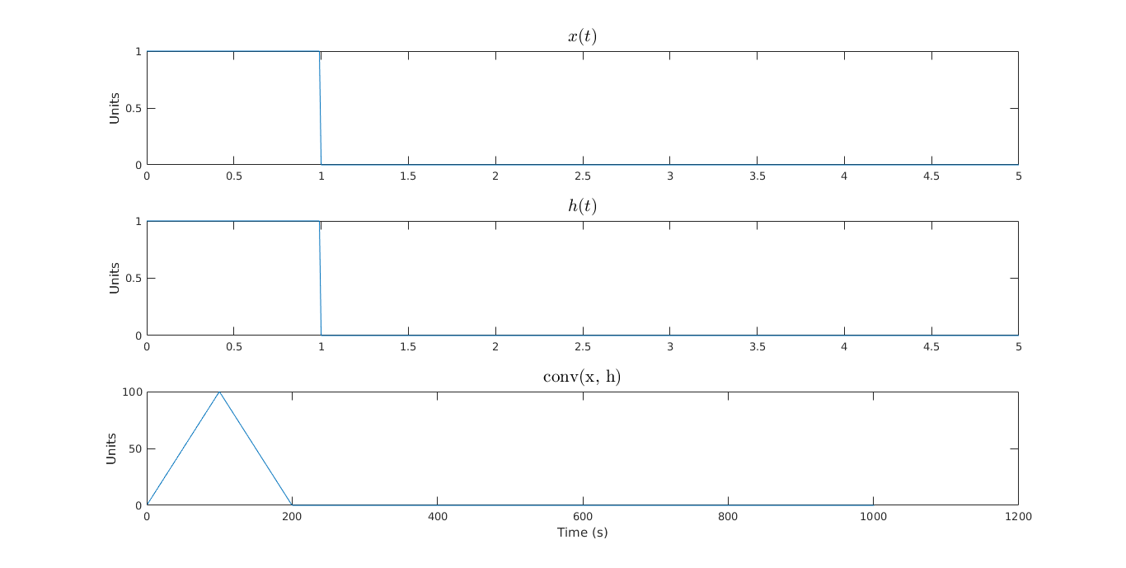

**Figure 2: Convolution of two identical unit pulses, computed by MATLAB’s conv method**

Step 3.2 increased the duration of the input to 2 seconds, which generated the following plots to bring the three different methods of the computation of the convolution to an agreement.

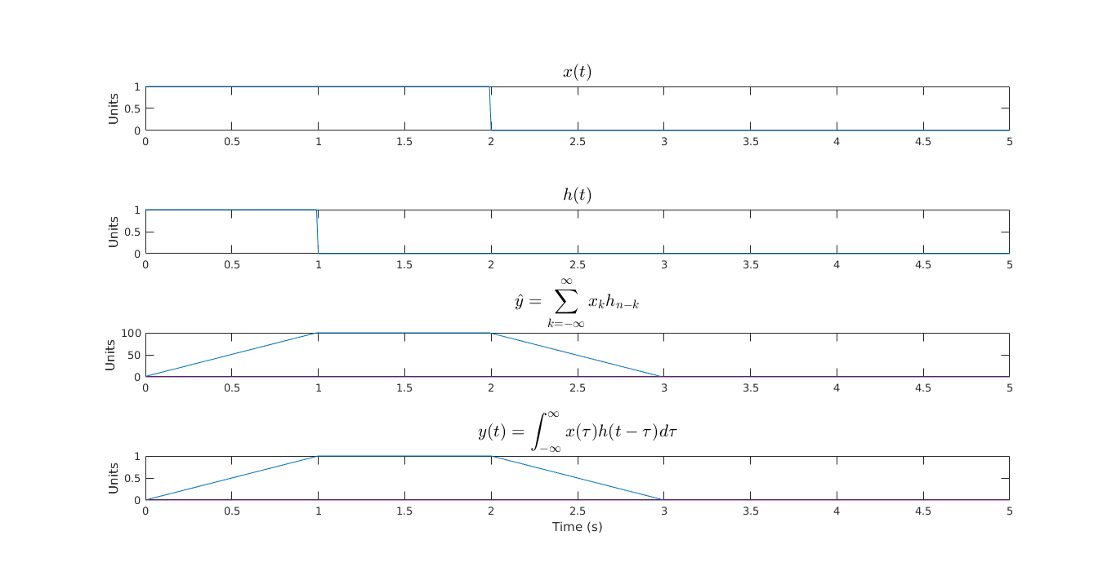

**Figure 3: Convolution of a unit pulse with a pulse of duration 2, computed by its convolution sum and its convolution integral**

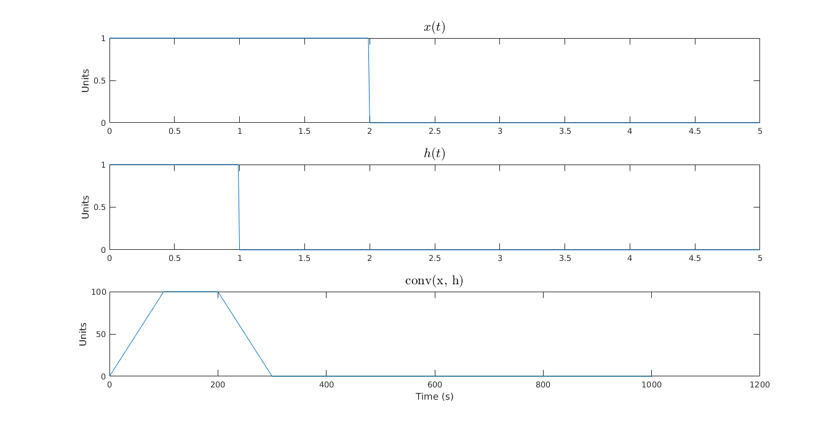

**Figure 4: Convolution of a unit pulse with a pulse of duration 2, computed by MATLAB’s conv method**

Step 3.3 added an offset to the input function. Since the functions start to convolve from x = -1 now, the modified time axis had to be instantiated to handle the new pulses. The iteration method failed to yield the correct convolution values, since the inner for-loop could not assign values to negative indices which were defaulted to 0. However, the integral piecewise function and MATLAB’s function came to an agreement.

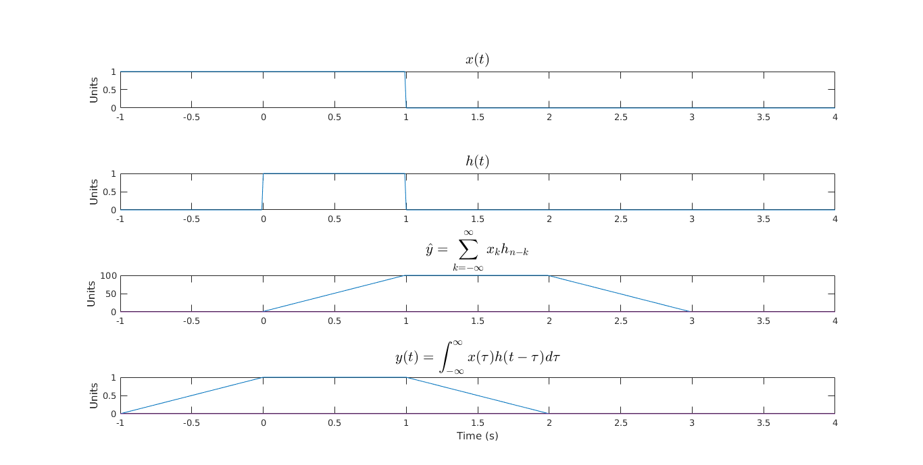

**Figure 5: Convolution of a unit pulse with a pulse of duration 2 with an offset of -1, computed by its convolution sum and its convolution integral**

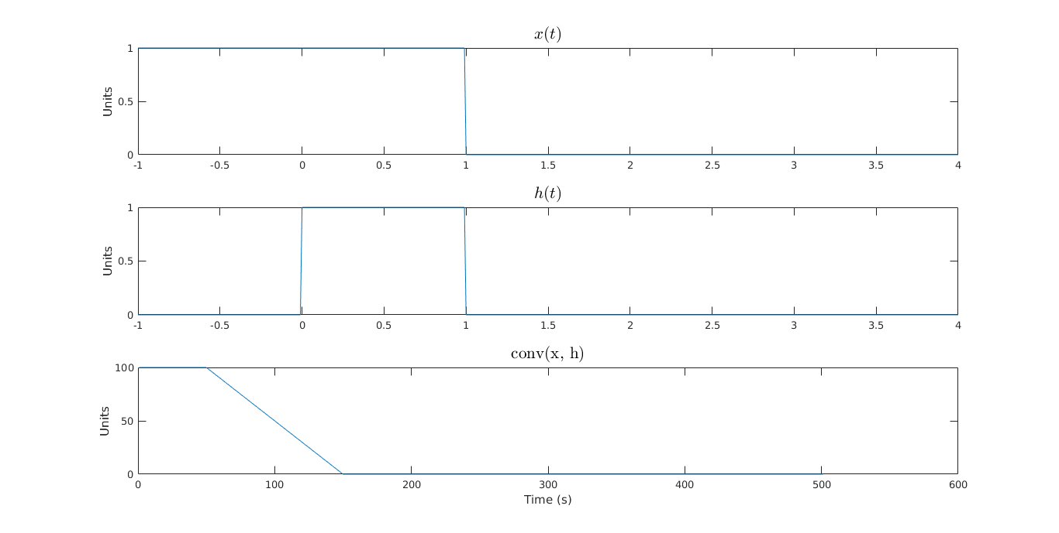

**Figure 6: Convolution of a unit pulse with a pulse of duration 2 and offset of -1, computed by MATLAB’s conv method**