**CMPE 323: Signals and Systems**

**Dr. LaBerge**

**Lab 04 Report:**

**More Convolution**

Sabbir Ahmed

1. **Introduction**

In this lab, the convolution integral

will be determined to be a filter operation.

1. **Equipment**

A computer with MATLAB installed.

1. **Procedure**
   1. **A Simple Filter**

Using a sample rate of 1 kHz, and a time record from -1 to +10 seconds, create a simple rectangular pulse and use it as the system impulse response. Then create system inputs . Using the MATLAB function, compute and plot the magnitude of the output for frequencies . Comment on whether this is a high pass, low pass or band pass filter.

Replot the results, discarding the convolution tail at the end of the output array. Then, recompute the convolution and replot the results using only the non-zero element of . Comment on any changes on the outputs.

* 1. **A Less Simple Filter**

Now compute a new . Compute and plot the magnitude of the convolution output of the system to the same set of exponentials. Explain the results, including the identification of the type of filter.

* 1. **A Mechanization of this Lab**

Create a MATLAB function to return an array of complex outputs representing the steady state output at each of the M frequencies.

* 1. **Complex Eigenvalues**

Use the function to compute and plot the responses of and from parts 3.1 and 3.2 to complex exponentials with circular frequencies Hz. Plot the amplitude and phase of the output as a function of .

1. **Results**

The pulse of duration 0.25 was created; . The system input was convoluted with the pulse and the following plots were created corresponding to the different frequencies:

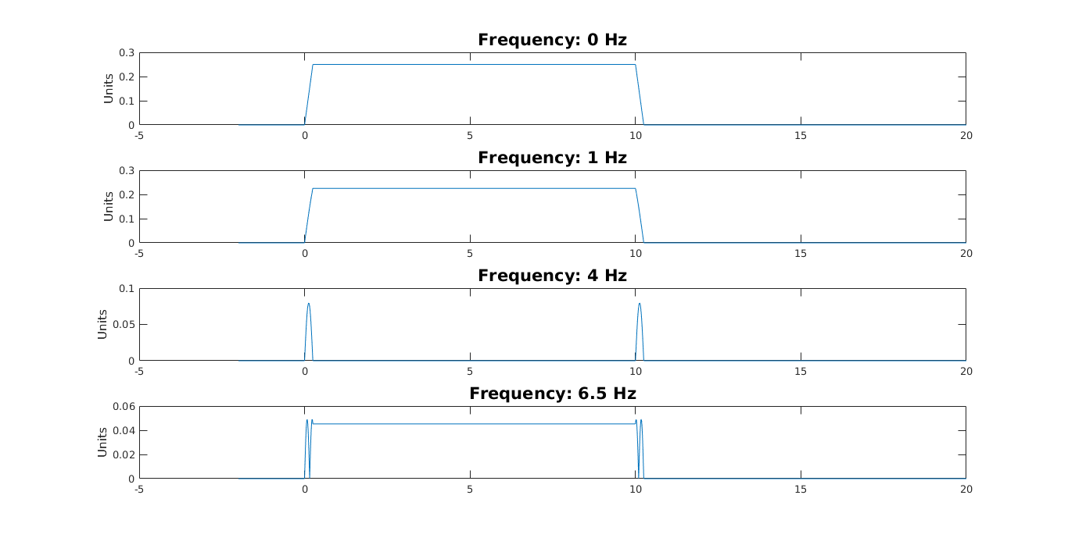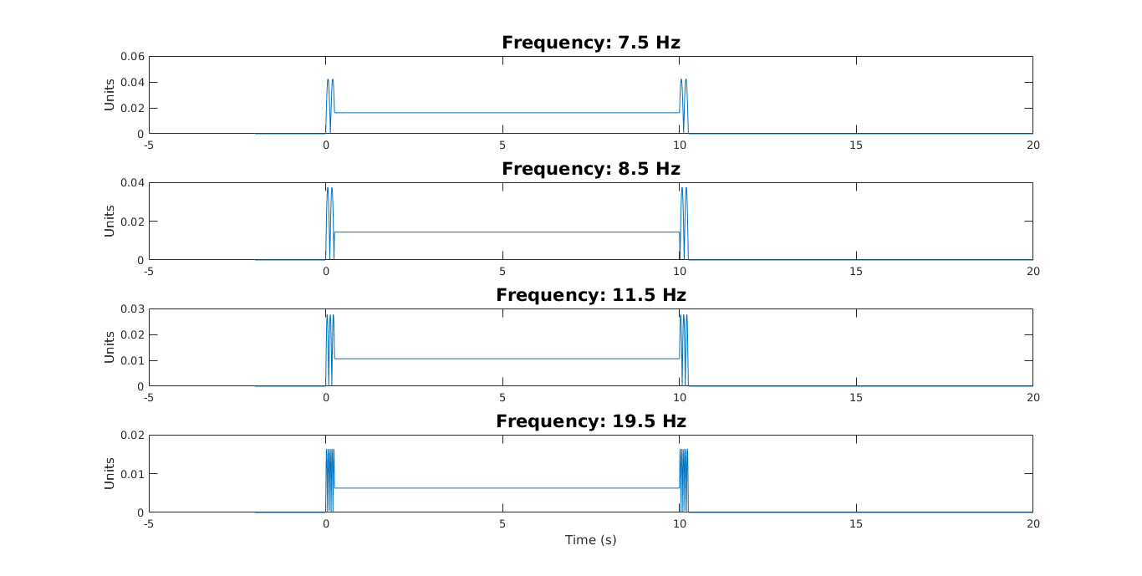

**Figure 1: Convolution of the system input with the pulse computed by MATLAB’s conv method**

The convolution tail was trimmed off to create a window consisting of the responses’ transient to steady state output.

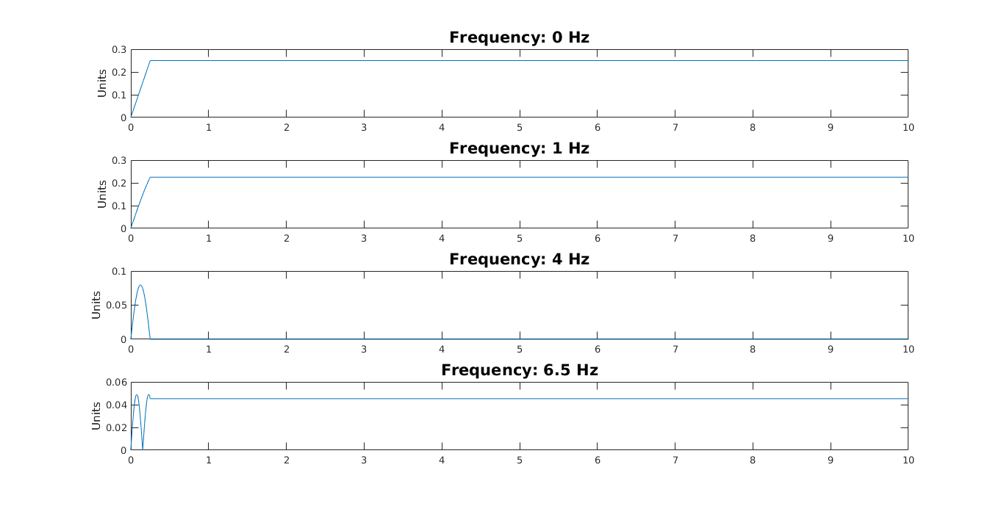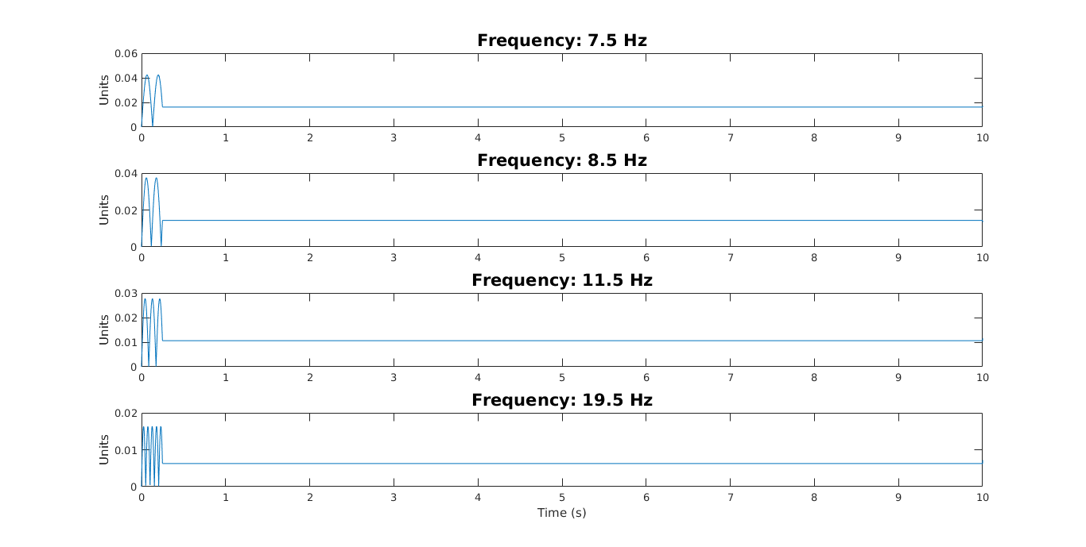

**Figure 2: Convolution of the system input with the pulse with the “convolution tail” cut off**

Only the non-zero values of the pulse array, , were considered and convoluted with the system input to create the following outputs.

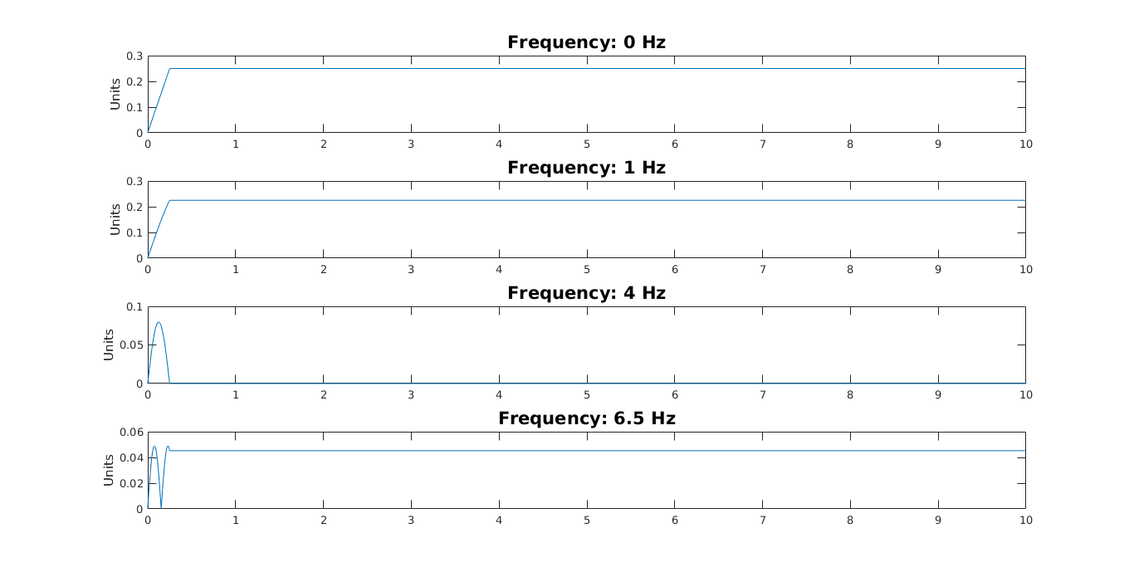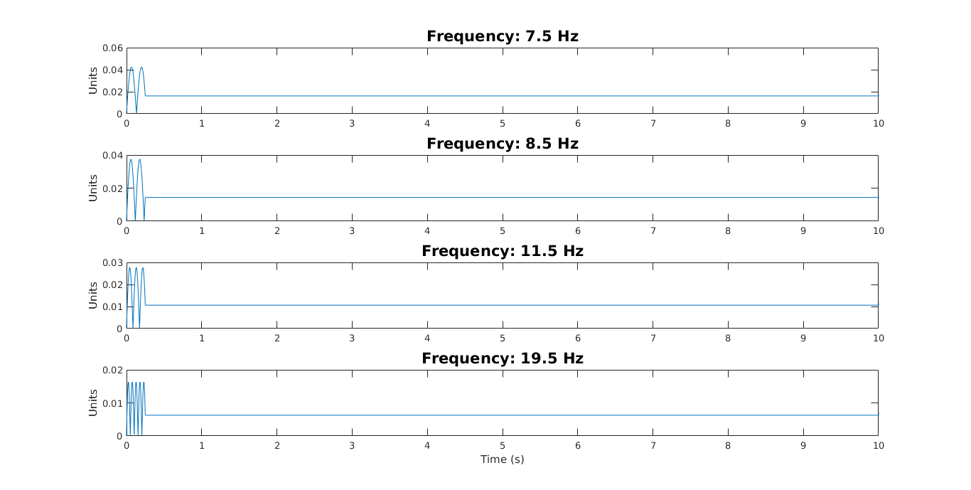

**Figure 3: Convolution of the system input with the non-zero values of the pulse**

The new pulse input was created and convoluted with the system input to create the following outputs:

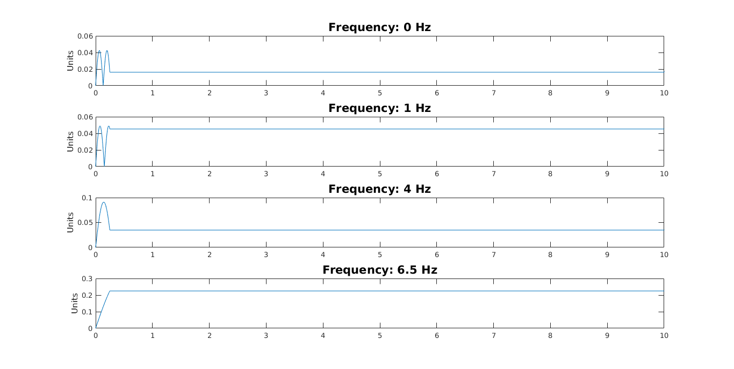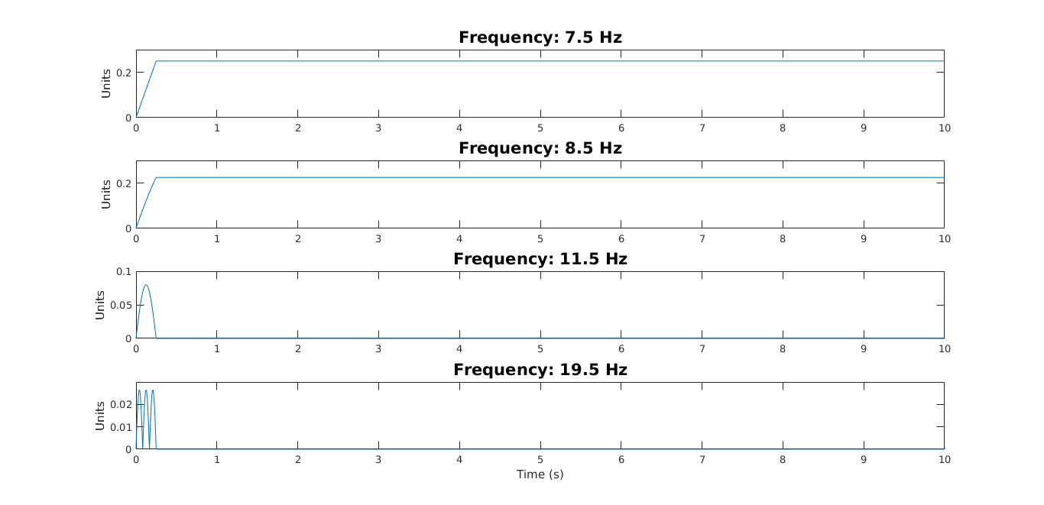

**Figure 4: Convolution of the system input with the new pulse**

1. **Appendices**
   1. **Appendix A**

Please refer to the following pages as Appendix A. The mathematical approach to the convolution integral was computed in the attached document.

* 1. **Appendix B**

Please refer to the attached zipped folder titled “scripts” as Appendix B. The computation required several scripts to modularize the code.