**CMPE 314: Principles of Electronic Circuits**

**Dr. Yan**

**Lab 05 Report**

**Common Emitter Amplifier Circuit**

**Sabbir Ahmed**

**Yu Fu**

1. **Objective**

Construct and study the common-emitter amplifier circuit.

1. **Equipment**
   1. Resistors;
      1. Given: 1 × 560 Ω, 1 × 2.2 kΩ
      2. Computed: 1 × 470 Ω, 2 × 4.7 kΩ, 1 × 6.8 kΩ, 1 × 15 kΩ, 1 × 22 kΩ, 1 × 47 kΩ
      3. Potentiometer: 1 × 2 MΩ
   2. Capacitor; 1 × 1 µF
   3. Transistor; 1 × 2N3904 NPN
   4. Breadboard, DC power supply, digital multi-meter(s), oscilloscope, function generator
2. **Background**

A common-emitter amplifier is one of three basic single-stage bipolar-junction- transistor (BJT) amplifier topologies, typically used as a voltage amplifier. In this circuit, the base terminal of the transistor serves as the input, the collector is the output, and the emitter is common to both.

1. **Procedures**

**4.1 Part A. Pre-lab Exercise**

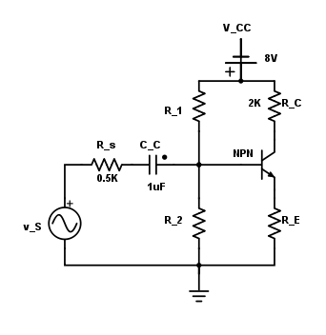

**Figure 1: Common Emitter Amplifier with an NPN Transistor**

* 1. Assuming βF = 100, study the circuit from Figure 1.
  2. Determine the values of R1, R2, and RE so that the Q-point is in the middle of the forward active region VCEQ = 4 V. Calculate IBQ, ICQ, and VCEQ.
  3. Repeat step b. so that the Q-point is near the cut-off region.
  4. Repeat step b. so that the Q-point is near the saturation region.

**4.2 Part B. Lab Procedures**

1. Set VCC = 8 V. Use the values given and computed in the pre-lab for R­1, R­2, R­C and R­E such that the Q-point is in the middle of the forward active region.
2. Measure IBQ, ICQ and VCEQ and compare against the calculated values. Find the DC forward current gain.
3. Connect the sinusoidal voltage source vs with amplitude ±100 mV and at frequency 10 kHz to the circuit. Record down both the input voltage vs and output voltage vo waveforms using the oscilloscope. Comment on the phase relationship. Find the small signal voltage gain and compare to the theoretical value.
4. Increase the input sinusoidal voltage, and record down any signal distortion. Comment on whether it is due to cutoff clipping or saturation clipping. What is the maximum symmetric swing?
5. Use a potentiometer as load resistor (20 MΩ). Vary and measure the resistance, record down the output waveforms. Comment how the small signal gain is influenced by the value of the load resistance, and the output impedance of the amplifier circuit.
6. Plot the DC and AC loadlines.
7. Change R1 or R2 value (near the cutoff region). Repeat steps b. to d.
8. Change R1 or R2 value (near the saturation region). Repeat from step b. to d.
9. **Results**

For computing the resistor values, only the portion of the circuit affected by the DC voltage was considered.

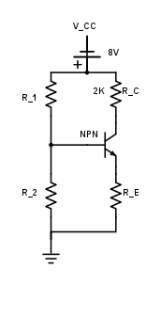

**Figure 2: DC Portion of Common Emitter Amplifier with an NPN Transistor**

<MORE EQUATIONS>

After all the resistor values for all the different regions were computed, the DC part of the circuit was constructed, as per Figure 2. The resistance values for the Q-point were selected as R1 = 22 kΩ and R2 = 4.7 kΩ. IBQ, ICQ and VCEQ were measured and the outputs are displayed below:

**Table 1: Transistor Voltage and Current Measured at Q-point**

|  |  |  |
| --- | --- | --- |
| **VCEQ (V)** | **ICQ (mA)** | **IBQ (mA)** |
| 3.78 | 1.5 | 0.2 |

The sinusoidal voltage source was added, along with the other components to construct the circuit from Figure 1. The following waveform was captured:

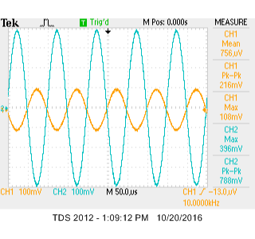

**Figure 3: Input and Output Voltages of the Circuit at Q-Point**

The voltage gain, , can be computed with the relationship:

1. **Conclusion**

The I-V characteristics curves plotted from the experiment have a large error from the one plotted from the simulated circuit on PSPICE. The of the curves from the measured data appear to be significantly larger than the simulated plot, and the seem to starting losing its data points after exceeds a certain threshold. The discrepancy of the plots might have been caused from inaccurate measurements of the very sensitive components used in the construction of the circuit.