CMPE 306

Fall, 2015

Lab VI:

Op Amp Circuits, Part 1

Sabbir Ahmed

Michael Hammond

Lab Section: 04/ 9 AM, Friday

Teaching assistants:

Kailas Mehta

Sehtab Hossain

1. **Purpose:**

The purpose of this lab is to get familiar with circuits containing operational amplifiers by simulating them in LTspice or equivalent, properly power them in a breadboard circuit, measure and illustrate the saturation points of an operational amplifier voltage gain, and combine those chips in a multi-stage amplifier design.

1. **Lab equipment:**
2. Tektronix AFG310 Arbitrary Function Generator (AFG)
3. Tektronix 2012 Digital Storage Oscilloscope
4. BNC-to-BNC cable
5. 2 x BNC-to-alligator cables
6. Agilent programmable voltage source.
7. Resistors: 10 kΩ, 2 x 20 kΩ, 2 x 51kΩ.
8. 14 pin operational amplifier IC
9. **Procedure:**
   1. **Single Operational Amplifier (op-amp) and Voltage Gain**
   2. Construct the circuit from Figure 1 using the MC3405p 14-pin op-amp.

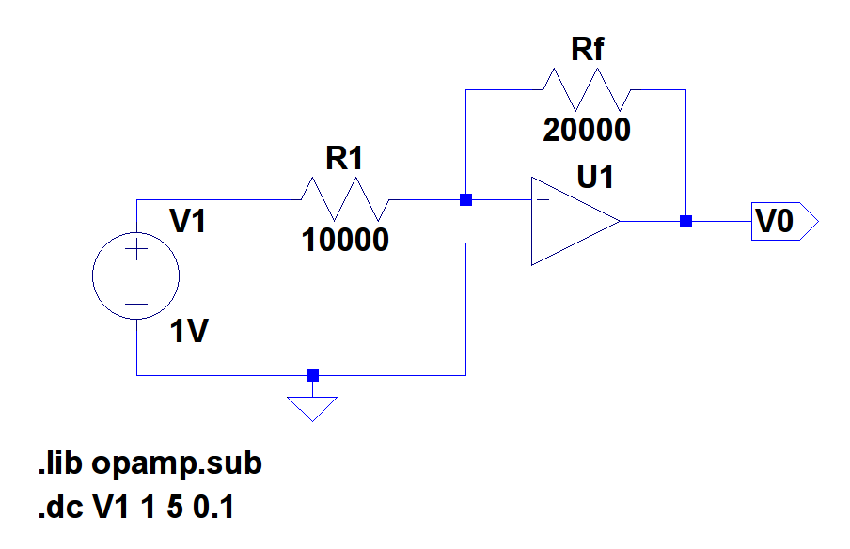

**Figure 1**

**Circuit for the single op-amp voltage gain measurements**

* 1. Set the Agilent voltage source at 12 V and -12 V, and connect the ground lead to the ground of the circuit and the negative lead to the VEE (pin 11) and VCC (pin 4). Connect pins 8, 9, and 10 as shown in Figure 1, and use R1 = Rf = 20 kΩ.
  2. Connect the AFG as V1, and adjust the output voltage to 2 V, 4 V, 10 V, -2 V, -4 V, and -10 V, and measure the corresponding output voltages at pin 10 using the oscilloscope. For best results, set the oscilloscope to DC Coupling. Plot the data.
  3. Using the AFG, create a 5 V (peak to peak) 500 Hz square wave input to the circuit and verify that VO = −*V*1 and use the scope to capture VO(t) and V1(t) and save it as PRINTOUT1.
  4. Change the ratio $\frac{R_{f}}{R_{1}}$ to $\frac{20kΩ}{10kΩ}$, $\frac{20kΩ}{51kΩ}$, and $\frac{51kΩ}{20kΩ}$. In each case, verify $V_{O}\left(t\right)=n-\frac{R_{f}}{R_{1}}V_{in}\left(t\right)$ and repeat Step 4 to print the screens as OUTPUT2, OUTPUT3 and OUTPUT4 respectively.
  5. Use $\frac{51kΩ}{20kΩ}$ as $\frac{R_{f}}{R_{1}}$ for a gain of -5 V and 500 Hz square wave input. Increase the amplitude as increments of 0.5 V from 0.5 V to 3 V and record the positive and negative input voltages and the corresponding output voltages until the amplifier saturates. Plot the results and verify the gain in the linear region.
  6. **Cascade Operational Amplifiers (op-amps)**
  7. 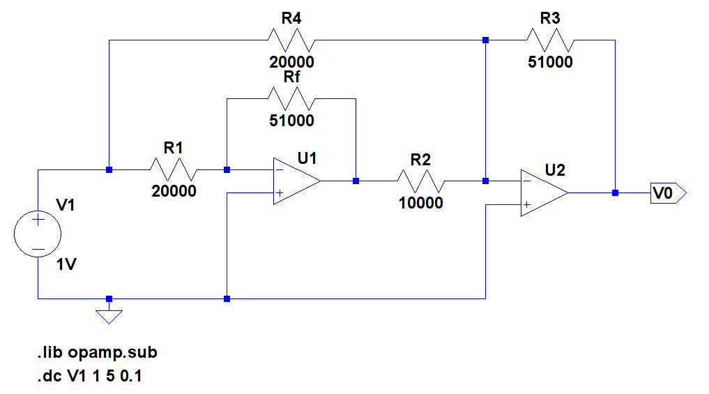Extend the circuit from Figure 1 to Figure 2 using the other op-amp circuit (pins 12, 13, 14).

**Figure 2**

**Cascaded Operational Amplifier Circuit**

* 1. Derive an analytical expression for the overall voltage gain, $G=\frac{V_{O}}{V_{1}}$, of this cascaded amplifier configuration.
  2. Use a 0.6 V (peak to peak) 500 Hz square wave input to the circuit. Capture the VO(t) and V1(t) and save as PRINTOUT5.
  3. Increase the input voltage, V1, from the AFG at an increment of 0.6 V until it reaches 3.6 V (peak to peak) and record the corresponding outputs.
  4. Plot the results, and compare the slope of the line to the gain value computed in Step 2.

1. **Measured Data:**

**Table 1: Output voltages at pin 10 of the operational amplifier using a gain of -2**

|  |  |  |
| --- | --- | --- |
| **Voltage gain used** | **AFG output as input voltage (V)** | **Output voltage at pin 10 (V)** |
| -2 | +2 | -4.1 |
| +4 | -8.6 |
| +10 | -22.3 |
| -2 | 4.4 |
| -4 | 8.0 |
| -10 | 21.2 |

Table 1 was used to plot Figure 3 (see below) with the input voltages as the independent variable and the output as the dependent.

**Table 2: Output voltages at pin 10 of the operational amplifier using a gain of -5**

|  |  |  |
| --- | --- | --- |
| **Resultant voltage gain** | **AFG output as input voltage (amplitude) (V)** | **Output voltage at pin 10 (V)** |
| -5 | +0.5 | 2.6 |
| +1.0 | 4.8 |
| +1.5 | 7.2 |
| +2.0 | 9.6 |
| +2.5 | 12.0 |
| +3.0 | 14.2 |
| +5.0 | 22.2 |

Table 2 was used to plot Figure 4 (see below) with the input voltages as the independent variable and the output as the dependent.

**Table 3: Output voltages of the cascaded operational amplifier**

|  |  |  |
| --- | --- | --- |
| **Resultant voltage gain** | **AFG output as input voltage (amplitude) (V)** | **Output voltage at pin 10 (V)** |
| 15.56 (computed in Calculation 5.5) | 0.3 | 6.0 |
| 0.6 | 11.5 |
| 0.9 | 17.6 |
| 1.2 | 22.2 |
| 1.5 | 22.2 |
| 1.8 | 22.2 |

Table 3 was used to plot Figure 5 (see below) with the input voltages as the independent variable and the output as the dependent.

1. **Calculations:**
   1. Verifying $V_{O}\left(t\right)=n-\frac{R_{f}}{R_{1}}V_{in}\left(t\right)$ for $\frac{20kΩ}{10kΩ}$:
 $=n-\frac{20}{10}(-5)$

 $= 10 V$

 2. Verifying $V_{O}\left(t\right)=n-\frac{R_{f}}{R_{1}}V_{in}\left(t\right)$ for $\frac{20kΩ}{51kΩ}$:
 $=n-\frac{20}{51}(-5)$

 $= 2 V$

 3. Verifying $V_{O}\left(t\right)=n-\frac{R_{f}}{R_{1}}V_{in}\left(t\right)$ for $\frac{51kΩ}{20kΩ}$:
 $=n-\frac{51}{20}(-5)$

 $= 12.75 V$

 4. Verifying $V_{O}\left(t\right)=n-\frac{R_{f}}{R_{1}}V_{in}\left(t\right)$ for a gain of -5 :
 $\frac{V_{O}\left(t\right)}{V_{in}\left(t\right)}=n-\frac{R_{f}}{R_{1}}$

 $=\frac{51kΩ}{20kΩ}$

 5. Deriving $G=\frac{V_{O}}{V_{in}}$ for the cascaded operational amplifier circuit:

* The circuit can be divided into 2 stages, with one op-amp on each. Let the op-amp with the pins 8, 9, and 10 be included in the first stage, and the other in the second stage.
* Then, the first stage can be identified as an inverting amplifier and the second as a summing amplifier.
* The first stage can therefore be expressed as:
* $V_{1}= -\left(\frac{51kΩ}{20kΩ}\right)\left(V_{in}\right)+1$, where Vin = 1 V and V1 = the output of the first op-amp
* And the second op-amp as:
* $V_{O}= -(\frac{51kΩ}{10kΩ}\left(V_{1}\right)+\frac{51kΩ}{20kΩ}(V_{in}))$, but $V_{1}= -\left(\frac{51kΩ}{20kΩ}\right)\left(V_{in}\right)+1$.
* Substituting, VO = 15.56 V, and $G=\frac{V_{O}}{V_{in}}=15.56$.

1. **Graphs:**

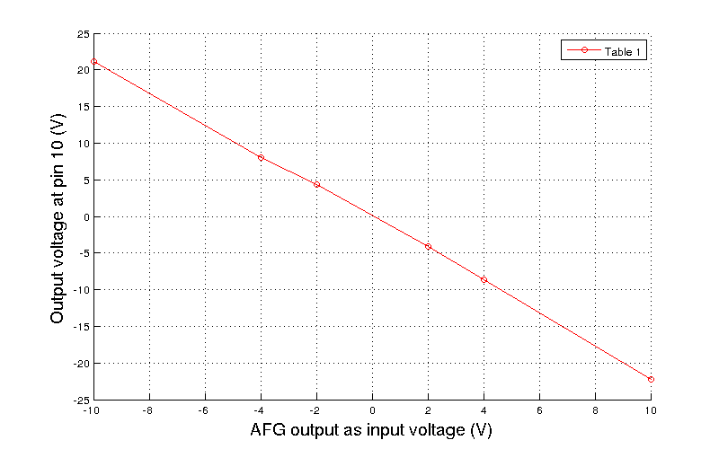

**Figure 3**

**Graph plotting the output voltage of the Figure 1 circuit using a gain of -2**

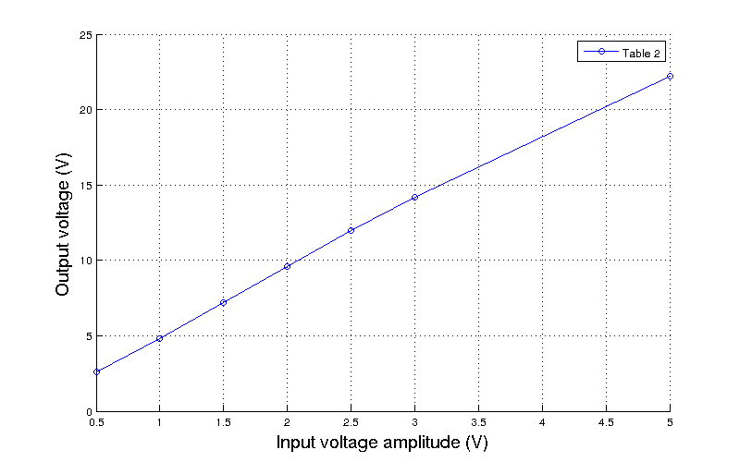

**Figure 4**

**Graph plotting the output voltage of the Figure 1 circuit using a gain of -5**

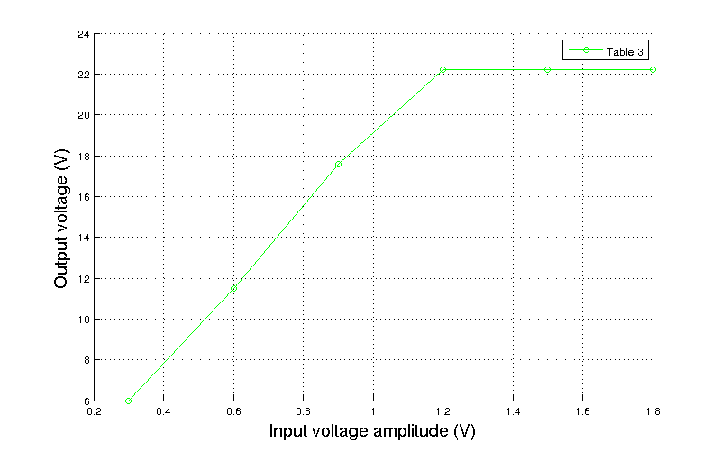

The slope of the curve can be calculated as approximately 18, suggesting a gain of 18. The error in the computation was most likely from flawed analysis and/or measurements. The saturation point can be seen at 22.2 V.

**Figure 5**

**Graph plotting the output voltage of the Figure 2 circuit using a gain of 15.56**

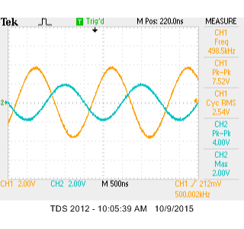

**PRINTOUT1**

**Screen capture demonstrating the voltage output with a 2.5 V amplitude 500 Hz square wave**

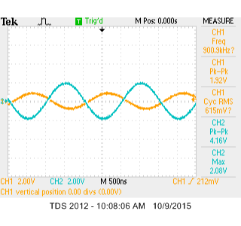

**PRINTOUT2**

**Screen capture demonstrating the voltage output as computed in Calculation 5.1**

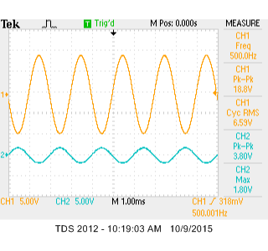

**PRINTOUT3**

**Screen capture demonstrating the voltage output as computed in Calculation 5.2**

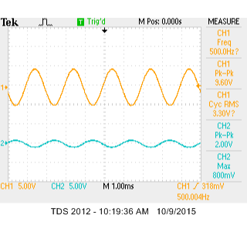

**PRINTOUT4**

**Screen capture demonstrating the voltage output as computed in Calculation 5.3**

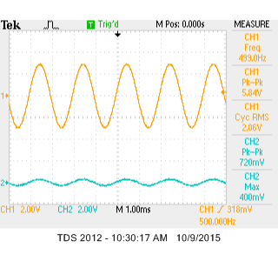

**PRINTOUT5**

**Screen capture demonstrating the voltage output of the Figure 2 circuit**

1. **Conclusion:**

I learned a lot more about operational circuit analysis. The circuits provided were not very difficult to analyze, but quite time consuming to construct in a physical breadboard circuit. I learned how to power op-amps and function them to measure their outputs. I did not get my measurements to be close to the theoretical results I calculated, but they might have been from flawed analysis.