**CMPE 323: Signals and Systems**

**Dr. LaBerge**

**Lab 06 Report**

**Fourier Series and the Gibbs Phenomenon**

Sabbir Ahmed

**Table of Content**

1. Introduction………………………………………………………………….3
2. Experiment……………………………………………………………………3
3. Procedure…………………………………………………………….……....3
   1. Determining Poles and Zeros…………...……...…………...3
   2. Creating a Pole Zero Plot……………………………………....3
   3. Partial Fraction Expansion…………………….…..…………..3
   4. Additional Practice…………………………………….…………..3
4. Results…………………………………………………………………………..4
5. Appendices……………………………………………………………………9
   1. Appendix A…………………………………………………………….9
6. **Introduction**

This lab explores the computation of the complex coefficients of a Fourier Series by direction computation and by evaluation of the analytical answer obtained in class.

1. **Equipment**

A computer with MATLAB installed.

1. **Procedure**
   1. **Computing the Coefficients**

Create an “infinite” square wave with the following functions:

where and is the duration of the pulse. Plot at least 7 periods of the periodic waveform using a sample rate of 10,000 sps. Is this waveform even or odd? Plot the waveform using professional practices.

Analytically compute the Fourier coefficients given by the analysis equation:

Write the closed form, simplified expression for the coefficients as a function of and .

Using the simulated x(t) developed above, numerically compute the coefficients for x(t) implementing 3. Compute the range and hold onto it for future use. Your answer will be complex. Examine the imaginary part and determine if it contributes to the answer. Based on your conclusion, plot the computed values and the theoretical values and compare them.

* 1. **Synthesizing the Waveform**

Using the computed in 3.1, synthesize an estimate of your periodic waveform over the full interval. The synthesis equation is:

where controls the number of terms in the estimate.

Compute estimates for *.* For each estimate, plot the real part of the estimate and the original waveform, . Comment on any differences.

For each estimate, compute the mean squared error (MSE) defined by

Plot the estimates as a function of .

* 1. **The Gibbs Phenomenon**

The finite sum estimate, , of the square wave exhibits a characteristic shape known as the Gibbs Phenomenon. This characteristic occurs whenever a limited number of Fourier coefficients (or a bandlimited Fourier Transform) is used to estimate a piecewise continuous time waveform. On a single plot, show the Gibbs Phenomenon for all of your *K*-limited estimates of the square wave by plotting only the region . Comment on the shape and extent of the Gibbs phenomenon as the number of terms in the sum increases.

* 1. **A Different Waveform**

Create a new waveform,

where . This produces a periodic saw-tooth wave. Repeat the process used in 3.1 and 3.2 to synthesize from K-sums of the Fourier coefficients. Comment on any Gibbs phenomenon effects on your estimates.

1. **Results**

The pulse train with an amplitude of 1 and a period of 4 was created and 7 periods of the function were plotted:

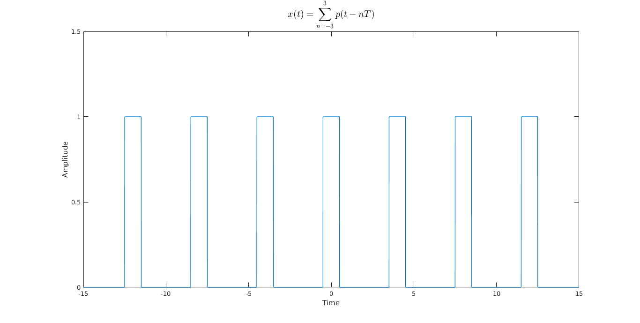

**Figure 1: A Pulse Train with an Amplitude of 1 and Period of 4**

The Fourier coefficients were computed with the following steps:

After the coefficients were computed analytically, the simplified closed form equation for the coefficients of the periodic pulse function, , was plotted as shown below:

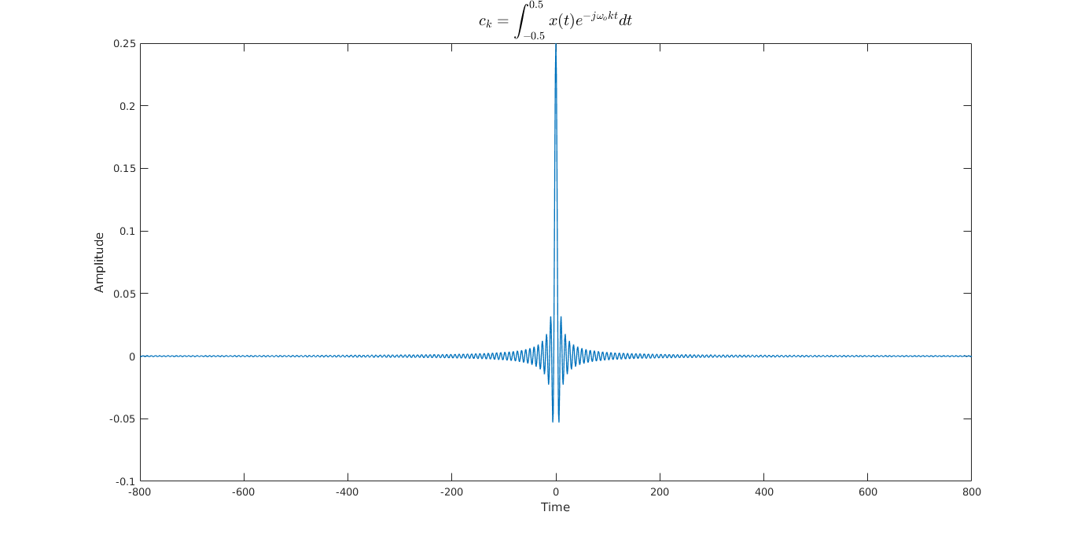

**Figure 2: Fourier Coefficients of the Pulse Function**

The imaginary part of the coefficients did not contribute to the function at all, so only the real part was plotted.

The waveform was then synthesized with the synthesis equation,

The different terms in were individually substituted into the equation to create their corresponding synthesized waveforms.

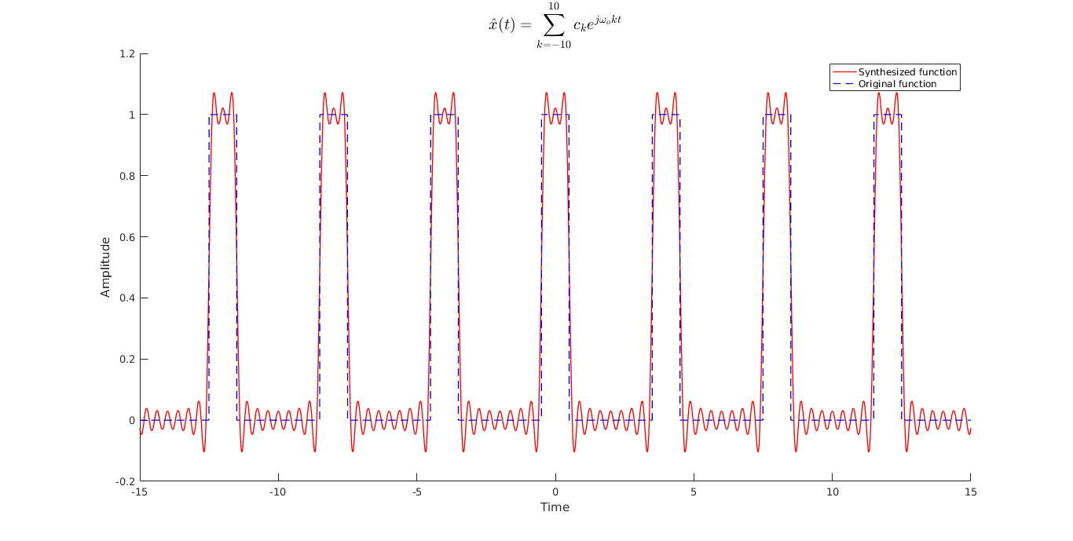

**Figure 3: Waveform synthesized with K = 10**

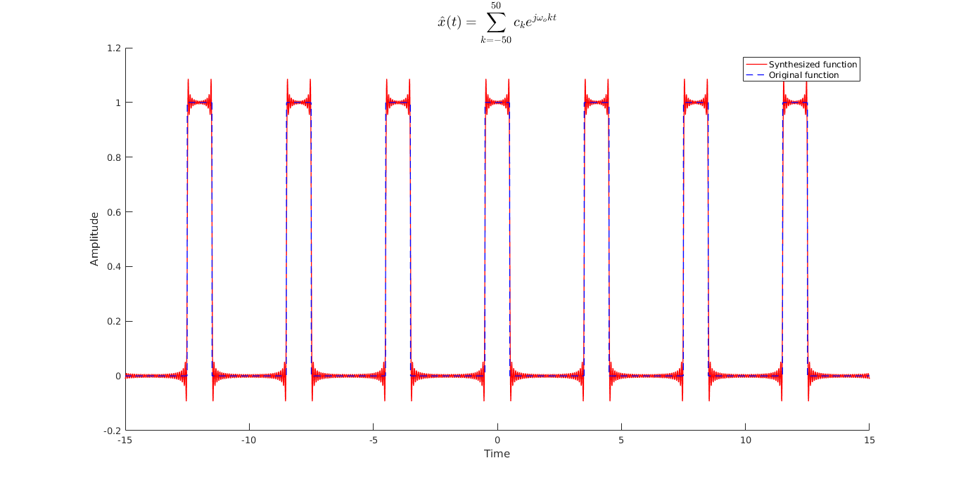

**Figure 4: Waveform synthesized with K = 50**

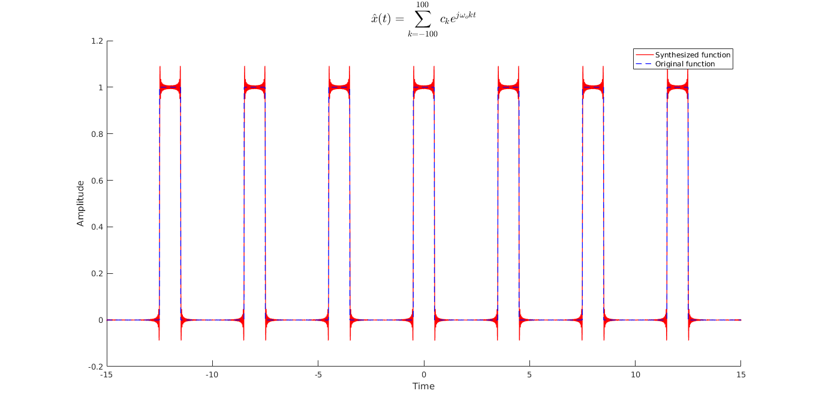

**Figure 5: Waveform synthesized with K = 100**

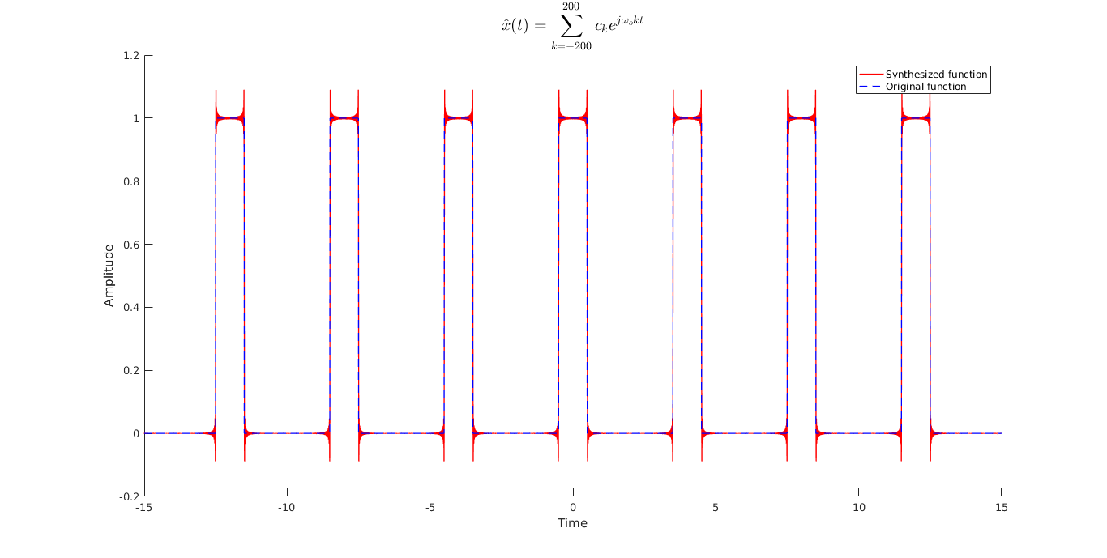

**Figure 6: Waveform synthesized with K = 200**

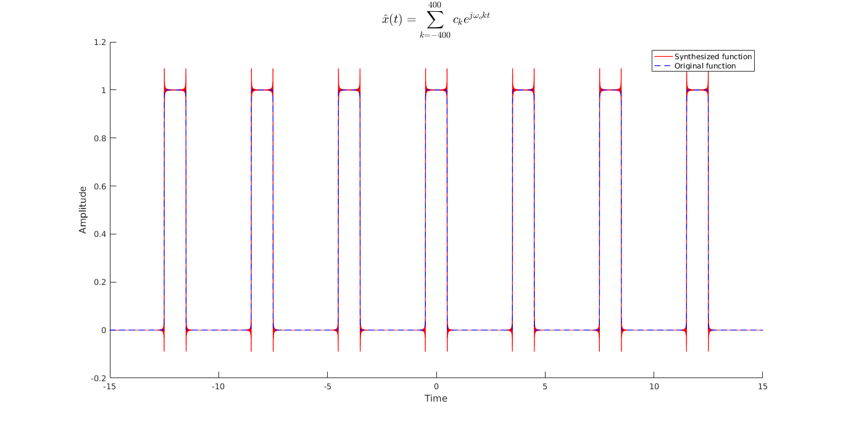

**Figure 7: Waveform synthesized with K = 400**

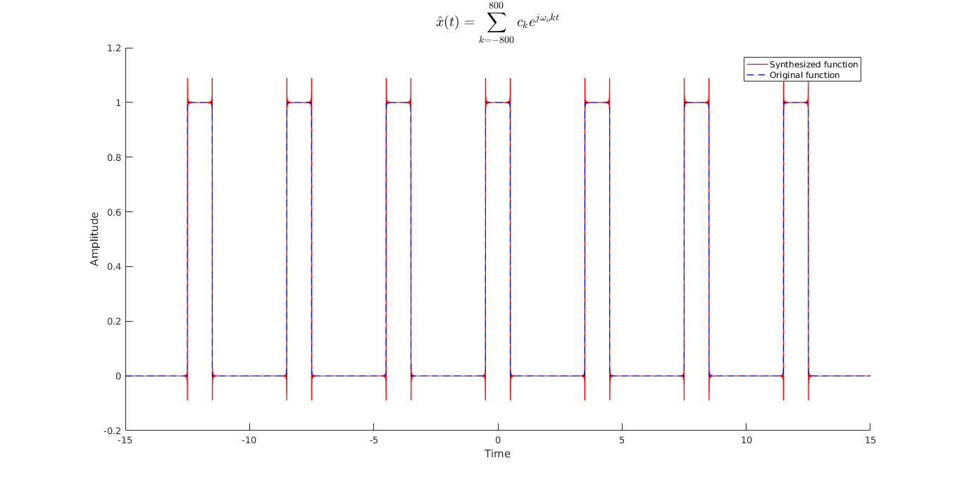

**Figure 8: Waveform synthesized with K = 800**

The mean squared error of the synthesized waveform was computed and plotted against the K terms.

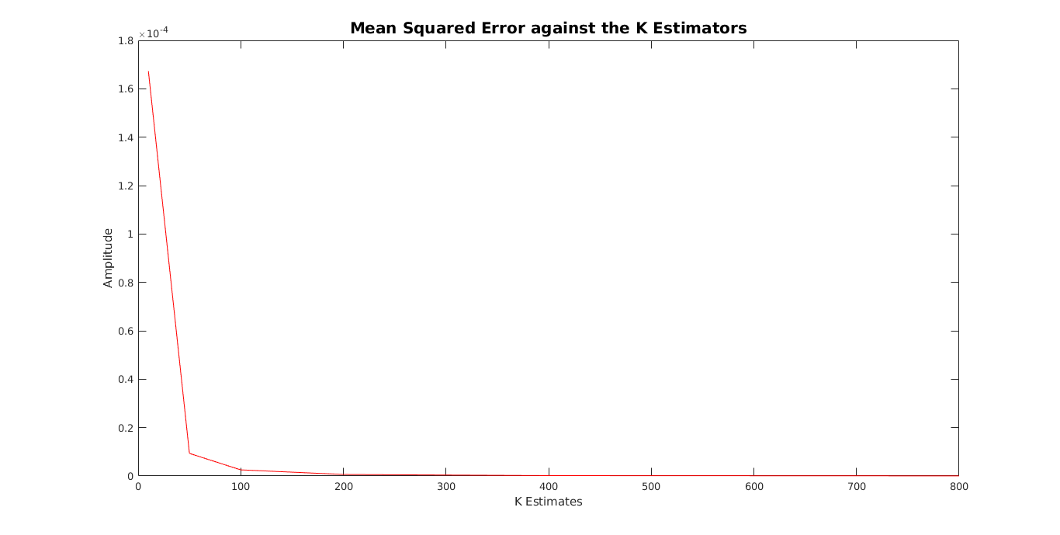

**Figure 10: The MSE of the Synthesize Waveform Decreasing as the K-terms Increase**

1. **Appendices**
   1. **Appendix A**

Please refer to the attached script as Appendix A. The definition and documentation