CMPE 306

Fall, 2015

Lab IX:

Frequency Selective RC and RL Circuits

Sabbir Ahmed

Michael Hammond

Lab Section: 04/ 9 AM, Friday

Teaching assistants:

Kailas Mehta

Sehtab Hossain

1. **Purpose:**

The purpose of this lab is to construct and observe simple frequency-selective first-order circuits consisting of resistors and capacitors (in RC circuits) and resistors and inductors (in RL circuits). The only filters observed in this lab are those that can be constructed with first-order circuits, low pass and high pass filters.

1. **Lab equipment:**
2. Tektronix AFG310 Arbitrary Function Generator (AFG)
3. Tektronix 2012 Digital Storage Oscilloscope
4. BNC-to-BNC cable
5. Multimeter
6. 2 x BNC-to-alligator cables
7. Resistors: 1 kΩ, 2 kΩ
8. Capacitors: 100 nF
9. Inductors: 10 mH
10. **Procedure:**
    1. **RC Low Pass Filter**

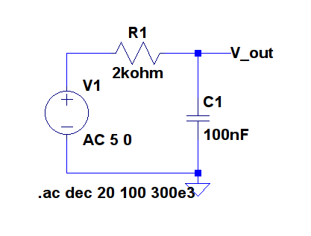

**Figure 1:** RC circuit used for a low pass filter

* 1. Construct the circuit from Figure 1 using a 5 V (amplitude, offset 0 V) sinusoidal output from the AFG as the input voltage.
  2. Measure the output voltage for frequencies from 100 Hz to 300 kHz in 8 intervals.
  3. Plot the measured ratio of the amplitudes of the output sine wave to the input sine wave, on the y-axis vs. log10(*f*) on the x-axis.
  4. Calculate the half power frequency, ${|V}_{out}|=|V_{in}|×\frac{1}{\sqrt{1+{\left(2πfRC\right)}^{2}}}$ and locate the value on the graph.
  5. **RC High Pass Filter**

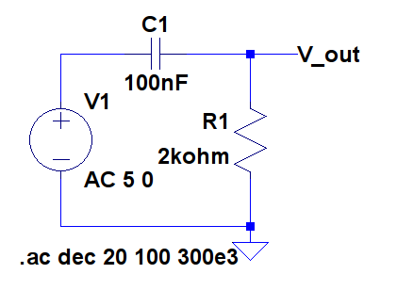

**Figure 2:** RC circuit used a high pass filter

* 1. Construct the circuit from Figure 2 using a 5 V (amplitude, offset 0 V) sinusoidal output from the AFG as the input voltage, assuming the complex voltage ratio to find the half power frequency is $\frac{\left|V_{out}\right|}{\left|V_{in}\right|}=\frac{j2πfRC}{1+j2πfRC}$
  2. Measure the output voltage for frequencies from 100 Hz to 300 kHz in 8 intervals.
  3. Plot the measured ratio of the amplitudes of the output sine wave to the input sine wave, on the y-axis vs. log10(*f*) on the x-axis.
  4. Calculate the half power frequency, ${|V}_{out}|=|V_{in}|×\frac{1}{\sqrt{1+{\left(2πfRC\right)}^{2}}}$ and locate the value on the graph.
  5. **RL Low Pass Filter**

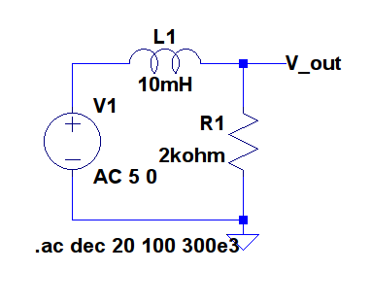

**Figure 3:** RL circuit used for a low pass filter

* 1. Construct the circuit from Figure 1 using a 5 V (amplitude, offset 0 V) sinusoidal output from the AFG as the input voltage.
  2. Measure the output voltage for frequencies from 100 Hz to 300 kHz in 8 intervals.
  3. Plot the measured ratio of the amplitudes of the output sine wave to the input sine wave, on the y-axis vs. log10(*f*) on the x-axis.
  4. Calculate the half power frequency, ${|V}_{out}|=|V_{in}|×\frac{1}{\sqrt{1+{\left(2πfRC\right)}^{2}}}$ and locate the value on the graph. Calculate the inductance of the inductor used and compare with the value with 10 mH.
  5. **RL High Pass Filter**

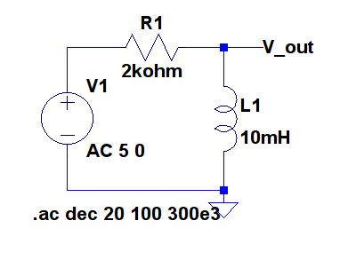

**Figure 4:** RL circuit used for a high pass filter

* 1. Construct the circuit from Figure 1 using a 5 V (amplitude, offset 0 V) sinusoidal output from the AFG as the input voltage.
  2. Measure the output voltage for frequencies from 100 Hz to 300 kHz in 8 intervals.
  3. Plot the measured ratio of the amplitudes of the output sine wave to the input sine wave, on the y-axis vs. log10(*f*) on the x-axis.
  4. Calculate the half power frequency, ${|V}_{out}|=|V_{in}|×\frac{1}{\sqrt{1+{\left(2πfRC\right)}^{2}}}$ and locate the value on the graph.

1. **Measured Data:**

**Table 1:** Measured output voltages from the Figure 1 circuit

|  |  |  |
| --- | --- | --- |
| **Input voltage (V)** | **Input frequency (Hz)** | **Output voltage (V)** |
| 5 | 100 | 5 |
| 500 | 4.96 |
| 1 k | 4.78 |
| 5 k | 4.62 |
| 10 k | 4.59 |
| 50 k | 4.52 |
| 150 k | 4.46 |
| 300 k | 4.27 |

**Table 2:** Measured output voltages from the Figure 2 circuit

|  |  |  |
| --- | --- | --- |
| **Input voltage (V)** | **Input frequency (Hz)** | **Output voltage (V)** |
| 5 | 100 | 7.9 |
| 500 | 6.15 |
| 1 k | 5.36 |
| 5 k | 4.65 |
| 10 k | 4.59 |
| 50 k | 4.40 |
| 150 k | 4.39 |
| 300 k | 4.07 |

**Table 3:** Measured output voltages from the Figure 3 circuit

|  |  |  |
| --- | --- | --- |
| **Input voltage (V)** | **Input frequency (Hz)** | **Output voltage (V)** |
| 5 | 100 | 4.70 |
| 500 | 4.71 |
| 1 k | 4.71 |
| 5 k | 4.64 |
| 10 k | 4.70 |
| 50 k | 5.80 |
| 100 k | 6.51 |
| 300 k | 6.09 |

**Table 4:** Measured output voltages from the Figure 4 circuit

|  |  |  |
| --- | --- | --- |
| **Input voltage (V)** | **Input frequency (Hz)** | **Output voltage (V)** |
| 5 | 100 | 4.70 |
| 500 | 4.71 |
| 1 k | 4.70 |
| 5 k | 4.64 |
| 10 k | 4.71 |
| 50 k | 5.98 |
| 100 k | 6.69 |
| 300 k | 5.40 |

1. **Graphs:**

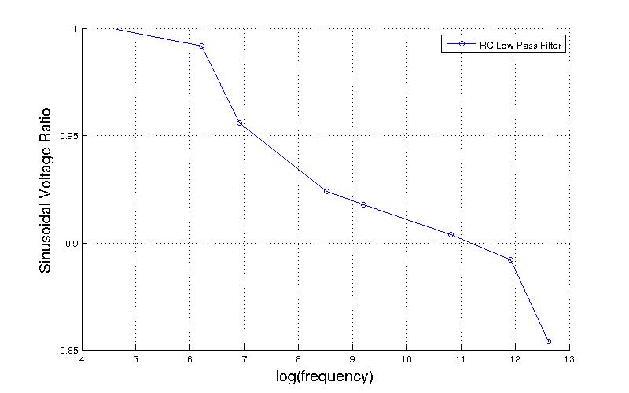

**Figure 5:** Plot of the voltage ratios and frequency of the Figure 1 circuit

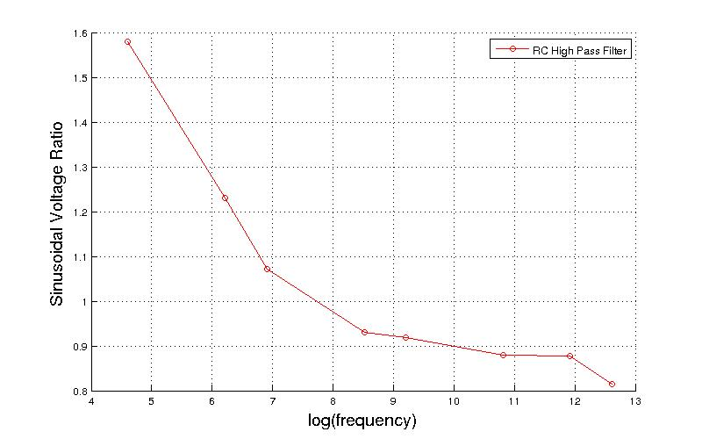

**Figure 6:** Plot of the voltage ratios and frequency of the Figure 2 circuit

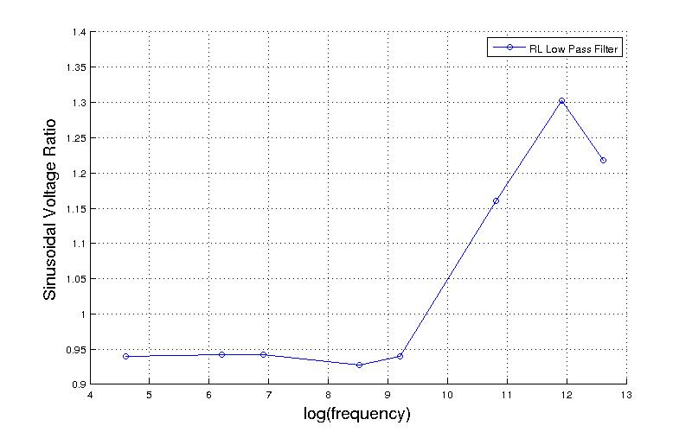

**Figure 7:** Plot of the voltage ratios and frequency of the Figure 3 circuit

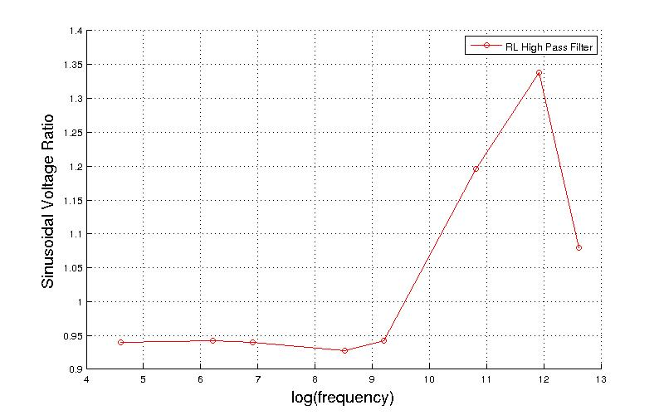

**Figure 8:** Plot of the voltage ratios and frequency of the Figure 4 circuit

1. **Conclusion:**

In this lab, I saw the application of calculating the half power frequency of a response, and how it is related to its bandwidth. I also learned about the important distinctions between low and high passes of first order circuits using capacitors and resistors or inductors and resistors. I found it intriguing how a simple orientation of the locations of the circuit components can result in different band passes.