CMPE 306

Fall, 2015

Lab X:

Frequency Selective RLC Circuits

Sabbir Ahmed

Michael Hammond

Lab Section: 04/ 9 AM, Friday

Teaching assistants:

Kailas Mehta

Sehtab Hossain

1. **Purpose:**

The purpose of this lab is to simulate and analyze second-order frequency-selective circuits composed of resistors, inductors and capacitors, and construct low pass and band pass filters with them by analyzing the complex impedance.

1. **Lab equipment:**
2. Tektronix AFG310 Arbitrary Function Generator (AFG)
3. Tektronix 2012 Digital Storage Oscilloscope
4. BNC-to-BNC cable
5. Multimeter
6. 2 x BNC-to-alligator cables
7. Resistors: 500 Ω, 1 kΩ
8. Capacitors: 10 nF, 100 nF
9. Inductors: 10 mH
10. **Procedure:**
    1. **Series RLC Circuit #1**

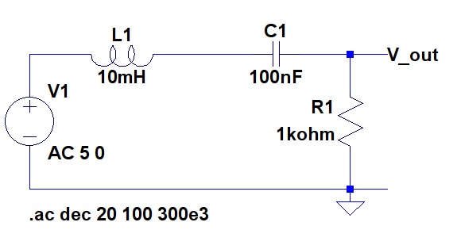

**Figure 1:** RLC circuit used for a bandpass filter

* 1. Construct the circuit from Figure 1 using a 5 V (amplitude, offset 0 V) sinusoidal output from the AFG as the input voltage.
  2. Measure the output voltage for frequencies from 100 Hz to 300 kHz in at least 8 intervals.
  3. Plot the measured ratio of the amplitudes of the output sine wave to the input sine wave, on the y-axis vs. log10(*f*) on the x-axis.
  4. Calculate the cutoff frequencies, $ω_{c_{n}}=\left|\sqrt{{\left(\frac{R}{2L}\right)}^{2}+\frac{1}{LC}}∓\frac{R}{2L}\right|×\frac{1}{2π}$ and resonance frequency, $ω_{0}=\frac{1}{\sqrt{LC}}×\frac{1}{2π}$ and locate the values on the graph.
  5. **Series RLC Circuit #2**

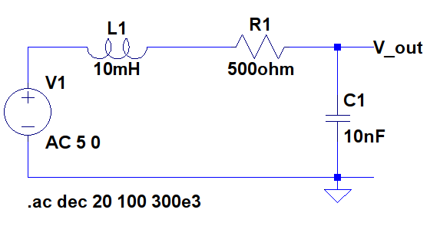

**Figure 2:** RLC circuit used for a low-pass bandpass filter

* 1. Construct the circuit from Figure 2 using a 5 V (amplitude, offset 0 V) sinusoidal output from the AFG as the input voltage.
  2. Measure the output voltage for frequencies from 100 Hz to 300 kHz in at least 8 intervals.
  3. Plot the measured ratio of the amplitudes of the output sine wave to the input sine wave, on the y-axis vs. log10(*f*) on the x-axis.
  4. Calculate the cutoff frequencies, $ω_{c_{n}}=\left|\sqrt{{\left(\frac{R}{2L}\right)}^{2}+\frac{1}{LC}}∓\frac{R}{2L}\right|×\frac{1}{2π}$ and resonance frequency, $ω_{0}=\frac{1}{\sqrt{LC}}×\frac{1}{2π}$ and locate the values on the graph.

1. **Measured Data:**

**Table 1:** Measured output voltages from the Figure 1 circuit

|  |  |  |
| --- | --- | --- |
| **Input voltage (V)** | **Input frequency (Hz)** | **Output voltage (V)** |
| 10 | 100 | 0.66 |
| 1000 | 3.90 |
| 2925 | 4.80 |
| 4000 | 4.90 |
| 5033 | 5.00 |
| 9000 | 4.80 |
| 12.99 k | 4.70 |
| 50 k | 3.05 |
| 300 k | 0.25 |

**Table 2:** Measured output voltages from the Figure 2 circuit

|  |  |  |
| --- | --- | --- |
| **Input voltage (V)** | **Input frequency (Hz)** | **Output voltage (V)** |
| 10 | 100 | 10.00 |
| 1000 | 10.00 |
| 7500 | 9.00 |
| 11.94 k | 7.80 |
| 13.50 k | 7.20 |
| 15.92 k | 6.40 |
| 17.50 k | 5.70 |
| 19.89 k | 5.00 |
| 25 k | 4.00 |
| 100 k | 1.20 |
| 300 k | 1.00 |

1. **Measurements:**

**5.1** Finding cutoff and resonance frequencies of Figure 1 RLC circuit:

$ω_{c_{n}}=\left|\sqrt{{\left(\frac{R}{2L}\right)}^{2}+\frac{1}{LC}}∓\frac{R}{2L}\right|×\frac{1}{2π}$

$ω_{c_{1}}=\left|\sqrt{{\left(\frac{1000 Ω}{2×10×{10}^{-3}}\right)}^{2}+\frac{1}{10×{10}^{-3}×100×{10}^{-9}}}-\frac{1000}{2×10×{10}^{-3}}\right|×\frac{1}{2π}=2925 Hz$

$ω_{c_{2}}=\left|\sqrt{{\left(\frac{1000 Ω}{2×10×{10}^{-3}}\right)}^{2}+\frac{1}{10×{10}^{-3}×100×{10}^{-9}}}+\frac{1000}{2×10×{10}^{-3}}\right|×\frac{1}{2π}=12991 Hz$

$ω_{0}=\frac{1}{\sqrt{LC}}×\frac{1}{2π}=\frac{1}{\sqrt{10×{10}^{-3}×100×{10}^{-9}}}×\frac{1}{2π}=5033 Hz$

**5.2** Finding cutoff and resonance frequencies of Figure 2 RLC circuit:

$ω_{c_{n}}=\left|\sqrt{{\left(\frac{R}{2L}\right)}^{2}+\frac{1}{LC}}∓\frac{R}{2L}\right|×\frac{1}{2π}$

$ω_{c_{1}}=\left|\sqrt{{\left(\frac{500 Ω}{2×10×{10}^{-3}}\right)}^{2}+\frac{1}{10×{10}^{-3}×10×{10}^{-9}}}-\frac{500}{2×10×{10}^{-3}}\right|×\frac{1}{2π}=11937 Hz$

$ω_{c_{2}}=\left|\sqrt{{\left(\frac{500 Ω}{2×10×{10}^{-3}}\right)}^{2}+\frac{1}{10×{10}^{-3}×10×{10}^{-9}}}+\frac{500}{2×10×{10}^{-3}}\right|×\frac{1}{2π}=19894 Hz$

$ω_{0}=\frac{1}{\sqrt{LC}}×\frac{1}{2π}=\frac{1}{\sqrt{10×{10}^{-3}×100×{10}^{-9}}}×\frac{1}{2π}=15916 Hz$

1. **Graphs:**

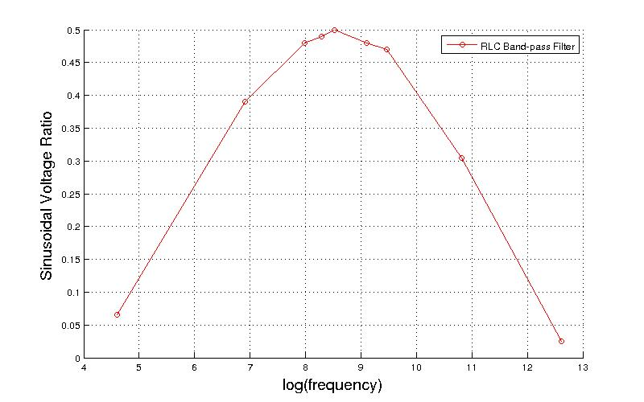

**Figure 3:** Plot of the voltage ratios and frequency of the Figure 1 circuit

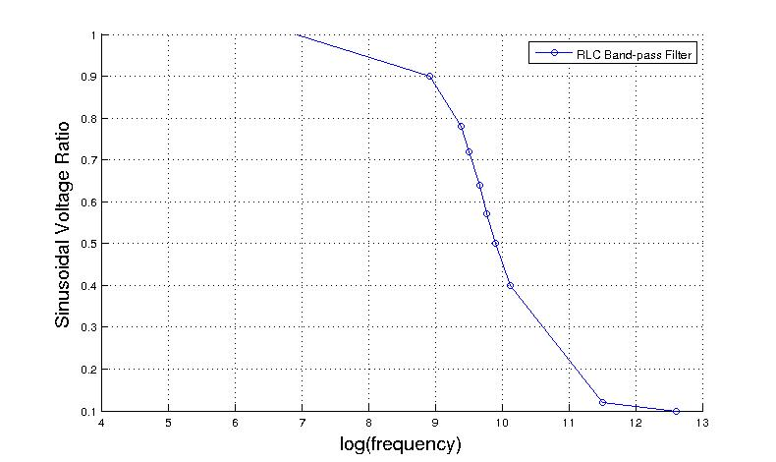

**Figure 4:** Plot of the voltage ratios and frequency of the Figure 2 circuit

1. **Conclusion:**

I learned how to construct second-order frequency-selective circuits consisting of resistors, inductors and capacitors and observe their behavior through their low pass and band pass output signals. I also learned how to calculate the transfer functions of the circuits with their complex inpedances.