**References**

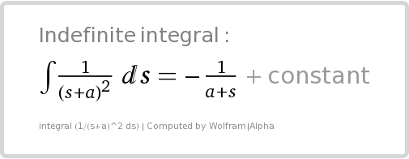

**Figure 1: Source 1: Computation of Integral used for Question 1**

**WolframAlpha | www.wolframalpha.com**

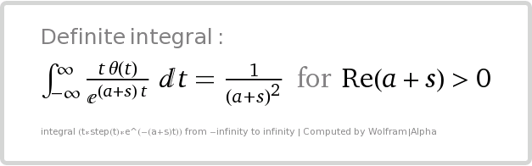

**Figure 2: Source 2: Computation of Integral used for Question 1**

**WolframAlpha | www.wolframalpha.com**

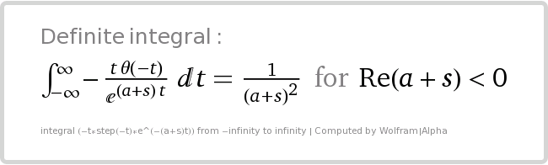

**Figure 3: Source 3: Computation of Integral used for Question 1**

**WolframAlpha | www.wolframalpha.com**

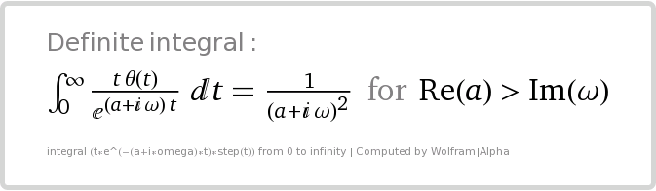

**Figure 4: Source 4: Computation of Integral used for Question 1**

**WolframAlpha | www.wolframalpha.com**

**5. StackExchange**

How do you find the Inverse Laplace Transform of 1(s−1)21(s−1)2? (n.d.). Retrieved from http://math.stackexchange.com/q/375550

**6. Inverse Laplace Transformation Table**

Laplace Transforms - Lamar University. (n.d.). Retrieved November 16, 2016, from http://tutorial.math.lamar.edu/pdf/Laplace_Table.pdf