**CMPE 314: Principles of Electronic Circuits**

**Dr. Yan**

**Lab Project Report**

**AM Radio Receiver**

**Sabbir Ahmed**

**Yu Fu**

1. **Objective**

Design, implement and demo a simple AM radio receiver circuit.

1. **Background**

An AM radio wave is an amplitude-modulated electromagnetic wave. It has a radio frequency carrier wave whose amplitude varies (modulated) with audio signals. The AM radio carrier frequencies are in the range of 540-1600 kHz, and the audio signal frequencies are in the range of 20 Hz to 20 kHz.

An AM radio receiver consists of the following basic functional building blocks: a frequency-tuning antenna, a radio frequency (RF) amplifier, an audio signal detector, and an audio signal amplifier.

1. **Equipment**
   1. Electrical Components:
      1. AM bar antenna (radio kit)
      2. Variable capacitor with a tuning knob (radio kit)
      3. Ceramic earphone (radio kit)
      4. Resistors; 1 × 1 kΩ, 2 × 2.2 kΩ, 2 × 2.7 kΩ, 4 × 10 kΩ, 2 × 15 kΩ, 3 × 47 kΩ
      5. Capacitors; 2 × 1 µF, 1 × 22 µF, 4 × 220 µF
      6. Transistors; 3 × 2N3904 NPN
      7. 9 V Battery
      8. Wires
   2. Mechanical Parts:
      1. Breadboard
      2. Cardboard paper panel with plastic frame
      3. Nuts, screws, antenna holder, spring terminals and a battery snap
   3. Development:
      1. DC power supply
      2. Digital multimeter
      3. Oscilloscope
      4. Arbitrary function generator
2. **Design and Implementation**

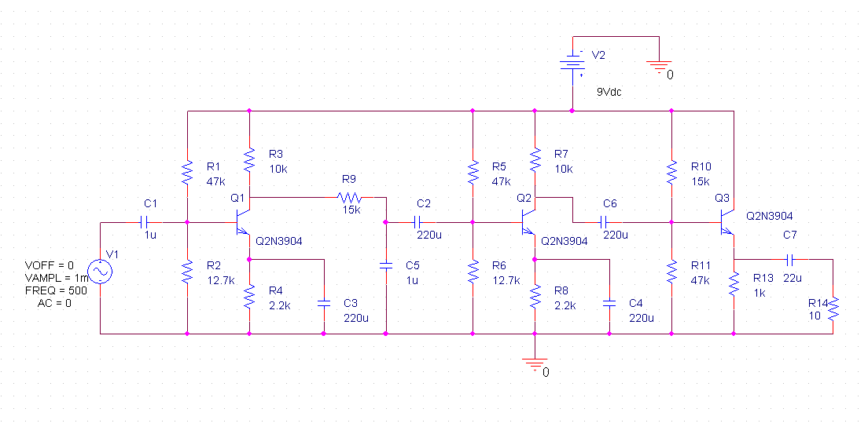

**Figure 1: Final Schematic of the AM Receiver Radio Circuit**

The ideal gain of the amplifier would range between 300 – 400. The gain of a common-emitter can be computed with the expressions

where;

The voltage gain across each stages of the circuit were tested individually before being connected:

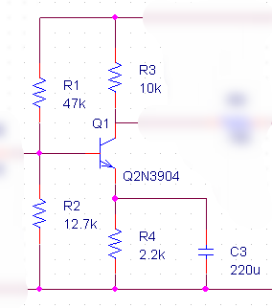

**Figure 2: Radio Frequency Amplifier with a Bypass Capacitor**

The gain was computed to be -28.4, and the output voltage measured across with input of 1 mV was 24.6 mV.

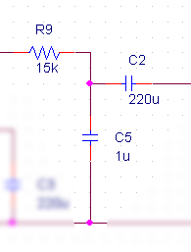

**Figure 3: Low-pass and High-pass Filters**

The filters were required for managing the input frequencies. The corner frequencies can be computed with the expression

The corner frequency for the low-pass filter was computed to be 10.6 Hz while the high-pass filter generated a corner frequency < 1 Hz. However, the values of the capacitors were varied during testing. The output voltage was measured to be 2.4 V.

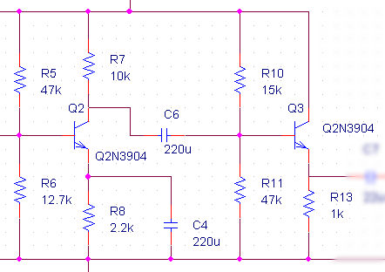

**Figure 4: Two-stage Audio Amplifier**

The total gain of the two amplifiers were computed to be 24.99.

Before the physical implementation, the circuit was tested in a simulation on PSPICE. The input frequency and voltages were replicated, with the DC input set to 9 V and the AC input set to a 1 mV, 500 Hz sine wave. The output voltage at the load resistor was captured and the data was dumped to generate the plot below:

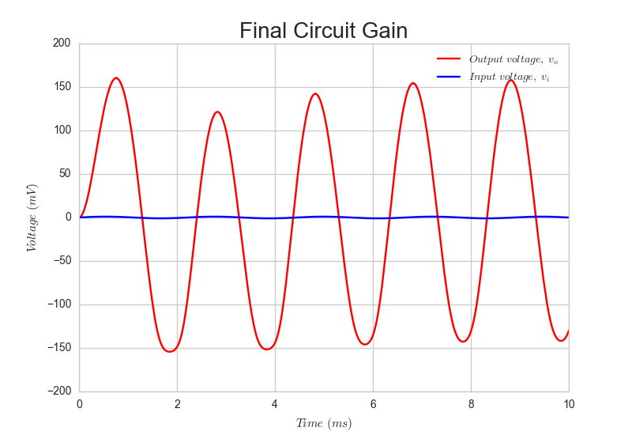

**Figure 5: vo of the Radio Circuit Simulated on PSPICE**

The gain yielded was not sufficient to be considered within the range to drive the speaker. The values of the capacitors in the filter were initially changed to gain a larger output, trading off the precision of the corner frequencies. Later, when it was realized this change caused significant clipping in the larger output, it was reverted with

The circuit was finally implemented with the physical components and tested.

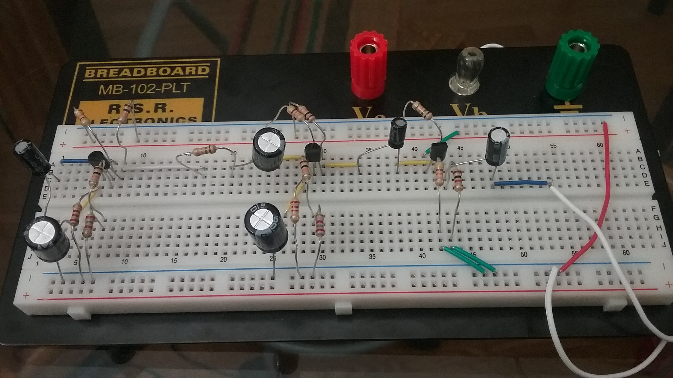

**Figure 6: Final Implementation of the Radio Circuit**

**(Not Including the Input Circuit Consisting of the Bar Antenna, 9 V DC Source, and Tuning Capacitor)**

The oscilloscope was used to measure the final gain of the circuit. Since the function generator was unable to yield signals lower than 50 mV, a voltage divider was initially used to strip out 1 mV. However, because the divider created significant noise because of the oscilloscope being insensitive to such small inputs, it had to be removed.