Project 0, World Education Statistics Calc

Due: Please check due date on BlackBoard

**Objectives**

The objective of this programming assignment is to have you practice inheritance, I/O, and basic C++ programming to prime you for the rest of the semesters work.

**Introduction**

You are (or probably are not) interested with the correlation between the expenditure of different countries on their public schooling and the corresponding literacy rates, as well as the differences in education in different countries between males and females. You’ve decided (or rather, have been told) to look into the statistics from the world bank on said things, and create a ranking of the countries with the highest literacy rates, primary school completion rates, and percent of GDP spent on education for each continent.

**Classes**

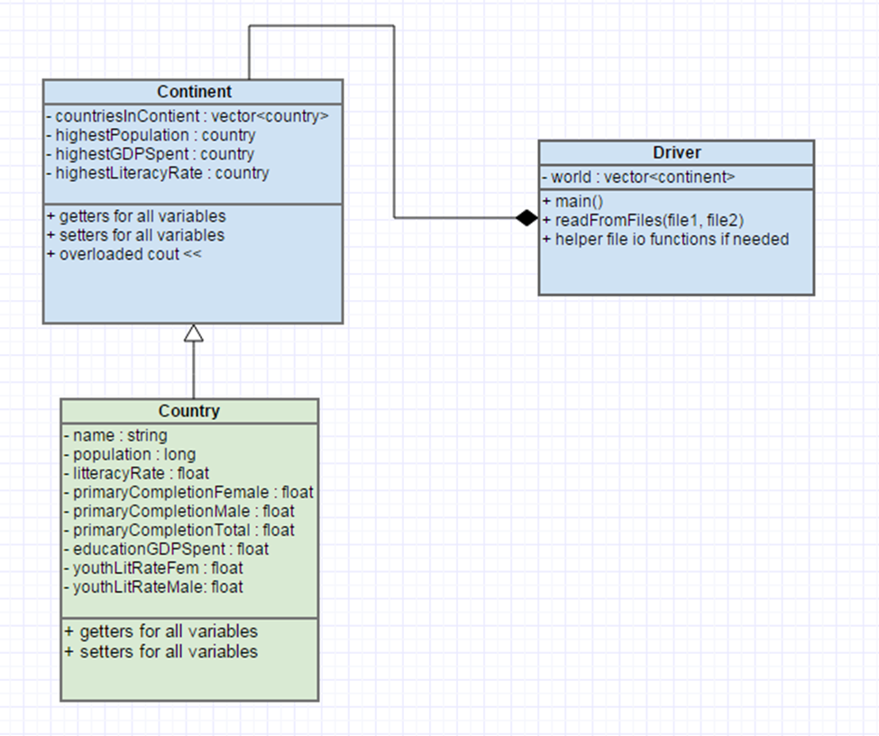You will want to break this down into at least two classes, the Country class and the Continent class, Continent should be the child of the Country class for how you want to display the data. The classes should use the following UML.

**Inheritance**

## The country class will be the parent class of the continent class. If you do not remember how inheritance works in C++ feel free to refer back to Professor Lupoli’s C++ inheritance notes [--HERE--](https://userpages.umbc.edu/~slupoli/notes/C++/InheritanceNotes.docx). (HINT You will want to add the populations from all of the countries to create the population for the continent.)

**Input using File I/O**

## You will be given two files, one that contains all of the statistical data for the countries (2013WorldBankEducationCensusData.txt) , and one that contains which countries belong in which continents (CountriesContinents.txt). If you don’t remember how to do file I/O from 202, feel free to review Professor Lupoli’s C++ File I/O notes [--HERE--](https://userpages.umbc.edu/~slupoli/notes/C++/FileIONotes.docx)

## You will need to create instances of the country class for each country in the statistical data set and map said country to the corresponding continent. In the file that states which countries belong in which continents you will notice that each continent is written in all caps, and has the number of countries within the continent on the same line. Note that there are some countries that are not included in the statistics, so you will want to first parse the statistical data and then sort the countries into continents in that order.

## **You’ll note that in the file containing statistics, some countries are missing data and have “N/A” in that place, you will be recording this data in the country class as a -1 instead of 0.** Every country has a population, so it is possible that the country with the highest population in a continent may not have statistics for other variables.

## A good way to parse this data would be to split each line into a vector of tokens and translate into floats and longs from there.

**Calculations**

## You will be calculating the total population for the continent, and searching for the country within the continent that has the highest % of GDP spent on education, population, and total literacy rate. Your **overloaded << operator** for the continent class will print out these statistics (see output section).

## **Output**

## Your file output for should look like so, using the overloaded COUT for the continent class:

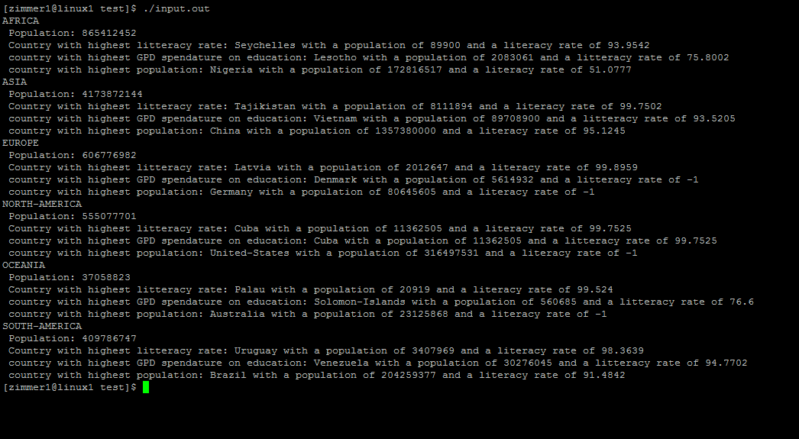

**Support**

A Piazza discussion board has been set up for questions. Please remember to use “Project 1” and that a TA will only look at it periodically so fellow students may have answered the question first.

**What to Submit**

Follow the [course project submission procedures](http://www.csee.umbc.edu/courses/undergraduate/341/fall14/projects/submission.shtml). You should copy over all of your C++ source code with .cpp/.h files under the src directory. You must also supply a Makefile build file.

Make sure that your code is in the ~/cs341proj/proj0/ directory and not in a subdirectory of ~/cs341proj/proj0/. In particular, the following Unix commands should work.

cd ~/cs341proj/proj0/src

make clearset=Clear1

make run

make clean

The command “make run” should simply run the project that compiled successfully.

Don't forget the Project Submission requirements shown online!! One hint, **after you submit**, if you type:

ls ~/cs341proj/proj0/

and you see a bunch of .cpp and .h files, this is WRONG. You should see:

src

instead. The C++ programs must be in directories under the src directory. Your submissions will be compiled by a script. The script will go to your proj1 directory and run your makefile. This is required. You will be severely penalized if you do not follow the submission instructions.

**Makefile Variable and Complier Definitions**

Make files can use variables to replace text to allow for easier changing of parameters or for passing in data. Variables can be defined and set inside the file, for example “CXXFLAGS= -ansi -Wall -g”. This will set the variable CXXFLAGS to “-ansi -Wall -g”. To use this you would then put the variable into a $(variable_name) syntax, for example $(CXXFLAGS). Make will replace “$(CXXFLAGS)” with “-ansi -Wall -g”.

You can also pass the value into make on the command line. For instance your project will require you to pass in the different clearset definition on the command line. We will be using 3 different clearsets: Clear1, Clear2 and Clear3. As an example to pass in Clear2 you would “make clearset=Clear2”. In your make file you would have $(clearset) in the appropriate place to accept this.

You will be passing in this data to then allow the compiler to pick the correct definition for certain variables. Please review #ifdef for C++ to understand how to use this.

**Addendum**

None yet!