Sports Club Automation System

Collaboration Diagram

Class Diagram

Information System Design Project

CSE A1

Group: 1

Rolls:

1005001

1005004

1005005

1005007

1005010

Sports Club Automation is an information system for any sports club in Bangladesh to manage and automate the whole system. This system can be a platform for administrator, all the stuffs, players and people related to the club.

Collaboration diagram and Class diagram for the use cases are an important task for implementation of the system. The subsystems of our proposed systems are:

**Subsystem:**

* Communication
* Registration
* Social Interaction
* Team Management
* Online Store

**Collaboration Diagram:**

Collaboration Diagram depicts the entire function calls and their serial of calling in a use case.

**Class Diagram:**

Class Diagram shows the functions and attributes that a class includes. It also shows the relationship between entity classes.

**1. Communication Subsystem**

1.1 Collaboration Diagram for Communication use-case:

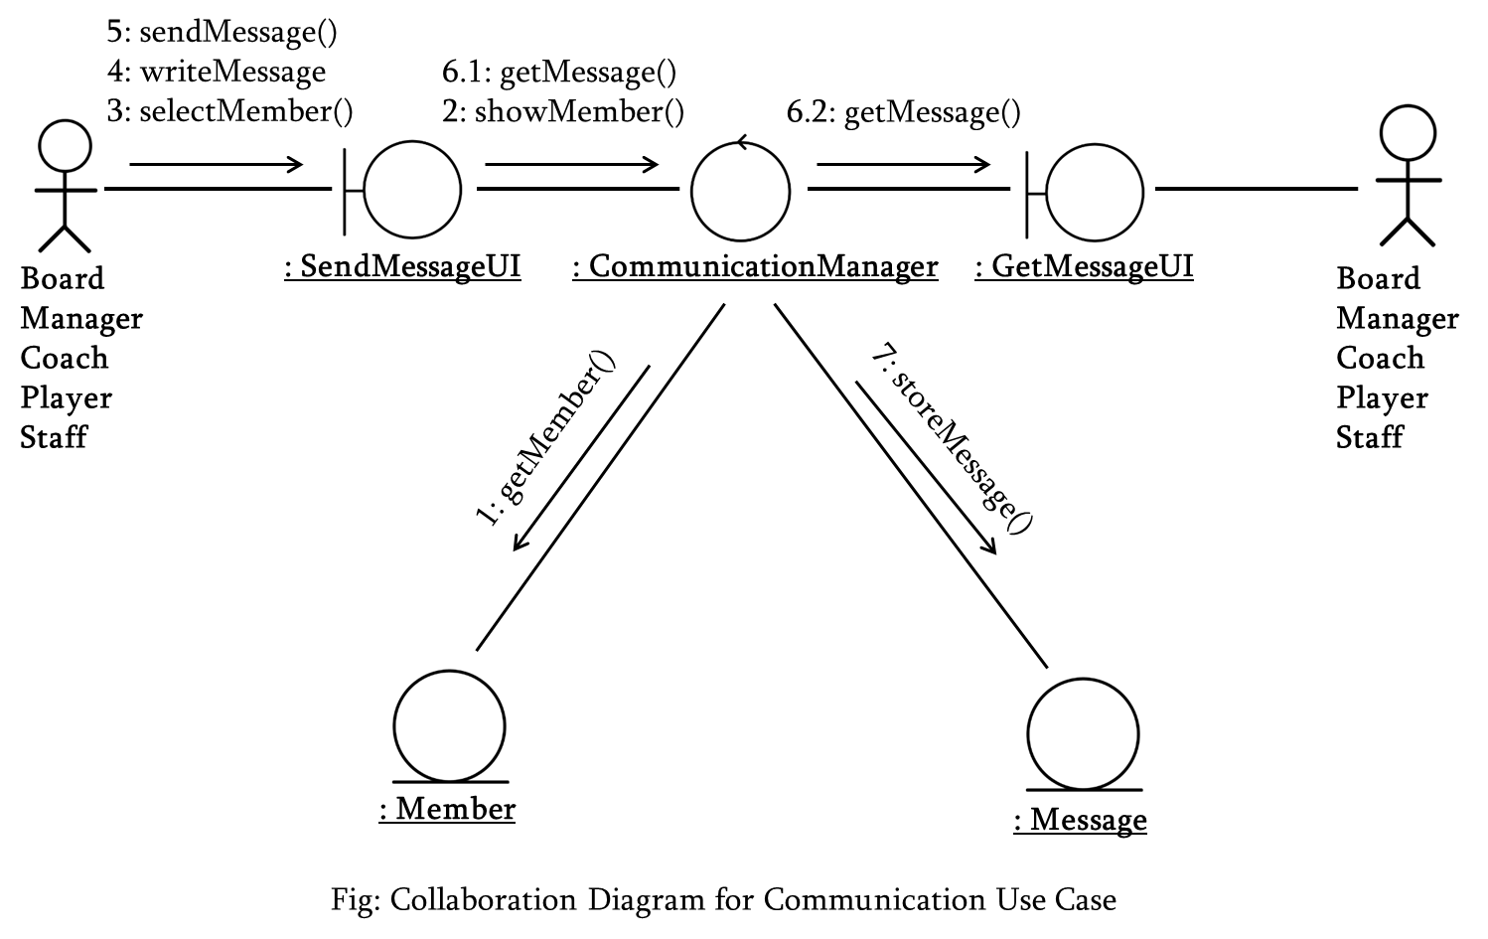

Class Diagram:

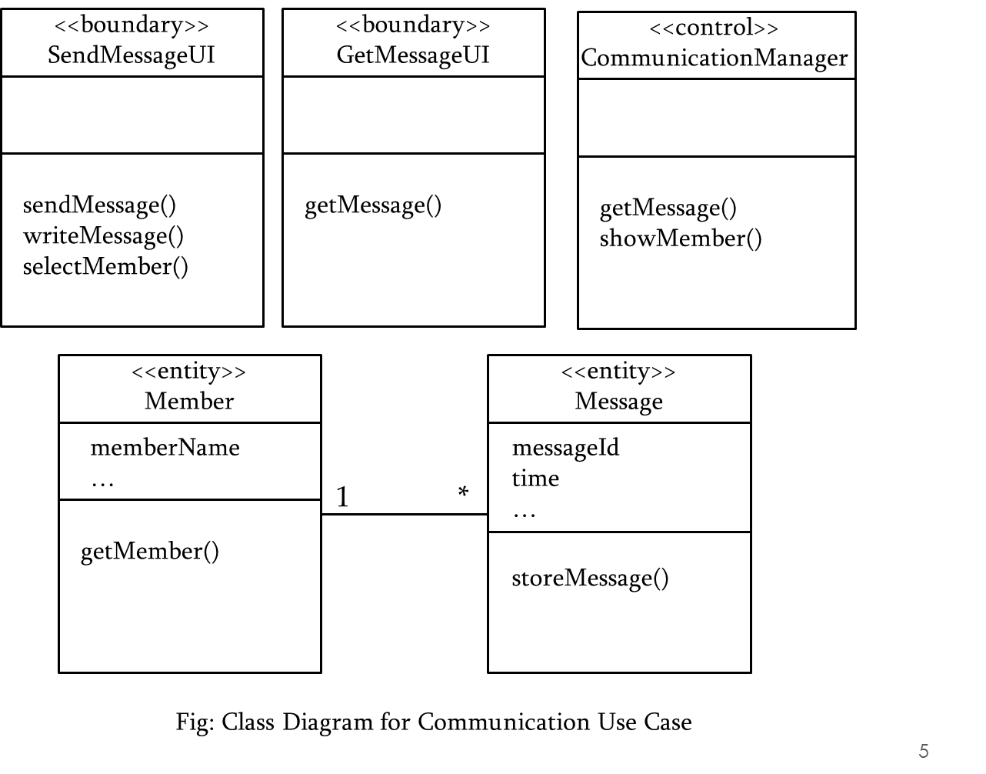

1.2 Collaboration Diagram for Notification use-case:

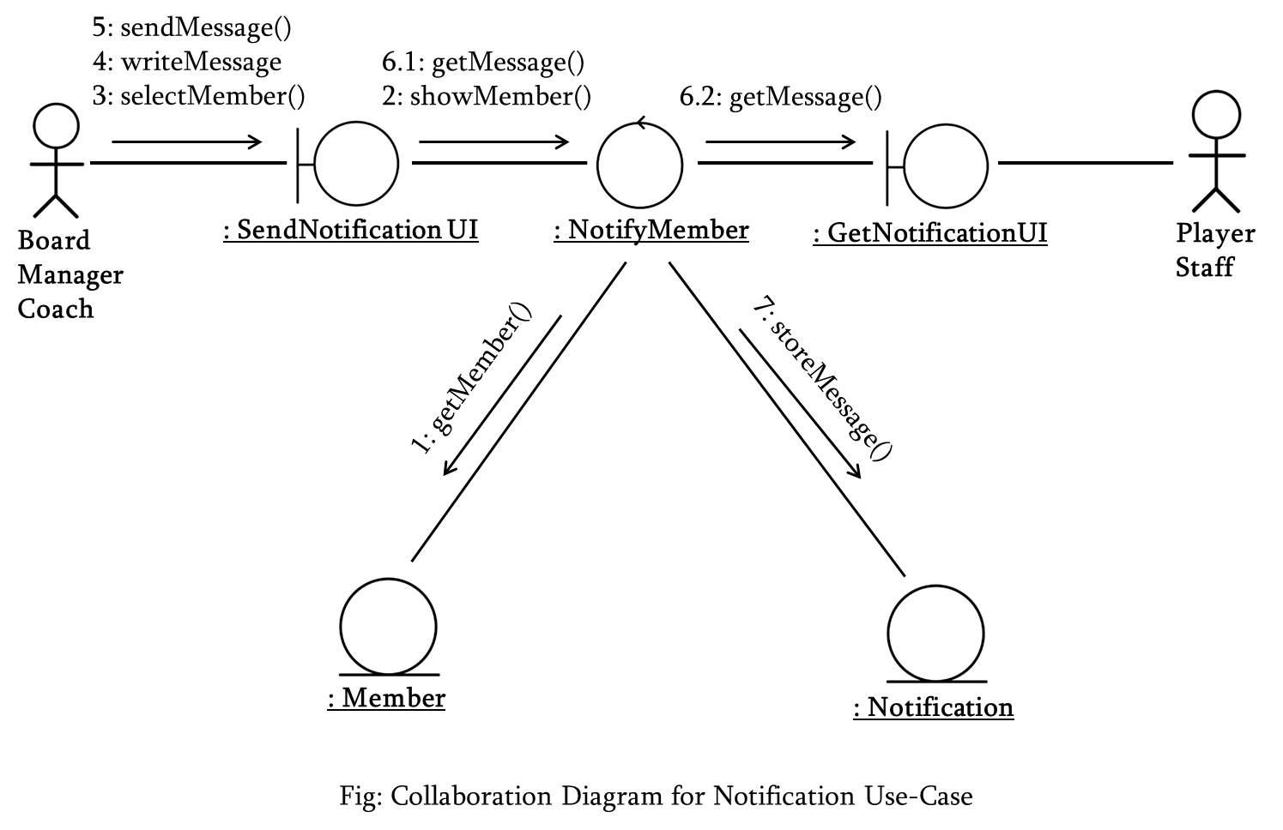

Class Diagram

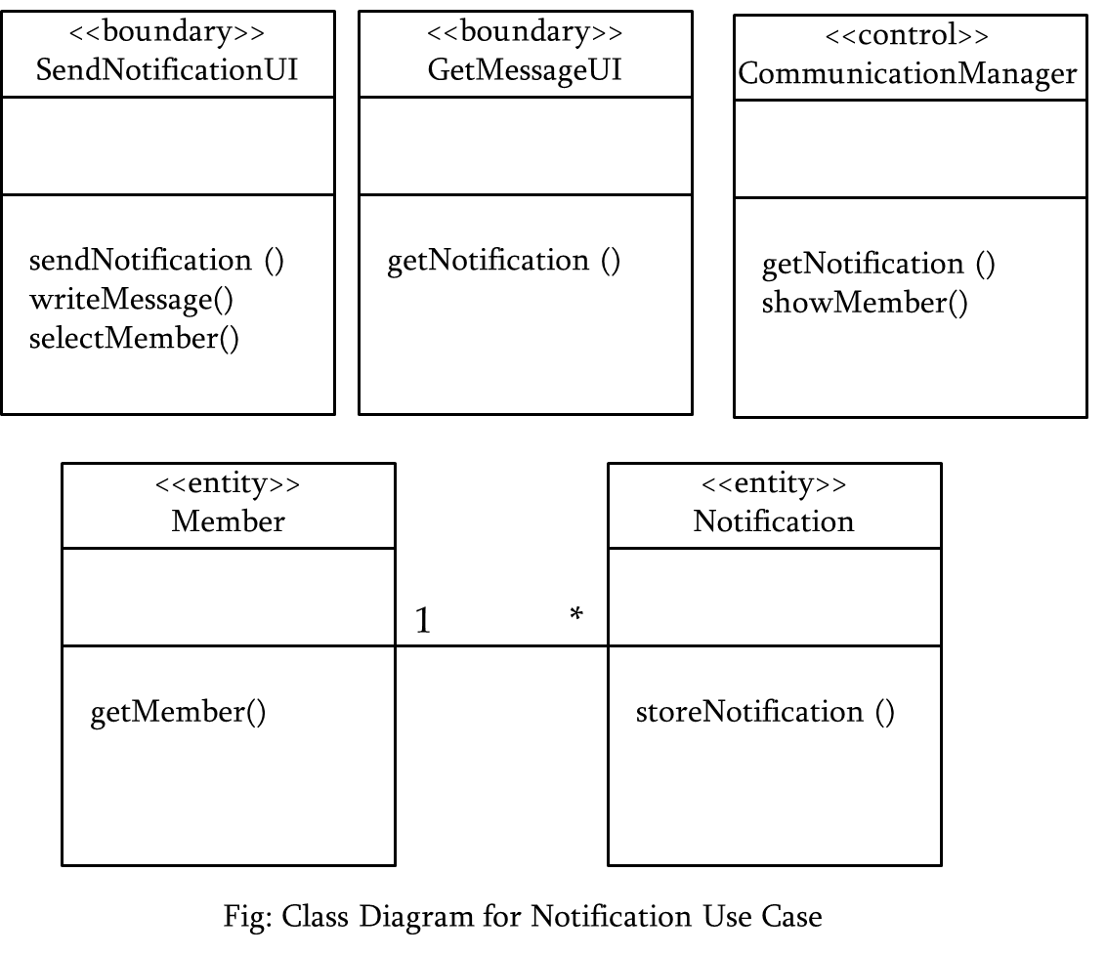

1.3 Collaboration Diagram for Complain use-case:

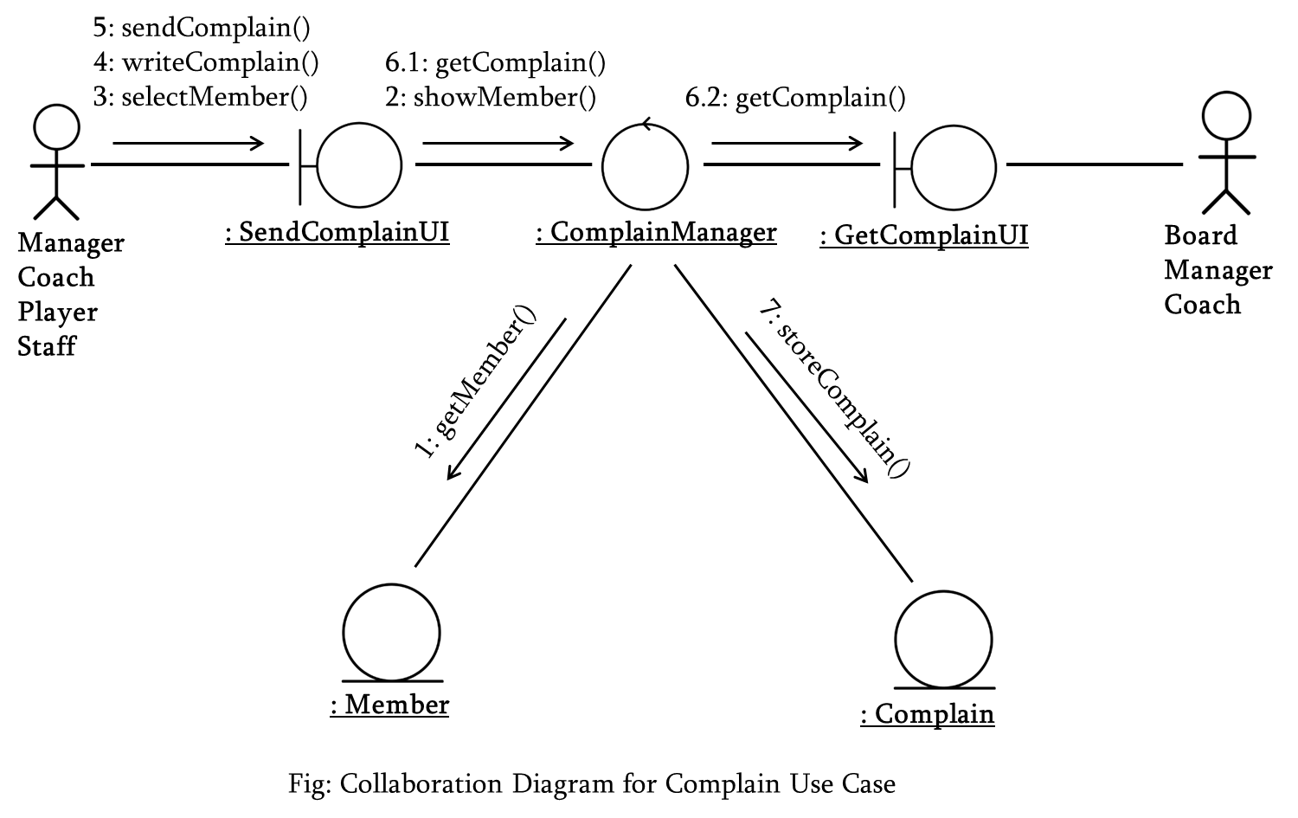

Class Diagram:

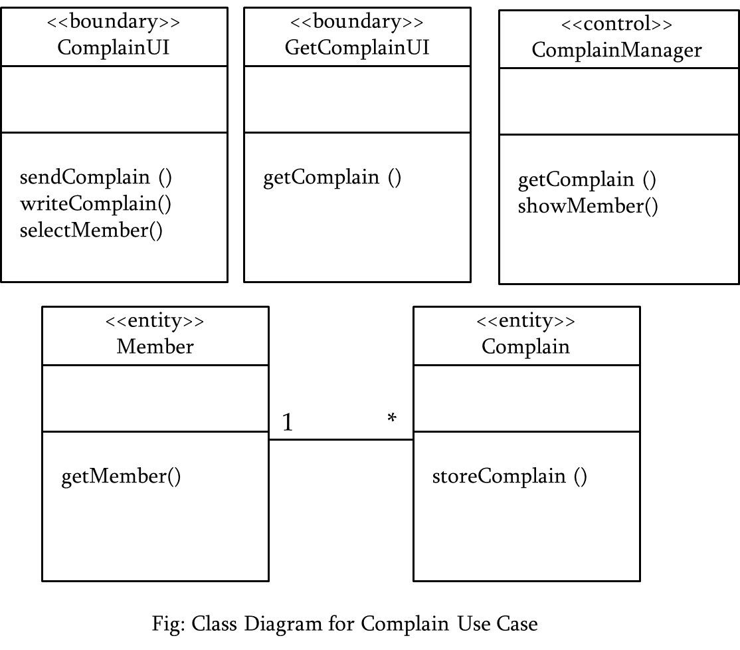

1.4 Collaboration Diagram for Login use-case:

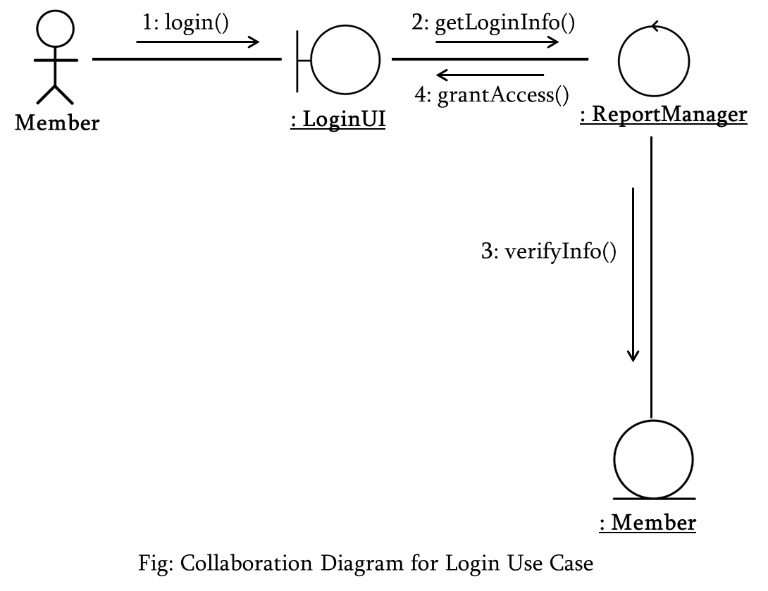

Class Diagram:

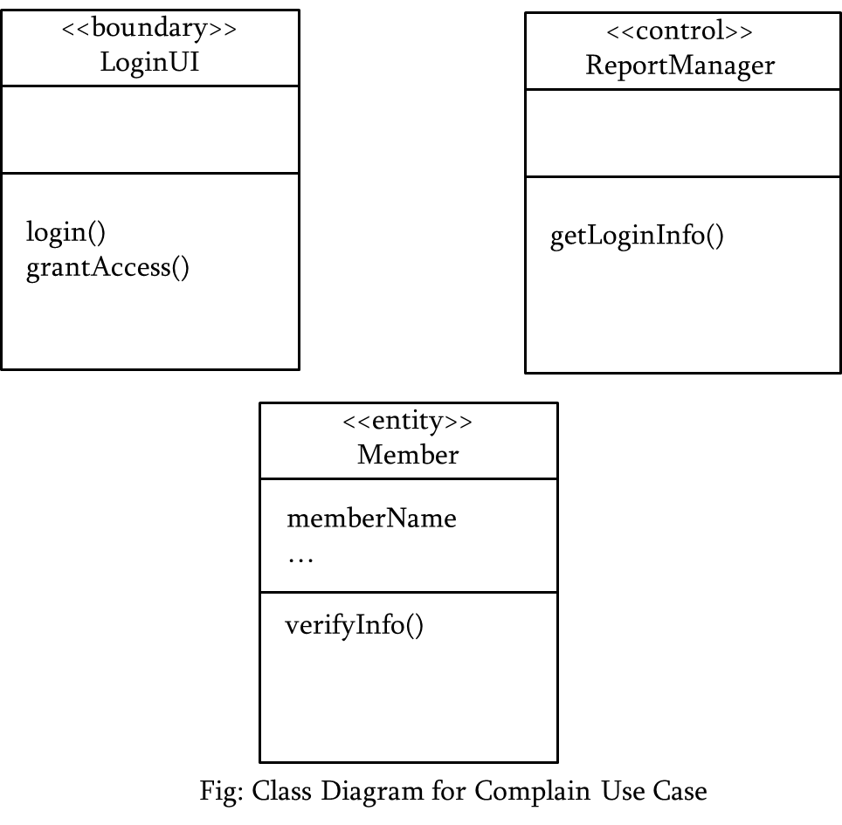

**2. Registration Subsystem**

2.1 Collaboration Diagram for Registration use-case:

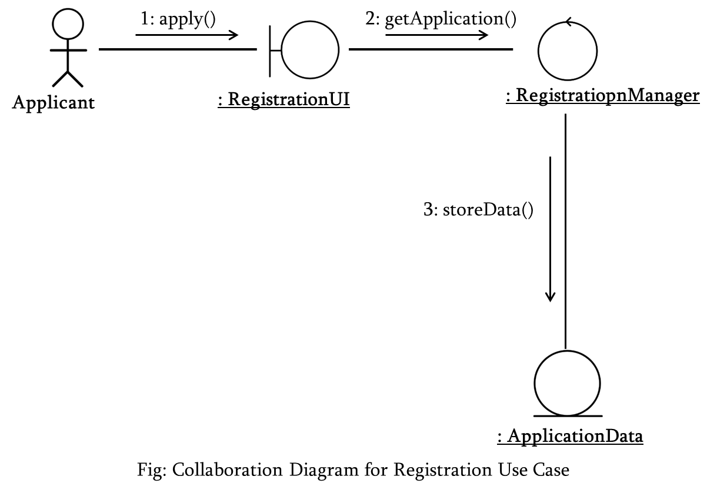

Class Diagram:

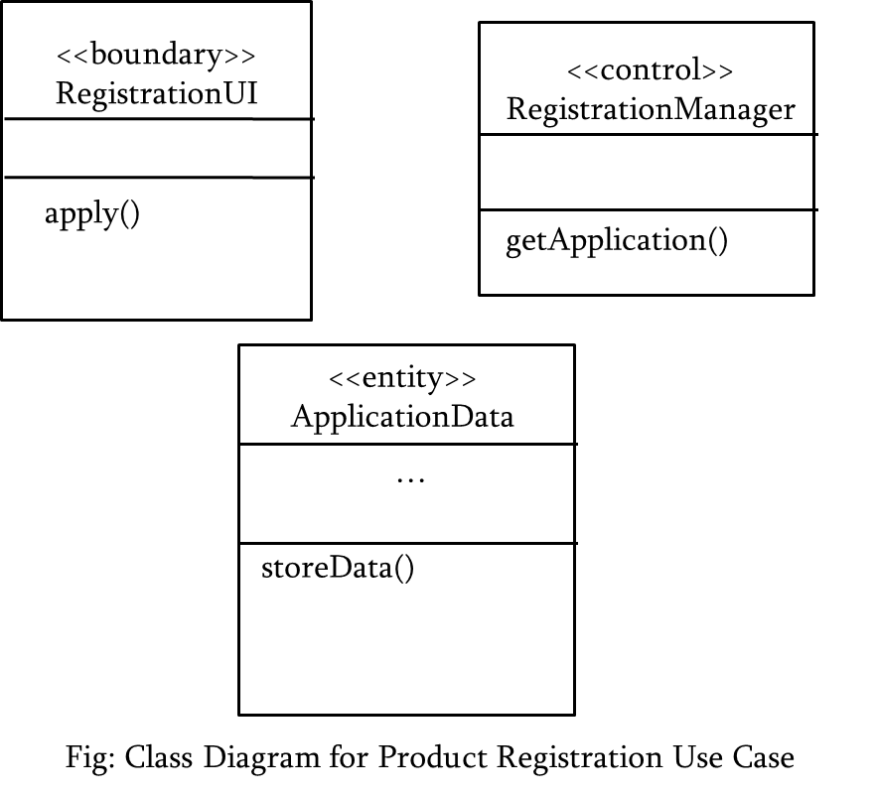

2.2 Collaboration Diagram for Confirmation use-case:

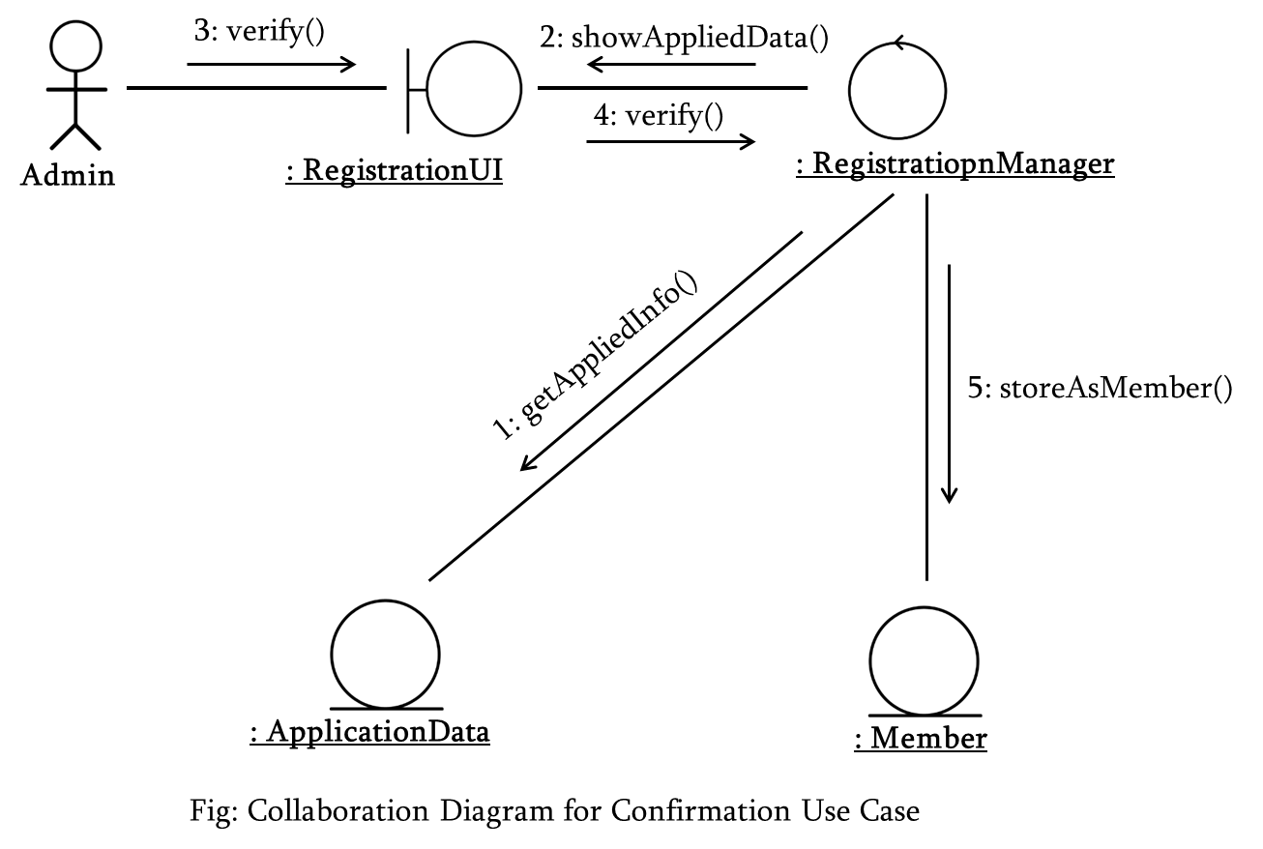

Class Diagram:

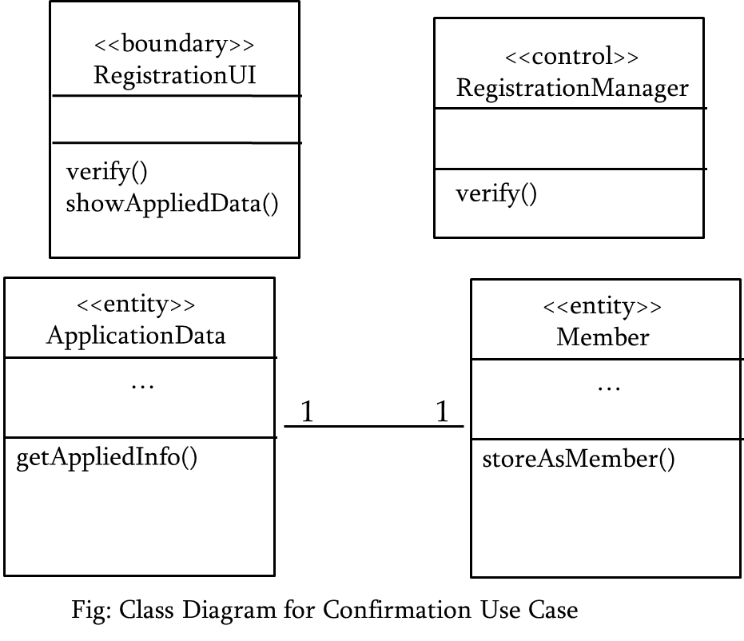

**3. Social Interaction Subsystem**

3.1 Collaboration Diagram for Entertain use-case:

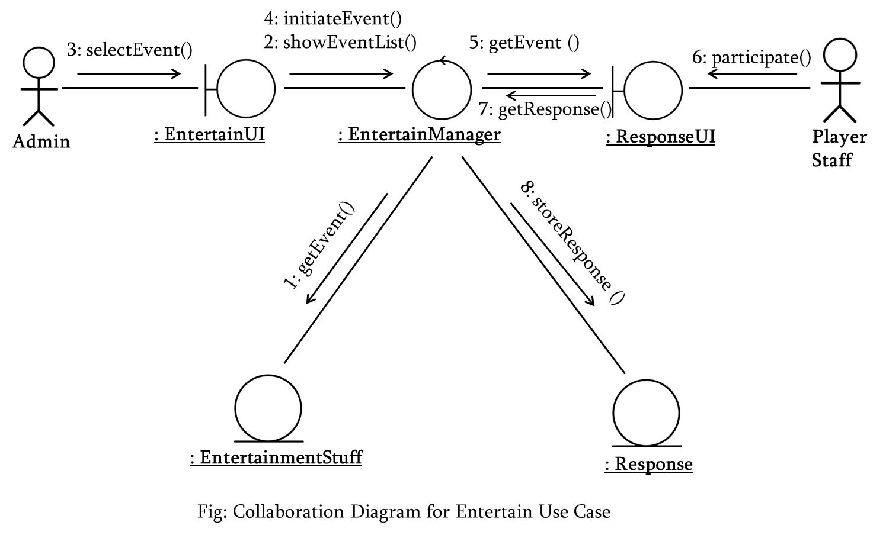

Class Diagram:

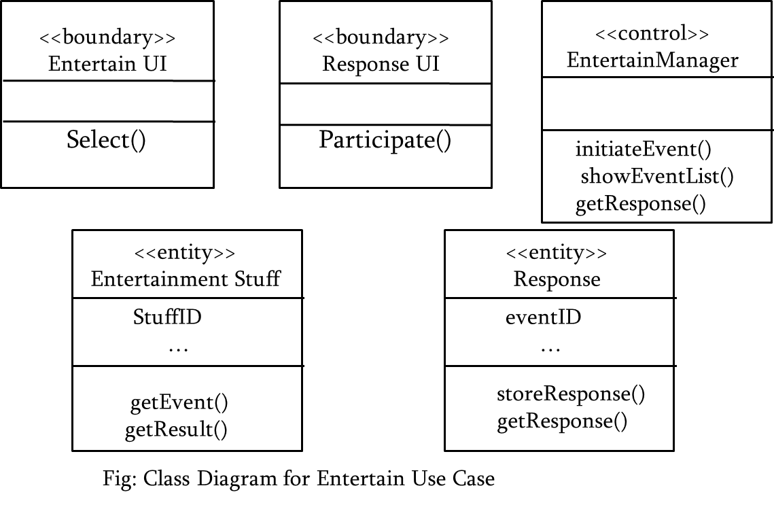

3.2 Collaboration Diagram for Result Publish use-case:

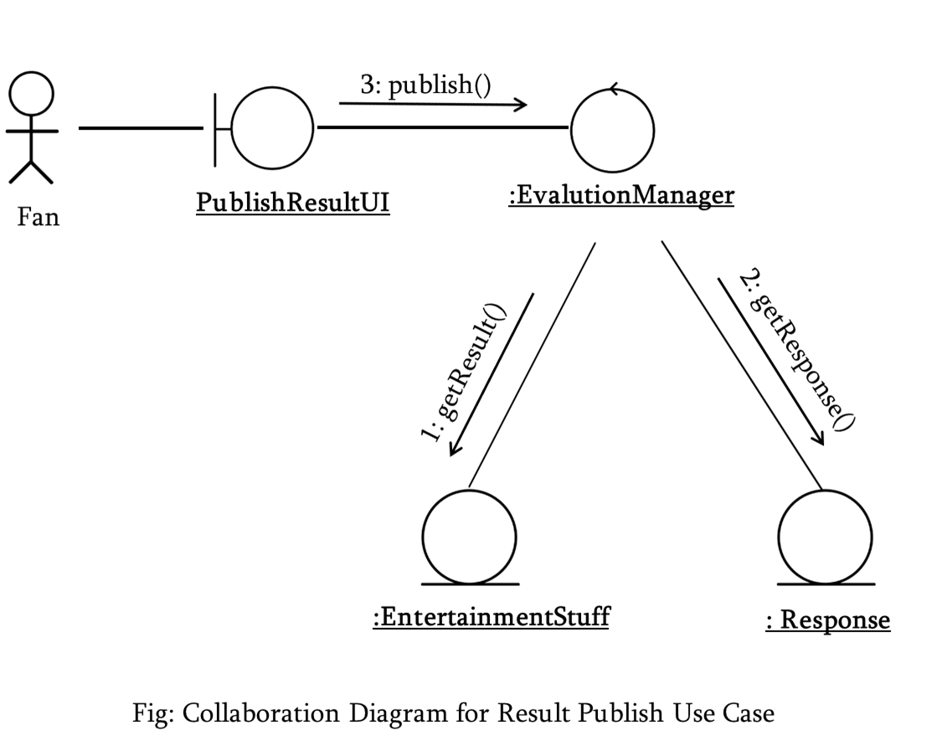

Class Diagram:

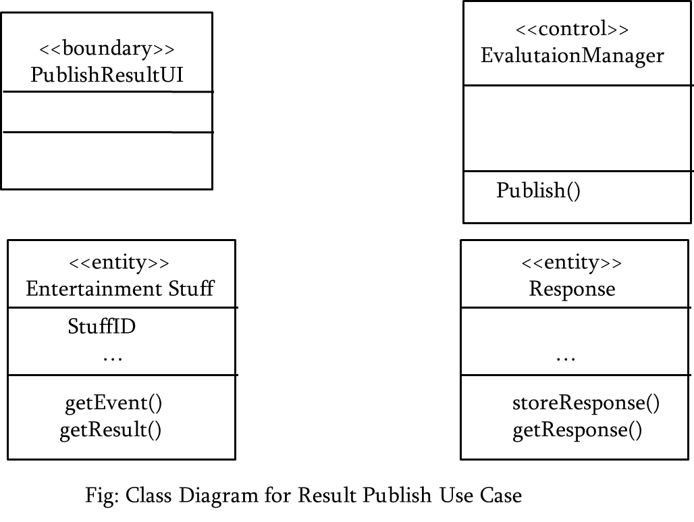

3.3 Collaboration Diagram for Update use-case:

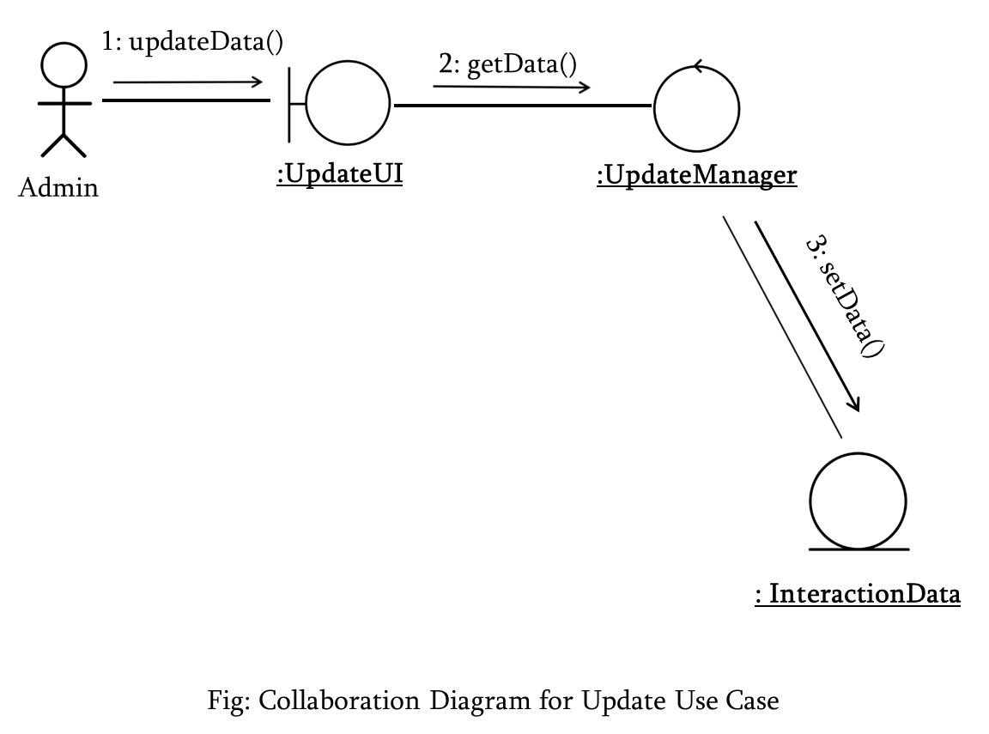

Class Diagram:

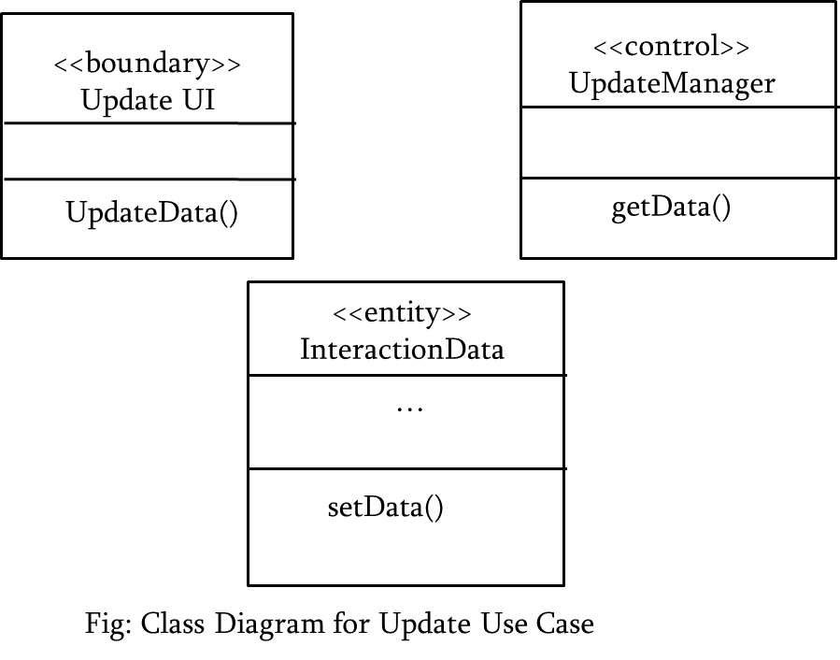

3.4 Collaboration Diagram for View Website use-case:

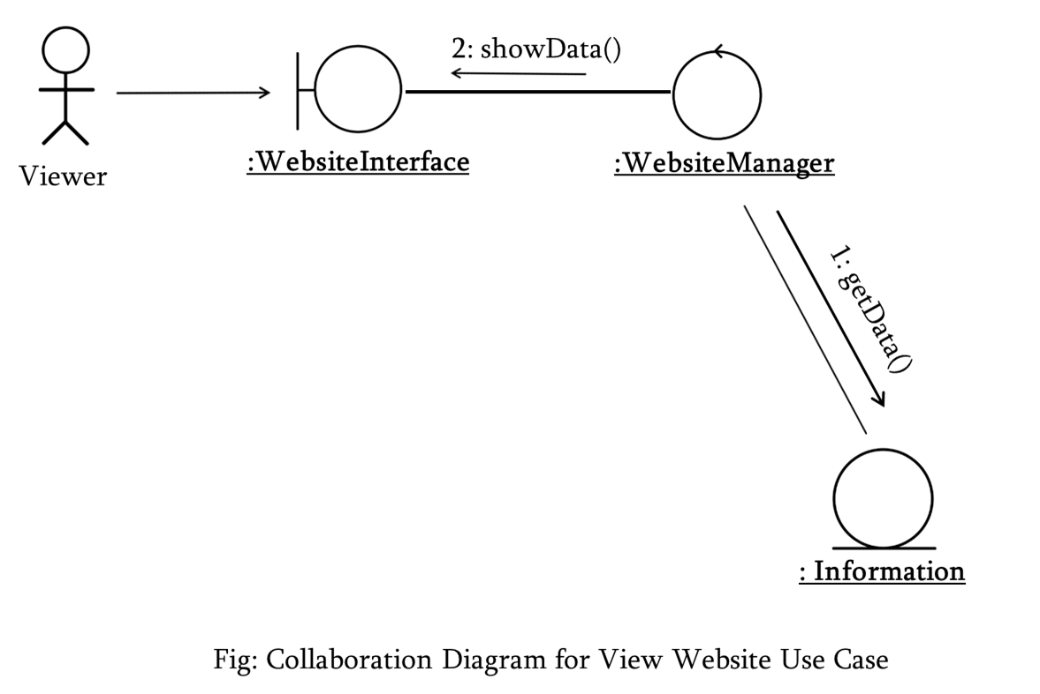

Class Diagram:

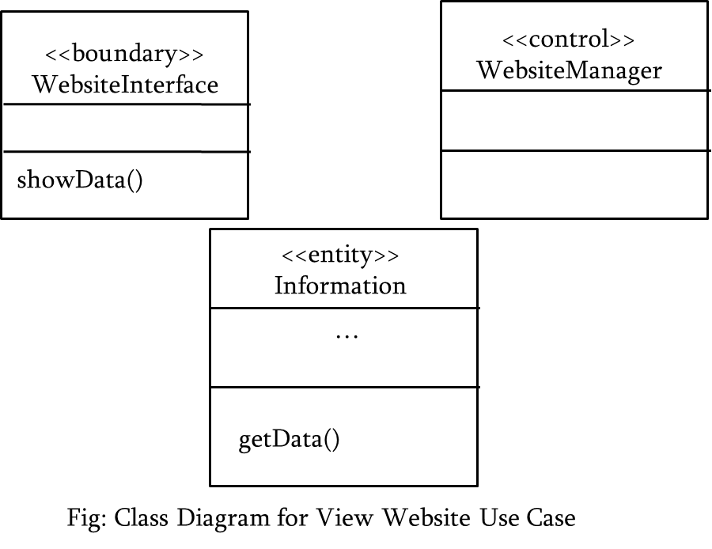

**4. Team Management Subsystem**

4.1 Collaboration Diagram for Squad Selection use-case: 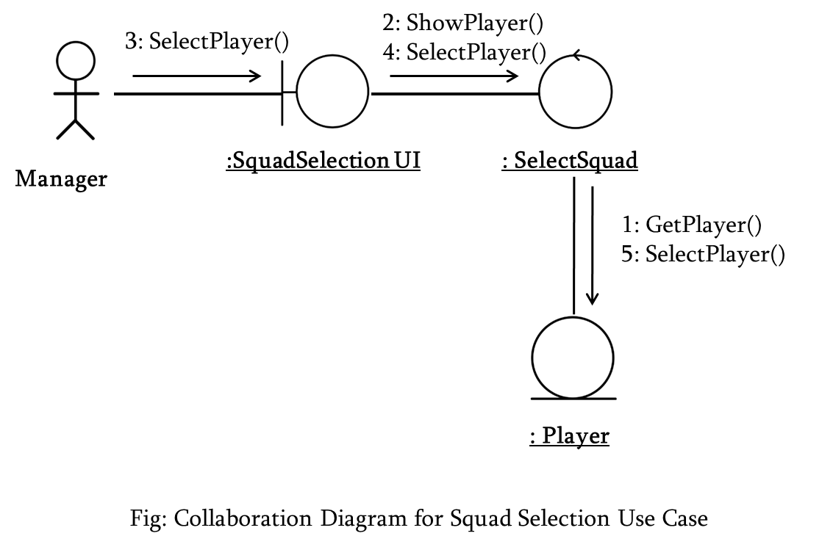

Class Diagram:

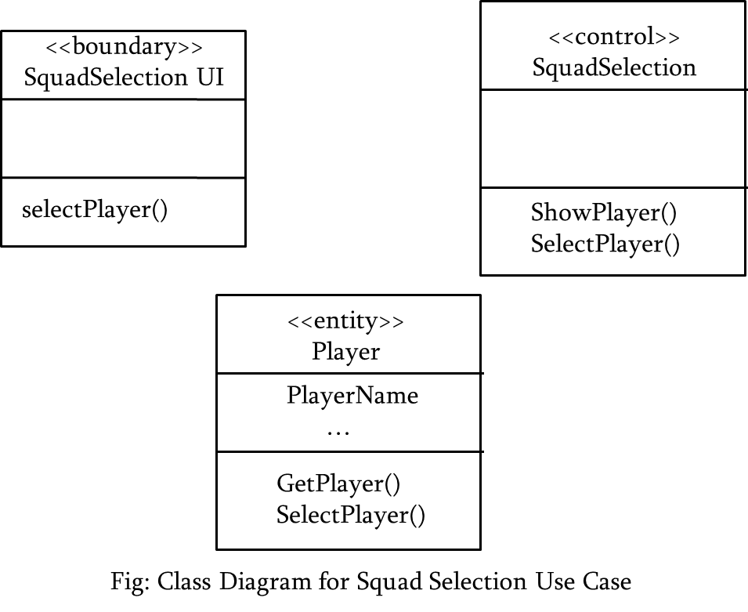

4.2 Collaboration Diagram for Schedule Management use-case:

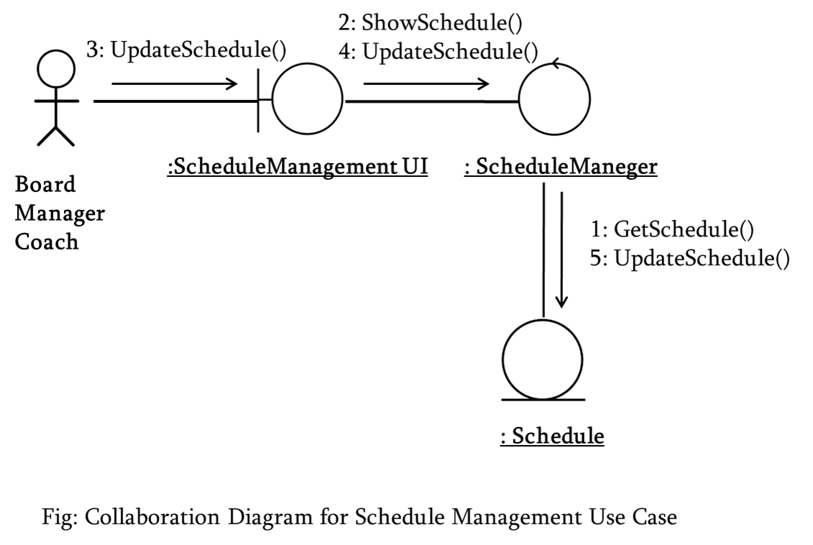

Class Diagram:

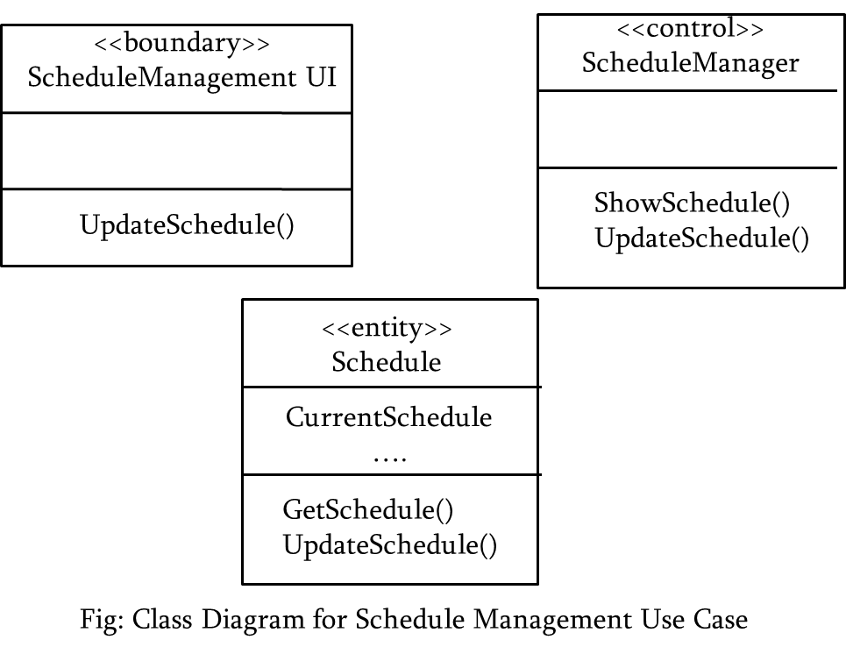

4.3 Collaboration Diagram for Evaluation use-case:

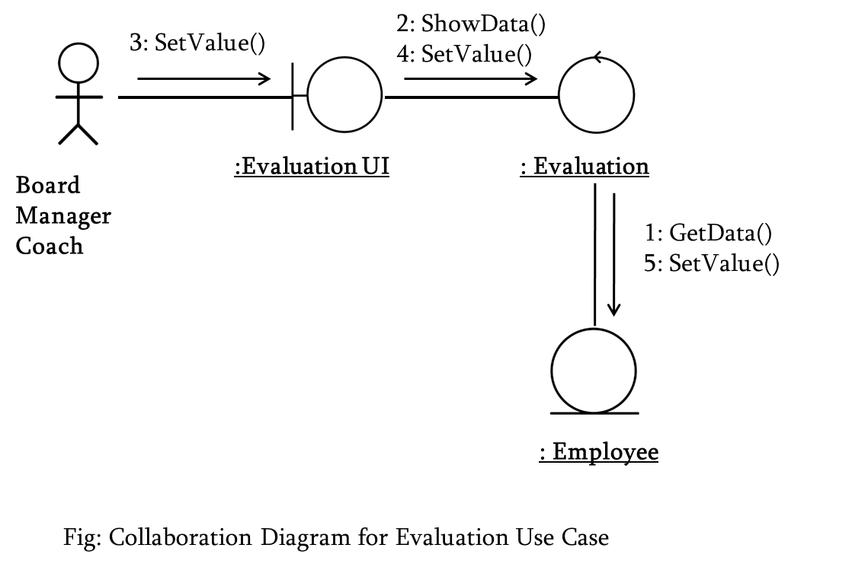

Class Diagram:

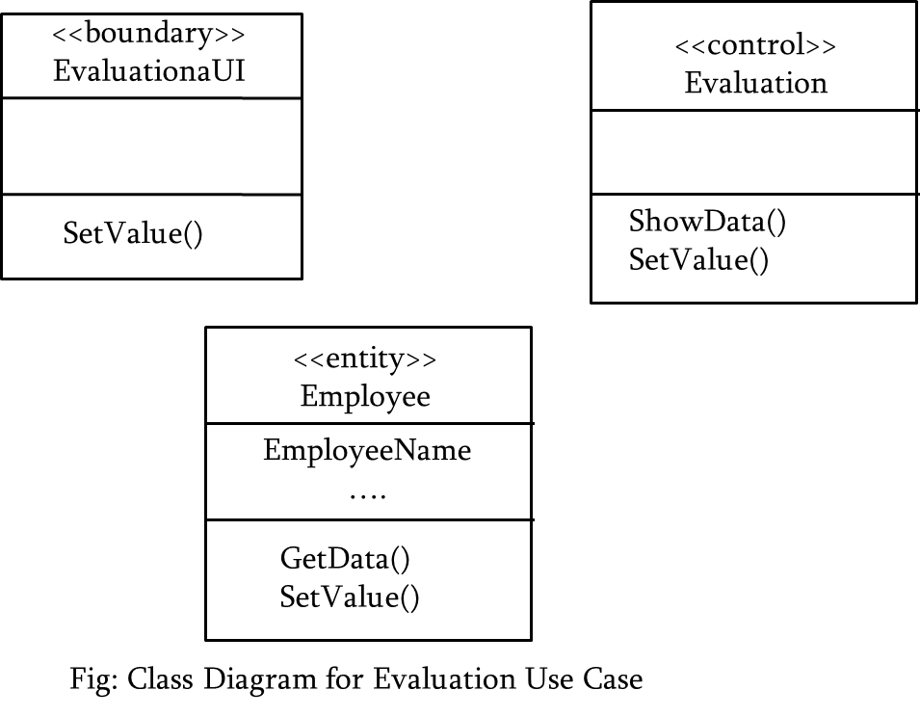

**5. Online Store Subsystem**

5.1 Collaboration Diagram for View Product use-case:

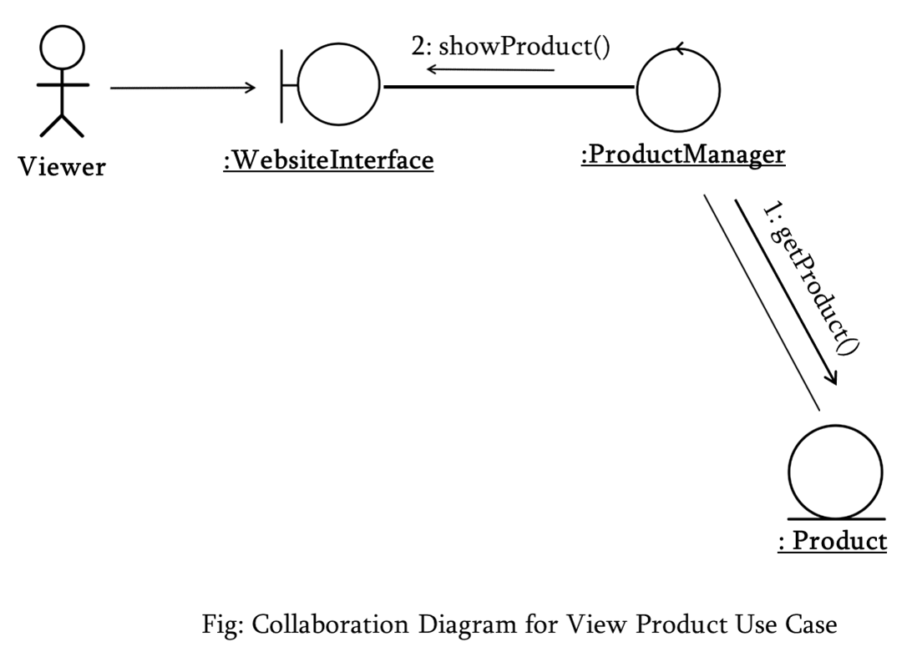

Class Diagram:

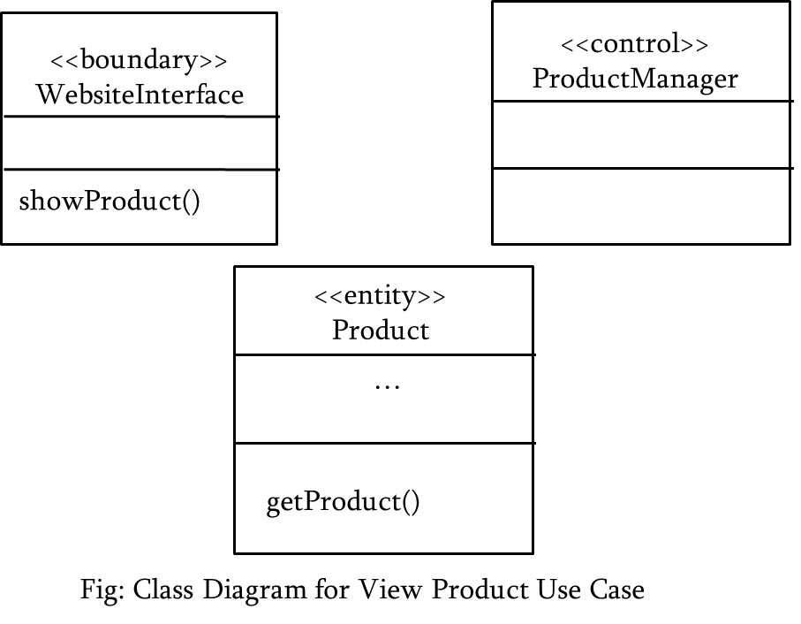

5.2 Collaboration Diagram for Product Booking use-case:

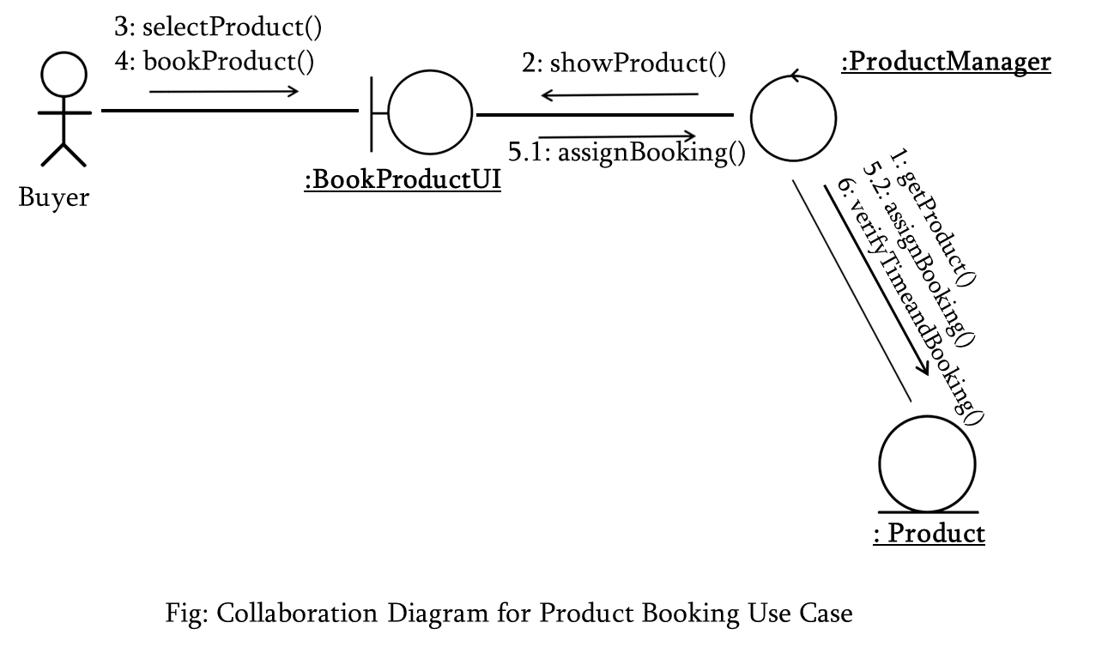

Class Diagram:

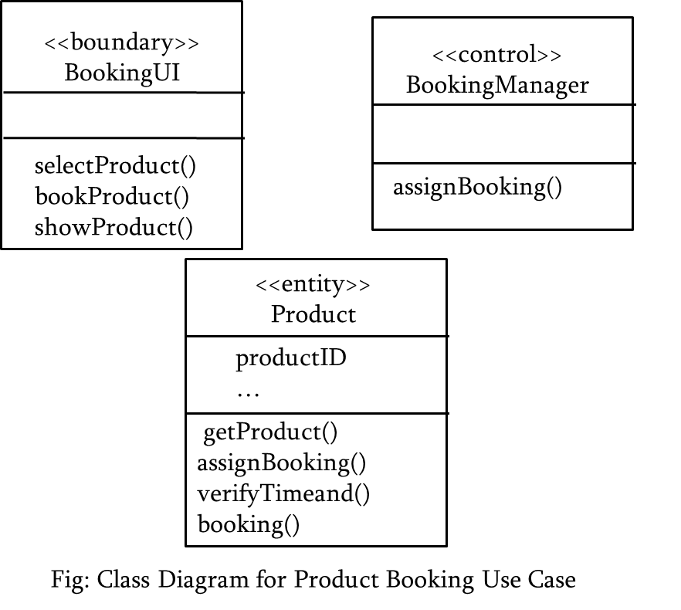

5.3 Collaboration Diagram for Product Update use-case:

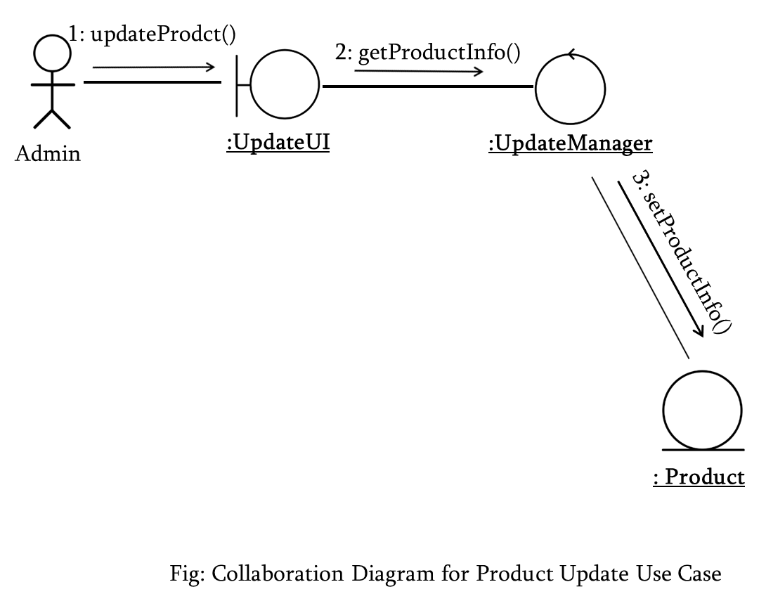

Class Diagram:

