**Sports Club Automation System**

**Fishbone Diagram, Data Flow Diagram**

**And**

**Feasibility Analysis**

Group: 1

1005001

1005004

1005005

1005007

1005010

**Outlines:**

Outlines of this document are:

* Fishbone Diagram
* Data flow Diagram
* Feasibility Analysis

**Subsystems:**

Subsystems of this document are:

* Communication Subsystem
* Social Interaction Subsystem
* Registration Subsystem
* Team Management Subsystem
* Online Store Subsystem

**Communication Subsystem:**

1. Fishbone Diagram:

Fishbone diagram of communication subsystem is shown below

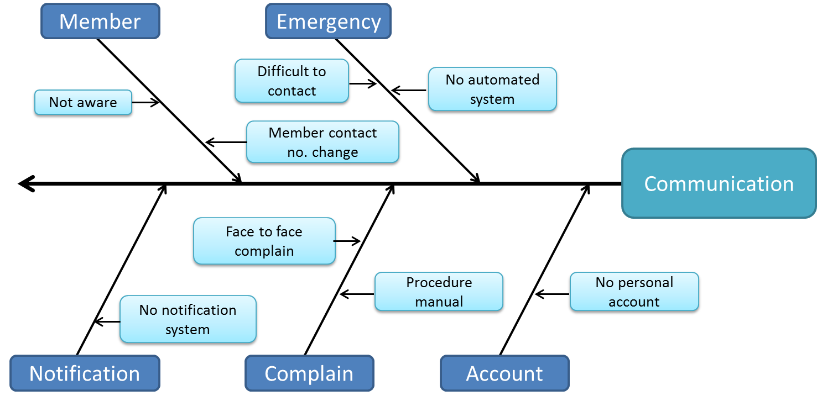

Fig: Fishbone Diagram for Communication Subsystem

2. Data Flow Diagram:

Data flow Diagram of Communication Subsystem is shown below:

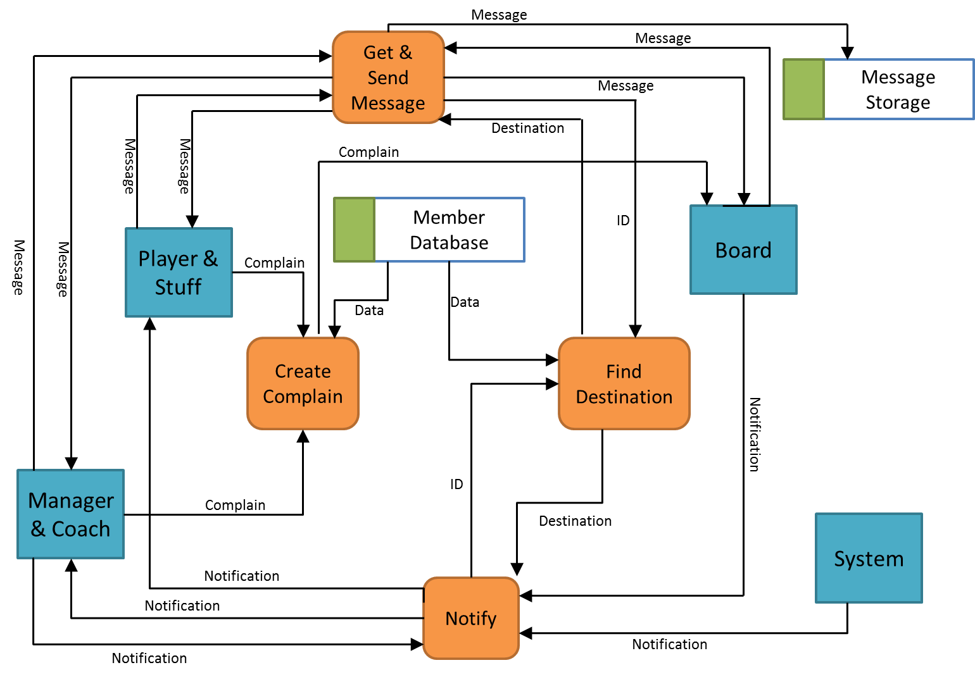

Fig: Data Flow Diagram for Communication Subsystem

**Social Interaction Subsystem:**

1. Fishbone Diagram:

Fishbone diagram of social interaction subsystem is shown below

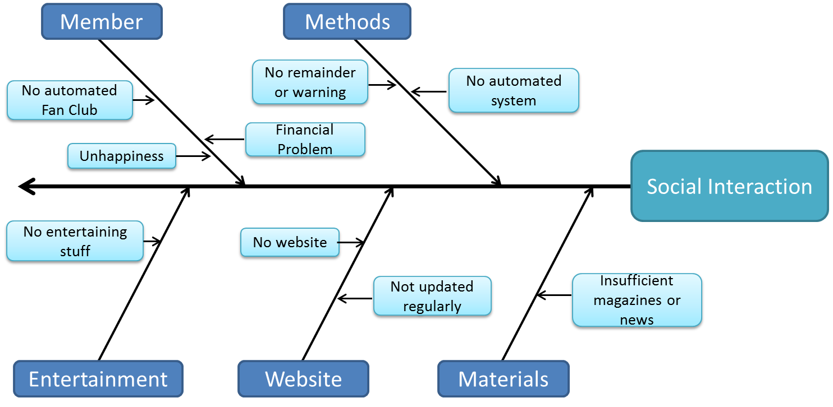

Fig: Fishbone Diagram for Social Interaction Subsystem

2. Data Flow Diagram:

Data flow Diagram of Social Interaction Subsystem is shown below:

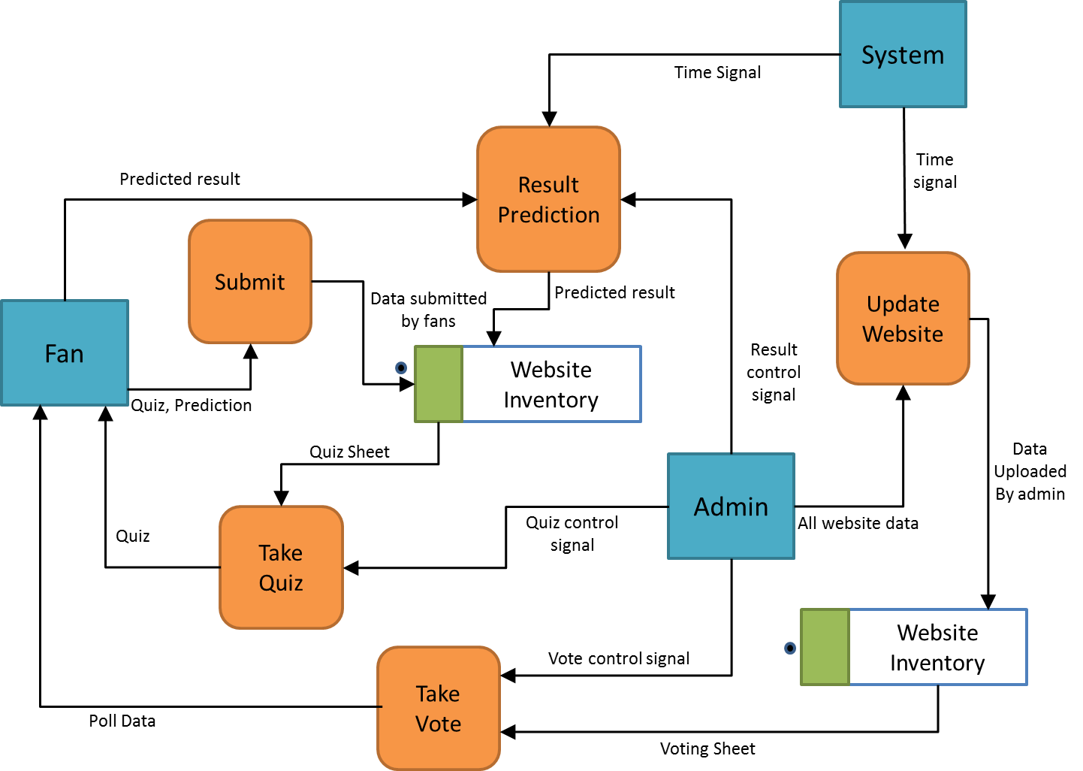

Fig: Fishbone Diagram for Registration Subsystem

**Registration Subsystem:**

1. Fishbone Diagram:

Fishbone diagram of Registration subsystem is shown below:

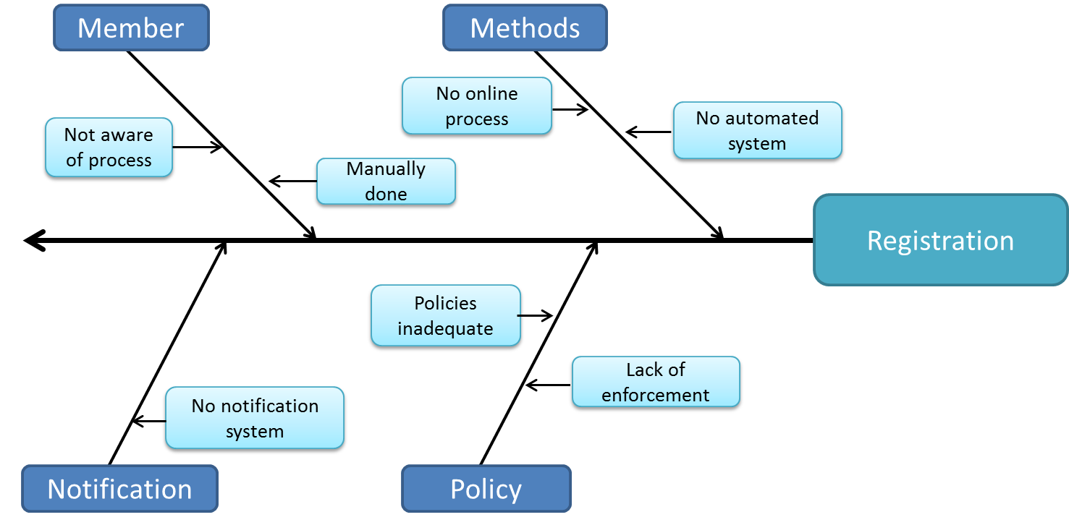

Fig: Fishbone Diagram for Registration Subsystem

2. Data Flow Diagram:

Data flow Diagram of Registration Subsystem is shown below:

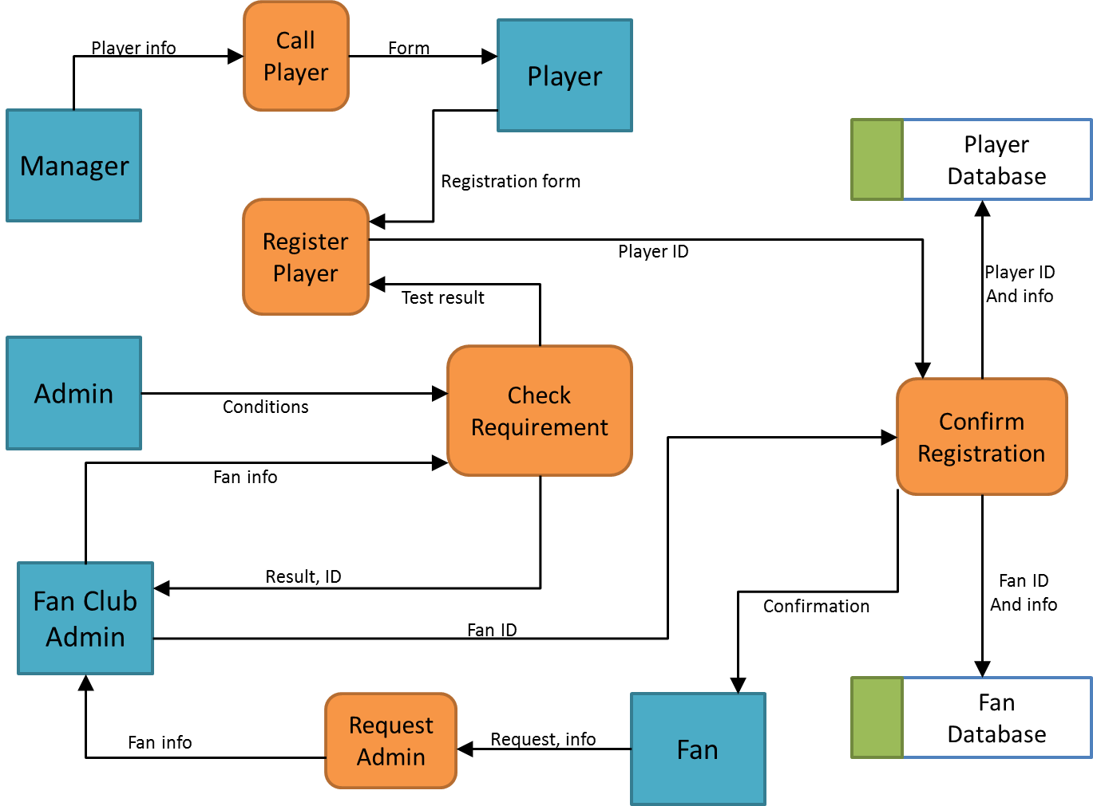

Fig: Data Flow Diagram for Registration Subsystem

**Online Store Subsystem:**

1. Fishbone Diagram:

Fishbone diagram of Registration subsystem is shown below:

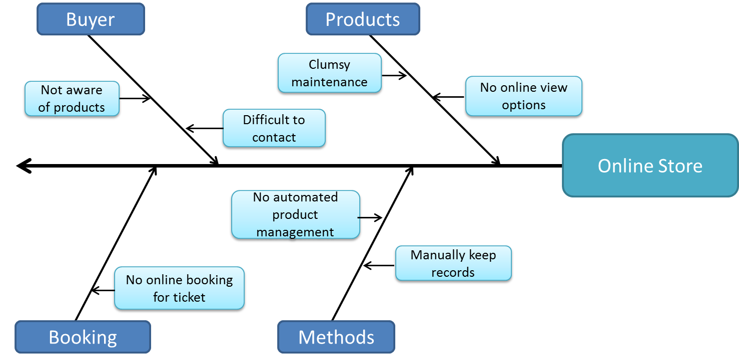

Fig: Fishbone Diagram for Online Store Subsystem

2. Data Flow Diagram:

Data flow Diagram of Online Store Subsystem is shown below:

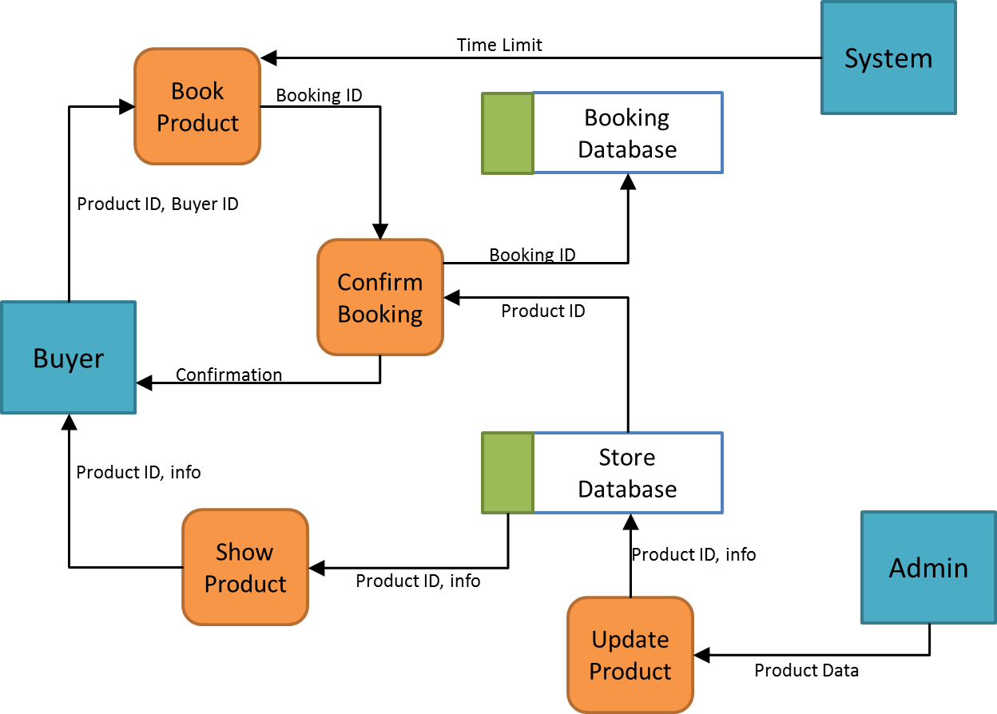

Fig: Data Flow Diagram for Online Store Subsystem

**Team Management Subsystem:**

1. Fishbone Diagram:

Fishbone diagram of Team Management subsystem is shown below:

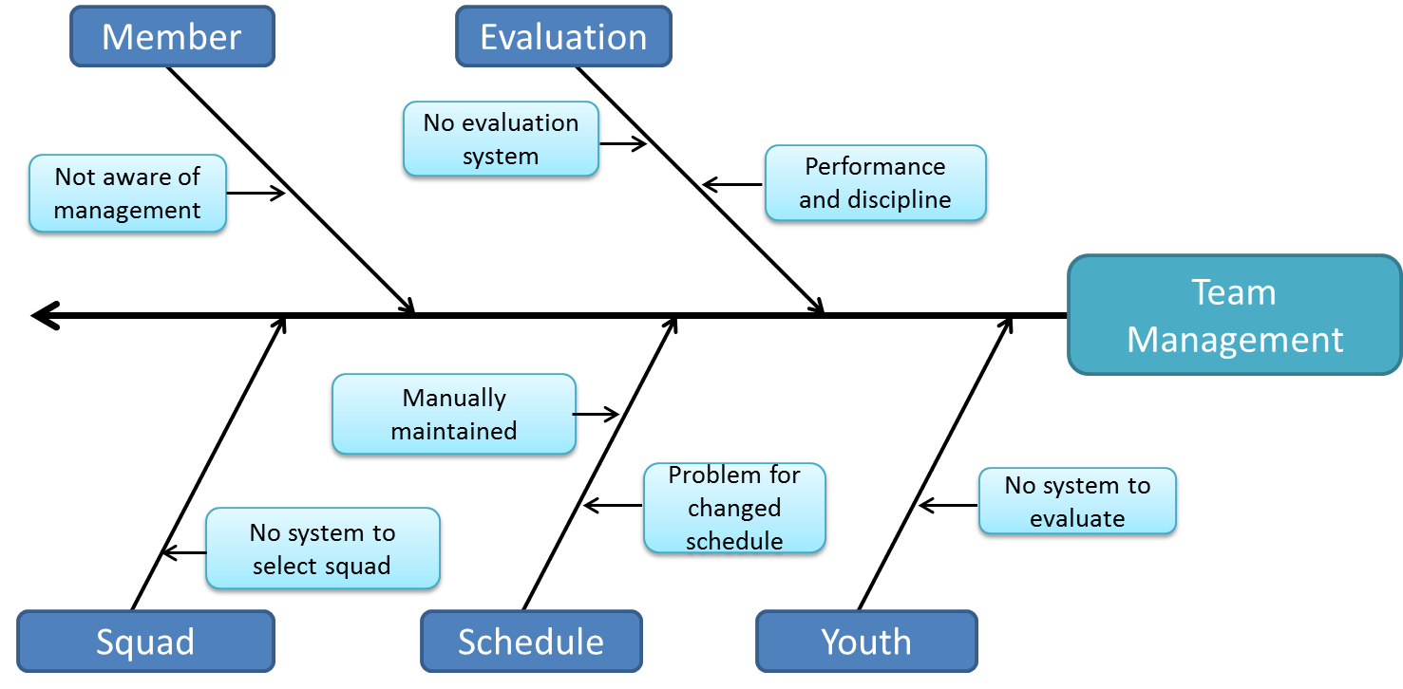

Fig: Fishbone Diagram for Team Management Subsystem

2. Data Flow Diagram:

Data flow Diagram of Online Store Subsystem is shown below:

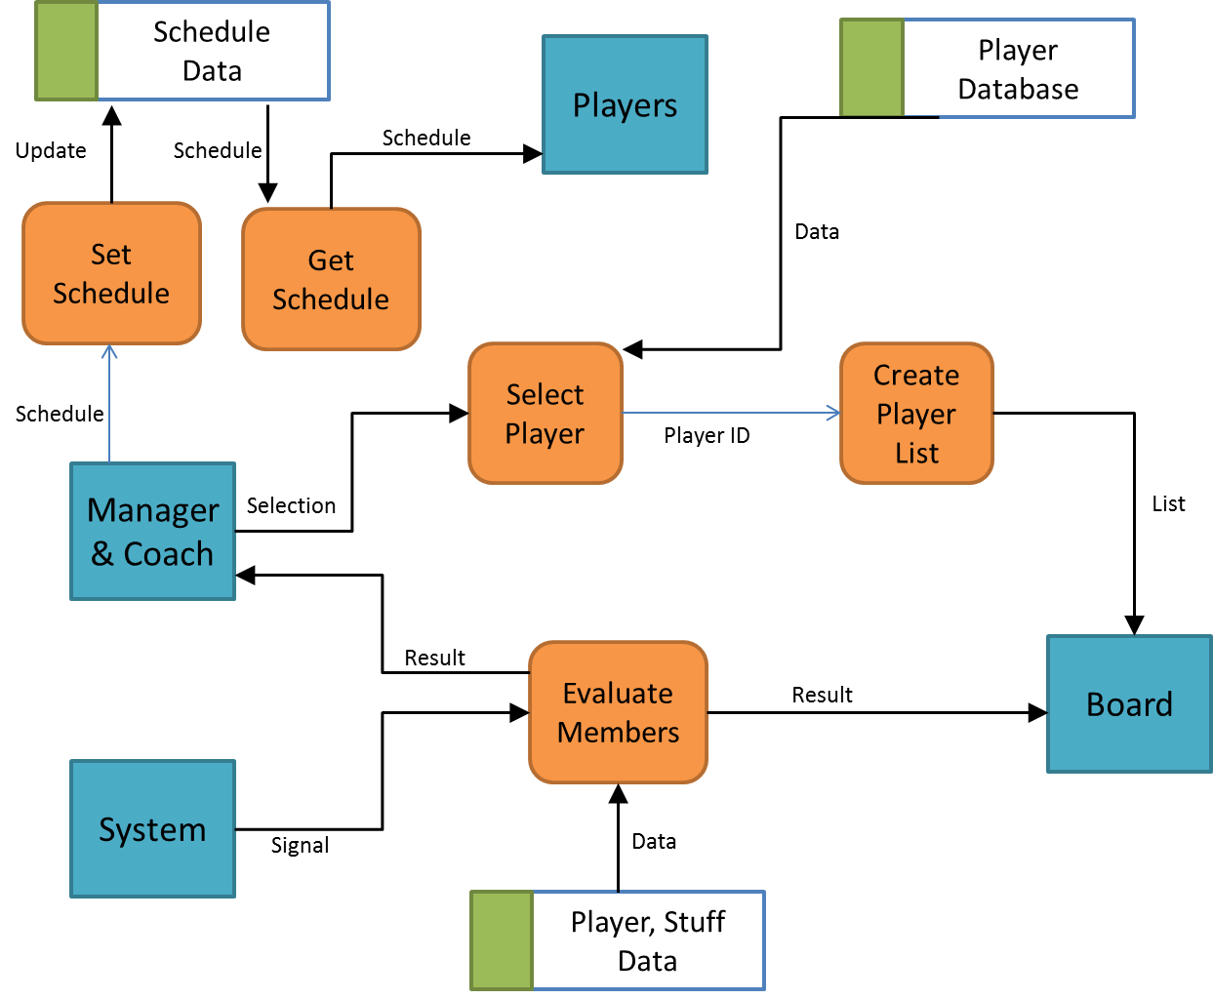

Fig: Data Flow Diagram for Online Store Subsystem

**Feasibility Analysis:**

Feasibility analysis of this project is done from following four perspective:

* Operational Feasibility
* Technical Feasibility
* Cultural Feasibility
* Economic Feasibility

Each of them is described here:

1. Operational feasibility:
2. From Board and Manager’s Perspective:
   * Registration process will become easier by the system, but training is needed so that members can be accustomed to it.
   * Coach and Manager should be trained for scheduling and continuous evaluation, notification and complaining system.
3. From Player and Staff’s Perspective:
   * Player and Staffs need to learn how to communication subsystem. Hence training program is needed initially.
   * They need to be aware of checking continuous evaluation of their performance.
4. From Fans Perspective:
   * Proper advertisement is needed to get fans introduced with the benefits they can get from this system.
5. Technical Feasibility:
   * PHP for server side scripting
   * MySQL for Database Management
   * Java for software based implementation
   * JavaScript for client side scripting
   * HTML, CSS for web designing
6. Cultural Feasibility:
   * Management, Coach, Player and other members are not habituated with this system.
   * Fans may not aware of the competitions and proper timing
7. Economic Feasibility:
8. Expenses*:*

Expenses are of two types:

i) Preliminary expenses:

At the very beginning to implement the project

ii) Yearly expenses:

This expenses consist of yearly maintenance of the project

1. Preliminary expenses:

|  |
| --- |
| Software Development Cost……………………… 1,000,000 BDT  Hardware Cost................................................. 700,000 BDT  Advertisement…………………….….…………………… 600,000 BDT  Web Server……………………….………………………… 100,000 BDT  Internet and Mobile…………….……………………... 600,000 BDT |
| Total………………………………..……………………….. 3,000,000 BDT |

Table: Preliminary Expenses

1. Yearly expenses:

|  |
| --- |
| Software Development Cost………………………… 150,000 BDT  Advertisement................................................. 250,000 BDT  Web Server …………………….….………………………. 100,000 BDT  Internet and Mobile .……….………………………… 400,000 BDT  Miscellaneous …………….……………………........... 100,000 BDT |
| Total………………………………..……………………….. 1,000,000 BDT |

Table: Yearly Expenses

b) Income*:*

Incomes can be found in two ways:

i) Membership Charge:

Annual membership charge given by each member

ii) Advertisement:

Advertisement given in website

* + 1. Membership Charge:

|  |  |
| --- | --- |
| **Year** | **Income(BDT)** |
| 1st | 300*500= 150,000 |
| 2nd | 500*500= 250,000 |
| 3rd | 700*500= 350,000 |
| 4th | 1000*500= 500,000 |

Table: Income from Membership charge

* + 1. Advertisement:

|  |  |
| --- | --- |
| **Year** | **Income(BDT)** |
| 1st | 100*5000=500,000 |
| 2nd | 200*5500= 1,100,000 |
| 3rd | 350*6000= 2,100,000 |
| 4th | 500*7000= 3,500,000 |

Table: Income from Advertisement

Overall benefit from four years time is given below

|  |  |  |  |  |
| --- | --- | --- | --- | --- |
|  | **1st Year** | **2nd Year** | **3rd Year** | **4th Year** |
| Expense | 3 million | 1 million | 1 million | 1 million |
| Revenue | 0.75 million | 1.35 million | 2.45 million | 4 million |
| Profit | -2.25 million | 0.35 million | 1.45 million | 3million |

Table: Profit from 4 years

**Tangible and Intangible Benefits:**

1. Tangible Benefits:

* Website Advertisement
* Membership charge

1. Intangible Benefits:
   * Easy Management
   * Fans’ Happiness
   * Convenient communication