Footwear Product Catalogue
Collection Part 5
9 selected footwear designs

01 Brown Mary Jane Block Heels
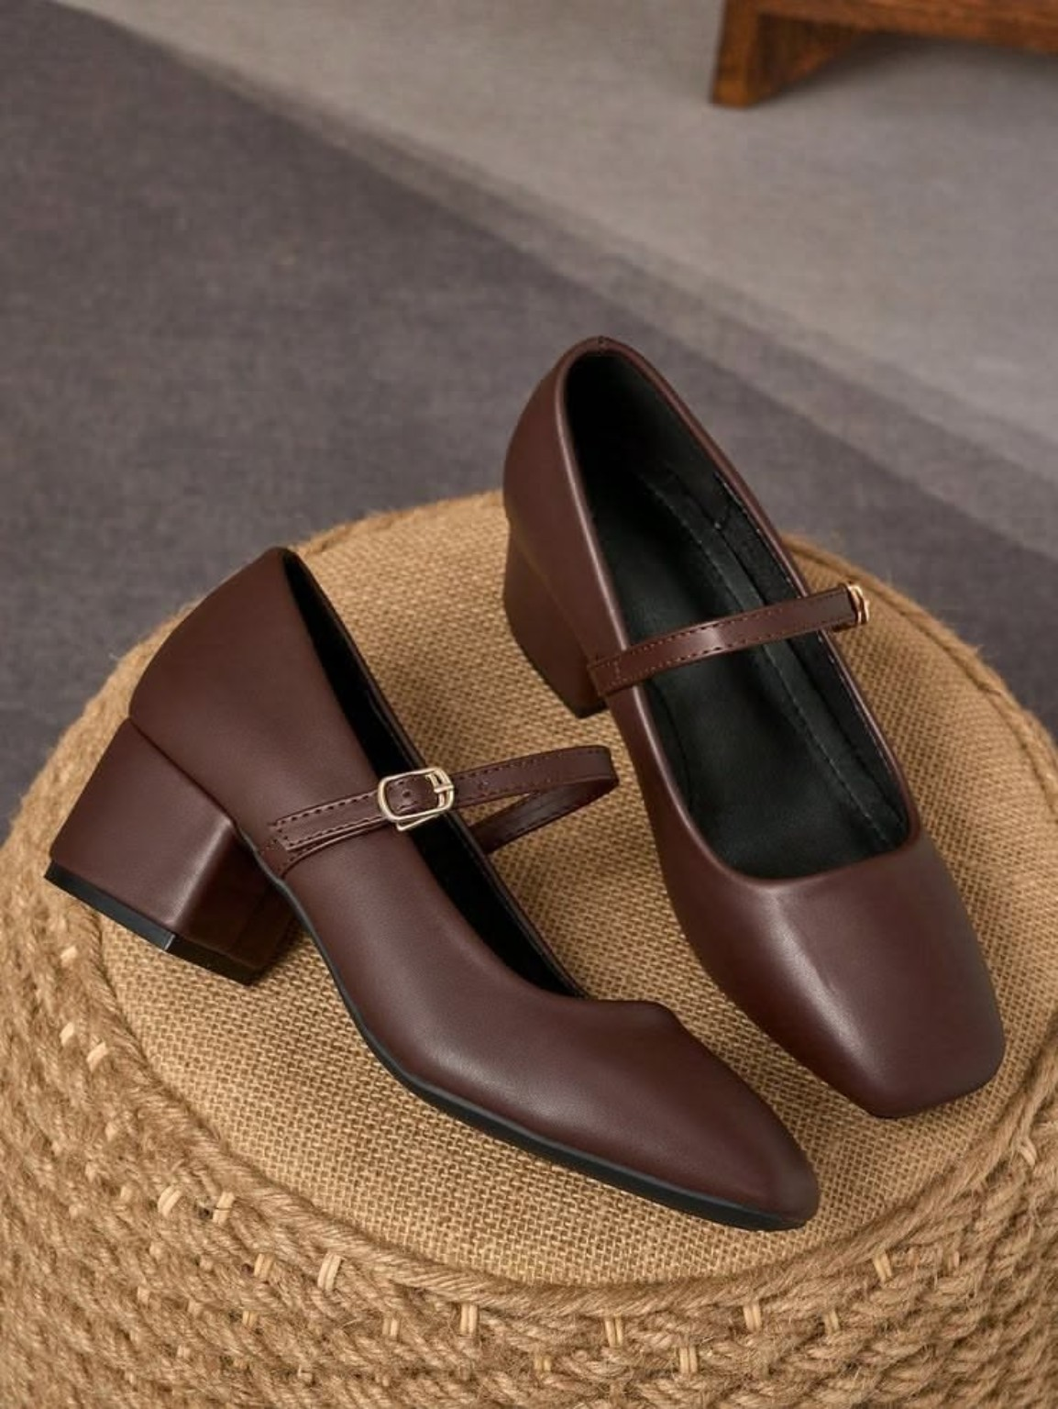

02 Brown V Vamp Mules
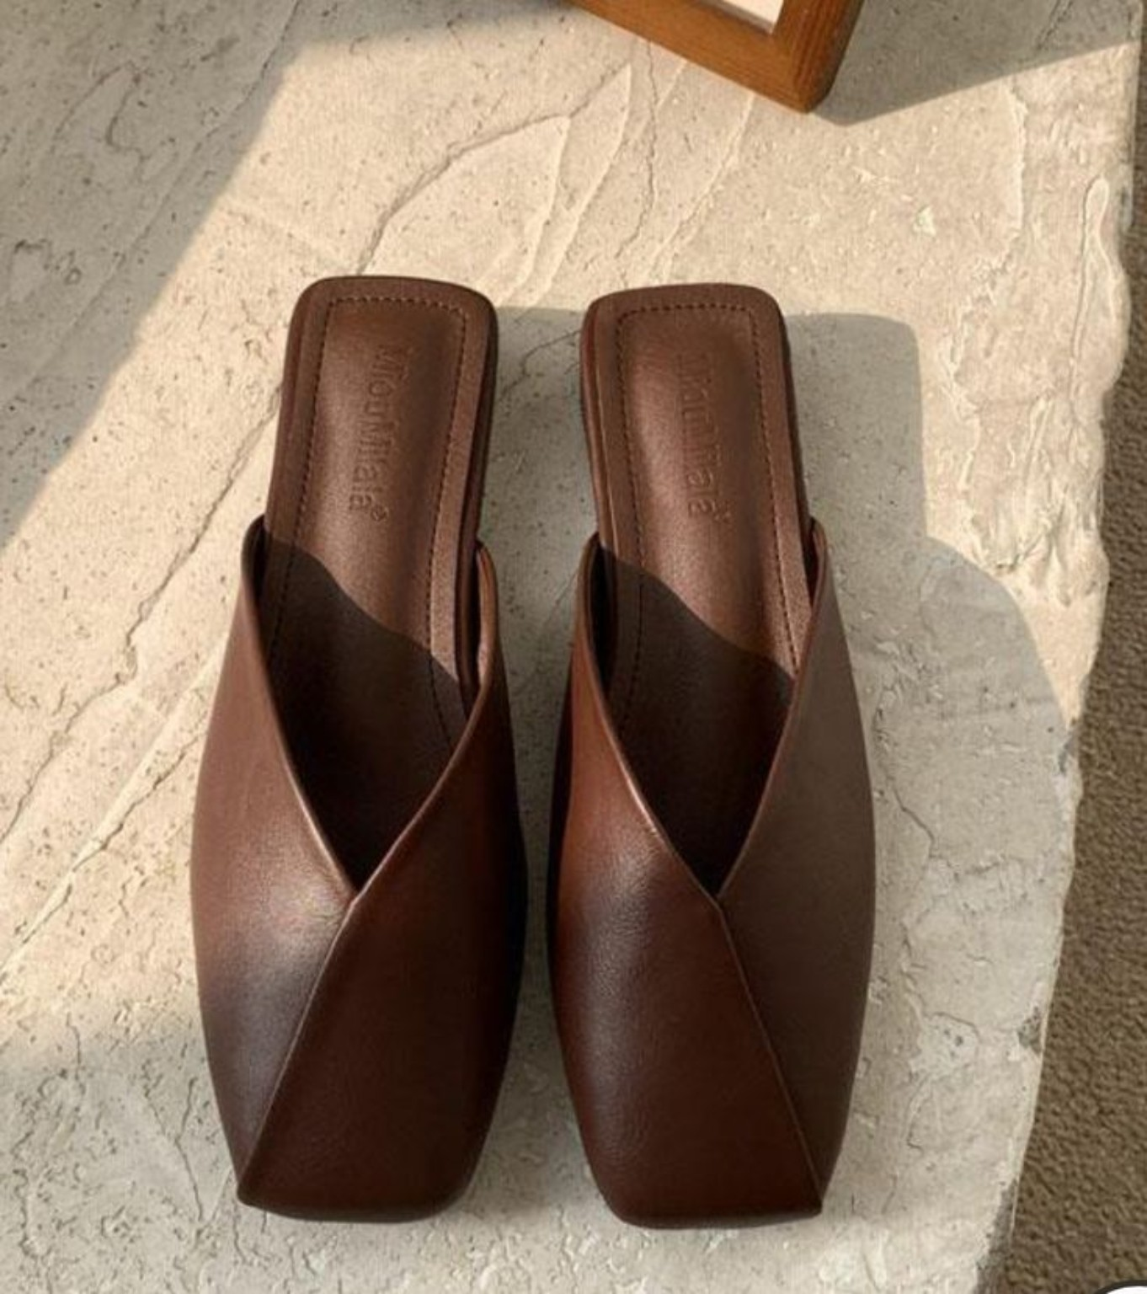

03 Braided Strap Flat Sandals
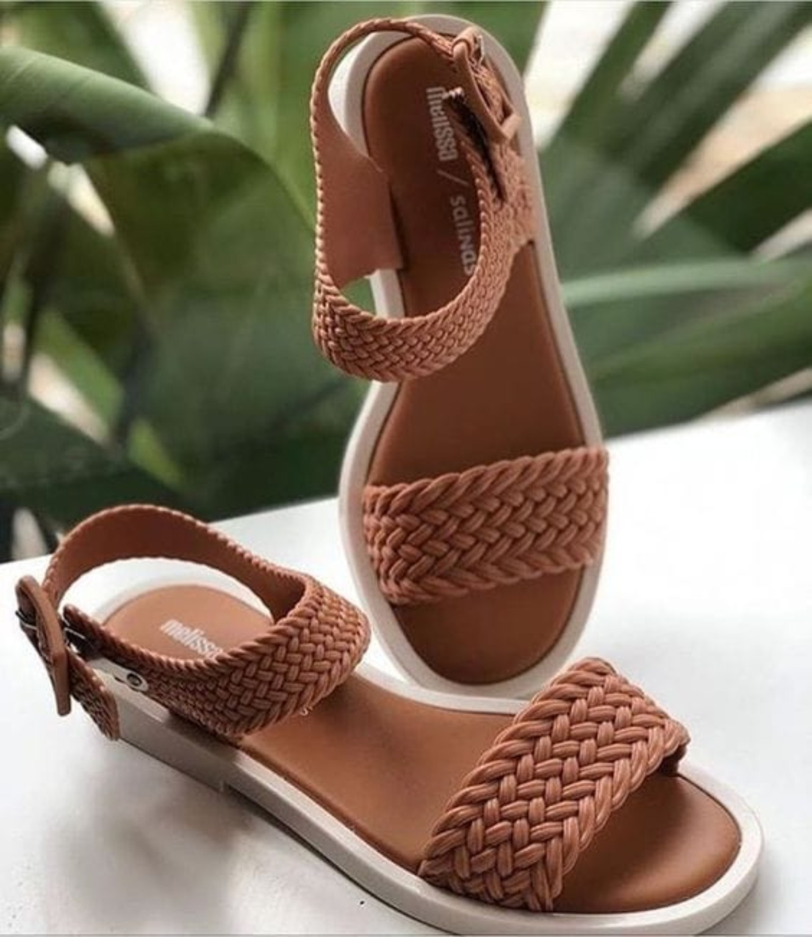

04 Brown Leather Derby Shoes
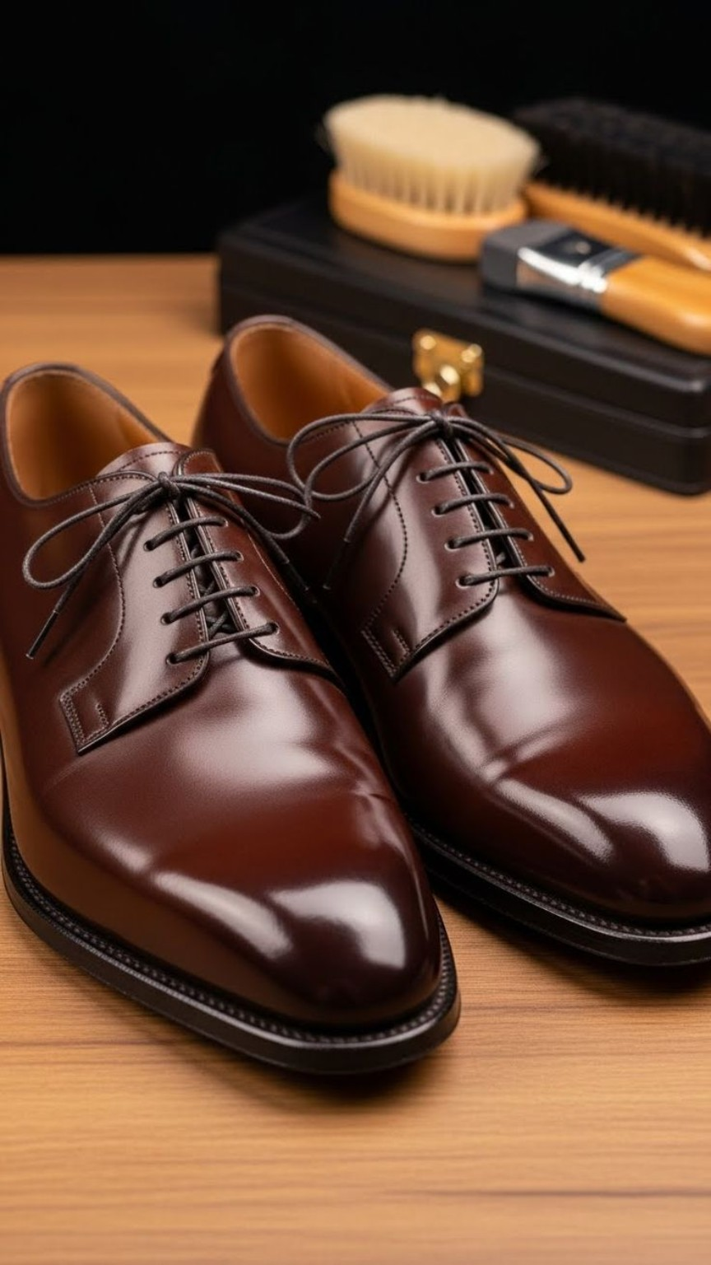

05 Chain Detail Mules
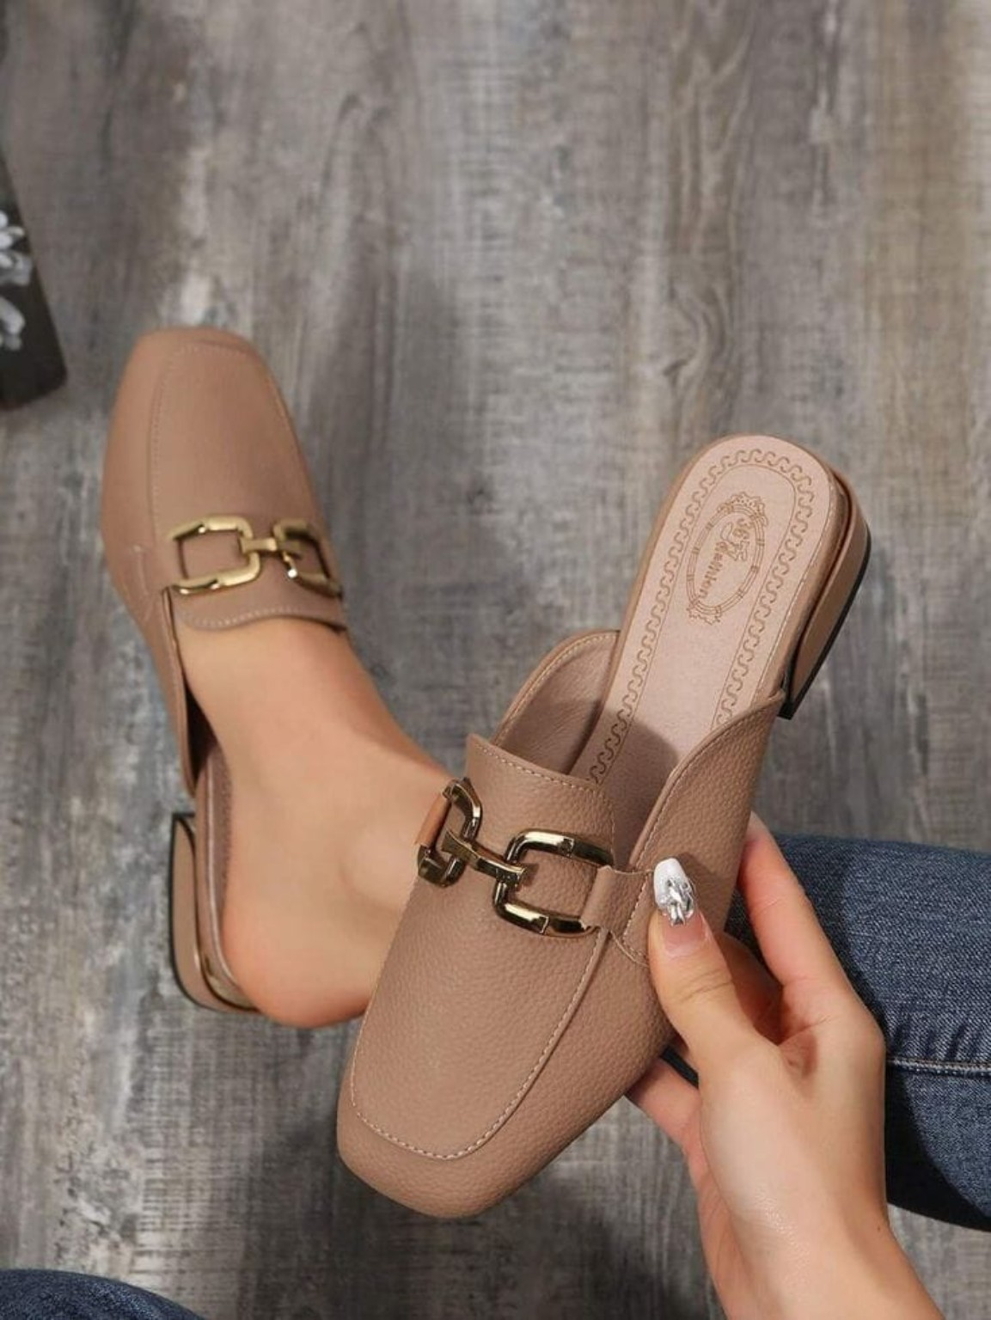

06 Dark Brown Thong Sandals
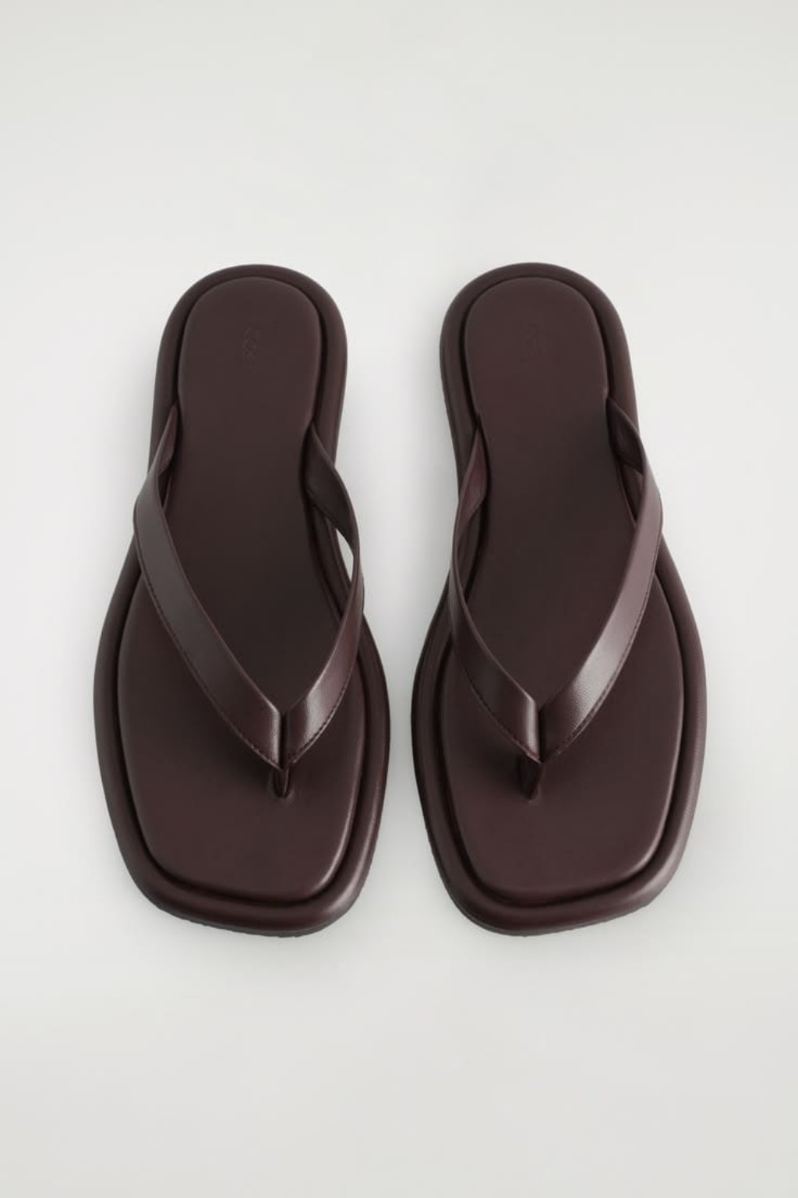

07 Brown Cutout Strap Slides
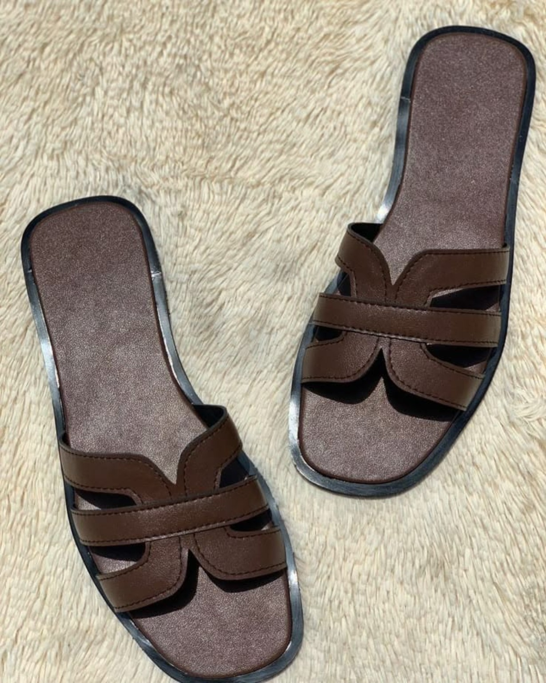

08 Burgundy Wide Strap Slides
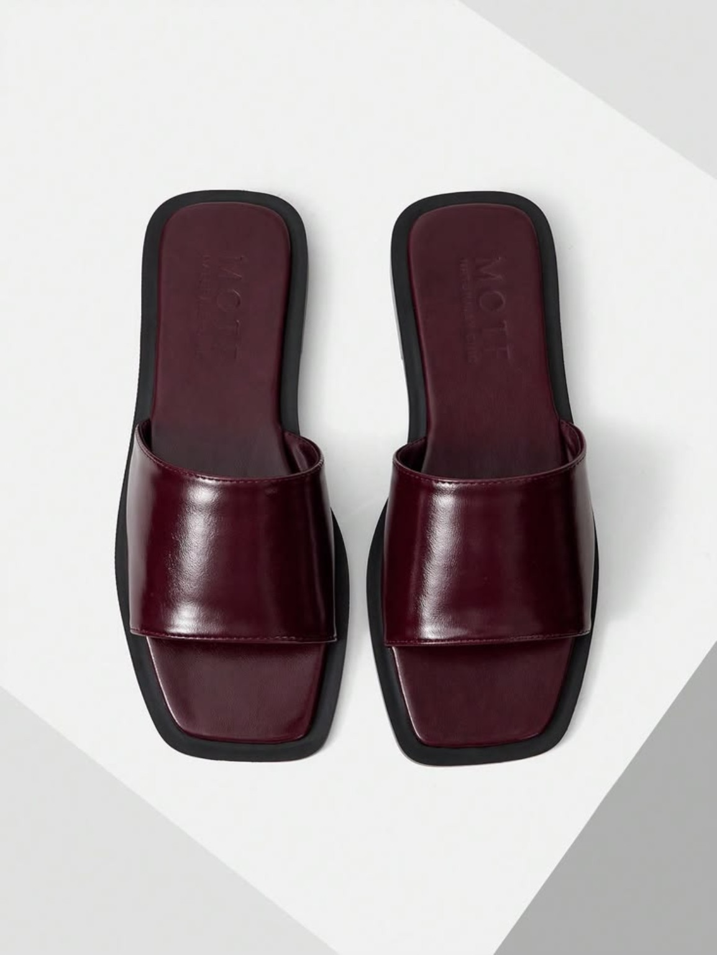

09 Black Suede Clogs
