Footwear Product Catalogue
Collection Part 6
5 selected footwear designs

01 Navy Performance Running Shoes
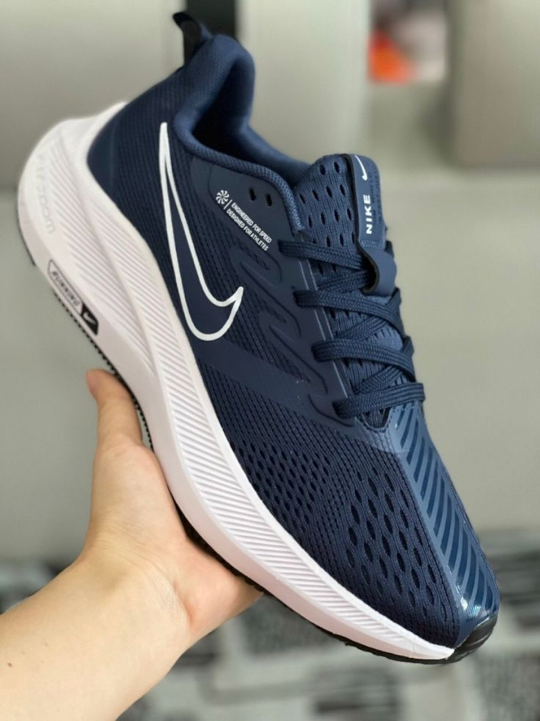

02 Grey Sports Running Shoes
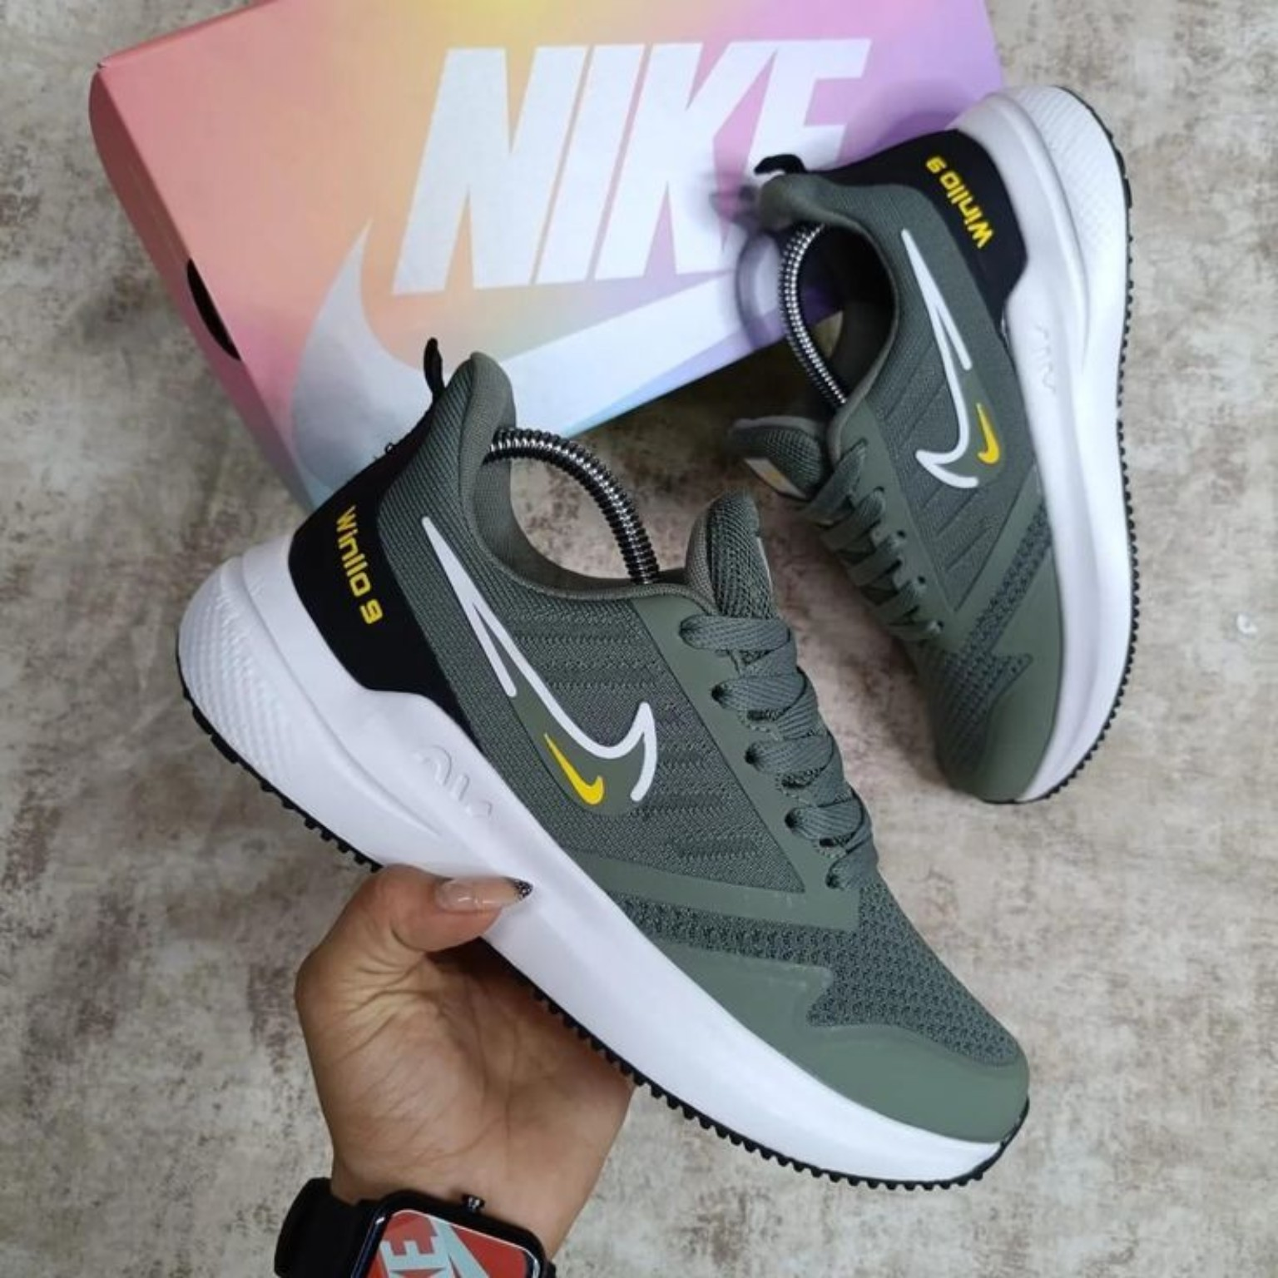

03 White and Navy Running Shoes
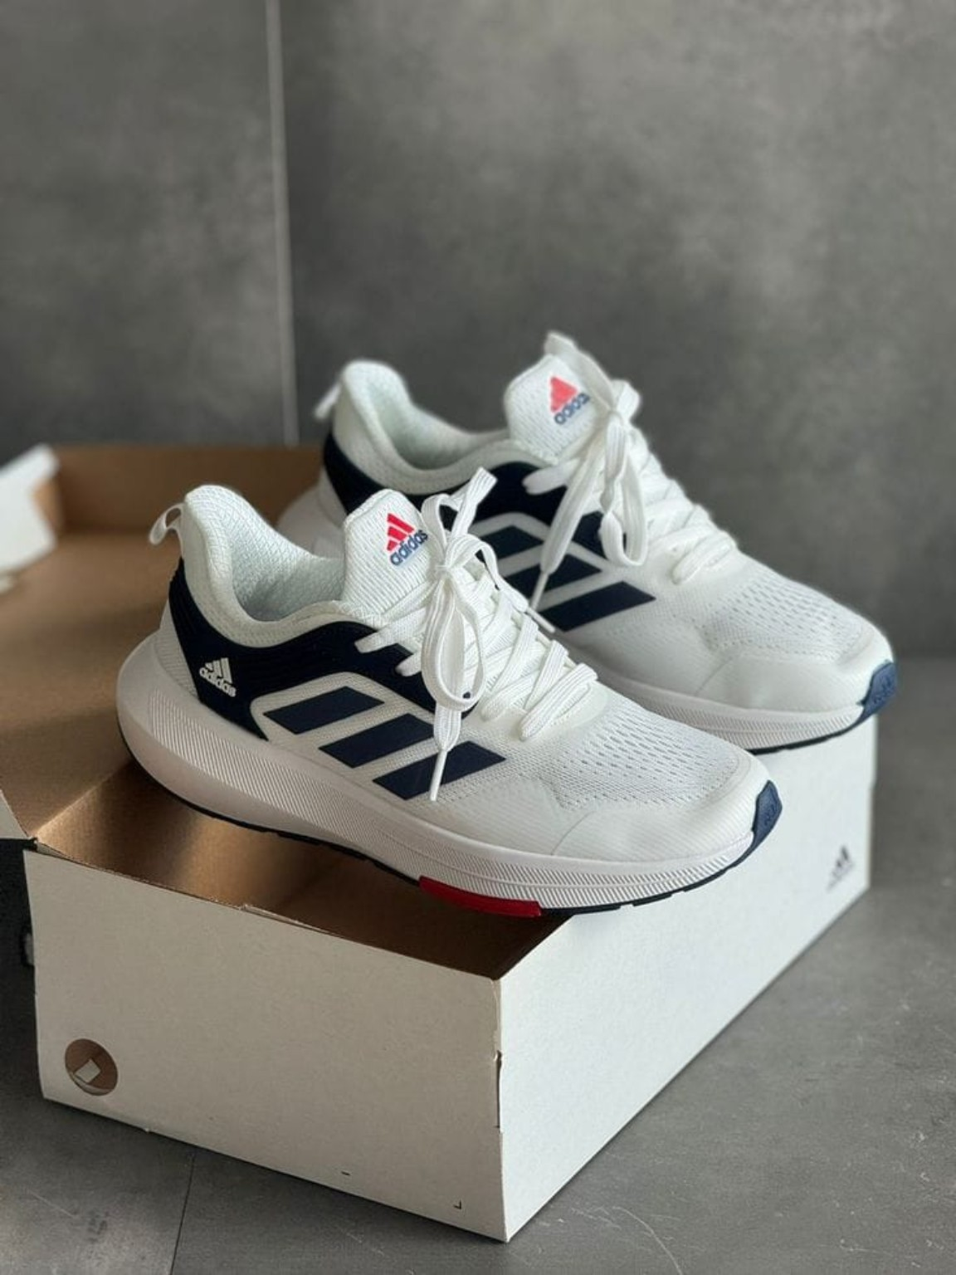

04 Olive Green Classic Loafers
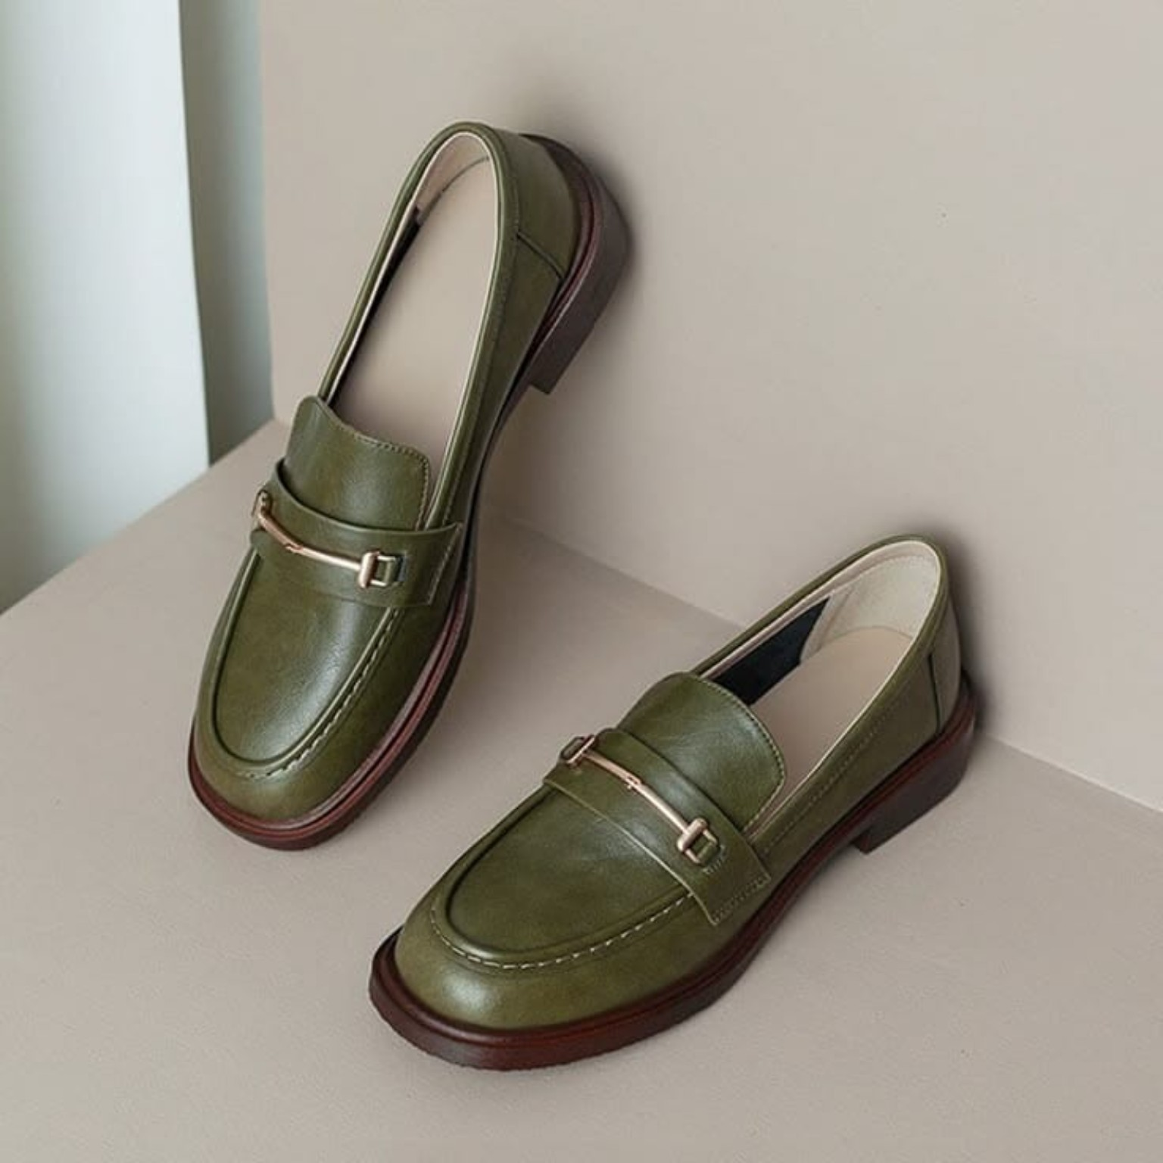

05 Black Turf Football Shoes
