Outline | Program Structure:

1. Initialize the board
2. Start the game & print the board
3. Computer places the ship using random co-ordinates
4. Get input co-ordinates from user
5. If user co-ordinates matches right the game ends
6. Check/validate the ship can be placed at given co-ordinates
7. Output warning if the guess matches previous guess given
8. If the guess is wrong, mark the point with an X and start again.
9. Print strike and updated board
10. If user has had 4 turns or strikes, game over !

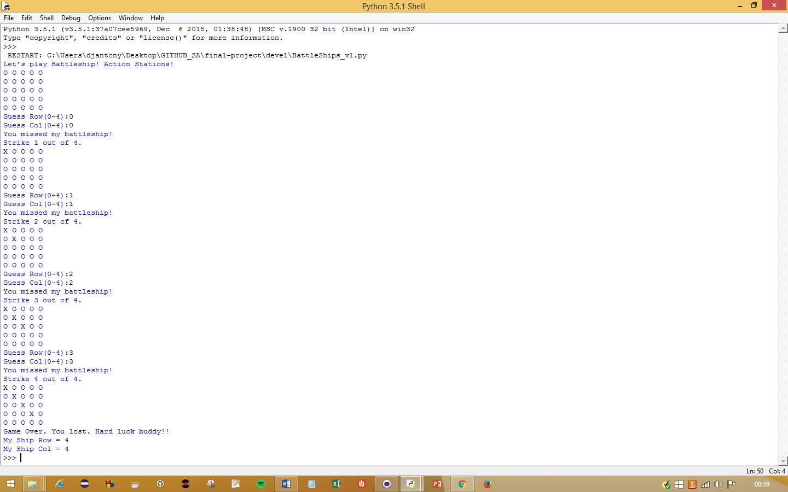Sample Game Play:

/End