**Bible Tagging Utility**

# Introduction

The purpose of this utility is to review, update and correct a tagged Bible. Although it can be used to tag an untagged Bible, but it will be a very tedious and lengthy process. Instead, a text aligner may be used to create an initial tagging of the text, then use this utility to review and correct the result. For details on using the text aligner, please refer to [Bible Tagging Preparation](https://github.com/sabdelmalik/BibleTaggingPraparation) and to my initial document [From-VPL-Bible-to-tagged-SWORD-module](https://github.com/sabdelmalik/BibleTagging/blob/main/docs/From-VPL-Bible-to-tagged-SWORD-module.docx).

# Installation

The utility is available in a zip file, which, when unzipped to some folder on your PC, will create the following directory structure

## The Bibles Folder

Contains the tagged Bibles to be reviewed. The folder shown contains only one Bible, NIV, but it may contain many Bibles, each in its own folder.

Each Bible folder should contain a subfolder named “tagged” and a configuration file “BiblesConfig.txt” (See the section on the BiblesConfig.txt at the end of the document)

### The tagged subfolder

It should contain only one file which is the version of the tagged bible to be edited or corrected.

When saving an edited version, the current version, before saving, is first moved to the OldTagged folder. The new edited version takes its place with the current timestamp appended to its name. The Bible file to be edited should be in a verse per line text file format as in the following example:

Gen 1:13 And the evening <06153> and the morning <01242> were the third <07992> day <03117>.

## The BibleTaggingUtility Folder

Contains all the binaries for the utility along with some supporting subfolders. The utility is run by double-clicking the “BibleTaggingUtility.exe”. A shortcut may be created for this file for easy access (one way to create a shortcut, is to right click the file and click copy – go to where you want the shortcut, e.g. the desktop, and right click – make sure you don’t click paste, but click “Paste shortcut” instead).

When the utility is run for the first time, a Settings dialog will display to configure the utility for use.

# Settings

The settings dialog automatically shows when the utility is run for the first time. In subsequent runs, it can be accessed through the File menu -> Settings.

The settings dialog has various tabs. For the application to work, the “Target Bible” and “Reference Bibles” tabs should be configured. Following are example settings.

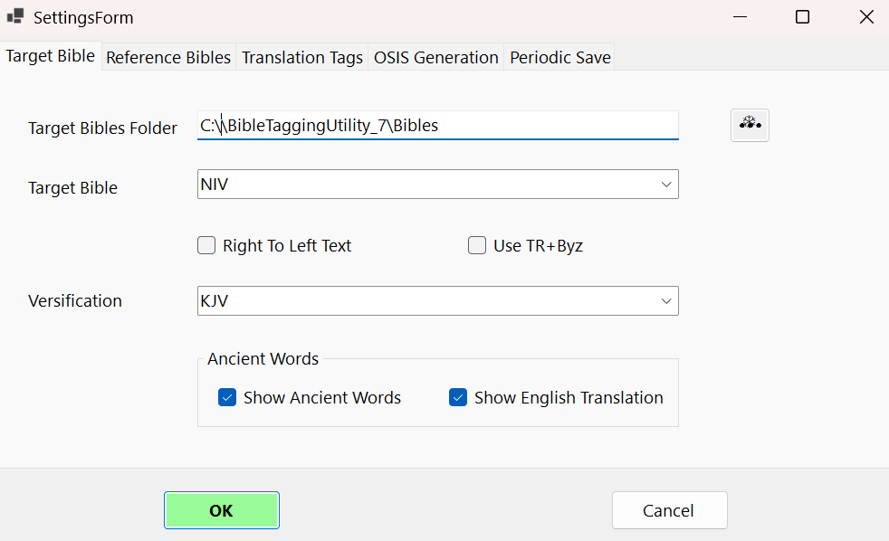

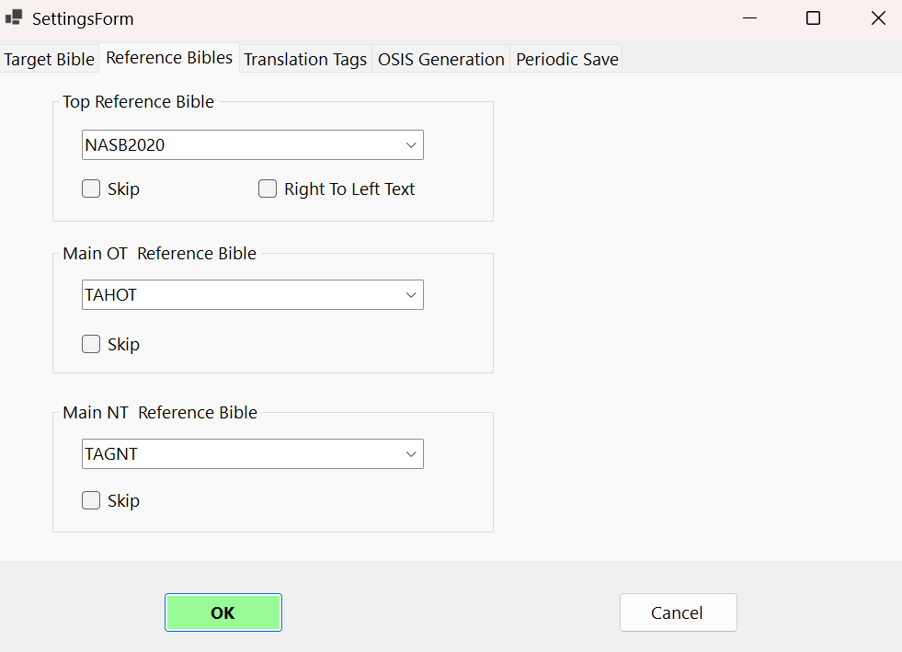

# The User Interface

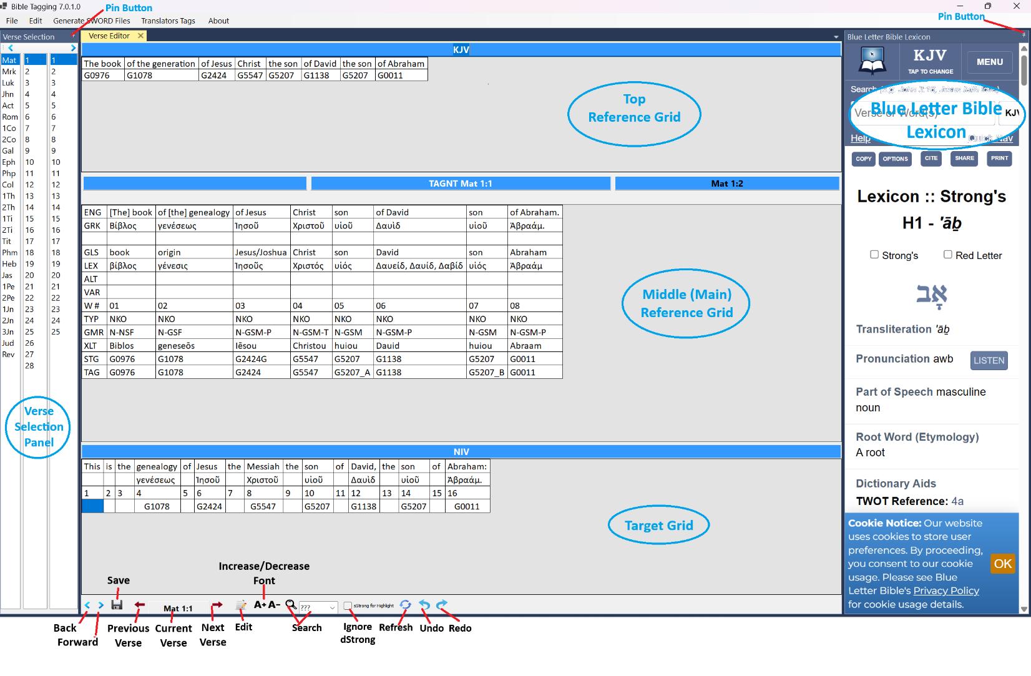

The user interface consists of a menu bar and 3 panels. The Verse Editor, shown as the middle panel above, is where all the tagging review and editing take place. The other two helper panels are to augment the review process. The Verse selection panel is simply to select a specific verse for review. The Blue Letter Bible Lexicon panel is to view Strong’s entries at an external source. All panels can be undocked and floated. Double click the title bar to re-dock.

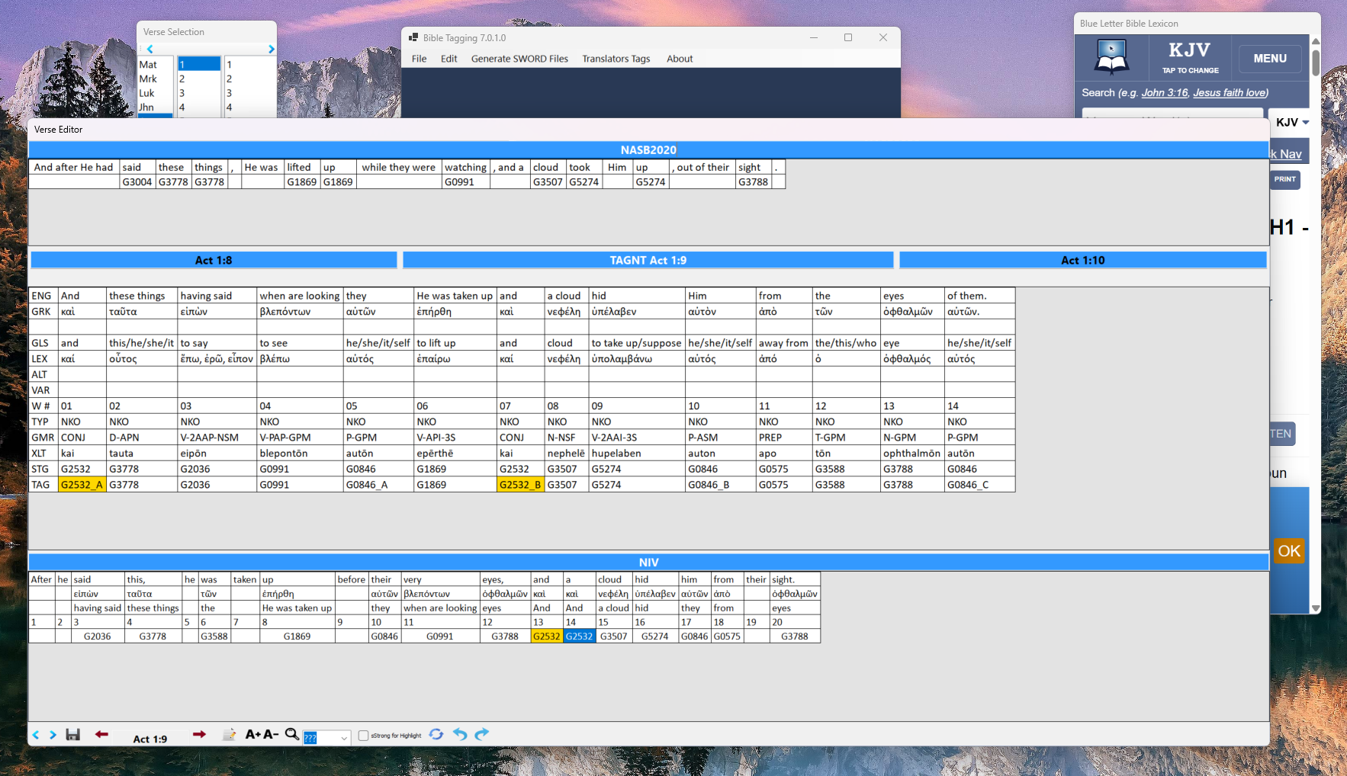

The width of two side panels is adjustable by pacing the curser on the edge and dragging. They can also be collapsed to the side to provide more room for viewing the data. Use the Pin button to control this behaviour.

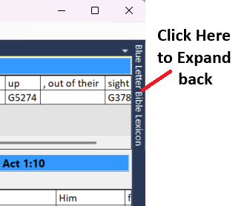

# The Verse Editor Panel

The Verse Editor consists of three grids and a bottom tool strip. The grids display the selected verse words and their tags. The height of each grid can be adjusted for the best viewing layout.

The top grid displays verses form an already tagged Bible which is selected in the Settings dialog.

The middle grid is the main reference Bible verse which is taken from TAHOT for the Old Testament, and from TAGNT for the New Testament. Those references can be found [here](https://github.com/STEPBible/STEPBible-Data/tree/master/Translators%20Amalgamated%20OT%2BNT).

The bottom grid is used to review and edit the target Bible. The following section describe the facilities available for reviewing and editing.

## The Tool Strip

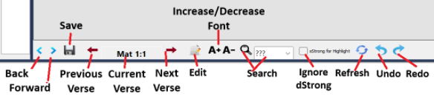

|  |  |
| --- | --- |
| **Back** | Goes back to the last viewed verse |
| **Forward** | If **Back** was used, moves forward to the next viewed verse |
| **Save** | Saves the changes made so far. The Bible file before the changes is moved first to the OldTagged folder, then the updated file takes its place with a timestamp appended to it. |
| **Previous Verse** | Advances to the next verse |
| **Current Verse** | Displays the current verse reference. If at last verse in the chapter, it moves to the first verse of the next chapter. |
| **Next Verse** | Moves back to the previous verse. If at first verse in the chapter, it moves to the last verse of the previous chapter. |
| **Edit** | This function is not typically used. It allows editing the text of the Bible being reviewed. A typical scenario is a missing space. Click Edit to enable editing the Biblical text. |
| **Font Size** | Use **A+** to increase the display font and **A-** to decrease it. |
| **Search** | (Not complete – searches for a Strong’s number, forward only ) enter the desired Strong’s number and click the magnifying glass.  With Ctrl, finds the tag that is repeated in two consecutive cells  With Alt, finds the tag in TAHOT or TAGNT, other wise in Target  With Shift, finds tag in cells with a single tag. |
| **Ignore dStrong** | When a cell is selected, the editor highlights all the cells that match Strong’s number exactly. If the current cell contains a dStrong (e.g. G3754H), checking this box highlights all cells matching G3754? |
| **Refresh** | (experimental -has no effect) |
| **Undo** | Reverse your last change |
| **Redo** | If **Undo** was used, it reverts back the change. |

## Drag and Drop behaviour

When a tag is dragged from a reference verse (top two grids) to the target verse (bottom grid), the dragged tag will replace the existing tag(s).  
However, if the dragged tag is dropped while the Ctrl key is pressed, it is added to the existing tag(s).

Multiple tags may be selected, from a reference verse and dropped together to a single cell in the target verse. To select multiple tags, click the first tag. While pressing the Ctrl key, click the other tags. The order of the tags in the target cell, will be in the same order of selecting the tags. To select adjacent tags, click the first tag, and while the mouse is down, drag it to the right or left as required.

## Merging two or more target words

Highlight (select) the target words, then right click on one of them. Click on Merge from the context menu. The merged cells must be adjacent words, otherwise you will not see the Merge menu. to highlight adjacent words, click on the first word, and while the mouse is down, drag it to the right or left as required.

## Splitting a multi word cell

If a target word cell contains more than word, it can be split into separate words. Click the word cell to select it. Right click the cell and click Split from the context menu.

## Swapping two tags

Select the two words that their tags are to be swapped. Right click one of them then click Swap from the context menu. To select two words, click on the first word to select it. While pressing Ctrl, click the second word.

## Deleting tag value

Right click the tag to delete using the context menu. Alternatively, select the tag, then press the delete key.

## Directly editing a tag

Press F2 to Enable editing the current tag cell.

## Use of the Blue Letter Bible Panel

A double click on any tag in the bottom row of any grid will retrieve its definition in the Blue Letter Bible Panel. If the cell contains more than one Strong’s number, a context menu will let the user select one of them.

## Utility short-cut keys

|  |  |
| --- | --- |
| Key | Function |
| Ctrl-S | Save |
| Ctrl-Z | Undo the last change |
| Ctrl-Y | Redo the last Undo |
| Pg dn | Move to next verse |
| Pg up | Move to previous verse |
| Delete | Deletes the currently selected tag in the target grid. |

# The BiblesConfig.txt File

Sample File

|  |
| --- |
| [Tagging]  untaggedBible=niv-sb_osis_ut.txt  taggedBible=niv-sb_osis.txt  [OSIS]  osisIDWork=NIV-SB  osisRefWork=bible  language=en  language-type=IETF  publisher=Biblica, Inc.®  title=New International Version  source=Biblica  contributor-role=  contributor-name=  type=Bible  scope=Gen-Rev  revision-prefix=NIV-SB version  revision =1.0.0  identifier=Bible.en.NIV-SB.2011  description=This work adds Strong's references to NIV.  rights=?  refSystem=Bible  ot-vpl-file=ot_niv_sb.txt  nt-vpl-file=nt_niv_sb.txt  output-file=niv_sb.xml  versification=KJV |