# **Capstone Project: Build a Complete Website**

This project is an addition to a previous hobby music website I created. The website showcases the skills I have learned in the HyperionDev Bootcamp including HTML, CSS and JavaScript. Using functions, loops, callbacks and many other components. This website includes extra functionality for:

* Save For Later
* Like Buttons
* Adding comments
* Creating an additional folder page to view saved items

# Table of Contents

Please select from the following topics and it will direct you to the relevant page:

* Installation
* Usage
* Navigation
* Like and Save for Later Feature
* Comments Feature
* Credits

# Installation

To install the project locally navigate to <https://github.com/sabdevi/finalCapstone> and select the green code button then select **Download** and download the files. Then copy it to your local drive. Alternatively, you can clone the project by using the ***git clone*** command using the link in the HTTPS link.

# Usage

Once you have copied all the files to your working directory locate the index.html file highlighted below and run it in your web browser. If you double-click on the file, it should load in your default web browser

# Navigation

You can navigate the website by selecting the various menu items

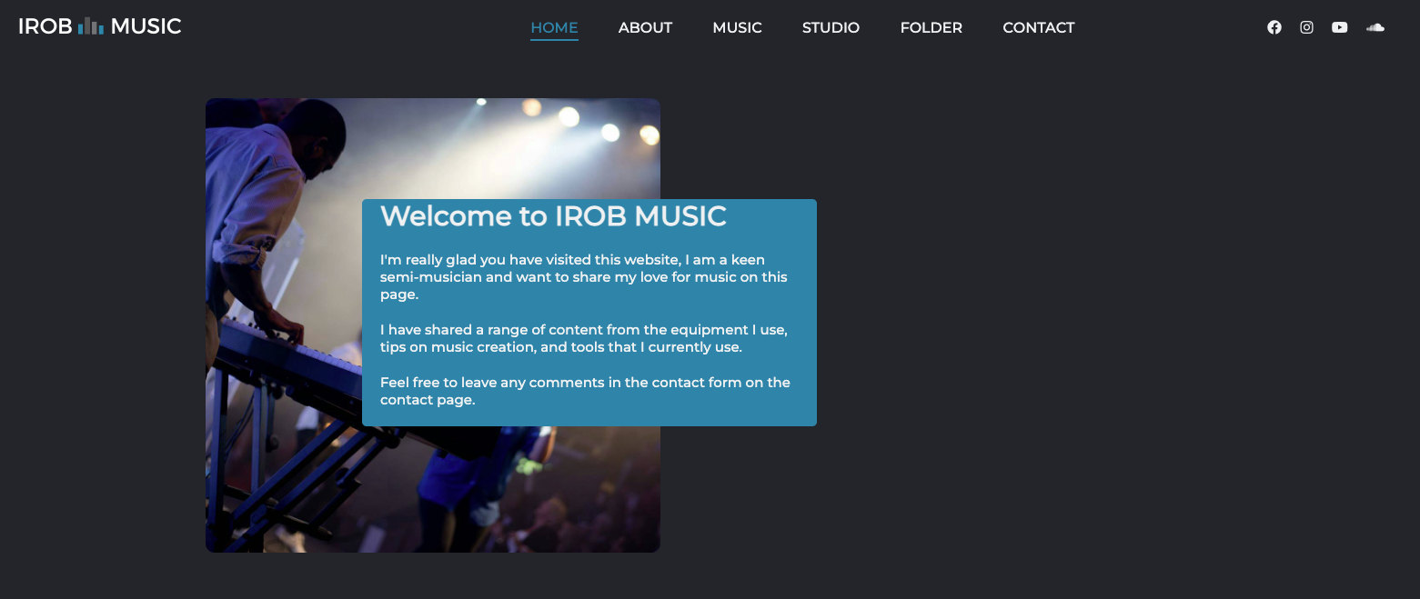

If you are using a mobile device, it will resize responsively and show a hamburger for navigation instead.

# Like and Save for Later Feature

You can like or save an item to be displayed later by pressing the like button or the “Save for Later” button. 

If you like a button, it will turn white 

If you press the “Save for Later” button it will add it to your list and a message will be displayed about how many items are in your folder (not the list will remain valid for the session, if the web browser is closed it will reset to the default of no items saved.

On the folder page it will display the items added in your folder

# Comments Feature

The comments section was added to the “Contact Us” page. User can add their name and short comments which will be dynamically added to the page.

# Credits

Thank you to the HyperionDev Bootcamp team, who have supported me in providing the relevant skills to complete this project.