The Golden Ratio and The Purification Verse

Al-hamdu liAllah, QuranCode now can split where each verse text into two parts at the golden ratio letter (point).

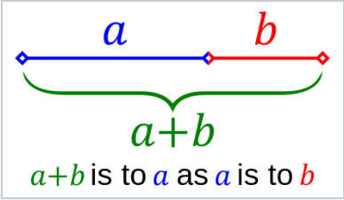
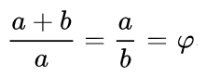

http://en.wikipedia.org/wiki/Golden_ratio.

The symbol φ is the small Greek letter phi which represents the golden ration.
φ = [1 + sqrt(5)] / 2 = 1.6180339887498948482045868343656…
The golden ratio is said to be “the most pleasing ratio to the eye”.

So the golden ratio φ ~= 1.618 : 1 which means that if we had a text string of 1618 letters then it can be split into two approximate golden parts as follows:
618 + 1000 letters or 1000 + 618 letters

Example 1:
In Quran 1:1 there are 19 letters:
19 / phi ~= 12 letters, which means 19 can be split as 7+12 or 12+7
QuranCode colorizes the first 7 letters differently than the remaining 12 letters:
بسم الله الرحمن الرحيم

Example 2:
In Quran 2:32 there are 47 letters:
47 / phi ~= 29 letters, which means 47 can be split as 18+29 or 29+18
QuranCode colorizes the first 29 letters differently than the remaining 18 letters:
قالوا سبحنك لا علم لنا الا ما علمتنا انك انت العليم الحكيم

Example 3:
In Quran 33:33 there are 122 letters:
122 / phi ~= 75 letters, which means 122 can be split as 47+75 or 75+47
QuranCode colorizes the first 75 letters differently than the remaining 47 letters:
وقرن في بيوتكن ولا تبرجن تبرج الجهليه الاولي واقمن الصلوه وءاتين الزكوه واطعن الله ورسوله انما يريد الله ليذهب عنكم الرجس اهل البيت ويطهركم تطهيرا

Note that the split occurs between words so QuranCode will still show the split when word boundary is imposed and also the split occurs between sentences so QuranCode will still show the split when sentence boundary is imposed.

In this example, the two golden verse parts were actually revealed on different occasions and were compiled together for then-unknown reasons. We now believe that one reason was to establish a mathematical code within the written Book, not the recited Quran. Allah knows better.

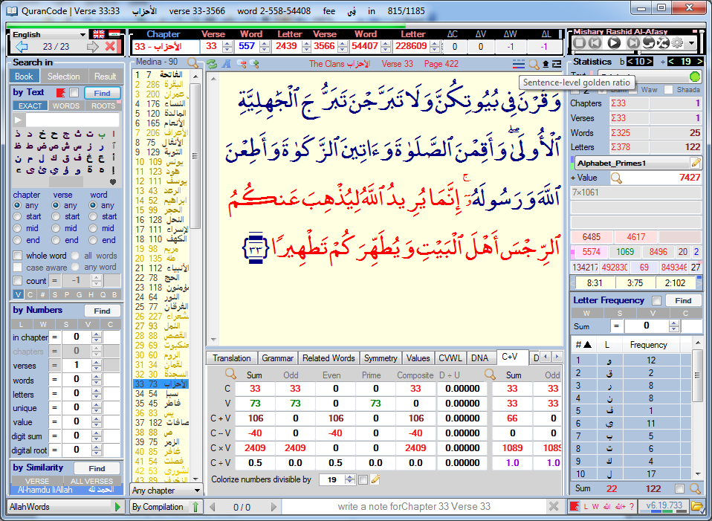

Al-hamdu liAllah Rabb al-3alemeen ALWAYS

Glory to Him THE ONE.

Ali Adams
heliwave.com

