電通二乙微處理器實驗 實驗結報

實驗名稱 | Lab03
組別 | 11 | 組員 | 陳奕璁

- 實驗目的
了解七段顯示器之臉是原理
共陰極與共陽極七段顯示器之不同?
如何讓七段顯示器0-f?
如何控制四合一七段顯示器?
如何讓四合一七段顯示顯示四位數字?
- 實驗步驟
四合一七段顯示器每隔0.3秒鐘會跳一個數字,從
000->0059->0100->跳至2359
於Pin10接一個按鍵,按下後歸零顯示
於pin11接一個按鍵,按下後倒數計時
- 程式碼
#include "SevSeg.h" SevSeg sevseg; //Instantiate a seven segment object void setup() { byte numDigits = 4; byte digitPins[] = {2, 3, 4, 5}; byte segmentPins[] = {8, 9, 10, 11, 12, 13, 14, 15}; sevseg.begin(COMMON_ANODE, numDigits, digitPins, segmentPins);
sevseg.setNumber(Hour * 100 + Min, 0); Min = Min + 1; If Min == 60 { Min = 0; If (Hour == 23) Hour=0; else Hour++; } sevseg.refreshDisplay(); sleep 0.3 second
- 實驗結果及分析
倒數比較難 因為有可能一個地方沒打好 就跑不出數字了
- 心得討論
現在做起來 大部分時候都是在想程式了
有比較熟悉了 線路感覺也比較沒那麼難了
- 修正電路圖
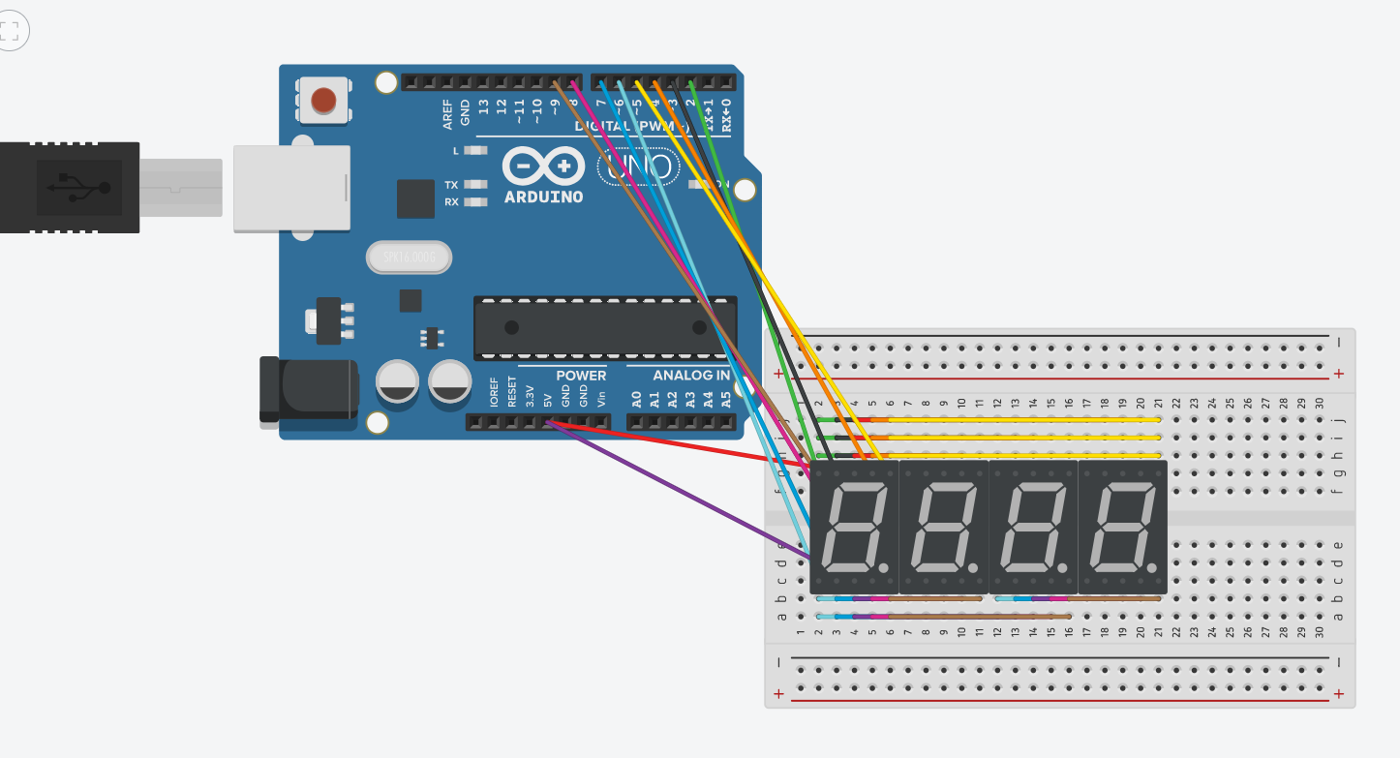
- 修正程式碼
(1)
#include "SevSeg.h"

SevSeg sevseg;

byte Pin6=digitalRead(6);

void setup()

{

byte numDigits = 4;

byte digitPins[] = {5, 4, 3, 2};

byte segmentPins[] = {8, 9, 10, 11,12, 13, 14};

bool resistorsOnSegments = false; // 'false' means resistors are on digit pins

byte hardwareConfig = COMMON_CATHODE; // See README.md for options

bool updateWithDelays = false; // Default. Recommended

bool leadingZeros = false; // Use 'true' if you'd like to keep the leading zeros

sevseg.begin(hardwareConfig, numDigits, digitPins, segmentPins, resistorsOnSegments, updateWithDelays, leadingZeros);

sevseg.setBrightness(90);

}

void loop()

{

static unsigned long timer = millis();

static int deciSeconds = 0;

sevseg.setNumber(deciSeconds, 3);

if (millis() - timer >= 300)

{

timer +=300;

if(deciSeconds%100 == 59)

{

deciSeconds=deciSeconds+41;

}

else

{

deciSeconds=deciSeconds+1;

}

if (deciSeconds == 2400)

{

deciSeconds=0;

}

}

sevseg.refreshDisplay(); // Must run repeatedly

}

/// END ///

(2)
#include "SevSeg.h"

SevSeg sevseg;

byte Pin6=digitalRead(6);

void setup()

{

byte numDigits = 4;

byte digitPins[] = {5, 4, 3, 2};

byte segmentPins[] = {8, 9, 10, 11,12, 13, 14};

bool resistorsOnSegments = false; // 'false' means resistors are on digit pins

byte hardwareConfig = COMMON_CATHODE; // See README.md for options

bool updateWithDelays = false; // Default. Recommended

bool leadingZeros = false; // Use 'true' if you'd like to keep the leading zeros

sevseg.begin(hardwareConfig, numDigits, digitPins, segmentPins, resistorsOnSegments, updateWithDelays, leadingZeros);

sevseg.setBrightness(90);

}

void loop()

{

static unsigned long timer = millis();

static int deciSeconds = 0;

sevseg.setNumber(deciSeconds, 3);

if (millis() - timer >= 300)

{

timer +=300;

if(deciSeconds%100 == 59)

{

deciSeconds=deciSeconds+41;

}

else

{

deciSeconds=deciSeconds+1;

}

if (deciSeconds == 2400)

{

deciSeconds=0;

}

if(Pin6==LOW)

{

deciSeconds = 0;

}

}

sevseg.refreshDisplay(); // Must run repeatedly

}

/// END ///
(3)
#include "SevSeg.h"
SevSeg sevseg; //Instantiate a seven segment controller object

void setup() {
byte numDigits = 4;
byte digitPins[] = {2, 3, 4, 5};
byte segmentPins[] = {8,9,10,11,12,13,14,15};
bool resistorsOnSegments = false; // 'false' means resistors are on digit pins
byte hardwareConfig = COMMON_CATHODE; // See README.md for options
sevseg.begin(hardwareConfig, numDigits, digitPins, segmentPins, resistorsOnSegments);
sevseg.setBrightness(90);
pinMode(6,INPUT);
pinMode(17,INPUT);
}

void loop()
{

static unsigned long timer = millis();
static int deciSeconds = 0;
boolean val=digitalRead(6);
boolean Pin17=digitalRead(17);
if(val)
{
sevseg.setNumber(0000, 3);
sevseg.refreshDisplay();
if(Pin17==HIGH)
deciSeconds=2400;
else
deciSeconds=0;

}
else if(Pin17==HIGH)
{
sevseg.setNumber(deciSeconds, 3);
if (millis() - timer >= 300)

{
timer += 300;
deciSeconds--;
if (deciSeconds%100 == 59)
{
deciSeconds=deciSeconds-59;
}
else
{
deciSeconds=deciSeconds-1;
}
}
if (deciSeconds == 0)
deciSeconds =2400 ;

sevseg.refreshDisplay(); // Must run repeatedly
}
else
{
sevseg.setNumber(deciSeconds, 3);
if (millis() - timer >= 300)
{
timer += 300;
deciSeconds++;
if (deciSeconds%100 == 59)
{
deciSeconds=deciSeconds+41;
}
else
{
deciSeconds=deciSeconds+1;
}
if (deciSeconds == 2400)
deciSeconds =0 ;
}

sevseg.refreshDisplay(); // Must run repeatedly
}
}

